231-889-4429 5471 Fairview Street, Box 119 Onekama, MI

TRINITY LUTHERAN CHURCH
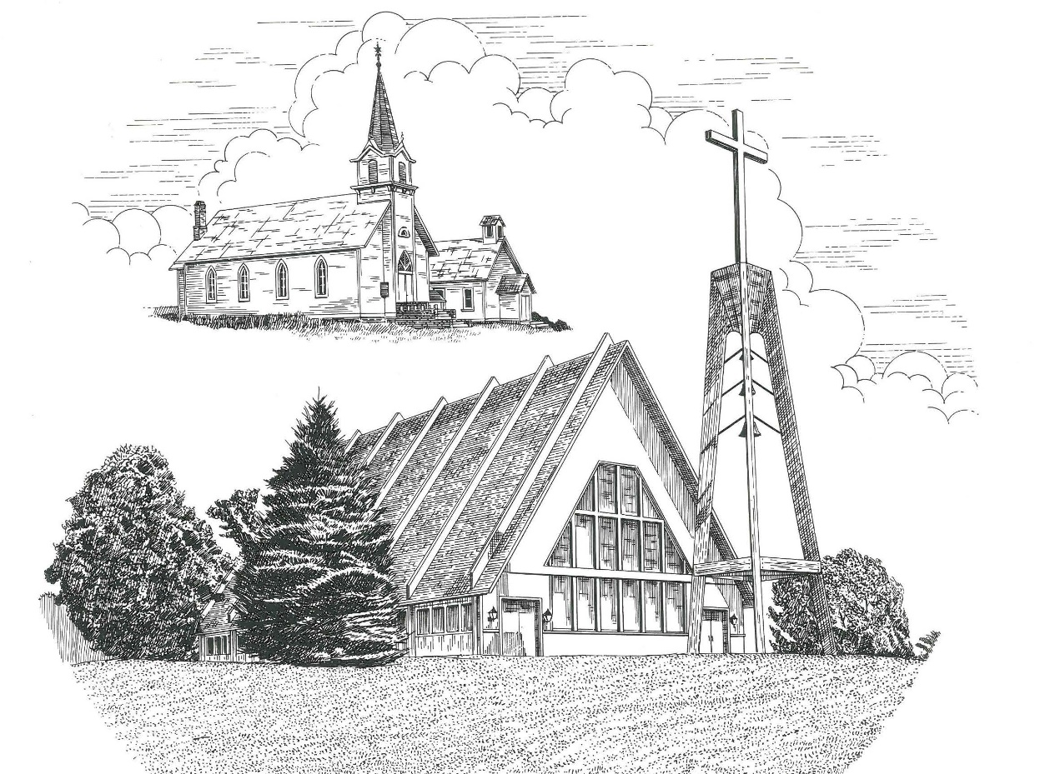

Second Sunday of Easter April 11th, 2021

WELCOME
Thanks for joining us!
Pastor Jacob Sherry Missouri Synod

~~PLEASE NOTE~~
Calling on the name of the Lord
Does not include the use of cell phones in the worship sanctuary.
Please check yours before the service begins. Thank you for your courtesy.
~~TO OUR GUESTS AND VISITORS~~
Please sign our guest book located on the stand at the church entrance. During the service, we ask you to sign the attendance booklet located at the end of each pew. If you need assistance or have questions about our worship service, please talk to an elder or any one of our church family. We are glad you could join us and hope to have you worship with us again soon.

~~ATTENDING HOLY COMMUNION~~
By checking the “Communing Today” box on the registration form found in the attendance booklet, you are agreeing with the following statements:

- I am a baptized Christian who believes Jesus Christ is my Lord and Savior.
- I believe that I am a sinner in need of Christ freely offered forgiveness.
- I believe that in the Lord’s Supper the body and blood of Jesus Christ
are truly present in, with, and under the bread and wine.
- I believe that my participation in Holy Communion grants me forgiveness
of my sins, new spiritual life, and eternal salvation.
- With God’s help, I sincerely seek to repent of my sins, live in service
to my Lord, and await His return.

If you agree with the above statements, you are welcome to attend the Lord’s Supper with us. May God bless your worship time with us.
We do offer gluten-free wafers, please quietly ask an elder to help you.

Covid-19 Guidance for Worship
* Masks are to be properly worn during worship.
* Please sit on the ends of the pews and not directly behind someone.
* Maintain social distancing with other members even at the communion rail.
* If you are feeling ill, please remain home and watch the service online.
Order of Divine Service Setting Four

Pre-Service Music……………..Call to Worship………………….Greeting

OPENING HYMN: “Christ the Lord Is Risen Today”………………...LSB #469

OPENING LITURGY:
Confession & Absolution……………………………………….LSB p. 203
Kyrie……………………………………………………………..LSB p. 204
Gloria in Excelsis………………………………………………..LSB p. 204
Salutation….…………………………………………………….LSB p. 205

Collect Prayer
Almighty God, grant that we who have celebrated the Lord’s resurrection may by Your grace confess in our life and conversation that Jesus is Lord and God; through the same Jesus Christ, Your Son, who lives and reigns with You and the Holy Spirit, one God, now and forever.

THE HOLY SCRIPTURES

FIRST READING: (Acts 4:32-35)
³² Now the full number of those who believed were of one heart and soul, and no one said that any of the things that belonged to him was his own, but they had everything in common. ³³ And with great power the apostles were giving their testimony to the resurrection of the Lord Jesus, and great grace was upon them all. ³⁴ There was not a needy person among them, for as many as were owners of lands or houses sold them and brought the proceeds of what was sold ³⁵ and laid it at the apostles' feet, and it was distributed to each as any had need.

R: This is the Word of the Lord. Cong: Thanks be to God.

GRADUAL
Reader: Christ has risen from the dead.
Cong.: God the Father has crowned him with glory and honor,
Reader: He has given him dominion over the works of his hands;
Cong.: he has put all things under his feet.

SECOND READING: (1 John 1:1 – 2:2)
That which was from the beginning, which we have heard, which we have seen with our eyes, which we looked upon and have touched with our hands, concerning the word of life— ² the life was made manifest, and we have seen it, and testify to it and proclaim to you the eternal life, which was with the Father and was made manifest to us— ³ that which we have seen and heard we proclaim also to you, so that you too may have fellowship with us; and indeed our fellowship is with the Father and with his Son Jesus Christ. ⁴ And we are writing these things so that our joy may be complete. ⁵ This is the message we have heard from him and proclaim to you, that God is light, and in him is no darkness at all. ⁶ If we say we have fellowship with him while we walk in darkness, we lie and do not practice the truth. ⁷ But if we walk in the light, as he is in the light, we have fellowship with one another, and the blood of Jesus his Son cleanses us from all sin. ⁸ If we say we have no sin, we deceive ourselves, and the truth is not in us. ⁹ If we confess our sins, he is faithful and just to forgive us our sins and to cleanse us from all unrighteousness. ¹⁰ If we say we have not sinned, we make him a liar, and his word is not in us. My little children, I am writing these things to you so that you may not sin. But if anyone does sin, we have an advocate with the Father, Jesus Christ the righteous. ² He is the propitiation for our sins, and not for ours only but also for the sins of the whole world.

R: This is the Word of the Lord. Cong: Thanks be to God.

(PLEASE RISE for the reading of the Gospel)

R: The Holy Gospel according to St. John, the 20th chapter.
Cong: Glory to You, O Lord

HOLY GOSPEL: (John 20:19-31)
¹⁹ On the evening of that day, the first day of the week, the doors being locked where the disciples were for fear of the Jews, Jesus came and stood among them and said to them, “Peace be with you.” ²⁰ When he had said this, he showed them his hands and his side. Then the disciples were glad when they saw the Lord. ²¹ Jesus said to them again, “Peace be with you. As the Father has sent me, even so I am sending you.” ²² And when he had said this, he breathed on them and said to them, “Receive the Holy Spirit. ²³ If you forgive the sins of any, they are forgiven them; if you withhold forgiveness from any, it is withheld.”
²⁴ Now Thomas, one of the twelve, called the Twin, was not with them when Jesus came. ²⁵ So the other disciples told him, “We have seen the Lord.” But he said to them, “Unless I see in his hands the mark of the nails, and place my finger into the mark of the nails, and place my hand into his side, I will never believe.” ²⁶ Eight days later, his disciples were inside again, and Thomas was with them. Although the doors were locked, Jesus came and stood among them and said, “Peace be with you.” ²⁷ Then he said to Thomas, “Put your finger here, and see my hands; and put out your hand, and place it in my side. Do not disbelieve, but believe.” ²⁸ Thomas answered him, “My Lord and my God!” ²⁹ Jesus said to him, “Have you believed because you have seen me? Blessed are those who have not seen and yet have believed.”
³⁰ Now Jesus did many other signs in the presence of the disciples, which are not written in this book; ³¹ but these are written so that you may believe that Jesus is the Christ, the Son of God, and that by believing you may have life in his name.

R: This is the Gospel of the Lord. Cong: Praise to You, O Christ.

Nicene Creed
I believe in one God, the Father Almighty, maker of heaven and earth and of all things visible and invisible.
And in one Lord Jesus Christ, the only-begotten Son of God, begotten of His Father before all worlds, God of God, Light of Light, very God of very God, begotten, not made, being of one substance with the Father, by whom all things were made; who for us men and for our salvation came down from heaven and was incarnate by the Holy Spirit of the virgin Mary and was made man; and was crucified also for us under Pontius Pilate. He suffered and was buried. And the third day He rose again according to the Scriptures and ascended into heaven and sits at the right hand of the Father. And He will come again with glory to judge both the living and the dead, whose kingdom will have no end.
And I believe in the Holy Spirit, the Lord and giver of life, who proceeds from the Father and the Son, who with the Father and the Son together is worshiped and glorified, who spoke by the prophets. And I believe in one holy Christian and apostolic Church, I acknowledge one Baptism for the remission of sins, and I look for the resurrection of the dead and the life of the world to come. Amen.

SERMON HYMN: “O Worship the King”…………………………..….LSB #804

SERMON

THE GENERAL PRAYERS

INSTITUTION OF THE LORD’S SUPPER
Preface…………………………………….…………….………..LSB p. 208

Proper Preface
It is truly good, right, and salutary that we should at all times and in all places give thanks to You, O Lord, holy Father, almighty and everlasting God, for the countless blessings You so freely bestow on us and all creation. Above all, we give thanks for Your boundless love shown to us when You sent Your only-begotten Son, Jesus Christ, into our flesh and laid on Him our sin, giving Him into death that we might not die eternally. Because He is now risen from the dead and lives and reigns to all eternity, all who believe in Him will overcome sin and death and will rise again to new life. Therefore, with angels and archangels and with all the company of heaven we laud and magnify Your glorious name, ever more praising You and saying:

Sanctus, Lord’s Prayer, The Words of Our Lord………………….....LSB pp. 208-209
Agnus Dei………………………………………………………………..LSB p. 210
If you are not communing it is acceptable to remain seated.

COMMUNION DISTRIBUTION HYMNS:
LSB #470 “O Sons and Daughters of the King”
LSB #691 “Fruitful Trees, the Spirit’s Sowing”

CLOSING LITURGY:………………………………………………....LSB pp. 211-212

CLOSING HYMN: “Alleluia! Jesus Is Risen”......................................LSB #474

The Mission of Trinity Onekama Is To SERVE

For even the Son of Man did not come to be served
but to serve and to give his life as a ransom for many.
Mark 10:45

S haring Jesus’s truth
E quipping for life
R eaching Out
V aluing each other
E vangelizing all ages
Mission Statement
The mission of Trinity Onekama is to SERVE
For even the Son of Man did not come to be served, but to serve,
and to give his life as a ransom for many. Mark 10:45
S haring Jesus’ ruth
E quipping for life
R eaching Out
V aluing each other
E vangelizing all age

CHURCH INFORMATION
Church Office: (231) 889-4429 Website: www.trinityonekama.org
E-mail: trinityonekama@sbcglobal.net
Address: P.O. Box 119, 5471 Fairview Street, Onekama, MI 49675
Adult Bible Study: Sunday @ 9:15 am (year round)
Worship: Sunday @ 10:30 am The Lord’s Supper: Celebrated 2nd & 4th Sundays
Pastoral Hours: Wednesday and Friday 8:30am – Noon
Pastor Phone: 231-655-2680 Pastor Email: trinityonekama@gmail.com

Copyright licensing covered under CCLI #2802932

