**231-889-4429 5471 Fairview Street, Box 119 Onekama, MI**

**TRINITY LUTHERAN CHURCH**

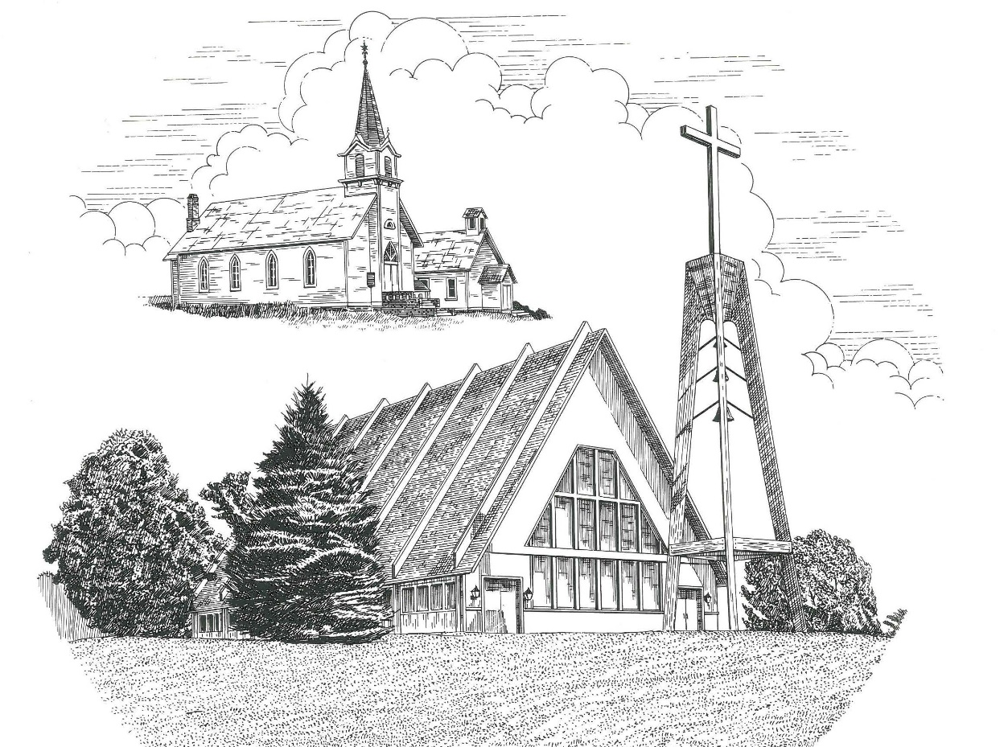

Easter Sunday April 12th, 2020

**WELCOME**

**Thanks for joining us!**

**Pastor Jacob Sherry Missouri Synod**

**~~PLEASE NOTE~~Calling on the name of the Lord**

Does not include the use of cell phones in the worship sanctuary.

Please check yours before the service begins. Thank you for your courtesy.

**~~TO OUR GUESTS AND VISITORS~~**

Please sign our guest book located on the stand at the church entrance. During the service, we ask you to sign the attendance booklet located at the end of each pew. If you need assistance or have questions about our worship service, please talk to an elder or any one of our church family. We are glad you could join us and hope to have you worship with us again soon.

**~~ATTENDING HOLY COMMUNION~~**

By checking the “Communing Today” box on the registration form found in the attendance booklet, you are agreeing with the following statements:

* **I am a baptized Christian who believes Jesus Christ is my Lord and Savior.**
* **I believe that I am a sinner in need of Christ freely offered forgiveness.**
* **I believe that in the Lord’s Supper the body and blood of Jesus Christ**

**are truly present in, with, and under the bread and wine.**

* **I believe that my participation in Holy Communion grants me forgiveness**

**of my sins, new spiritual life, and eternal salvation.**

* **With God’s help, I sincerely seek to repent of my sins, live in service**

**to my Lord, and await His return.**

**If you agree with the above statements, you are welcome to attend the Lord’s Supper with us. May God bless your worship time with us.**

We do offer gluten-free wafers, please quietly ask an elder to help you.

***He has risen!***

***He has risen indeed! Alleluia!***

Order of Divine Service Setting Three

**Pre-Service Music……………..Call to Worship………………….Greeting**

**OPENING HYMN:** *“Jesus Christ Is Risen Today”*……………………LSB #457

**OPENING LITURGY:**

**Confession & Absolution**……………………………………….LSB pp. 184-185

**Kyrie**……………………………………………………………..LSB p. 186

**Gloria In Excelsis**……………………………………………….LSB pp. 187-189

**Salutation**….…………………………………………………….LSB p. 189

**Collect Prayer**

Almighty God the Father, through Your only-begotten Son, Jesus Christ, You have overcome death and opened the gate of everlasting life to us. Grant the we, who celebrate with joy the day of our Lord’s resurrection, may be raised from the death of sin by Your life-giving Spirit; through Jesus Christ, our Lord, who lives and reigns with You and the Holy Spirit, one God, now and forever.

**THE HOLY SCRIPTURES**

**FIRST READING:** (Acts 10:34-43)

**34**So Peter opened his mouth and said: “Truly I understand that God shows no partiality, **35**but in every nation anyone who fears him and does what is right is acceptable to him. **36**As for the word that he sent to Israel, preaching good news of peace through Jesus Christ (he is Lord of all), **37**you yourselves know what happened throughout all Judea, beginning from Galilee after the baptism that John proclaimed: **38**how God anointed Jesus of Nazareth with the Holy Spirit and with power. He went about doing good and healing all who were oppressed by the devil, for God was with him. **39**And we are witnesses of all that he did both in the country of the Jews and in Jerusalem. They put him to death by hanging him on a tree, **40**but God raised him on the third day and made him to appear, **41**not to all the people but to us who had been chosen by God as witnesses, who ate and drank with him after he rose from the dead. **42**And he commanded us to preach to the people and to testify that he is the one appointed by God to be judge of the living and the dead. **43**To him all the prophets bear witness that everyone who believes in him receives forgiveness of sins through his name.”

**R:** This is the Word of the Lord**.** **Cong: Thanks be to God.**

**GRADUAL**

Reader: Christ has risen from the dead.

**Cong.: God the Father has crowned him with glory and honor,**

Reader: He has given him dominion over the works of his hands;

**Cong.: he has put all things under his feet.**

**SECOND READING:** (Colossians 3:1-4)

If then you have been raised with Christ, seek the things that are above, where Christ is, seated at the right hand of God. **2**Set your minds on things that are above, not on things that are on earth. **3**For you have died, and your life is hidden with Christ in God. **4**When Christ who is your life appears, then you also will appear with him in glory.

**R:** This is the Word of the Lord. **Cong: Thanks be to God.**

**(PLEASE RISE for the reading of the Gospel)**



**R:** The Holy Gospel according to St. Matthew, the 28th chapter.

# download (2)

**HOLY GOSPEL:** (Matthew 28:1-10)

Now after the Sabbath, toward the dawn of the first day of the week, Mary Magdalene and the other Mary went to see the tomb. **2**And behold, there was a great earthquake, for an angel of the Lord descended from heaven and came and rolled back the stone and sat on it. **3**His appearance was like lightning, and his clothing white as snow. **4**And for fear of him the guards trembled and became like dead men. **5**But the angel said to the women, “Do not be afraid, for I know that you seek Jesus who was crucified. **6**He is not here, for he has risen, as he said. Come, see the place where he lay. **7**Then go quickly and tell his disciples that he has risen from the dead, and behold, he is going before you to Galilee; there you will see him. See, I have told you.” **8**So they departed quickly from the tomb with fear and great joy, and ran to tell his disciples. **9**And behold, Jesus met them and said, “Greetings!” And they came up and took hold of his feet and worshiped him. **10**Then Jesus said to them, “Do not be afraid; go and tell my brothers to go to Galilee, and there they will see me.”

**R:** This is the Gospel of the Lord.

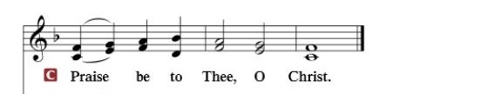

**Nicene Creed**…...……………………………………………………..…LSB p. 191

I believe in one God, the Father Almighty, maker of heaven and earth and of all things visible and invisible.

And in one Lord Jesus Christ, the only-begotten Son of God, begotten of His Father before all worlds, God of God, Light of Light, very God of very God, begotten, not made, being of one substance with the Father, by whom all things were made; who for us men and for our salvation came down from heaven and was incarnate by the Holy Spirit of the virgin Mary and was made man; and was crucified also for us under Pontius Pilate. He suffered and was buried. And the third day He rose again according to the Scriptures and ascended into heaven and sits at the right hand of the Father. And He will come again with glory to judge both the living and the dead, whose kingdom will have no end.

And I believe in the Holy Spirit, the Lord and giver of life, who proceeds from the Father and the Son, who with the Father and the Son together is worshiped and glorified, who spoke by the prophets. And I believe in one holy Christian and apostolic Church, I acknowledge one Baptism for the remission of sins, and I look for the resurrection of the dead and the life of the world to come. Amen.

**SERMON HYMN**: *“Christ the Lord Is Risen Today”*………………….LSB #469

**SERMON**

**GATHERING OF OUR FIRST FRUITS & OFFERTORY**…………LSB pp. 192-193

**THE GENERAL PRAYERS**

**Congregational Sharing of the Peace of the Lord**

**INSTITUTION OF THE LORD’S SUPPER**

**Preface**…………………………………….…………….………..LSB p. 194

**Proper Preface**

It is truly good, right, and salutary that we should at all times and in all places give thanks to You, holy Lord, almighty Father, everlasting God. And most especially are we bound to praise You on this day for the glorious resurrection of Your Son, Jesus Christ, the very Paschal Lamb, who was sacrificed for us and bore the sins of the world. By His dying, He has destroyed death, and by His rising again, He has restored to us everlasting life. Therefore, with Mary Magdalene, Peter and John, and all the witnesses of the resurrection, with angels and archangels and with all the company of heaven, we laud and magnify Your glorious name, ever more praising You and saying:

**Sanctus, Lord’s Prayer, The Words of Our Lord**………………….....LSB pp. 195-197

**Agnus Dei**………………………………………………………………..LSB p. 198

*If you are not communing, it is acceptable to remain seated.*

**COMMUNION DISTRIBUTION HYMNS:**

LSB #461 *“I Know That My Redeemer Lives”*

LSB #466 *“Christ Has Arisen, Alleluia”*

**CLOSING LITURGY:**………………………………………………....LSB pp. 199-202

**CLOSING HYMN:** *“Alleluia! Jesus Is Risen”*......................................LSB #474



**Special Prayers**

Morris Armbruster Jill Hoseler (Cancer) Marjorie Nelson

Kaydence Devenport Delbert Kelley Barbara Potter

Dylan Gladding Margaret Meachum Steve Schimke

Gayle Harthun (Cancer) Gerald Meister Rev. Jeff Walsh (Cancer)

Bob Hilliard (Heart) Rita Merkey Sandy Wing

**Prayers for Our Military**

**Andrew Burch**, **Jr**., grandson of John & Loree Sprawka.

**Mark Granzotto** with U.S. Navy in Bahrain, grandson of Rita Merkey

**Colonel Joel Briske** serving in Washington D.C. son of the late Bonnie Harnish

**Army Major Riley Morgan Kennedy, s**tationed in Washington, DC, George & Margaret Punches’ grand-niece

**Steve & Carol Sprawka,** son & daughter-in-law of John & Loree Sprawka

**Derek Sprawka,** grandson of John & Loree Sprawka

**Cody Stefanick,** nephew to Janette & Fred May

**Ian Nelson,** nephew of Jack and Pebbla Nelson

**Tyge Nelson & family,** nephew of Jack and Pebbla Nelson

**Lt. Tim Brandt** at Uniformed Services University, Bethesda, MD, son of Bruce & Debbie Brandt

***If you wish to add someone’s name, please call or e-mail the church office.***

***When someone’s name is placed on prayer lists,***

***his or her name will remain until instructed to remove it. Thank you!***

The Mission of Trinity Onekama Is To **SERVE**

For even the Son of Man did not come to be served

but to serve and to give his life as a ransom for many.            
                                                                       Mark 10:45



**S**haring Jesus’s **t**ruth

**E**quipping for life

**R**eaching Out

**V**aluing each other

**E**vangelizing all ages

Mission Statement

The mission of Trinity Onekama is to SERVE

For even the Son of Man did not come to be served, but to serve,

and to give his life as a ransom for many. Mark 10:45

S haring Jesus’ ruth

E quipping for life

R eaching Out

V aluing each other

E vangelizing all age

**CHURCH INFORMATION**

**Church Office:** (231) 889-4429 **Website:** www.trinityonekama.org

**E-mail:** [trinityonekama@sbcglobal.net](mailto:trinityonekama@sbcglobal.net)

**Address:** P.O. Box 119, 5471 Fairview Street, Onekama, MI 49675

**Adult Bible Study**: Sunday @ 9:15 am (year round)

**Worship:** Sunday @ 10:30 am **The Lord’s Supper:**  Celebrated 2nd & 4th Sundays

**Pastoral Hours:** Wednesday and Friday 8:30am – Noon

**Pastor Phone:** 231-655-2680 **Pastor Email:** trinityonekama@gmail.com

**Copyright licensing covered under CCLI #2802932**