231-889-4429 5471 Fairview Street, Box 119 Onekama, MI

TRINITY LUTHERAN CHURCH
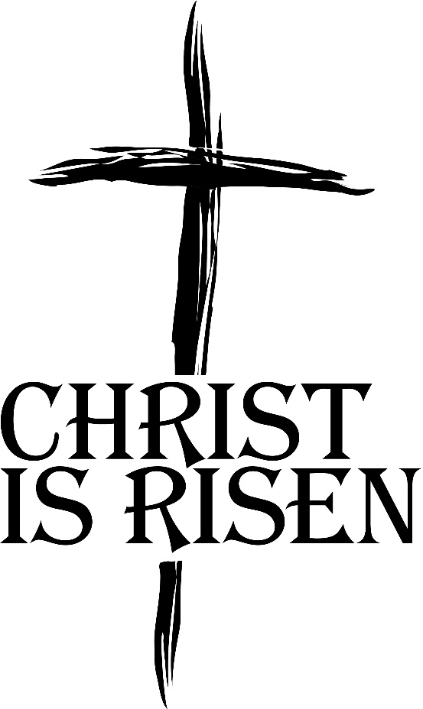

The Resurrection of Our Lord April 17th, 2022

WELCOME
Thanks for joining us!
Pastor Jacob Sherry Missouri Synod

~~PLEASE NOTE~~
Calling on the name of the Lord
Does not include the use of cell phones in the worship sanctuary.
Please check yours before the service begins. Thank you for your courtesy.
~~TO OUR GUESTS AND VISITORS~~
Please sign our guest book located on the stand at the church entrance. During the service, we ask you to sign the attendance sheet in your bulletin and leave it in the pew when you leave. If you need assistance or have questions about our worship service, please talk to an elder or any one of our church family. We are glad you could join us and hope to have you worship with us again soon.

~~ATTENDING HOLY COMMUNION~~
By checking the “Communing Today” box on the attendance sheet in your bulletin, you are agreeing with the following statements:

- I am a baptized Christian who believes Jesus Christ is my Lord and Savior.
- I believe that I am a sinner in need of Christ freely offered forgiveness.
- I believe that in the Lord’s Supper the body and blood of Jesus Christ
are truly present in, with, and under the bread and wine.
- I believe that my participation in Holy Communion grants me forgiveness
of my sins, new spiritual life, and eternal salvation.
- With God’s help, I sincerely seek to repent of my sins, live in service
to my Lord, and await His return.

If you agree with the above statements, you are welcome to attend the Lord’s Supper with us. May God bless your worship time with us.
We do offer gluten-free wafers, please quietly ask an elder to help you.

Order of Divine Service

Pre-Service Music……………..Call to Worship………………….Greeting

OPENING HYMN: “Jesus Christ Is Risen Today”…..………………………..LSB #457

OPENING LITURGY
P: In the name of the Father and the Son and the Holy Spirit.
C: Amen.

P: Alleluia! Christ is risen!
C: He is risen indeed! Alleluia!
P: Sing to the Lord a new song,
C: for he has done marvelous things.

P: Our help is in the name of the Lord,
C: who made heaven and earth.
P: If You, O Lord, kept a record of sins, O Lord, who could stand?
C: But with You there is forgiveness; therefore You are feared.

P: Since we are gathered to hear God’s Word, call upon Him in prayer and praise, and receive the body and blood of our Lord Jesus Christ in the fellowship of this altar, let us first consider our unworthiness and confess before God and one another that we have sinned in thought, word, and deed, and that we cannot free ourselves from our sinful condition. Together as His people let us take refuge in the infinite mercy of God, our heavenly Father, seeking His grace for the sake of Christ, and saying: God, be merciful to me, a sinner.
C: Almighty God, have mercy upon us, forgive us our sins, and lead us to everlasting life. Amen.
P: Almighty God in His mercy has given His Son to die for you and for His sake forgives you all your sins. As a called and ordained servant of Christ, and by His authority, I therefore forgive you all your sins in the name of the Father and of the Son and of the Holy Spirit.
C: Amen.

INTROIT
P: I will sing to the Lord, for he has triumphed gloriously;
C: the horse and his rider he has thrown in to the sea.
P: The Lord is my strength and my song,
C: and he has become my sal vation;
P: Your right hand, O Lord, glorious in power,
C: your right hand, O Lord, shatters the enemy.
P: You have led in your steadfast love the people whom you have redeemed;
C: you have guided them by your strength to your ho ly abode.
P: You will bring them in and plant them on your own mountain,
C: the place, O Lord, which you have made for your abode,
P: the sanctuary, O Lord, which your hands have es tablished.
C: The Lord will reign forever and ever.
ALL: Glory be to the Father and to the Son
and to the Holy Spirit;
as it was in the be ginning,
is now, and will be forever. Amen.

KYRIE
P: In peace let us pray to the Lord.

P: For the peace from above and for our salvation let us pray to the Lord.

P: For the peace of the whole world, for the well-being of the Church of God,
and for the unity of all let us pray to the Lord.

P: For this holy house and for all who offer here their worship and praise
let us pray to the Lord.

P: Help, save, comfort, and defend us, gracious Lord.

CANTICLE HYMN: “Alleluia! Jesus Is Risen”……………………………...LSB #474

SALUTATION
P: The Lord be with you.

P: Let us pray.
Collect Prayer
Almighty God the Father, through Your only-begotten Son, Jesus Christ, You have overcome death and opened the gate of everlasting life to us. Grant that we, who celebrate with joy the day of our Lord’s resurrection, may be raised from the death of sin by Your life-giving Spirit; through Jesus Christ, our Lord, who lives and reigns with You and the Holy Spirit, one God, now and forever.
C: Amen.

THE HOLY SCRIPTURES

OLD TESTAMENT: (Isaiah 65:17-25)
¹⁷ “For behold, I create new heavens
and a new earth,
and the former things shall not be remembered
or come into mind.
¹⁸ But be glad and rejoice forever
in that which I create;
for behold, I create Jerusalem to be a joy,
and her people to be a gladness.
¹⁹ I will rejoice in Jerusalem
and be glad in my people;
no more shall be heard in it the sound of weeping
and the cry of distress.
²⁰ No more shall there be in it
an infant who lives but a few days,
or an old man who does not fill out his days,
for the young man shall die a hundred years old,
and the sinner a hundred years old shall be accursed.
²¹ They shall build houses and inhabit them;
they shall plant vineyards and eat their fruit.
²² They shall not build and another inhabit;
they shall not plant and another eat;
for like the days of a tree shall the days of my people be,
and my chosen shall long enjoy the work of their hands.
²³ They shall not labor in vain
or bear children for calamity,
for they shall be the offspring of the blessed of the Lord,
and their descendants with them.
²⁴ Before they call I will answer;
while they are yet speaking I will hear.
²⁵ The wolf and the lamb shall graze together;
the lion shall eat straw like the ox,
and dust shall be the serpent's food.
They shall not hurt or destroy
in all my holy mountain,”
says the Lord.

R: This is the Word of the Lord. Cong: Thanks be to God.

GRADUAL
Reader: Christ has risen from the dead.
Cong.: God the Father has crowned him with glory and honor,
Reader: He has given him dominion over the works of his hands;
Cong.: he has put all things under his feet.

EPISTLE: (1 Corinthians 15:19-26)
¹⁹ If in Christ we have hope in this life only, we are of all people most to be pitied. ²⁰ But in fact Christ has been raised from the dead, the firstfruits of those who have fallen asleep. ²¹ For as by a man came death, by a man has come also the resurrection of the dead. ²² For as in Adam all die, so also in Christ shall all be made alive. ²³ But each in his own order: Christ the firstfruits, then at his coming those who belong to Christ. ²⁴Then comes the end, when he delivers the kingdom to God the Father after destroying every rule and every authority and power. ²⁵ For he must reign until he has put all his enemies under his feet. ²⁶ The last enemy to be destroyed is death.

R: This is the Word of the Lord. Cong: Thanks be to God.

(PLEASE RISE for the reading of the Gospel)

P: The Holy Gospel according to St. Luke, the 24th chapter.

HOLY GOSPEL: (Luke 24:1-12)
But on the first day of the week, at early dawn, they went to the tomb, taking the spices they had prepared. ² And they found the stone rolled away from the tomb, ³ but when they went in they did not find the body of the Lord Jesus. ⁴ While they were perplexed about this, behold, two men stood by them in dazzling apparel. ⁵ And as they were frightened and bowed their faces to the ground, the men said to them, “Why do you seek the living among the dead? ⁶ He is not here, but has risen. Remember how he told you, while he was still in Galilee, ⁷ that the Son of Man must be delivered into the hands of sinful men and be crucified and on the third day rise.” ⁸ And they remembered his words, ⁹ and returning from the tomb they told all these things to the eleven and to all the rest. ¹⁰ Now it was Mary Magdalene and Joanna and Mary the mother of James and the other women with them who told these things to the apostles, ¹¹ but these words seemed to them an idle tale, and they did not believe them. ¹² But Peter rose and ran to the tomb; stooping and looking in, he saw the linen cloths by themselves; and he went home marveling at what had happened.

P: This is the Gospel of the Lord.

Nicene Creed
I believe in one God, the Father Almighty, maker of heaven and earth and of all things visible and invisible.
And in one Lord Jesus Christ, the only-begotten Son of God, begotten of His Father before all worlds, God of God, Light of Light, very God of very God, begotten, not made, being of one substance with the Father, by whom all things were made; who for us men and for our salvation came down from heaven and was incarnate by the Holy Spirit of the virgin Mary and was made man; and was crucified also for us under Pontius Pilate. He suffered and was buried. And the third day He rose again according to the Scriptures and ascended into heaven and sits at the right hand of the Father. And He will come again with glory to judge both the living and the dead, whose kingdom will have no end.
And I believe in the Holy Spirit, the Lord and giver of life, who proceeds from the Father and the Son, who with the Father and the Son together is worshiped and glorified, who spoke by the prophets. And I believe in one holy Christian and apostolic Church, I acknowledge one Baptism for the remission of sins, and I look for the resurrection of the dead and the life of the world to come. Amen.

SERMON HYMN: “Christ the Lord Is Risen Today”…………………………LSB #469

SERMON

DOXOLOGY HYMN: “Praise God, From Whom All Blessings Flow”……...LSB #805

PRAYERS OF THE CHURCH

SERVICE OF THE SACRAMENT
P: The Lord be with you.

P: Lift up your hearts.

P: Let us give thanks unto the Lord, our God.

Proper Preface
It is truly good, right, and salutary that we should at all times and in all places give thanks to You, holy Lord, almighty Father, everlasting God. And most especially are we bound to praise You on this day for the glorious resurrection of Your Son, Jesus Christ, the very Paschal Lamb, who was sacrificed for us and bore the sins of the world. By His dying He has destroyed death, and by His rising again He has restored to us everlasting life. Therefore, with Mary Magdalene, Peter and John, and with all the witnesses of the resurrection, with angels and archangels, and with all the company of heaven we laud and magnify Your glorious name, ever more praising You and saying:

SANCTUS

PRAYER OF THANKSGIVING
For Christ, our Passover Lamb, has been sacrificed. By His death, He has redeemed us from bondage to sin and death, and by His resurrection, He has delivered us into new life in Him. Grant us to keep the Feast in sincerity and truth, faithfully eating His body given into death and drinking His life’s blood poured out for our salvation until we pass through death to the promised land of life eternal.
Hear us as we pray in His name and as He has taught us:

LORD’S PRAYER

THE WORDS OF OUR LORD

P: The peace of the Lord be with you always.

AGNUS DEI

COMMUNION DISTRIBUTION HYMNS:
LSB #461 “I Know That My Redeemer Lives”
LSB #633 “At the Lamb’s High Feast We Sing”
LSB #462 “All the Earth with Joy Is Sounding”

THANK THE LORD

POST-COMMUNION COLLECT
P: Let us pray.
We give thanks to You, almighty God, that You have refreshed us through this salutary gift, and we implore You that of Your mercy You would strengthen us through the same in faith toward You and in fervent love toward one another; through Jesus Christ, Your Son, our Lord, who lives and reigns with You and the Holy Spirit, one God, now and forever.
C: Amen.

P: Let us bless the Lord.
C: Thanks be to God.

P: Alleluia! Christ is risen!
C: He is risen indeed! Alleluia!

P: The Lord bless you and keep you.
The Lord make His face shine on you and be gracious to you.
The Lord look upon you with favor and give you peace.
C: Amen.

CLOSING HYMN: “He’s Risen, He’s Risen”...................................................LSB #480

The angel said to the women,
“Do not be afraid, for I know that you are looking for Jesus, who was crucified. He is not here; he has risen, just as he said.”

Matthew 28:5-6a

“Don’t be alarmed,” he said. You are looking for Jesus the Nazarene, who was crucified. He has risen! He is not here.”

Mark 16:6a

But the men said to them,
“Why do you look for the living among the dead? He is not here; he has risen!”

Luke 24:5b-6a

The Mission of Trinity Onekama Is To SERVE

For even the Son of Man did not come to be served
but to serve and to give his life as a ransom for many.
Mark 10:45

S haring Jesus’s truth
E quipping for life
R eaching Out
V aluing each other
E vangelizing all ages
Mission Statement
The mission of Trinity Onekama is to SERVE
For even the Son of Man did not come to be served, but to serve,
and to give his life as a ransom for many. Mark 10:45
S haring Jesus’ ruth
E quipping for life
R eaching Out
V aluing each other
E vangelizing all age

CHURCH INFORMATION
Church Office: (231) 889-4429 Website: www.trinityonekama.org
E-mail: trinityonekama@sbcglobal.net
Address: P.O. Box 119, 5471 Fairview Street, Onekama, MI 49675
Adult Bible Study: Sunday @ 11:30 am (year round)
Worship: Sunday @ 10:30 am The Lord’s Supper: Celebrated 2nd & 4th Sundays
Pastoral Hours: Wednesday and Friday 9:00am – Noon
Pastor Phone: 231-655-2680 Pastor Email: trinityonekama@gmail.com

Copyright licensing covered under CCLI #2802932

