**231-889-4429 5471 Fairview Street, Box 119 Onekama, MI**

**TRINITY LUTHERAN CHURCH**

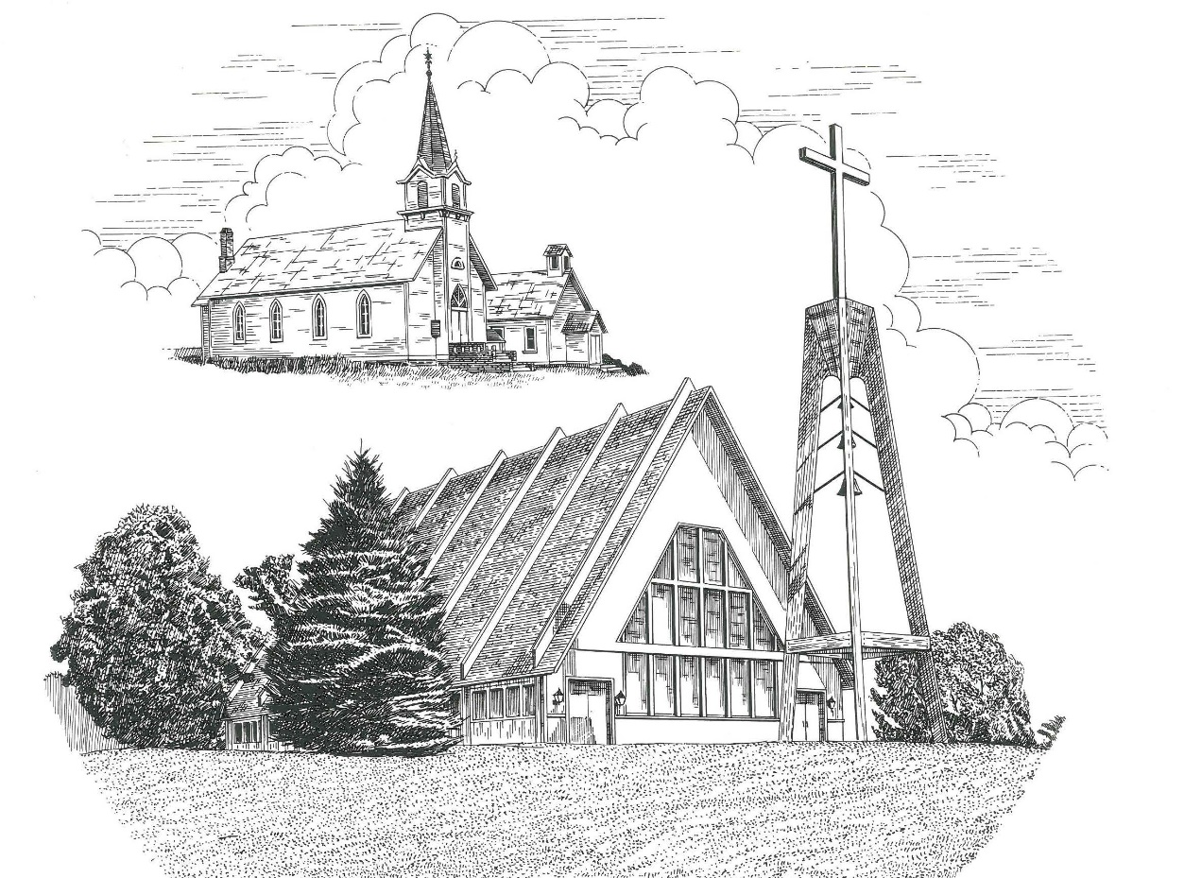

**Second Sunday of Easter April 24th, 2022**

**WELCOME**

**Thanks for joining us!**

**Pastor Jacob Sherry Missouri Synod**

**~~PLEASE NOTE~~Calling on the name of the Lord**

Does not include the use of cell phones in the worship sanctuary.

Please check yours before the service begins. Thank you for your courtesy.

**~~TO OUR GUESTS AND VISITORS~~**

Please sign our guest book located on the stand at the church entrance. During the service, we ask you to sign the attendance sheets located inside your bulletin and leave them on the pew as you leave. If you need assistance or have questions about our worship service, please talk to an elder or any one of our church family. We are glad you could join us and hope to have you worship with us again soon.

**~~ATTENDING HOLY COMMUNION~~**

By checking the “Communing Today” box on the registration form on the attendance sheet, you are agreeing with the following statements:

* **I am a baptized Christian who believes Jesus Christ is my Lord and Savior.**
* **I believe that I am a sinner in need of Christ freely offered forgiveness.**
* **I believe that in the Lord’s Supper the body and blood of Jesus Christ**

**are truly present in, with, and under the bread and wine.**

* **I believe that my participation in Holy Communion grants me forgiveness**

**of my sins, new spiritual life, and eternal salvation.**

* **With God’s help, I sincerely seek to repent of my sins, live in service**

**to my Lord, and await His return.**

**If you agree with the above statements, you are welcome to attend the Lord’s Supper with us. May God bless your worship time with us.**

We do offer gluten-free wafers, please quietly ask an elder to help you.

**Order of Divine Service Setting One**

**Pre-Service Music……………..Call to Worship………………….Greeting**

**OPENING HYMN:** *“Now All the Vault of Heaven Resounds”*………...LSB #465

**CONFESSION & ABSOLUTION**……………………………………..LSB p. 151

**KYRIE**…………………………………………………………………...LSB pp. 152-153

**THIS IS THE FEAST**…………………………………………………...LSB p. 155

**SALUTATION**…………………………………………………………..LSB p. 156

**Collect Prayer**

Almighty God, grant that we who have celebrated the Lord’s resurrection may by Your grace confess in our life and conversation that Jesus is Lord and God; through the same Jesus Christ, Your Son, who lives and reigns with You and the Holy Spirit, one God, now and forever.

**THE HOLY SCRIPTURES**

**FIRST READING:** (Acts 5:12-32)

**12**Now many signs and wonders were regularly done among the people by the hands of the apostles. And they were all together in Solomon's Portico.  **13**None of the rest dared join them, but the people held them in high esteem.  **14**And more than ever believers were added to the Lord, multitudes of both men and women, **15**so that they even carried out the sick into the streets and laid them on cots and mats, that as Peter came by at least his shadow might fall on some of them.  **16**The people also gathered from the towns around Jerusalem, bringing the sick and those afflicted with unclean spirits, and they were all healed.

**17**But the high priest rose up, and all who were with him (that is, the party of the Sadducees), and filled with jealousy **18**they arrested the apostles and put them in the public prison.  **19**But during the night an angel of the Lord opened the prison doors and brought them out, and said, **20**“Go and stand in the temple and speak to the people all the words of this Life.”  **21**And when they heard this, they entered the temple at daybreak and began to teach.

Now when the high priest came, and those who were with him, they called together the council, all the senate of the people of Israel, and sent to the prison to have them brought. **22**But when the officers came, they did not find them in the prison, so they returned and reported, **23**“We found the prison securely locked and the guards standing at the doors, but when we opened them we found no one inside.”  **24**Now when the captain of the temple and the chief priests heard these words, they were greatly perplexed about them, wondering what this would come to.  **25**And someone came and told them, “Look! The men whom you put in prison are standing in the temple and teaching the people.” **26**Then the captain with the officers went and brought them, but not by force, for they were afraid of being stoned by the people.

**27**And when they had brought them, they set them before the council. And the high priest questioned them, **28**saying, “We strictly charged you not to teach in this name, yet here you have filled Jerusalem with your teaching, and you intend to bring this man's blood upon us.”  **29**But Peter and the apostles answered, “We must obey God rather than men. **30**The God of our fathers raised Jesus, whom you killed by hanging him on a tree. **31**God exalted him at his right hand as Leader and Savior, to give repentance to Israel and forgiveness of sins.  **32**And we are witnesses to these things, and so is the Holy Spirit, whom God has given to those who obey him.”

**R:** This is the Word of the Lord**.** **Cong: Thanks be to God.**

**GRADUAL**

Reader: Christ has risen from the dead.

**Cong.: God the Father has crowned him with glory and honor,**

Reader: He has given him dominion over the works of his hands;

**Cong.: he has put all things under his feet.**

**SECOND READING:** (Revelation 1:4-18)

**4**John to the seven churches that are in Asia:

Grace to you and peace from him who is and who was and who is to come, and from the seven spirits who are before his throne, **5**and from Jesus Christ the faithful witness, the firstborn of the dead, and the ruler of kings on earth. To him who loves us and has freed us from our sins by his blood **6**and made us a kingdom, priests to his God and Father, to him be glory and dominion forever and ever. Amen. **7**Behold, he is coming with the clouds, and every eye will see him, even those who pierced him, and all tribes of the earth will wail on account of him. Even so. Amen. **8**“I am the Alpha and the Omega,” says the Lord God, “who is and who was and who is to come, the Almighty.”

**9**I, John, your brother and partner in the tribulation and the kingdom and the patient endurance that are in Jesus, was on the island called Patmos on account of the word of God and the testimony of Jesus. **10**I was in the Spirit on the Lord's day, and I heard behind me a loud voice like a trumpet **11**saying, “Write what you see in a book and send it to the seven churches, to Ephesus and to Smyrna and to Pergamum and to Thyatira and to Sardis and to Philadelphia and to Laodicea.”

**12**Then I turned to see the voice that was speaking to me, and on turning I saw seven golden lampstands, **13**and in the midst of the lampstands one like a son of man, clothed with a long robe and with a golden sash around his chest. **14**The hairs of his head were white, like white wool, like snow. His eyes were like a flame of fire, **15**his feet were like burnished bronze, refined in a furnace, and his voice was like the roar of many waters. **16**In his right hand he held seven stars, from his mouth came a sharp two-edged sword, and his face was like the sun shining in full strength.

**17**When I saw him, I fell at his feet as though dead. But he laid his right hand on me, saying, “Fear not, I am the first and the last, **18**and the living one. I died, and behold I am alive forevermore, and I have the keys of Death and Hades.

**R:** This is the Word of the Lord. **Cong: Thanks be to God.**

**(PLEASE RISE for the reading of the Gospel)**



**R:** The Holy Gospel according to St. John, the 20th chapter.



**HOLY GOSPEL:** (John 20:19-31)

**19**On the evening of that day, the first day of the week, the doors being locked where the disciples were for fear of the Jews, Jesus came and stood among them and said to them, “Peace be with you.” **20**When he had said this, he showed them his hands and his side. Then the disciples were glad when they saw the Lord. **21**Jesus said to them again, “Peace be with you. As the Father has sent me, even so I am sending you.” **22**And when he had said this, he breathed on them and said to them, “Receive the Holy Spirit. **23**If you forgive the sins of any, they are forgiven them; if you withhold forgiveness from any, it is withheld.”

**24**Now Thomas, one of the twelve, called the Twin, was not with them when Jesus came. **25**So the other disciples told him, “We have seen the Lord.” But he said to them, “Unless I see in his hands the mark of the nails, and place my finger into the mark of the nails, and place my hand into his side, I will never believe.”

**26**Eight days later, his disciples were inside again, and Thomas was with them. Although the doors were locked, Jesus came and stood among them and said, “Peace be with you.” **27**Then he said to Thomas, “Put your finger here, and see my hands; and put out your hand, and place it in my side. Do not disbelieve, but believe.” **28**Thomas answered him, “My Lord and my God!” **29**Jesus said to him, “Have you believed because you have seen me? Blessed are those who have not seen and yet have believed.”

**30**Now Jesus did many other signs in the presence of the disciples, which are not written in this book; **31**but these are written so that you may believe that Jesus is the Christ, the Son of God, and that by believing you may have life in his name.

**R:** This is the Gospel of the Lord.



**SERMON HYMN**: *“Christ Has Arisen, Alleluia”*…………………...............LSB #466

**SERMON**

**NICENE CREED**

I believe in one God, the Father Almighty, maker of heaven and earth and of all things visible and invisible.

And in one Lord Jesus Christ, the only-begotten Son of God, begotten of His Father before all worlds, God of God, Light of Light, very God of very God, begotten, not made, being of one substance with the Father, by whom all things were made; who for us men and for our salvation came down from heaven and was incarnate by the Holy Spirit of the virgin Mary and was made man; and was crucified also for us under Pontius Pilate. He suffered and was buried. And the third day He rose again according to the Scriptures and ascended into heaven and sits at the right hand of the Father. And He will come again with glory to judge both the living and the dead, whose kingdom will have no end.

And I believe in the Holy Spirit, the Lord and giver of life, who proceeds from the Father and the Son, who with the Father and the Son together is worshiped and glorified, who spoke by the prophets. And I believe in one holy Christian and apostolic Church, I acknowledge one Baptism for the remission of sins, and I look for the resurrection of the dead and the life of the world to come. Amen.

**THE GENERAL PRAYERS OF THE CHURCH**

**SERVICE OF THE SACRAMENT**

**PREFACE**……………………………………………………………………..LSB p. 160

**Proper Preface**

It is truly good, right, and salutary that we should at all times and in all places give thanks to You, holy Lord, almighty Father, everlasting God, through Jesus Christ, our Lord, who, out of love for His fallen creation, humbled Himself by taking on the form of a servant, becoming obedient unto death, even death upon a cross. Risen from the dead, He has freed us from eternal death and given us life everlasting. Therefore, with angels and archangels and with all the company of heaven we laud and magnify Your glorious name, ever more praising You and saying:

**SANCTUS**……………………………………………………………………...LSB p. 161

**THE WORDS OF OUR LORD**……………………………………………….LSB p. 162

**AGNUS DEI**……………………………………………………………………LSB p. 163

*If you are not communing, it is acceptable to remain seated.*

**COMMUNION DISTRIBUTION HYMNS**

LSB #464 *“The Strife Is O’er, the Battle Done”*

LSB #467 *“Awake, My Heart, with Gladness”*

**THANK THE LORD**………………………………………………………….LSB p. 164

**POST-COMMUNION COLLECT PRAYER**……………………………….LSB p. 166

**BENEDICTION**……………………………………………………………….LSB p. 166

**CLOSING HYMN:** *“Alleluia, Alleluia! Hearts to Heaven”*……..…………..LSB #477

**CHURCH INFORMATION**

**Church Office:** (231) 889-4429 **Website:** www.trinityonekama.org

**E-mail:** [trinityonekama@sbcglobal.net](mailto:trinityonekama@sbcglobal.net)

**Address:** P.O. Box 119, 5471 Fairview Street, Onekama, MI 49675

**Adult Bible Study**: Sunday @ 11:30 am (year round)

**Worship:** Sunday @ 10:30 am **The Lord’s Supper:**  Celebrated 2nd & 4th Sundays

**Pastoral Hours:** Wednesday and Friday 9:00am – Noon

**Pastor Phone:** 231-655-2680 **Pastor Email:** trinityonekama@gmail.com

**Copyright licensing covered under CCLI #2802932**