**231-889-4429 5471 Fairview Street, Box 119 Onekama, MI**

**TRINITY LUTHERAN CHURCH**

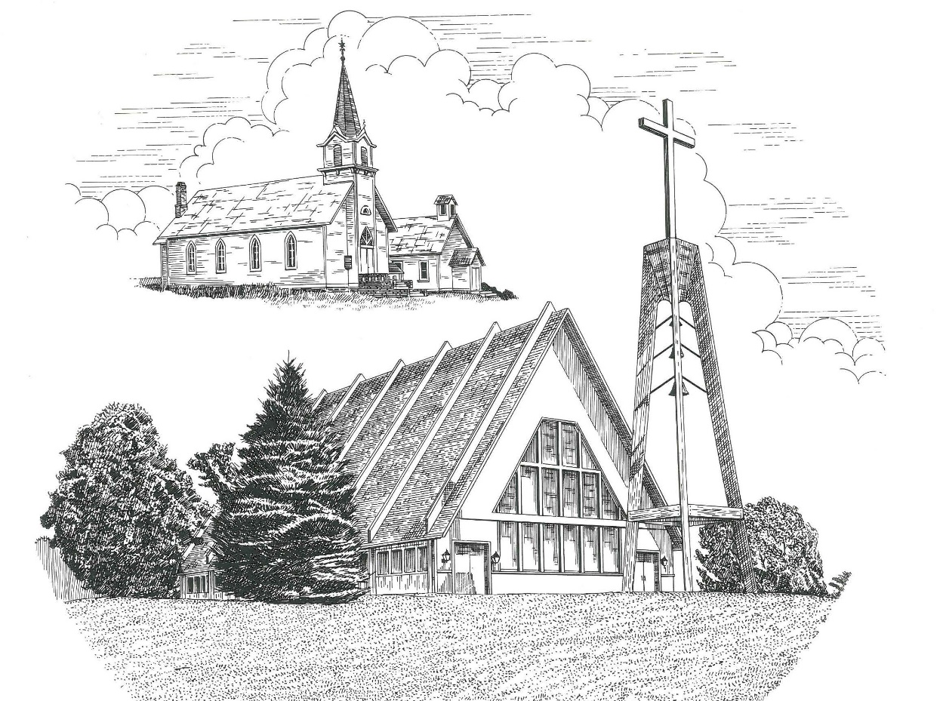

**Fourth Sunday of Easter April 25th, 2021**

**WELCOME**

**Thanks for joining us!**

**Pastor Jacob Sherry Missouri Synod**

**~~PLEASE NOTE~~Calling on the name of the Lord**

Does not include the use of cell phones in the worship sanctuary.

Please check yours before the service begins. Thank you for your courtesy.

**~~TO OUR GUESTS AND VISITORS~~**

Please sign our guest book located on the stand at the church entrance. During the service, we ask you to sign the attendance booklet located at the end of each pew. If you need assistance or have questions about our worship service, please talk to an elder or any one of our church family. We are glad you could join us and hope to have you worship with us again soon.

**~~ATTENDING HOLY COMMUNION~~**

By checking the “Communing Today” box on the registration form found in the attendance booklet, you are agreeing with the following statements:

* **I am a baptized Christian who believes Jesus Christ is my Lord and Savior.**
* **I believe that I am a sinner in need of Christ freely offered forgiveness.**
* **I believe that in the Lord’s Supper the body and blood of Jesus Christ**

**are truly present in, with, and under the bread and wine.**

* **I believe that my participation in Holy Communion grants me forgiveness**

**of my sins, new spiritual life, and eternal salvation.**

* **With God’s help, I sincerely seek to repent of my sins, live in service**

**to my Lord, and await His return.**

**If you agree with the above statements, you are welcome to attend the Lord’s Supper with us. May God bless your worship time with us.**

We do offer gluten-free wafers, please quietly ask an elder to help you.

**Covid-19 Guidance for Worship**

* Masks are to be properly worn during worship.

* Please sit on the ends of the pews and not directly behind someone.

* Maintain social distancing with other members even at the communion rail.

* If you are feeling ill, please remain home and watch the service online.

**Order of Divine Service Setting One**

**Pre-Service Music……………..Call to Worship………………….Greeting**

**OPENING HYMN:** *“He’s Risen, He’s Risen”*…………………............LSB #480

**CONFESSION & ABSOLUTION**……………………………………..LSB p. 151

**KYRIE**…………………………………………………………………...LSB pp. 152-153

**THIS IS THE FEAST**…………………………………………………...LSB p. 155

**SALUTATION**…………………………………………………………..LSB p. 156

**Collect Prayer**

Almighty God, merciful Father, since You have wakened from death the Shepherd of Your sheep, grant us Your Holy Spirit that when we hear the voice of our Shepherd, we may know Him who calls us each by name and follow where He leads; through the same Jesus Christ, Your Son, our Lord, who lives and reign with You and the Holy Spirit, one God, now and forever.

**THE HOLY SCRIPTURES**

**FIRST READING:** (Acts 4:1-12)

And as they were speaking to the people, the priests and the captain of the temple and the Sadducees came upon them, **2**greatly annoyed because they were teaching the people and proclaiming in Jesus the resurrection from the dead.  **3**And they arrested them and put them in custody until the next day, for it was already evening.  **4**But many of those who had heard the word believed, and the number of the men came to about five thousand. **5**On the next day their rulers and elders and scribes gathered together in Jerusalem, **6**with Annas the high priest and Caiaphas and John and Alexander, and all who were of the high-priestly family.  **7**And when they had set them in the midst, they inquired, “By what power or by what name did you do this?”  **8**Then Peter, filled with the Holy Spirit, said to them, “Rulers of the people and elders, **9**if we are being examined today concerning a good deed done to a crippled man, by what means this man has been healed, **10**let it be known to all of you and to all the people of Israel that by the name of Jesus Christ of Nazareth, whom you crucified, whom God raised from the dead—by him this man is standing before you well.  **11**This Jesus is the stone that was rejected by you, the builders, which has become the cornerstone.  **12**And there is salvation in no one else, for there is no other name under heaven given among men by which we must be saved.”

**R:** This is the Word of the Lord**.** **Cong: Thanks be to God.**

**GRADUAL**

Reader: Christ has risen from the dead.

**Cong.: God the Father has crowned him with glory and honor,**

Reader: He has given him dominion over the works of his hands;

**Cong.: he has put all things under his feet.**

**SECOND READING:** (1 John 3:16-24)

**16**By this we know love, that he laid down his life for us, and we ought to lay down our lives for the brothers.  **17**But if anyone has the world's goods and sees his brother in need, yet closes his heart against him, how does God's love abide in him?  **18**Little children, let us not love in word or talk but in deed and in truth. **19**By this we shall know that we are of the truth and reassure our heart before him; **20**for whenever our heart condemns us, God is greater than our heart, and he knows everything.  **21**Beloved, if our heart does not condemn us, we have confidence before God; **22**and whatever we ask we receive from him, because we keep his commandments and do what pleases him.  **23**And this is his commandment, that we believe in the name of his Son Jesus Christ and love one another, just as he has commanded us.  **24**Whoever keeps his commandments abides in God, and God in him. And by this we know that he abides in us, by the Spirit whom he has given us.

**R:** This is the Word of the Lord. **Cong: Thanks be to God.**

**(PLEASE RISE for the reading of the Gospel)**



**R:** The Holy Gospel according to St. John, the 10th chapter.



**HOLY GOSPEL:** (John 10:11-18)

**11**I am the good shepherd. The good shepherd lays down his life for the sheep.  **12**He who is a hired hand and not a shepherd, who does not own the sheep, sees the wolf coming and leaves the sheep and flees, and the wolf snatches them and scatters them. **13**He flees because he is a hired hand and cares nothing for the sheep.  **14**I am the good shepherd.  I know my own and my own know me, **15**just as the Father knows me and I know the Father; and I lay down my life for the sheep.  **16**And I have other sheep that are not of this fold. I must bring them also, and they will listen to my voice. So there will be one flock, one shepherd.  **17**For this reason the Father loves me, because I lay down my life that I may take it up again.  **18**No one takes it from me, but I lay it down of my own accord. I have authority to lay it down, and I have authority to take it up again.  This charge I have received from my Father.”

**R:** This is the Gospel of the Lord.



**SERMON HYMN**: *“Jesus Lives! The Victory’s Won”*………………………LSB #490

**SERMON**

**NICENE CREED**

I believe in one God, the Father Almighty, maker of heaven and earth and of all things visible and invisible.

And in one Lord Jesus Christ, the only-begotten Son of God, begotten of His Father before all worlds, God of God, Light of Light, very God of very God, begotten, not made, being of one substance with the Father, by whom all things were made; who for us men and for our salvation came down from heaven and was incarnate by the Holy Spirit of the virgin Mary and was made man; and was crucified also for us under Pontius Pilate. He suffered and was buried. And the third day He rose again according to the Scriptures and ascended into heaven and sits at the right hand of the Father. And He will come again with glory to judge both the living and the dead, whose kingdom will have no end.

And I believe in the Holy Spirit, the Lord and giver of life, who proceeds from the Father and the Son, who with the Father and the Son together is worshiped and glorified, who spoke by the prophets. And I believe in one holy Christian and apostolic Church, I acknowledge one Baptism for the remission of sins, and I look for the resurrection of the dead and the life of the world to come. Amen.

**THE GENERAL PRAYERS OF THE CHURCH**

**OFFERTORY**…………………………………………………………...LSB pp. 159-160

**SERVICE OF THE SACRAMENT**

**PREFACE**……………………………………………………………….LSB p. 160

**Proper Preface**

It is truly good, right, and salutary that we should at all times and in all places give thanks to You, holy Lord, almighty Father, everlasting God, through Jesus Christ, our Lord, who, out of love for His fallen creation, humbled Himself by taking on the form of a servant, becoming obedient unto death, even death upon a cross. Risen from the dead, He has freed us from eternal death and given us life everlasting. Therefore, with angels and archangels and with all the company of heaven we laud and magnify Your glorious name, ever more praising You and saying:

**SANCTUS**……………………………………………………………….LSB p. 161

**THE WORDS OF OUR LORD**………………………………………..LSB p. 162

**AGNUS DEI**…………………………………………………………….LSB p. 163

*If you are not communing it is acceptable to remain seated.*

**COMMUNION DISTRIBUTION HYMNS**

LSB #464 *“The Strife Is O’er, the Battle Done”*

LSB #468 *“I Am Content! My Jesus Ever Lives”*

**THANK THE LORD**………………………………………………………….LSB p. 164

**POST-COMMUNION COLLECT PRAYER**……………………………….LSB p. 166

**BENEDICTION**……………………………………………………………….LSB p. 166

**CLOSING HYMN:** *“Alleluia, Alleluuia! Hearts to Heaven”*……..…………LSB #477

The Mission of Trinity Onekama Is To **SERVE**

For even the Son of Man did not come to be served

but to serve and to give his life as a ransom for many.            
                                                                       Mark 10:45



**S**haring Jesus’s **t**ruth

**E**quipping for life

**R**eaching Out

**V**aluing each other

**E**vangelizing all ages

Mission Statement

The mission of Trinity Onekama is to SERVE

For even the Son of Man did not come to be served, but to serve,

and to give his life as a ransom for many. Mark 10:45

S haring Jesus’ ruth

E quipping for life

R eaching Out

V aluing each other

E vangelizing all age

**CHURCH INFORMATION**

**Church Office:** (231) 889-4429 **Website:** www.trinityonekama.org

**E-mail:** [trinityonekama@sbcglobal.net](mailto:trinityonekama@sbcglobal.net)

**Address:** P.O. Box 119, 5471 Fairview Street, Onekama, MI 49675

**Adult Bible Study**: Sunday @ 9:15 am (year round)

**Worship:** Sunday @ 10:30 am **The Lord’s Supper:**  Celebrated 2nd & 4th Sundays

**Pastoral Hours:** Wednesday and Friday 8:30am – Noon

**Pastor Phone:** 231-655-2680 **Pastor Email:** trinityonekama@gmail.com

**Copyright licensing covered under CCLI #2802932**