231-889-4429 5471 Fairview Street, Box 119 Onekama, MI

TRINITY LUTHERAN CHURCH
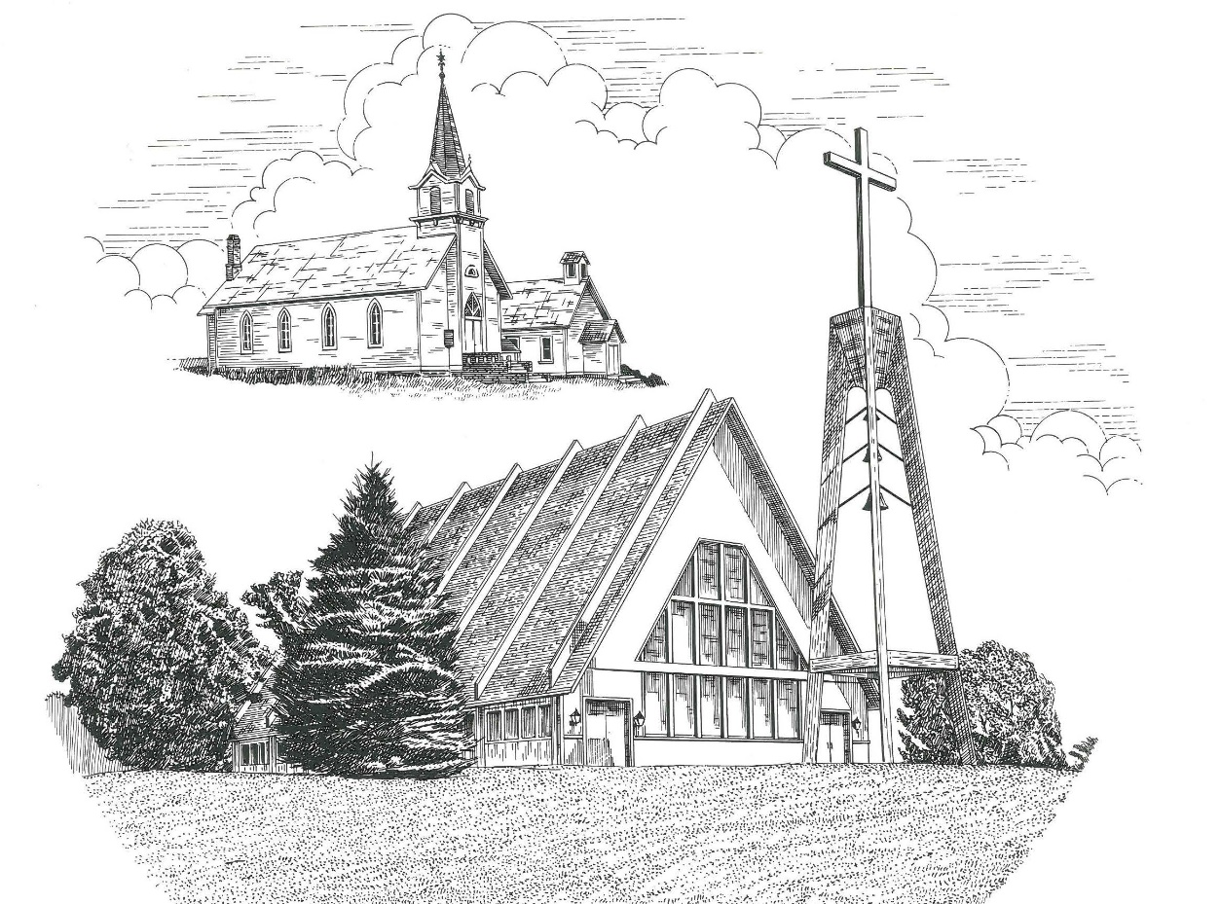

Fourth Sunday of Easter April 30th, 2023

WELCOME
Thanks for joining us!
Pastor Jacob Sherry Missouri Synod

~~PLEASE NOTE~~
Calling on the name of the Lord
Does not include the use of cell phones in the worship sanctuary.
Please check yours before the service begins. Thank you for your courtesy.
~~TO OUR GUESTS AND VISITORS~~
Please sign our guest book located on the stand at the church entrance. During the service, we ask you to sign the attendance sheet in your bulletin and leave it on the pew as you leave. If you need assistance or have questions about our worship service, please talk to an elder or any one of our church family. We are glad you could join us and hope to have you worship with us again soon.

~~ATTENDING HOLY COMMUNION~~
By checking the “Communing Today” box on the registration form found on the attendance sheet in your bulletin, you are agreeing with the following statements:

- I am a baptized Christian who believes Jesus Christ is my Lord and Savior.
- I believe that I am a sinner in need of Christ’s freely offered forgiveness.
- I believe that in the Lord’s Supper the body and blood of Jesus Christ
are truly present in, with, and under the bread and wine.
- I believe that my participation in Holy Communion grants me forgiveness
of my sins, new spiritual life, and eternal salvation.
- With God’s help, I sincerely seek to repent of my sins, live in service
to my Lord, and await His return.

If you agree with the above statements, you are welcome to attend the Lord’s Supper with us. May God bless your worship time with us.
We do offer gluten-free wafers, please quietly ask an elder to help you.

Order of Divine Service Setting Four

Pre-Service Music……………..Call to Worship………………….Greeting

OPENING HYMN: “Savior, like a Shepherd Lead Us”……………….LSB #711

OPENING LITURGY
Confession & Absolution……………………………………….LSB p. 203
Kyrie……………………………………………………………..LSB p. 204
Gloria in Excelsis………………………………………………..LSB p. 204
Salutation….…………………………………………………….LSB p. 205

Collect Prayer
Almighty God, merciful Father, since You have wakened from death the Shepherd of Your sheep, grant us Your Holy Spirit that when we hear the voice of our Shepherd we may know Him who calls us each by name and follow where He leads: through the same Jesus Christ, Your Son, our Lord, who lives and reigns with You and the Holy Spirit, one God, now and forever.

THE HOLY SCRIPTURES

FIRST READING: (Acts 2:42-47)
⁴² And they devoted themselves to the apostles' teaching and the fellowship, to the breaking of bread and the prayers. ⁴³ And awe came upon every soul, and many wonders and signs were being done through the apostles. ⁴⁴ And all who believed were together and had all things in common. ⁴⁵ And they were selling their possessions and belongings and distributing the proceeds to all, as any had need. ⁴⁶ And day by day, attending the temple together and breaking bread in their homes, they received their food with glad and generous hearts, ⁴⁷ praising God and having favor with all the people. And the Lord added to their number day by day those who were being saved.

R: This is the Word of the Lord. Cong: Thanks be to God.

GRADUAL
Reader: Christ has risen from the dead.
Cong.: God the Father has crowned him with glory and honor,
Reader: He has given him dominion over the works of his hands;
Cong.: he has put all things under his feet.

EPISTLE: (1 Peter 2:19-25)
¹⁹ For this is a gracious thing, when, mindful of God, one endures sorrows while suffering unjustly. ²⁰ For what credit is it if, when you sin and are beaten for it, you endure? But if when you do good and suffer for it you endure, this is a gracious thing in the sight of God. ²¹ For to this you have been called, because Christ also suffered for you, leaving you an example, so that you might follow in his steps. ²² He committed no sin, neither was deceit found in his mouth. ²³ When he was reviled, he did not revile in return; when he suffered, he did not threaten, but continued entrusting himself to him who judges justly. ²⁴ He himself bore our sins in his body on the tree, that we might die to sin and live to righteousness. By his wounds you have been healed. ²⁵ For you were straying like sheep, but have now returned to the Shepherd and Overseer of your souls.

R: This is the Word of the Lord. Cong: Thanks be to God.

(PLEASE RISE for the reading of the Gospel)

R: The Holy Gospel according to St. John, the 10th chapter.
Cong: Glory to You, O Lord

HOLY GOSPEL: (John 10:1-10)
“Truly, truly, I say to you, he who does not enter the sheepfold by the door but climbs in by another way, that man is a thief and a robber. ² But he who enters by the door is the shepherd of the sheep. ³ To him the gatekeeper opens. The sheep hear his voice, and he calls his own sheep by name and leads them out. ⁴ When he has brought out all his own, he goes before them, and the sheep follow him, for they know his voice. ⁵ A stranger they will not follow, but they will flee from him, for they do not know the voice of strangers.” ⁶ This figure of speech Jesus used with them, but they did not understand what he was saying to them.
⁷ So Jesus again said to them, “Truly, truly, I say to you, I am the door of the sheep. ⁸ All who came before me are thieves and robbers, but the sheep did not listen to them. ⁹ I am the door. If anyone enters by me, he will be saved and will go in and out and find pasture. ¹⁰ The thief comes only to steal and kill and destroy. I came that they may have life and have it abundantly.

R: This is the Gospel of the Lord. Cong: Praise to You, O Christ.

NICENE CREED
I believe in one God, the Father Almighty, maker of heaven and earth and of all things visible and invisible.
And in one Lord Jesus Christ, the only-begotten Son of God, begotten of His Father before all worlds, God of God, Light of Light, very God of very God, begotten, not made, being of one substance with the Father, by whom all things were made; who for us men and for our salvation came down from heaven and was incarnate by the Holy Spirit of the virgin Mary and was made man; and was crucified also for us under Pontius Pilate. He suffered and was buried. And the third day He rose again according to the Scriptures and ascended into heaven and sits at the right hand of the Father. And He will come again with glory to judge both the living and the dead, whose kingdom will have no end.
And I believe in the Holy Spirit, the Lord and giver of life, who proceeds from the Father and the Son, who with the Father and the Son together is worshiped and glorified, who spoke by the prophets. And I believe in one holy Christian and apostolic Church, I acknowledge one Baptism for the remission of sins, and I look for the resurrection of the dead and the life of the world to come. Amen.
SERMON HYMN: “The King of Love My Shepherd Is”…………………LSB #709

SERMON
THE GENERAL PRAYERS

OFFERTORY HYMN: “We Give Thee But Thine Own”………………LSB #781
verse 1

Sharing the Peace of the Lord

SERVICE OF THE SACRAMENT
Preface…………………………………….…………….………..LSB p. 208
Proper Preface
It is truly good, right, and salutary that we should at all times and in all places give thanks to You, O Lord, holy Father, almighty and everlasting God, for the countless blessings You so freely bestow on us and all creation. Above all, we give thanks for Your boundless love shown to us when You sent Your only-begotten Son, Jesus Christ, into our flesh and laid on Him our sin, giving Him into death that we might not die eternally. Because He is now risen from the dead and lives and reigns to all eternity, all who believe in Him will overcome sin and death and will rise again to new life. Therefore, with angels and archangels and with all the company of heaven we laud and magnify Your glorious name, ever more praising You and saying:

Sanctus, Lord’s Prayer, The Words of Our Lord………………….....LSB pp. 208-209
Agnus Dei………………………………………………………………..LSB p. 210
If you are not communing, it is acceptable to remain seated.

COMMUNION DISTRIBUTION HYMNS:
LSB #710 “The Lord’s My Shepherd, I’ll Not Want”
LSB #628 “Your Table I Approach”
LSB #685 “Let Us Ever Walk with Jesus”

CLOSING LITURGY:………………………………………………....LSB pp. 211-212

CLOSING HYMN: “Jesus Lives! The Victory’s Won”.........................LSB #490

Special Prayers

Bill Bankstahl Rita Merkey Phyllis Schramski
McAnn Bradford Jim Poellet Terri Vertalka
Scott Gill Shirley Poellet Peggy Wickstrom
Joan Malmgren Steve Schimke Sheldon Voigt

For the 91st Birthday of Rita Merkey tomorrow.

For the 50th Anniversary of Bob & Jan Hilliard on Friday.

Prayers for Our Military
Andrew Burch, Jr., grandson of John & Loree Sprawka.
Mark Granzotto with U.S. Navy in Bahrain, grandson of Rita Merkey
Derek Sprawka, grandson of John & Loree Sprawka
Alyssa & Trevor Eisenlohr siblings both with the U.S. Navy, friends of Janette & Fred May
Ian Nelson, nephew of Jack and Pebbla Nelson
Tyge Nelson & family, nephew of Jack and Pebbla Nelson
Capt. Tim Brandt at Madigan Medical Center, Fort Lewis, WA, son of Bruce & Debbie Brandt

If you wish to add someone’s name, please call or e-mail the church office.

The Mission of Trinity Onekama Is To SERVE

For even the Son of Man did not come to be served
but to serve and to give his life as a ransom for many.
Mark 10:45

S haring Jesus’s truth
E quipping for life
R eaching Out
V aluing each other
E vangelizing all ages
Mission Statement
The mission of Trinity Onekama is to SERVE
For even the Son of Man did not come to be served, but to serve,
and to give his life as a ransom for many. Mark 10:45
S haring Jesus’ ruth
E quipping for life
R eaching Out
V aluing each other
E vangelizing all age

CHURCH INFORMATION
Church Office: (231) 889-4429 Website: www.trinityonekama.org
E-mail: trinityonekama@sbcglobal.net
Address: P.O. Box 119, 5471 Fairview Street, Onekama, MI 49675
Sunday School & Adult Bible Study: Sunday @ 9:30am
Worship: Sunday @ 10:30 am The Lord’s Supper: Celebrated 2nd & 4th Sundays
Pastoral Hours: Wednesday and Friday 9:00am – Noon
Pastor Phone: 231-655-2680 Pastor Email: trinityonekama@gmail.com

Copyright licensing covered under CCLI #2802932

