231-889-4429 5471 Fairview Street, Box 119 Onekama, MI

TRINITY LUTHERAN CHURCH
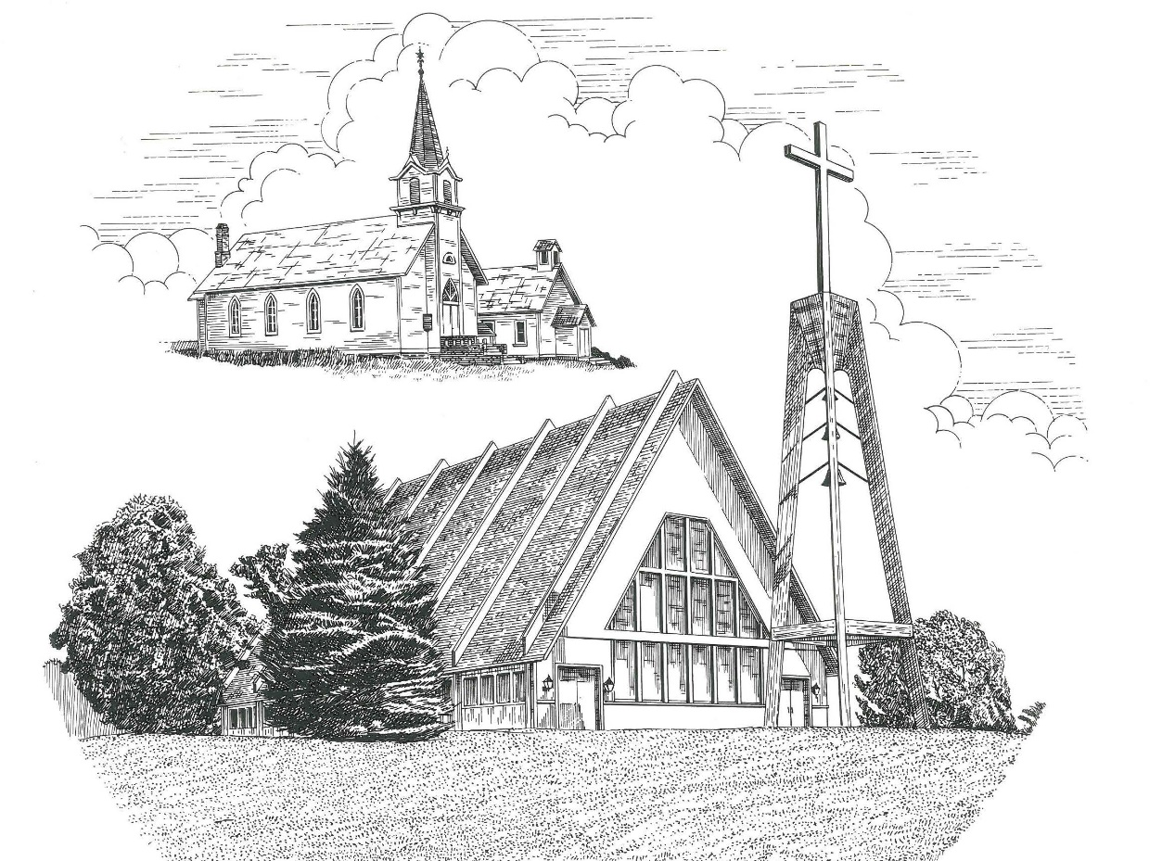

The Resurrection of Our Lord April 9th, 2023

WELCOME
Thanks for joining us!
Pastor Jacob Sherry Missouri Synod

~~PLEASE NOTE~~
Calling on the name of the Lord
Does not include the use of cell phones in the worship sanctuary.
Please check yours before the service begins. Thank you for your courtesy.
~~TO OUR GUESTS AND VISITORS~~
Please sign our guest book located on the stand at the church entrance. During the service, we ask you to sign the attendance sheet in your bulletin and leave it on the pew as you leave. If you need assistance or have questions about our worship service, please talk to an elder or any one of our church family. We are glad you could join us and hope to have you worship with us again soon.

~~ATTENDING HOLY COMMUNION~~
By checking the “Communing Today” box on the registration form found on the attendance sheet in your bulletin, you are agreeing with the following statements:

- I am a baptized Christian who believes Jesus Christ is my Lord and Savior.
- I believe that I am a sinner in need of Christ’s freely offered forgiveness.
- I believe that in the Lord’s Supper the body and blood of Jesus Christ
are truly present in, with, and under the bread and wine.
- I believe that my participation in Holy Communion grants me forgiveness
of my sins, new spiritual life, and eternal salvation.
- With God’s help, I sincerely seek to repent of my sins, live in service
to my Lord, and await His return.

If you agree with the above statements, you are welcome to attend the Lord’s Supper with us. May God bless your worship time with us.
We do offer gluten-free wafers, please quietly ask an elder to help you.

Order of Divine Service Setting Four

Pre-Service Music……………..Call to Worship………………….Greeting

P: Alleluia! Christ is risen!
C: He is risen indeed! Alleluia!

OPENING HYMN: “Jesus Christ Is Risen Today”…………….……...LSB #457

OPENING LITURGY
Confession & Absolution……………………………………….LSB p. 203
Kyrie……………………………………………………………..LSB p. 204
Gloria in Excelsis………………………………………………..LSB p. 204
Salutation….…………………………………………………….LSB p. 205

Collect Prayer
Almighty God the Father, through Your only-begotten Son, Jesus Christ, You have overcome death and opened the gate of everlasting life to us. Grant that we, who celebrate with joy the day of our Lord’s resurrection, may be raised from the death of sin by Your life-giving Spirit; through Jesus Christ, our Lord, who lives and reigns with Your and the Holy Spirit, one God, now and forever.

THE HOLY SCRIPTURES

OLD TESTAMENT: (Jeremiah 31:1-6)
“At that time, declares the Lord, I will be the God of all the clans of Israel, and they shall be my people.”
² Thus says the Lord:
“The people who survived the sword
found grace in the wilderness;
when Israel sought for rest,
³ the Lord appeared to him from far away.
I have loved you with an everlasting love;
therefore I have continued my faithfulness to you.
⁴ Again I will build you, and you shall be built,
O virgin Israel!
Again you shall adorn yourself with tambourines
and shall go forth in the dance of the merrymakers.
⁵ Again you shall plant vineyards
on the mountains of Samaria;
the planters shall plant
and shall enjoy the fruit.
⁶ For there shall be a day when watchmen will call
in the hill country of Ephraim:
‘Arise, and let us go up to Zion,
to the Lord our God.’”

R: This is the Word of the Lord. Cong: Thanks be to God.

GRADUAL
Reader: Christ has risen from the dead.
Cong.: God the Father has crowned him with glory and honor,
Reader: He has given him dominion over the works of his hands;
Cong.: he has put all things under his feet.

EPISTLE: (Colossians 3:1-4)
If then you have been raised with Christ, seek the things that are above, where Christ is, seated at the right hand of God. ² Set your minds on things that are above, not on things that are on earth. ³ For you have died, and your life is hidden with Christ in God. ⁴ When Christ who is your life appears, then you also will appear with him in glory.

R: This is the Word of the Lord. Cong: Thanks be to God.

(PLEASE RISE for the reading of the Gospel)

R: The Holy Gospel according to St. Matthew, the 28th chapter.
Cong: Glory to You, O Lord

HOLY GOSPEL: (Matthew 28:1-10)
Now after the Sabbath, toward the dawn of the first day of the week, Mary Magdalene and the other Mary went to see the tomb. ² And behold, there was a great earthquake, for an angel of the Lord descended from heaven and came and rolled back the stone and sat on it. ³ His appearance was like lightning, and his clothing white as snow. ⁴ And for fear of him the guards trembled and became like dead men. ⁵ But the angel said to the women, “Do not be afraid, for I know that you seek Jesus who was crucified. ⁶ He is not here, for he has risen, as he said. Come, see the place where he lay. ⁷ Then go quickly and tell his disciples that he has risen from the dead, and behold, he is going before you to Galilee; there you will see him. See, I have told you.” ⁸ So they departed quickly from the tomb with fear and great joy, and ran to tell his disciples. ⁹ And behold, Jesus met them and said, “Greetings!” And they came up and took hold of his feet and worshiped him. ¹⁰ Then Jesus said to them, “Do not be afraid; go and tell my brothers to go to Galilee, and there they will see me.”

R: This is the Gospel of the Lord. Cong: Praise to You, O Christ.

NICENE CREED
I believe in one God, the Father Almighty, maker of heaven and earth and of all things visible and invisible.
And in one Lord Jesus Christ, the only-begotten Son of God, begotten of His Father before all worlds, God of God, Light of Light, very God of very God, begotten, not made, being of one substance with the Father, by whom all things were made; who for us men and for our salvation came down from heaven and was incarnate by the Holy Spirit of the virgin Mary and was made man; and was crucified also for us under Pontius Pilate. He suffered and was buried. And the third day He rose again according to the Scriptures and ascended into heaven and sits at the right hand of the Father. And He will come again with glory to judge both the living and the dead, whose kingdom will have no end.
And I believe in the Holy Spirit, the Lord and giver of life, who proceeds from the Father and the Son, who with the Father and the Son together is worshiped and glorified, who spoke by the prophets. And I believe in one holy Christian and apostolic Church, I acknowledge one Baptism for the remission of sins, and I look for the resurrection of the dead and the life of the world to come. Amen.

SERMON HYMN: “I Know That My Redeemer Lives”………………..LSB #461

SERMON

THE GENERAL PRAYERS

OFFERTORY HYMN: “Doxology”……………………………………LSB #805

Sharing the Peace of the Lord

SERVICE OF THE SACRAMENT
Preface…………………………………….…………….………..LSB p. 208
Proper Preface
It is truly good, right, and salutary that we should at all times and in all places give thanks to You, O Lord, holy Father, almighty and everlasting God, for the countless blessings You so freely bestow on us and all creation. Above all, we give thanks for Your boundless love shown to us when You sent Your only-begotten Son, Jesus Christ, into our flesh and laid on Him our sin, giving Him into death that we might not die eternally. Because He is now risen from the dead and lives and reigns to all eternity, all who believe in Him will overcome sin and death and will rise again to new life. Therefore, with angels and archangels and with all the company of heaven we laud and magnify Your glorious name, ever more praising You and saying:

Sanctus, Lord’s Prayer, The Words of Our Lord………………….....LSB pp. 208-209
Agnus Dei………………………………………………………………..LSB p. 210
If you are not communing, it is acceptable to remain seated.

COMMUNION DISTRIBUTION HYMNS:
LSB #469 “Christ the Lord Is Risen Today”
LSB #467 “Awake, My Heart, with Gladness”
LSB #633 “At the Lamb’s High Feast We Sing”

CLOSING LITURGY:………………………………………………....LSB pp. 211-212

P: Alleluia! Christ is risen!
C: He is risen indeed! Alleluia!

CLOSING HYMN: “Now All the Vault of Heaven Resounds”...............LSB #465

The Mission of Trinity Onekama Is To SERVE

For even the Son of Man did not come to be served
but to serve and to give his life as a ransom for many.
Mark 10:45

S haring Jesus’s truth
E quipping for life
R eaching Out
V aluing each other
E vangelizing all ages
Mission Statement
The mission of Trinity Onekama is to SERVE
For even the Son of Man did not come to be served, but to serve,
and to give his life as a ransom for many. Mark 10:45
S haring Jesus’ ruth
E quipping for life
R eaching Out
V aluing each other
E vangelizing all age

CHURCH INFORMATION
Church Office: (231) 889-4429 Website: www.trinityonekama.org
E-mail: trinityonekama@sbcglobal.net
Address: P.O. Box 119, 5471 Fairview Street, Onekama, MI 49675
Sunday School & Adult Bible Study: Sunday @ 9:30am
Worship: Sunday @ 10:30 am The Lord’s Supper: Celebrated 2nd & 4th Sundays
Pastoral Hours: Wednesday and Friday 9:00am – Noon
Pastor Phone: 231-655-2680 Pastor Email: trinityonekama@gmail.com

Copyright licensing covered under CCLI #2802932

