231-889-4429 5471 Fairview Street, Box 119 Onekama, MI

TRINITY LUTHERAN CHURCH
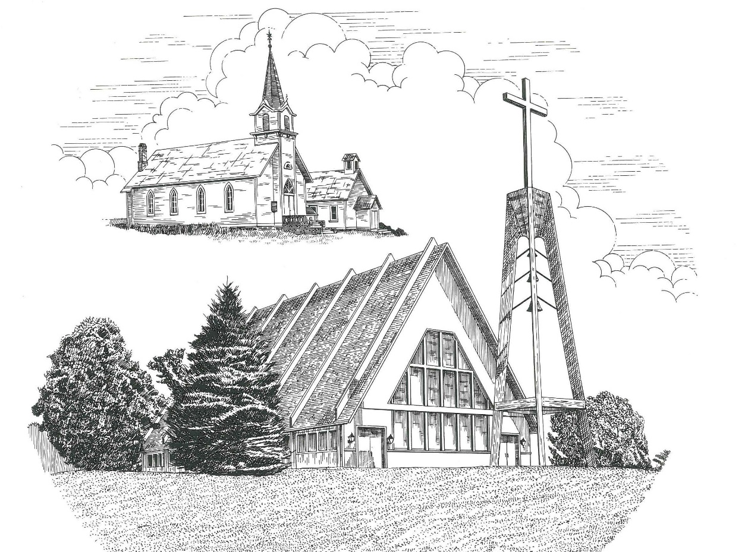

Tenth Sunday after Pentecost August 14th, 2022

WELCOME
Thanks for joining us!
Pastor Jacob Sherry Missouri Synod

~~PLEASE NOTE~~
Calling on the name of the Lord
Does not include the use of cell phones in the worship sanctuary.
Please check yours before the service begins. Thank you for your courtesy.
~~TO OUR GUESTS AND VISITORS~~
Please sign our guest book located on the stand at the church entrance. During the service, we ask you to sign the attendance sheet in your bulletin and leave it on the pew as you leave. If you need assistance or have questions about our worship service, please talk to an elder or any one of our church family. We are glad you could join us and hope to have you worship with us again soon.

~~ATTENDING HOLY COMMUNION~~
By checking the “Communing Today” box on the registration form found on the attendance sheet, you are agreeing with the following statements:

- I am a baptized Christian who believes Jesus Christ is my Lord and Savior.
- I believe that I am a sinner in need of Christ freely offered forgiveness.
- I believe that in the Lord’s Supper the body and blood of Jesus Christ
are truly present in, with, and under the bread and wine.
- I believe that my participation in Holy Communion grants me forgiveness
of my sins, new spiritual life, and eternal salvation.
- With God’s help, I sincerely seek to repent of my sins, live in service
to my Lord, and await His return.

If you agree with the above statements, you are welcome to attend the Lord’s Supper with us. May God bless your worship time with us.
We do offer gluten-free wafers, please quietly ask an elder to help you.

Order of Divine Service Setting Four

Pre-Service Music……………..Call to Worship………………….Greeting

OPENING HYMN: “This Is the Day the Lord Has Made”……………LSB #903

OPENING LITURGY
Confession & Absolution……………………………………….LSB p. 203
Kyrie……………………………………………………………..LSB p. 204
Gloria in Excelsis………………………………………………..LSB p. 204
Salutation….…………………………………………………….LSB p. 205

Collect Prayer
Merciful Lord, cleanse and defend Your Church by the sacrifice of Christ. United with Him in Holy Baptism, give us grace to receive with thanksgiving the fruits of His redeeming work and daily follow in His way; through the same Jesus Christ, Your Son, our Lord, who lives and reigns with Your and the Holy Spirit, one God, now and forever.

THE HOLY SCRIPTURES

OLD TESTAMENT: (Jeremiah 23:16-29)
¹⁶ Thus says the Lord of hosts: “Do not listen to the words of the prophets who prophesy to you, filling you with vain hopes. They speak visions of their own minds, not from the mouth of the Lord. ¹⁷ They say continually to those who despise the word of the Lord, ‘It shall be well with you’; and to everyone who stubbornly follows his own heart, they say, ‘No disaster shall come upon you.’”
¹⁸ For who among them has stood in the council of the Lord
to see and to hear his word,
or who has paid attention to his word and listened?
¹⁹ Behold, the storm of the Lord!
Wrath has gone forth,
a whirling tempest;
it will burst upon the head of the wicked.
²⁰ The anger of the Lord will not turn back
until he has executed and accomplished
the intents of his heart.
In the latter days you will understand it clearly.
²¹ “I did not send the prophets,
yet they ran;
I did not speak to them,
yet they prophesied.
²² But if they had stood in my council,
then they would have proclaimed my words to my people,
and they would have turned them from their evil way,
and from the evil of their deeds.

²³ “Am I a God at hand, declares the Lord, and not a God far away? ²⁴ Can a man hide himself in secret places so that I cannot see him? declares the Lord. Do I not fill heaven and earth? declares the Lord. ²⁵ I have heard what the prophets have said who prophesy lies in my name, saying, ‘I have dreamed, I have dreamed!’ ²⁶ How long shall there be lies in the heart of the prophets who prophesy lies, and who prophesy the deceit of their own heart, ²⁷ who think to make my people forget my name by their dreams that they tell one another, even as their fathers forgot my name for Baal? ²⁸ Let the prophet who has a dream tell the dream, but let him who has my word speak my word faithfully. What has straw in common with wheat? declares the Lord. ²⁹ Is not my word like fire, declares the Lord, and like a hammer that breaks the rock in pieces?

R: This is the Word of the Lord. Cong: Thanks be to God.

GRADUAL
Reader: Fear the Lord, you his saints,
Cong.: for those who fear him lack nothing!
Reader: Many are the afflictions of the righteous,
Cong.: but the Lord delivers him out of them all.

EPISTLE: (Hebrews 11:17-31; 12:1-3)
¹⁷ By faith Abraham, when he was tested, offered up Isaac, and he who had received the promises was in the act of offering up his only son, ¹⁸ of whom it was said, “Through Isaac shall your offspring be named.” ¹⁹ He considered that God was able even to raise him from the dead, from which, figuratively speaking, he did receive him back. ²⁰ By faith Isaac invoked future blessings on Jacob and Esau. ²¹ By faith Jacob, when dying, blessed each of the sons of Joseph, bowing in worship over the head of his staff. ²² By faith Joseph, at the end of his life, made mention of the exodus of the Israelites and gave directions concerning his bones.
²³ By faith Moses, when he was born, was hidden for three months by his parents, because they saw that the child was beautiful, and they were not afraid of the king's edict. ²⁴ By faith Moses, when he was grown up, refused to be called the son of Pharaoh's daughter, ²⁵ choosing rather to be mistreated with the people of God than to enjoy the fleeting pleasures of sin. ²⁶ He considered the reproach of Christ greater wealth than the treasures of Egypt, for he was looking to the reward. ²⁷ By faith he left Egypt, not being afraid of the anger of the king, for he endured as seeing him who is invisible. ²⁸ By faith he kept the Passover and sprinkled the blood, so that the Destroyer of the firstborn might not touch them.
²⁹ By faith the people crossed the Red Sea as on dry land, but the Egyptians, when they attempted to do the same, were drowned. ³⁰ By faith the walls of Jericho fell down after they had been encircled for seven days. ³¹ By faith Rahab the prostitute did not perish with those who were disobedient, because she had given a friendly welcome to the spies.
Therefore, since we are surrounded by so great a cloud of witnesses, let us also lay aside every weight, and sin which clings so closely, and let us run with endurance the race that is set before us, ² looking to Jesus, the founder and perfecter of our faith, who for the joy that was set before him endured the cross, despising the shame, and is seated at the right hand of the throne of God. ³ Consider him who endured from sinners such hostility against himself, so that you may not grow weary or fainthearted.

R: This is the Word of the Lord. Cong: Thanks be to God.

(PLEASE RISE for the reading of the Gospel)

R: The Holy Gospel according to St. Luke, the 12th chapter.

Cong: Glory to You, O Lord

HOLY GOSPEL: (Luke 12:49-53)
⁴⁹ “I came to cast fire on the earth, and would that it were already kindled! ⁵⁰ I have a baptism to be baptized with, and how great is my distress until it is accomplished! ⁵¹ Do you think that I have come to give peace on earth? No, I tell you, but rather division. ⁵²For from now on in one house there will be five divided, three against two and two against three. ⁵³ They will be divided, father against son and son against father, mother against daughter and daughter against mother, mother-in-law against her daughter-in-law and daughter-in-law against mother-in-law.”

R: This is the Gospel of the Lord. Cong: Praise to You, O Christ.

NICENE CREED
I believe in one God, the Father Almighty, maker of heaven and earth and of all things visible and invisible.
And in one Lord Jesus Christ, the only-begotten Son of God, begotten of His Father before all worlds, God of God, Light of Light, very God of very God, begotten, not made, being of one substance with the Father, by whom all things were made; who for us men and for our salvation came down from heaven and was incarnate by the Holy Spirit of the virgin Mary and was made man; and was crucified also for us under Pontius Pilate. He suffered and was buried. And the third day He rose again according to the Scriptures and ascended into heaven and sits at the right hand of the Father. And He will come again with glory to judge both the living and the dead, whose kingdom will have no end.
And I believe in the Holy Spirit, the Lord and giver of life, who proceeds from the Father and the Son, who with the Father and the Son together is worshiped and glorified, who spoke by the prophets. And I believe in one holy Christian and apostolic Church, I acknowledge one Baptism for the remission of sins, and I look for the resurrection of the dead and the life of the world to come. Amen.

SERMON HYMN: “Lord, Keep Us Steadfast in Your Word”…………..LSB #655

SERMON

THE GENERAL PRAYERS

OFFERTORY HYMN: “Let the Vineyards Be Fruitful”………………LSB #955

Sharing the Peace of the Lord

SERVICE OF THE SACRAMENT
Preface…………………………………….…………….………..LSB p. 208
Proper Preface
It is truly good, right, and salutary that we should at all times and in all places give thanks to You, O Lord, holy Father, almighty and everlasting God, for the countless blessings You so freely bestow on us and all creation. Above all, we give thanks for Your boundless love shown to us when You sent Your only-begotten Son, Jesus Christ, into our flesh and laid on Him our sin, giving Him into death that we might not die eternally. Because He is now risen from the dead and lives and reigns to all eternity, all who believe in Him will overcome sin and death and will rise again to new life. Therefore, with angels and archangels and with all the company of heaven we laud and magnify Your glorious name, ever more praising You and saying:

Sanctus, Lord’s Prayer, The Words of Our Lord………………….....LSB pp. 208-209
Agnus Dei………………………………………………………………..LSB p. 210
If you are not communing, it is acceptable to remain seated.

COMMUNION DISTRIBUTION HYMNS:
LSB #411 “I Want to Walk as a Child of the Light”
LSB #685 “Let Us Ever Walk with Jesus”
LSB #617“O Lord, We Praise Thee”

CLOSING LITURGY:………………………………………………....LSB pp. 211-212

CLOSING HYMN: “Go, My Children, with My Blessing”....................LSB #922

CHURCH INFORMATION
Church Office: (231) 889-4429 Website: www.trinityonekama.org
E-mail: trinityonekama@sbcglobal.net
Address: P.O. Box 119, 5471 Fairview Street, Onekama, MI 49675
Adult Bible Study: Sunday @ 11:30 am (year round)
Worship: Sunday @ 10:30 am The Lord’s Supper: Celebrated 2nd & 4th Sundays
Pastoral Hours: Wednesday and Friday 9:00am – Noon
Pastor Phone: 231-655-2680 Pastor Email: trinityonekama@gmail.com

Copyright licensing covered under CCLI #2802932

