**231-889-4429 5471 Fairview Street, Box 119 Onekama, MI**

**TRINITY LUTHERAN CHURCH**

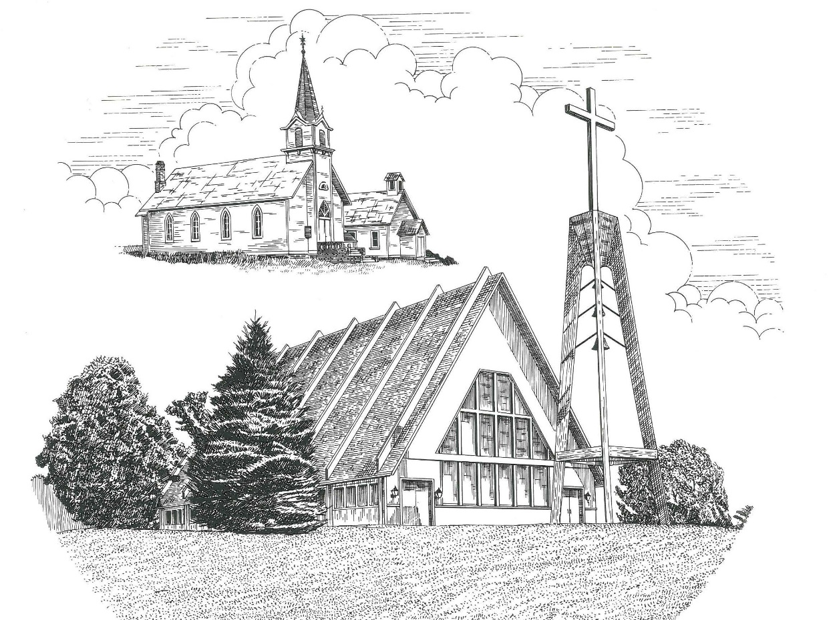

**Eleventh Sunday after Pentecost August 8th, 2021**

**WELCOME**

**Thanks for joining us!**

**Pastor Jacob Sherry Missouri Synod**

**~~PLEASE NOTE~~Calling on the name of the Lord**

Does not include the use of cell phones in the worship sanctuary.

Please check yours before the service begins. Thank you for your courtesy.

**~~TO OUR GUESTS AND VISITORS~~**

Please sign our guest book located on the stand at the church entrance. During the service, we ask you to sign the attendance booklet located at the end of each pew. If you need assistance or have questions about our worship service, please talk to an elder or any one of our church family. We are glad you could join us and hope to have you worship with us again soon.

**~~ATTENDING HOLY COMMUNION~~**

By checking the “Communing Today” box on the registration form found in the attendance booklet, you are agreeing with the following statements:

* **I am a baptized Christian who believes Jesus Christ is my Lord and Savior.**
* **I believe that I am a sinner in need of Christ freely offered forgiveness.**
* **I believe that in the Lord’s Supper the body and blood of Jesus Christ**

**are truly present in, with, and under the bread and wine.**

* **I believe that my participation in Holy Communion grants me forgiveness**

**of my sins, new spiritual life, and eternal salvation.**

* **With God’s help, I sincerely seek to repent of my sins, live in service**

**to my Lord, and await His return.**

**If you agree with the above statements, you are welcome to attend the Lord’s Supper with us. May God bless your worship time with us.**

We do offer gluten-free wafers, please quietly ask an elder to help you.

**Order of Divine Service Setting One**

**Pre-Service Music……………..Call to Worship………………….Greeting**

**OPENING HYMN:** *“O Savior, Precious Savior”*………………….......LSB #527

**CONFESSION & ABSOLUTION**……………………………………..LSB p. 151

**KYRIE**…………………………………………………………………...LSB pp. 152-153

**THIS IS THE FEAST**…………………………………………………..LSB p. 155

**SALUTATION**………………………………………………………….LSB p. 156

**Collect Prayer**

Gracious Father, Your blessed Son came down from heaven to be the true bread that gives life to the world. Grant that Christ, the bread of life, may live in us and we in Him, who lives and reign with You and the Holy Spirit, one God, now and forever.

**THE HOLY SCRIPTURES**

**OLD TESTAMENT:** (1 Kings 19:1-8)

Now Ahab told Jezebel everything Elijah had done and how he had killed all the prophets with the sword.  **2**So Jezebel sent a messenger to Elijah to say, “May the gods deal with me, be it ever so severely, if by this time tomorrow I do not make your life like that of one of them.”

**3**Elijah was afraid and ran for his life.  When he came to Beersheba in Judah, he left his servant there, **4**while he himself went a day’s journey into the wilderness. He came to a broom bush, sat down under it and prayed that he might die. “I have had enough, Lord,” he said. “Take my life; I am no better than my ancestors.”  **5**Then he lay down under the bush and fell asleep.

All at once an angel touched him and said, “Get up and eat.”  **6**He looked around, and there by his head was some bread baked over hot coals, and a jar of water. He ate and drank and then lay down again.

**7**The angel of the Lord came back a second time and touched him and said, “Get up and eat, for the journey is too much for you.”  **8**So he got up and ate and drank. Strengthened by that food, he traveled forty days and forty nights until he reached Horeb, the mountain of God.

**R:** This is the Word of the Lord**.** **Cong: Thanks be to God.**

**GRADUAL**

Reader: Fear the Lord, you his saints,

**Cong.: for those who fear him lack nothing!**

Reader: Many are the afflictions of the righteous,

**Cong.: but the Lord delivers him out of them all.**

**EPISTLE:** (Ephesians 4:17 – 5:2)

**17**So I tell you this, and insist on it in the Lord, that you must no longer live as the Gentiles do, in the futility of their thinking.  **18**They are darkened in their understanding and separated from the life of God because of the ignorance that is in them due to the hardening of their hearts.  **19**Having lost all sensitivity, they have given themselves over to sensuality so as to indulge in every kind of impurity, and they are full of greed. **20**That, however, is not the way of life you learned **21**when you heard about Christ and were taught in him in accordance with the truth that is in Jesus.  **22**You were taught, with regard to your former way of life, to put off your old self, which is being corrupted by its deceitful desires; **23**to be made new in the attitude of your minds; **24**and to put on the new self, created to be like God in true righteousness and holiness. **25**Therefore each of you must put off falsehood and speak truthfully to your neighbor, for we are all members of one body.  **26**“In your anger do not sin”:  Do not let the sun go down while you are still angry, **27**and do not give the devil a foothold.  **28**Anyone who has been stealing must steal no longer, but must work, doing something useful with their own hands, that they may have something to share with those in need. **29**Do not let any unwholesome talk come out of your mouths, but only what is helpful for building others up according to their needs, that it may benefit those who listen.  **30**And do not grieve the Holy Spirit of God, with whom you were sealed for the day of redemption.  **31**Get rid of all bitterness, rage and anger, brawling and slander, along with every form of malice.  **32**Be kind and compassionate to one another, forgiving each other, just as in Christ God forgave you.  **1**Follow God’s example, therefore, as dearly loved children **2**and walk in the way of love, just as Christ loved us and gave himself up for us as a fragrant offering and sacrifice to God.

**R:** This is the Word of the Lord. **Cong: Thanks be to God.**

**(PLEASE RISE for the reading of the Gospel)**



**R:** The Holy Gospel according to St. John, the 6th chapter.



**HOLY GOSPEL:** (John 6:35-51)

**35**Then Jesus declared, “I am the bread of life.  Whoever comes to me will never go hungry, and whoever believes in me will never be thirsty.  **36**But as I told you, you have seen me and still you do not believe.  **37**All those the Father gives me will come to me, and whoever comes to me I will never drive away.  **38**For I have come down from heaven not to do my will but to do the will of him who sent me.  **39**And this is the will of him who sent me, that I shall lose none of all those he has given me, but raise them up at the last day.  **40**For my Father’s will is that everyone who looks to the Son and believes in him shall have eternal life, and I will raise them up at the last day.”

**41**At this the Jews there began to grumble about him because he said, “I am the bread that came down from heaven.”  **42**They said, “Is this not Jesus, the son of Joseph, whose father and mother we know?  How can he now say, ‘I came down from heaven’?”

**43**“Stop grumbling among yourselves,” Jesus answered.  **44**“No one can come to me unless the Father who sent me draws them, and I will raise them up at the last day.  **45**It is written in the Prophets: ‘They will all be taught by God.’  Everyone who has heard the Father and learned from him comes to me.  **46**No one has seen the Father except the one who is from God; only he has seen the Father.  **47**Very truly I tell you, the one who believes has eternal life.  **48**I am the bread of life.  **49**Your ancestors ate the manna in the wilderness, yet they died.  **50**But here is the bread that comes down from heaven, which anyone may eat and not die.  **51**I am the living bread that came down from heaven. Whoever eats this bread will live forever. This bread is my flesh, which I will give for the life of the world.”

**R:** This is the Gospel of the Lord.



**SERMON HYMN**: *“Praise, My Soul, the King of Heaven”*……………LSB #793

**SERMON**

**NICENE CREED**

I believe in one God, the Father Almighty, maker of heaven and earth and of all things visible and invisible.

And in one Lord Jesus Christ, the only-begotten Son of God, begotten of His Father before all worlds, God of God, Light of Light, very God of very God, begotten, not made, being of one substance with the Father, by whom all things were made; who for us men and for our salvation came down from heaven and was incarnate by the Holy Spirit of the virgin Mary and was made man; and was crucified also for us under Pontius Pilate. He suffered and was buried. And the third day He rose again according to the Scriptures and ascended into heaven and sits at the right hand of the Father. And He will come again with glory to judge both the living and the dead, whose kingdom will have no end.

And I believe in the Holy Spirit, the Lord and giver of life, who proceeds from the Father and the Son, who with the Father and the Son together is worshiped and glorified, who spoke by the prophets. And I believe in one holy Christian and apostolic Church, I acknowledge one Baptism for the remission of sins, and I look for the resurrection of the dead and the life of the world to come. Amen.

**THE GENERAL PRAYERS OF THE CHURCH**

**OFFERTORY**…………………………………………………………...LSB pp. 159-160

**SERVICE OF THE SACRAMENT**

**PREFACE**……………………………………………………………………..LSB p. 160

**Proper Preface**

It is truly good, right, and salutary that we should at all times and in all places give thanks to You, holy Lord, almighty Father, everlasting God, through Jesus Christ, our Lord, who, out of love for His fallen creation, humbled Himself by taking on the form of a servant, becoming obedient unto death, even death upon a cross. Risen from the dead, He has freed us from eternal death and given us life everlasting. Therefore, with angels and archangels and with all the company of heaven we laud and magnify Your glorious name, ever more praising You and saying:

**SANCTUS**……………………………………………………………………...LSB p. 161

**THE WORDS OF OUR LORD**……………………………………………….LSB p. 162

**AGNUS DEI**……………………………………………………………………LSB p. 163

*If you are not communing it is acceptable to remain seated.*

**COMMUNION DISTRIBUTION HYMNS**

LSB #636 *“Soul, Adorn Yourself with Gladness”*

LSB #740 *“I Am Jesus’ Little Lamb”*

**THANK THE LORD**………………………………………………………….LSB p. 164

**POST-COMMUNION COLLECT PRAYER**……………………………….LSB p. 166

**BENEDICTION**……………………………………………………………….LSB p. 166

**CLOSING HYMN:** *“My Hope Is Built on Nothing Less”*……..……………..LSB #575

The Mission of Trinity Onekama Is To **SERVE**

For even the Son of Man did not come to be served

but to serve and to give his life as a ransom for many.            
                                                                       Mark 10:45



**S**haring Jesus’s **t**ruth

**E**quipping for life

**R**eaching Out

**V**aluing each other

**E**vangelizing all ages

Mission Statement

The mission of Trinity Onekama is to SERVE

For even the Son of Man did not come to be served, but to serve,

and to give his life as a ransom for many. Mark 10:45

S haring Jesus’ ruth

E quipping for life

R eaching Out

V aluing each other

E vangelizing all age

**CHURCH INFORMATION**

**Church Office:** (231) 889-4429 **Website:** www.trinityonekama.org

**E-mail:** [trinityonekama@sbcglobal.net](mailto:trinityonekama@sbcglobal.net)

**Address:** P.O. Box 119, 5471 Fairview Street, Onekama, MI 49675

**Adult Bible Study**: Sunday @ 9:15 am (year round)

**Worship:** Sunday @ 10:30 am **The Lord’s Supper:**  Celebrated 2nd & 4th Sundays

**Pastoral Hours:** Wednesday and Friday 8:30am – Noon

**Pastor Phone:** 231-655-2680 **Pastor Email:** trinityonekama@gmail.com

**Copyright licensing covered under CCLI #2802932**