**231-889-4429 5471 Fairview Street, Box 119 Onekama, MI**

**TRINITY LUTHERAN CHURCH**

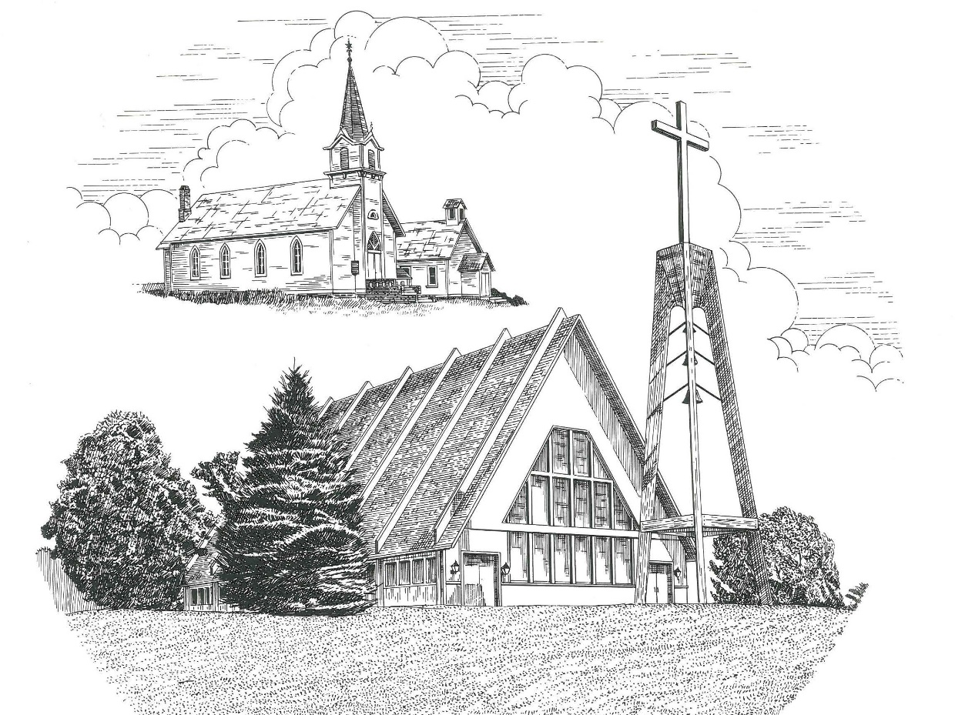

**Third Sunday in Advent December 12th, 2021**

**WELCOME**

**Thanks for joining us!**

**Pastor Jacob Sherry Missouri Synod**

**~~PLEASE NOTE~~Calling on the name of the Lord**

Does not include the use of cell phones in the worship sanctuary.

Please check yours before the service begins. Thank you for your courtesy.

**~~TO OUR GUESTS AND VISITORS~~**

Please sign our guest book located on the stand at the church entrance. During the service, we ask you to sign the attendance sheets located inside your bulletin and leave them on the pew as you leave. If you need assistance or have questions about our worship service, please talk to an elder or any one of our church family. We are glad you could join us and hope to have you worship with us again soon.

**~~ATTENDING HOLY COMMUNION~~**

By checking the “Communing Today” box on the registration form found in the attendance booklet, you are agreeing with the following statements:

* **I am a baptized Christian who believes Jesus Christ is my Lord and Savior.**
* **I believe that I am a sinner in need of Christ freely offered forgiveness.**
* **I believe that in the Lord’s Supper the body and blood of Jesus Christ**

**are truly present in, with, and under the bread and wine.**

* **I believe that my participation in Holy Communion grants me forgiveness**

**of my sins, new spiritual life, and eternal salvation.**

* **With God’s help, I sincerely seek to repent of my sins, live in service**

**to my Lord, and await His return.**

**If you agree with the above statements, you are welcome to attend the Lord’s Supper with us. May God bless your worship time with us.**

We do offer gluten-free wafers, please quietly ask an elder to help you.

**Order of Divine Service Setting One**

**Pre-Service Music……………..Call to Worship………………….Greeting**

**OPENING HYMN:** *“Come, Thou Long-Expected Jesus”*……………..LSB #338

**CONFESSION & ABSOLUTION**……………………………………..LSB p. 151

**KYRIE**…………………………………………………………………...LSB pp. 152-153

**SALUTATION**…………………………………………………………..LSB p. 156

**Collect Prayer**

Lord Jesus Christ, we implore You to hear our prayers and to lighten the darkness of our hearts by Your gracious visitation; for You live and reign with the Father and the Holy Spirit, one God, now and forever.

**THE HOLY SCRIPTURES**

**OLD TESTAMENT:** (Zephaniah 3:14-20)

**14**Sing aloud, O daughter of Zion;  
    shout, O Israel!  
Rejoice and exult with all your heart,  
    O daughter of Jerusalem!  
**15**The Lord has taken away the judgments against you;  
    he has cleared away your enemies.  
The King of Israel, the Lord, is in your midst;  
    you shall never again fear evil.  
**16**On that day it shall be said to Jerusalem:  
“Fear not, O Zion;  
    let not your hands grow weak.  
**17**The Lord your God is in your midst,  
    a mighty one who will save;  
he will rejoice over you with gladness;  
    he will quiet you by his love;  
he will exult over you with loud singing.  
**18**I will gather those of you who mourn for the festival,  
    so that you will no longer suffer reproach.  
**19**Behold, at that time I will deal  
    with all your oppressors.  
And I will save the lame  
    and gather the outcast,  
and I will change their shame into praise  
    and renown in all the earth.  
**20**At that time I will bring you in,  
    at the time when I gather you together;  
for I will make you renowned and praised  
    among all the peoples of the earth,  
when I restore your fortunes  
    before your eyes,” says the Lord.

**R:** This is the Word of the Lord**.** **Cong: Thanks be to God.**

**GRADUAL**

Reader: Rejoice greatly, O daughter of Zion.

**Cong.: Shout aloud, O daughter of Jerusalem.**

Reader: Behold, your king is coming to you;

**Cong.: righteous and having salvation.**

Reader: Blessed is he who comes in the name of the Lord.

**Cong.: From the house of the Lord we bless you.**

**EPISTLE:** (Philippians 4:4-7)

**4**Rejoice in the Lord always; again I will say, rejoice.  **5**Let your reasonableness be known to everyone.  The Lord is at hand; **6**do not be anxious about anything, but in everything by prayer and supplication with thanksgiving let your requests be made known to God.  **7**And the peace of God, which surpasses all understanding, will guard your hearts and your minds in Christ Jesus.

**R:** This is the Word of the Lord. **Cong: Thanks be to God.**

**(PLEASE RISE for the reading of the Gospel)**



**R:** The Holy Gospel according to St. Luke, the 7th chapter.



**HOLY GOSPEL:** (Luke 7:18-28)

**18**The disciples of John reported all these things to him. And John, **19**calling two of his disciples to him, sent them to the Lord, saying, “Are you the one who is to come, or shall we look for another?”  **20**And when the men had come to him, they said, “John the Baptist has sent us to you, saying, ‘Are you the one who is to come, or shall we look for another?’”  **21**In that hour he healed many people of diseases and plagues and evil spirits, and on many who were blind he bestowed sight.  **22**And he answered them, “Go and tell John what you have seen and heard: the blind receive their sight, the lame walk, lepers are cleansed, and the deaf hear, the dead are raised up, the poor have good news preached to them.  **23**And blessed is the one who is not offended by me.”

**24**When John's messengers had gone, Jesus began to speak to the crowds concerning John: “What did you go out into the wilderness to see?  A reed shaken by the wind? **25**What then did you go out to see? A man dressed in soft clothing? Behold, those who are dressed in splendid clothing and live in luxury are in kings' courts.  **26**What then did you go out to see?  A prophet? Yes, I tell you, and more than a prophet.  **27**This is he of whom it is written,

“‘Behold, I send my messenger before your face,  
    who will prepare your way before you.’

**28**I tell you, among those born of women none is greater than John. Yet the one who is least in the kingdom of God is greater than he.”

**R:** This is the Gospel of the Lord.



**SERMON HYMN**: *“Hark! A Thrilling Voice Is Sounding”*…………………...LSB #345

**SERMON**

**NICENE CREED**

I believe in one God, the Father Almighty, maker of heaven and earth and of all things visible and invisible.

And in one Lord Jesus Christ, the only-begotten Son of God, begotten of His Father before all worlds, God of God, Light of Light, very God of very God, begotten, not made, being of one substance with the Father, by whom all things were made; who for us men and for our salvation came down from heaven and was incarnate by the Holy Spirit of the virgin Mary and was made man; and was crucified also for us under Pontius Pilate. He suffered and was buried. And the third day He rose again according to the Scriptures and ascended into heaven and sits at the right hand of the Father. And He will come again with glory to judge both the living and the dead, whose kingdom will have no end.

And I believe in the Holy Spirit, the Lord and giver of life, who proceeds from the Father and the Son, who with the Father and the Son together is worshiped and glorified, who spoke by the prophets. And I believe in one holy Christian and apostolic Church, I acknowledge one Baptism for the remission of sins, and I look for the resurrection of the dead and the life of the world to come. Amen.

**THE GENERAL PRAYERS OF THE CHURCH**

**OFFERTORY**…………………………………………………………...LSB pp. 159-160

**SERVICE OF THE SACRAMENT**

**PREFACE**……………………………………………………………………..LSB p. 160

**Proper Preface**

It is truly good, right, and salutary that we should at all times and in all places give thanks to You, holy Lord, almighty Father, everlasting God, through Jesus Christ, our Lord, whose way John the Baptist prepared, proclaiming Him the promised Messiah, the very Lamb of God who takes away the sin of the world, and calling sinners to repentance that they might escape from the wrath to be revealed when He comes again in glory. Therefore, with angels and archangels and with all the company of heaven we laud and magnify Your glorious name, ever more praising You and saying:

**SANCTUS**……………………………………………………………………...LSB p. 161

**THE WORDS OF OUR LORD**……………………………………………….LSB p. 162

**AGNUS DEI**……………………………………………………………………LSB p. 163

*If you are not communing, it is acceptable to remain seated.*

**COMMUNION DISTRIBUTION HYMNS**

LSB #618 *“I Come, O Savior, to Thy Table”*

LSB #634 *“The Death of Jesus Christ, Our Lord”*

**THANK THE LORD**………………………………………………………….LSB p. 164

**POST-COMMUNION COLLECT PRAYER**……………………………….LSB p. 166

**BENEDICTION**……………………………………………………………….LSB p. 166

**CLOSING HYMN:** *“Lo! He Comes with Clouds Descending”*……..……….LSB #336

The Mission of Trinity Onekama Is To **SERVE**

For even the Son of Man did not come to be served

but to serve and to give his life as a ransom for many.            
                                                                       Mark 10:45



**S**haring Jesus’s **t**ruth

**E**quipping for life

**R**eaching Out

**V**aluing each other

**E**vangelizing all ages

Mission Statement

The mission of Trinity Onekama is to SERVE

For even the Son of Man did not come to be served, but to serve,

and to give his life as a ransom for many. Mark 10:45

S haring Jesus’ ruth

E quipping for life

R eaching Out

V aluing each other

E vangelizing all age

**CHURCH INFORMATION**

**Church Office:** (231) 889-4429 **Website:** www.trinityonekama.org

**E-mail:** [trinityonekama@sbcglobal.net](mailto:trinityonekama@sbcglobal.net)

**Address:** P.O. Box 119, 5471 Fairview Street, Onekama, MI 49675

**Adult Bible Study**: Sunday @ 11:30 am (year round)

**Worship:** Sunday @ 10:30 am **The Lord’s Supper:**  Celebrated 2nd & 4th Sundays

**Pastoral Hours:** Wednesday and Friday 9:00am – Noon

**Pastor Phone:** 231-655-2680 **Pastor Email:** trinityonekama@gmail.com

**Copyright licensing covered under CCLI #2802932**