**231-889-4429 5471 Fairview Street, Box 119 Onekama, MI**

**TRINITY LUTHERAN CHURCH**

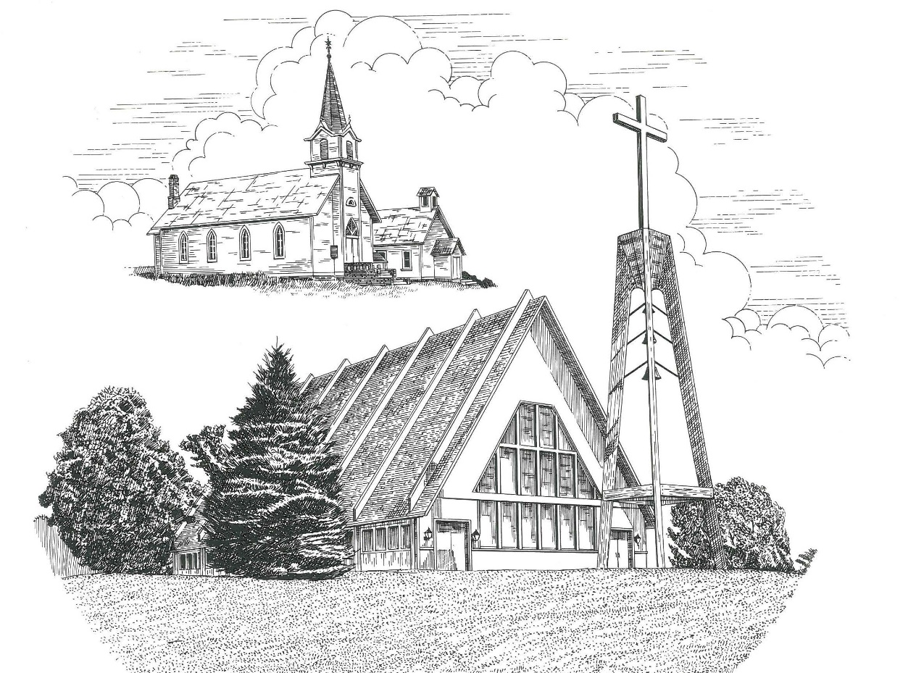

**Third Sunday in Advent December 13th, 2020**

**WELCOME**

**Thanks for joining us!**

**Pastor Jacob Sherry Missouri Synod**

**~~PLEASE NOTE~~Calling on the name of the Lord**

Does not include the use of cell phones in the worship sanctuary.

Please check yours before the service begins. Thank you for your courtesy.

**~~TO OUR GUESTS AND VISITORS~~**

Please sign our guest book located on the stand at the church entrance. During the service, we ask you to sign the attendance booklet located at the end of each pew. If you need assistance or have questions about our worship service, please talk to an elder or any one of our church family. We are glad you could join us and hope to have you worship with us again soon.

**~~ATTENDING HOLY COMMUNION~~**

By checking the “Communing Today” box on the registration form found in the attendance booklet, you are agreeing with the following statements:

* **I am a baptized Christian who believes Jesus Christ is my Lord and Savior.**
* **I believe that I am a sinner in need of Christ freely offered forgiveness.**
* **I believe that in the Lord’s Supper the body and blood of Jesus Christ**

**are truly present in, with, and under the bread and wine.**

* **I believe that my participation in Holy Communion grants me forgiveness**

**of my sins, new spiritual life, and eternal salvation.**

* **With God’s help, I sincerely seek to repent of my sins, live in service**

**to my Lord, and await His return.**

**If you agree with the above statements, you are welcome to attend the Lord’s Supper with us. May God bless your worship time with us.**

We do offer gluten-free wafers, please quietly ask an elder to help you.

**Order of Divine Service Setting One**

**Pre-Service Music……………..Call to Worship………………….Greeting**

**OPENING HYMN:** *“With the Lord Begin Your Task”*…………………….....LSB #869

**CONFESSION & ABSOLUTION**…………………………………………....LSB p. 151

**KYRIE**…………………………………………………………………...LSB pp. 152-153

**SALUTATION**…………………………………………………………….…..LSB p. 156

**Collect Prayer**

Lord Jesus Christ, we implore You to hear our prayers and to lighten the darkness of our hearts by Your gracious visitation; for You lives and reign with the Father and the Holy Spirit, one God, now and forever.

**C: Amen.**

**THE HOLY SCRIPTURES**

**OLD TESTAMENT:** (Isaiah 61:1-4, 8-11)

The Spirit of the Lord God is upon me,  
    because the Lord has anointed me  
to bring good news to the poor;  
    he has sent me to bind up the brokenhearted,  
to proclaim liberty to the captives,  
    and the opening of the prison to those who are bound;  
**2**to proclaim the year of the Lord's favor,  
    and the day of vengeance of our God;  
    to comfort all who mourn;  
**3**to grant to those who mourn in Zion—  
    to give them a beautiful headdress instead of ashes,  
the oil of gladness instead of mourning,  
    the garment of praise instead of a faint spirit;  
that they may be called oaks of righteousness,  
    the planting of the Lord, that he may be glorified.  
**4**They shall build up the ancient ruins;  
    they shall raise up the former devastations;  
they shall repair the ruined cities,  
    the devastations of many generations.

**8**For I the Lord love justice;  
    I hate robbery and wrong;  
I will faithfully give them their recompense,  
    and I will make an everlasting covenant with them.  
**9**Their offspring shall be known among the nations,  
    and their descendants in the midst of the peoples;  
all who see them shall acknowledge them,  
    that they are an offspring the Lord has blessed.

**10**I will greatly rejoice in the Lord;  
    my soul shall exult in my God,  
for he has clothed me with the garments of salvation;  
    he has covered me with the robe of righteousness,  
as a bridegroom decks himself like a priest with a beautiful headdress,  
    and as a bride adorns herself with her jewels.  
**11**For as the earth brings forth its sprouts,  
    and as a garden causes what is sown in it to sprout up,  
so the Lord God will cause righteousness and praise  
    to sprout up before all the nations.

**R:** This is the Word of the Lord**.** **Cong: Thanks be to God.**

**GRADUAL**

Reader: Rejoice greatly, O daughter of Zion.

**Cong.: Shout aloud, O daughter of Jerusalem.**

Reader: Behold, your king is coming to you;

**Cong.: righteous and having salvation.**

Reader: Blessed is he who comes in the name of the Lord.

**Cong.: From the house of the Lord we bless you.**

**EPISTLE:** (1 Thessalonians 5:16-24)

**16**Rejoice always, **17**pray without ceasing, **18**give thanks in all circumstances; for this is the will of God in Christ Jesus for you.  **19**Do not quench the Spirit.  **20**Do not despise prophecies, **21**but test everything; hold fast what is good.  **22**Abstain from every form of evil. **23**Now may the God of peace himself sanctify you completely, and may your whole spirit and soul and body be kept blameless at the coming of our Lord Jesus Christ.  **24**He who calls you is faithful; he will surely do it.

**R:** This is the Word of the Lord. **Cong: Thanks be to God.**

**(PLEASE RISE for the reading of the Gospel)**



**R:** The Holy Gospel according to St. John, the 1st chapter.



**HOLY GOSPEL:** (John 1:6-8, 19-28)

**6**There was a man sent from God, whose name was John.  **7**He came as a witness, to bear witness about the light, that all might believe through him.  **8**He was not the light, but came to bear witness about the light.

**19**And this is the testimony of John, when the Jews sent priests and Levites from Jerusalem to ask him, “Who are you?”  **20**He confessed, and did not deny, but confessed, “I am not the Christ.”  **21**And they asked him, “What then?  Are you Elijah?” He said, “I am not.” “Are you the Prophet?” And he answered, “No.”  **22**So they said to him, “Who are you? We need to give an answer to those who sent us. What do you say about yourself?” **23**He said, “I am the voice of one crying out in the wilderness, ‘Make straight the way of the Lord,’ as the prophet Isaiah said.” **24**(Now they had been sent from the Pharisees.)  **25**They asked him, “Then why are you baptizing, if you are neither the Christ, nor Elijah, nor the Prophet?”  **26**John answered them, “I baptize with water, but among you stands one you do not know, **27**even he who comes after me, the strap of whose sandal I am not worthy to untie.”  **28**These things took place in Bethany across the Jordan, where John was baptizing.

**R:** This is the Gospel of the Lord.



**SERMON HYMN**: *“Hark! A Thrilling Voice Is Sounding”*…………………...LSB #345

**SERMON**

**NICENE CREED**

I believe in one God, the Father Almighty, maker of heaven and earth and of all things visible and invisible.

And in one Lord Jesus Christ, the only-begotten Son of God, begotten of His Father before all worlds, God of God, Light of Light, very God of very God, begotten, not made, being of one substance with the Father, by whom all things were made; who for us men and for our salvation came down from heaven and was incarnate by the Holy Spirit of the virgin Mary and was made man; and was crucified also for us under Pontius Pilate. He suffered and was buried. And the third day He rose again according to the Scriptures and ascended into heaven and sits at the right hand of the Father. And He will come again with glory to judge both the living and the dead, whose kingdom will have no end.

And I believe in the Holy Spirit, the Lord and giver of life, who proceeds from the Father and the Son, who with the Father and the Son together is worshiped and glorified, who spoke by the prophets. And I believe in one holy Christian and apostolic Church, I acknowledge one Baptism for the remission of sins, and I look for the resurrection of the dead and the life of the world to come. Amen.

**THE GENERAL PRAYERS OF THE CHURCH**

**SERVICE OF THE SACRAMENT**

**PREFACE**……………………………………………………………………..LSB p. 160

**Proper Preface**

It is truly good, right, and salutary that we should at all times and in all places give thanks to You, holy Lord, almighty Father, everlasting God, through Jesus Christ, our Lord, whose way John the Baptist prepared, proclaiming Him the promised Messiah, the very Lamb of God who takes away the sin of the world, and calling sinners to repentance that they might escape from the wrath to be revealed when He comes again in glory. Therefore, with angels and archangels and with all the company of heaven we laud and magnify Your glorious name, ever more praising You and saying:

**SANCTUS**……………………………………………………………………...LSB p. 161

**LORD’S PRAYER**

**THE WORDS OF OUR LORD**…………………………………………….....LSB p. 162

**AGNUS DEI**…………………………………………………………………....LSB p. 163

*If you are not communing it is acceptable to remain seated.*

**COMMUNION DISTRIBUTION HYMNS**

LSB #622 *“Lord Jesus Christ, You have Prepared”*

LSB #756 *“Why Should Cross and Trial Grieve Me”*

**THANK THE LORD**………………………………………………………….LSB p. 164

**POST-COMMUNION COLLECT PRAYER**……………………………….LSB p. 166

**BENEDICTION**……………………………………………………………….LSB p. 166

**CLOSING HYMN:** *“Hark the Glad Sound”*……..…………………………...LSB #349

The Mission of Trinity Onekama Is To **SERVE**

For even the Son of Man did not come to be served

but to serve and to give his life as a ransom for many.            
                                                                       Mark 10:45



**S**haring Jesus’s **t**ruth

**E**quipping for life

**R**eaching Out

**V**aluing each other

**E**vangelizing all ages

Mission Statement

The mission of Trinity Onekama is to SERVE

For even the Son of Man did not come to be served, but to serve,

and to give his life as a ransom for many. Mark 10:45

S haring Jesus’ ruth

E quipping for life

R eaching Out

V aluing each other

E vangelizing all age

**CHURCH INFORMATION**

**Church Office:** (231) 889-4429 **Website:** www.trinityonekama.org

**E-mail:** [trinityonekama@sbcglobal.net](mailto:trinityonekama@sbcglobal.net)

**Address:** P.O. Box 119, 5471 Fairview Street, Onekama, MI 49675

**Adult Bible Study**: Sunday @ 9:15 am (year round)

**Worship:** Sunday @ 10:30 am **The Lord’s Supper:**  Celebrated 2nd & 4th Sundays

**Pastoral Hours:** Wednesday and Friday 8:30am – Noon

**Pastor Phone:** 231-655-2680 **Pastor Email:** trinityonekama@gmail.com

**Copyright licensing covered under CCLI #2802932**