231-889-4429 5471 Fairview Street, Box 119 Onekama, MI

TRINITY LUTHERAN CHURCH
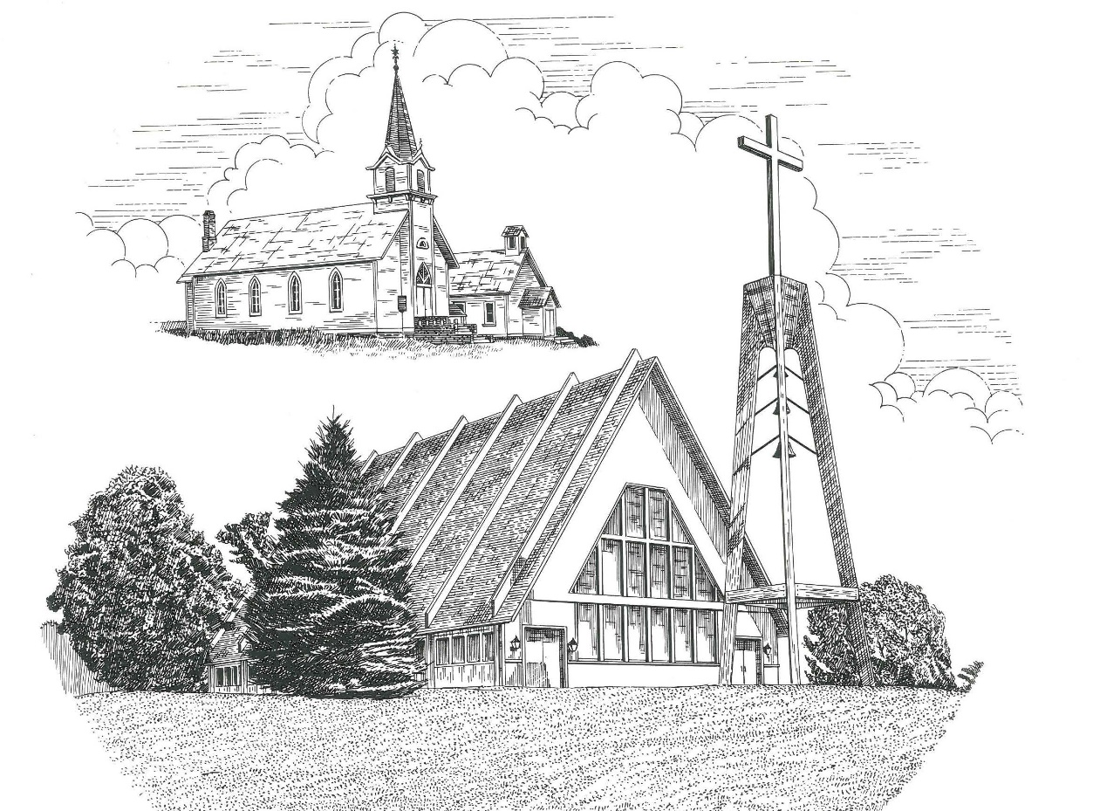

Third Sunday in Advent December 15th, 2019

WELCOME
Thanks for joining us!
Pastor Jacob Sherry Missouri Synod

~~PLEASE NOTE~~
Calling on the name of the Lord
Does not include the use of cell phones in the worship sanctuary.
Please check yours before the service begins. Thank you for your courtesy.
~~TO OUR GUESTS AND VISITORS~~
Please sign our guest book located on the stand at the church entrance. During the service, we ask you to sign the attendance booklet located at the end of each pew. If you need assistance or have questions about our worship service, please talk to an elder or any one of our church family. We are glad you could join us and hope to have you worship with us again soon.

Order of Divine Service Setting Three

Pre-Service Music……………..Call to Worship………………….Greeting

OPENING HYMN: “Hark the Glad Sound”…..………………………LSB #349
OPENING LITURGY:
Confession & Absolution……………………………………….LSB pp. 184-185
Kyrie……………………………………………………………..LSB p. 186
Salutation….…………………………………………………….LSB p. 189

Collect Prayer
Lord Jesus Christ, we implore You to hear our prayers and to lighten the darkness of our hearts by Your gracious visitation; for You live and reign with the Father and the Holy Spirit, one God, now and forever.

CHILDREN’S ADVENT PROGRAM
Children, Go Where I Send Thee

Group 1: God sent Jesus down from above. God sends me to tell of His love.
Group 2: Children, go where I send thee.
Group 3: How shall I send thee?
Group 4: I’m gonna send thee five by five.

Children Sing: Children, go where I send thee. How shall I send thee? I’m gonna
send thee five by five. Five for the people counted alive. Born, born, born in Bethlehem.

READING: Luke 2:1-3

Reader: Caesar wanted a count of his kingdom for tax purposes. Our Heavenly
Father has a count of His kingdom also. We count as children of God. We have been counted for heaven and the Bible assures us our names are written in the book of life, but what about our sins? Don’t they count against us?

Children: NO! God doesn’t count our sins! God count us!

Reader: Romans 4:7-8 reminds us: “Blessed are they whose transgressions are
forgiven, whose sins are covered. Blessed is the man whose sin the Lord will never count against him.”

SONG: “O Little Town of Bethlehem” – verses 1 & 2 LSB # 361

Group 1: God sent Jesus down from above. God sends me to tell of His love.
Group 2: Children, go where I send thee.
Group 3: How shall I send thee?
Group 4: I’m gonna send thee four by four.

Children Sing: Children, go where I send thee. How shall I send thee? I’m gonna
send thee four by four. Four for the angels’ singing tour. Five for the people counted alive. Born, born, born in Bethlehem.

READING: Luke 2:8-14

Reader: The words of the angels gave joy rather than fear. We fear God because
we know of His awesome power, but He does not want us to be afraid of Him. We are His children and His love fills our hearts with joy. Jesus tells us, “I have told you this so that my joy may be in you and that your joy may be complete.” John 15:11

SONG: “Away in the Manger” – verses 1 & 2 LSB # 364

Group 1: God sent Jesus down from above. God sends me to tell of His love.
Group 2: Children, go where I send thee.
Group 3: How shall I send thee?
Group 4: I’m gonna send thee three by three.

Children Sing: Children, go where I send thee. How shall I send thee? I’m gonna
send thee three by three. Three for the shepherd’s bended knee. Four for the angels’ singing tour. Five for the people counted alive. Born, born, born in Bethlehem.

READING: Luke 2:15-16

Children: Baby Jesus is here! He is God’s Son!

Reader: The shepherds struck with awe by the angel’s words and the sight of their
long awaited Savior, knelt to worship the newborn child. Join with us in worship as we recite Psalm 100, a song of praise, thanking God for His immeasurable love for us.

Reader: Shout for joy to the Lord all the earth.
Cong.: Know that the Lord is God.
Reader: It is He who made us and we are His; we are His people the sheep of
His pasture.
Cong.: Enter His gates with thanksgiving and His courts with praise:
Reader: Give thanks to Him and praise His name.
Cong.: For the Lord is good and His love endures forever;
Reader: His faithfulness continues through all generations.

SONG: “Hark! The Herald Angels Sing” – verses 1 & 2 LSB #380

Group 1: God sent Jesus down from above. God sends me to tell of His love.
Group 2: Children, go where I send thee.
Group 3: How shall I send thee?
Group 4: I’m gonna send thee two by two.

Children Sing: Children, go where I send thee. How shall I send thee? I’m gonna
send thee two by two. Two for His parents chosen, too. Three for the shepherd’s bended knee. Four for the angels’ singing tour. Five for the people counted alive. Born, born, born in Bethlehem.

READING: Matthew 1:18-22

Reader: Mary and Joseph were indeed chosen by God. We are also numbered
among the chosen. We are His children through our baptism and have been chosen to complete God’s story. He sends us to spread His word, to do His work, and to share His love with the rest of His world. In John 15:16, Jesus tells us, “You did not choose Me, but I chose you and appointed you to go and bear fruit.”

SONG: “Joy to the World” – verses 1 & 2 LSB #387

Group 1: God sent Jesus down from above. God sends me to tell of His love.
Group 2: Children, go where I send thee.
Group 3: How shall I send thee?
Group 4: I’m gonna send thee one by one.

Children Sing: Children, go where I send thee. How shall I send thee? I’m gonna
send thee one by one to tell the world of God’s own Son. Two for His parents chosen, too. Three for the shepherd’s bended knee. Four for the angels’ singing tour. Five for the people counted alive. Born, born, born in Bethlehem.

READING: Luke 2:17-20

Children: The Messiah is here!

Reader: God’s Good News is too big to keep quiet. Our joy is too big to be held
only in our hearts. Through the saving work of His Son, God commands us, enables us, and aids us to spread the news and makes disciples. “Therefore, go and make disciples of all nations, baptizing them in the name of the Father and of the Son and of the Holy Spirit, and teaching them to obey everything I have commanded you. And surely I am with you always, to the end of the age.” Matthew 28:19-20

Children Sing: Children, go where I send thee. How shall I send thee? I’m gonna
send thee one by one to tell the world of God’s own Son. Born, born, born in Bethlehem.

Children: God sent Jesus down from above. God sends me to tell of His love.

The children close by playing “Silent Night” on the hand bells.

GATHERING OF OUR FIRST FRUITS & OFFERTORY…………LSB pp. 192-193

THE GENERAL PRAYERS

THE LORD’S PRAYER

CLOSING HYMN: “Let the Earth Now Praise the Lord”.................................LSB #352

CHURCH INFORMATION
Church Office: (231) 889-4429 Website: www.trinityonekama.org
E-mail: trinityonekama@sbcglobal.net
Address: P.O. Box 119, 5471 Fairview Street, Onekama, MI 49675
Adult Bible Study: Sunday @ 9:15 am (year round)
Worship: Sunday @ 10:30 am The Lord’s Supper: Celebrated 2nd & 4th Sundays
Pastoral Hours: Wednesday and Friday 8:30am – Noon
Pastor Phone: 231-655-2680 Pastor Email: trinityonekama@gmail.com

Copyright licensing covered under CCLI #2802932

