**231-889-4429 5471 Fairview Street, Box 119 Onekama, MI**

**TRINITY LUTHERAN CHURCH**

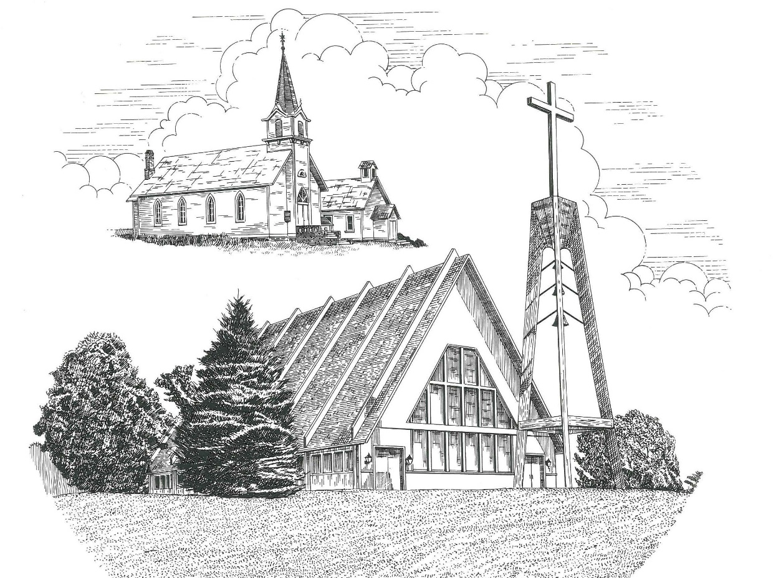

**Third Sunday in Advent December 17th, 2023**

**WELCOME**

**Thanks for joining us!**

**Pastor Jacob Sherry Missouri Synod**

**~~PLEASE NOTE~~Calling on the name of the Lord**

Does not include the use of cell phones in the worship sanctuary.

Please check yours before the service begins. Thank you for your courtesy.

**~~TO OUR GUESTS AND VISITORS~~**

Please sign our guest book located on the stand at the church entrance. During the service, we ask you to sign the attendance sheets located inside your bulletin and leave them on the pew as you leave. If you need assistance or have questions about our worship service, please talk to an elder or any one of our church family. We are glad you could join us and hope to have you worship with us again soon.

**Order of Divine Service Setting One**

**Pre-Service Music……………..Call to Worship………………….Greeting**

**OPENING HYMN:** *“I Want to Walk as a Child of the Light”*………………..LSB #411

**CONFESSION & ABSOLUTION**……………………………………………LSB p. 151

**INTROIT**

P: Show us your steadfast love, O Lord,

**C: and grant us your salvation.**

P: Let me hear what God the Lord will speak,

**C: for he will speak peace to his people, to his saints;**

**but let them not turn back to folly.**

P: Surely his salvation is near to those who fear him,

**C: that glory may dwell in our land.**

P: Yes, the Lord will give what is good,

**C: and our land will yield its increase.**

P: Righteousness will go before him

**C: and make his footsteps a way.**

**ALL: Glory be to the Father and to the Son and to the Holy Spirit; as it was in the**

**beginning, is now, and will be forever. Amen.**

P: Show us your steadfast love, O Lord,

**C: and grant us your salvation.**

**KYRIE**…………………………………………………………………...LSB pp. 152-153

**SALUTATION**…………………………………………………………..LSB p. 156

**Collect Prayer**

Lord Jesus Christ, we implore You to hear our prayers and to lighten the darkness of our hearts by Your gracious visitation; for You live and reign with the Father and the Holy Spirit, one God, now and forever.

**THE HOLY SCRIPTURES**

**OLD TESTAMENT:** (Isaiah 61:1-4, 8-11)

The Spirit of the Lord God is upon me,  
    because the Lord has anointed me  
to bring good news to the poor;  
    he has sent me to bind up the brokenhearted,  
to proclaim liberty to the captives,  
    and the opening of the prison to those who are bound;  
**2**to proclaim the year of the Lord's favor,  
    and the day of vengeance of our God;  
    to comfort all who mourn;  
**3**to grant to those who mourn in Zion—  
    to give them a beautiful headdress instead of ashes,  
the oil of gladness instead of mourning,  
    the garment of praise instead of a faint spirit;  
that they may be called oaks of righteousness,  
    the planting of the Lord, that he may be glorified.  
**4**They shall build up the ancient ruins;  
    they shall raise up the former devastations;  
they shall repair the ruined cities,  
    the devastations of many generations.

**8**For I the Lord love justice;  
    I hate robbery and wrong;  
I will faithfully give them their recompense,  
    and I will make an everlasting covenant with them.  
**9**Their offspring shall be known among the nations,  
    and their descendants in the midst of the peoples;  
all who see them shall acknowledge them,  
    that they are an offspring the Lord has blessed.

**10**I will greatly rejoice in the Lord;  
    my soul shall exult in my God,  
for he has clothed me with the garments of salvation;  
    he has covered me with the robe of righteousness,  
as a bridegroom decks himself like a priest with a beautiful headdress,  
    and as a bride adorns herself with her jewels.  
**11**For as the earth brings forth its sprouts,  
    and as a garden causes what is sown in it to sprout up,  
so the Lord God will cause righteousness and praise  
    to sprout up before all the nations.

**R:** This is the Word of the Lord**.** **Cong: Thanks be to God.**

**GRADUAL**

Reader: Rejoice greatly, O daughter of Zion.

**C: Shout aloud, O daughter of Jerusalen.**

Reader: Behold, your king is coming to you;

**C: righteous and having salvation.**

Reader: Blessed is he who comes in the name of the Lord.

**C: From the house of the Lord we bless you.**

**EPISTLE:** (1 Thessalonians 5:16-24)

**16**Rejoice always, **17**pray without ceasing, **18**give thanks in all circumstances; for this is the will of God in Christ Jesus for you. **19**Do not quench the Spirit. **20**Do not despise prophecies, **21**but test everything; hold fast what is good. **22**Abstain from every form of evil. **23**Now may the God of peace himself sanctify you completely, and may your whole spirit and soul and body be kept blameless at the coming of our Lord Jesus Christ. **24**He who calls you is faithful; he will surely do it.

**R:** This is the Word of the Lord. **Cong: Thanks be to God.**

**(PLEASE RISE for the reading of the Gospel)**



**R:** The Holy Gospel according to St. John, the 1st chapter.



**HOLY GOSPEL:** (John 1:6-8, 19-28)

**6**There was a man sent from God, whose name was John. **7**He came as a witness, to bear witness about the light, that all might believe through him. **8**He was not the light, but came to bear witness about the light.

**19**And this is the testimony of John, when the Jews sent priests and Levites from Jerusalem to ask him, “Who are you?” **20**He confessed, and did not deny, but confessed, “I am not the Christ.” **21**And they asked him, “What then? Are you Elijah?” He said, “I am not.” “Are you the Prophet?” And he answered, “No.” **22**So they said to him, “Who are you? We need to give an answer to those who sent us. What do you say about yourself?” **23**He said, “I am the voice of one crying out in the wilderness, ‘Make straight the way of the Lord,’ as the prophet Isaiah said.”

**24**(Now they had been sent from the Pharisees.) **25**They asked him, “Then why are you baptizing, if you are neither the Christ, nor Elijah, nor the Prophet?” **26**John answered them, “I baptize with water, but among you stands one you do not know, **27**even he who comes after me, the strap of whose sandal I am not worthy to untie.” **28**These things took place in Bethany across the Jordan, where John was baptizing.

**R:** This is the Gospel of the Lord.



**APOSTLES’ CREED**

I believe in God, the Father Almighty, maker of heaven and earth. And in Jesus Christ, His only Son, our Lord, who was conceived by the Holy Spirit, born of the virgin Mary, suffered under Pontius Pilate, was crucified, died and was buried. He descended into hell. The third day He rose again from the dead. He ascended into heaven and sits at the right hand of God the Father Almighty. From thence He will come to judge the living and the dead. I believe in the Holy Spirit, the holy Christian Church, the communion of saints, the forgiveness of sins, the resurrection of the body, and the life everlasting. Amen.

**SERMON HYMN**: *“Infant Holy, Infant Lowly”*……………………………...LSB #393

**CHILDREN’S CHRISTMAS PROGRAM**

**COLLECTION OF THE OFFERING**

**OFFERTORY HYMN:** *”Doxology”*…………………………………….…...LSB #805

**THE GENERAL PRAYERS OF THE CHURCH**

**THE LORD’S PRAYER**

**BENEDICTION**……………………………………………………………….LSB p. 166

**CLOSING HYMN:** *“Jesus Loves Me!”*……..………………………………..LSB #588



**Special Prayers**

Bill Bankstahl Pam Monroe Rose Ralls

Cherrie Burch Jim Poellet Steve Schimke

Tim Fogarty Shirley Poellet Phyllis Schramski

Melody Tessaro Maki Bill Ralls Terri Vertalka

Lavonne Miller

For Rev. Sherry and his family as they consider a call to

St. Peter’s Lutheran Church in Swanville, MN

**Prayers for Our Military**

**Capt. Tim Brandt** at Madigan Medical Center, Fort Lewis, WA, son of Bruce & Debbie Brandt

**Andrew Burch**, **Jr**., grandson of John & Loree Sprawka.

**Alyssa & Trevor Eisenlohr** siblings both with the U.S. Navy, friends of Janette & Fred May

**Jordan Fink**, grandson of Lila Fink

**Mark Granzotto** with U.S. Navy in Bahrain, grandson of Rita Merkey

**Ian Nelson,** nephew of Jack Nelson

**Tyge Nelson & family,** nephew of Jack Nelson

**Derek Sprawka,** grandson of John & Loree Sprawka

***If you wish to add someone’s name, please call or e-mail the church office.***

The Mission of Trinity Onekama Is To **SERVE**

For even the Son of Man did not come to be served

but to serve and to give his life as a ransom for many.            
                                                                       Mark 10:45



**S**haring Jesus’s **t**ruth

**E**quipping for life

**R**eaching Out

**V**aluing each other

**E**vangelizing all ages

Mission Statement

The mission of Trinity Onekama is to SERVE

For even the Son of Man did not come to be served, but to serve,

and to give his life as a ransom for many. Mark 10:45

S haring Jesus’ ruth

E quipping for life

R eaching Out

V aluing each other

E vangelizing all age

**CHURCH INFORMATION**

**Church Office:** (231) 889-4429 **Website:** www.trinityonekama.org

**E-mail:** [trinityonekama@sbcglobal.net](mailto:trinityonekama@sbcglobal.net)

**Address:** P.O. Box 119, 5471 Fairview Street, Onekama, MI 49675

**Sunday School & Adult Bible Study**: Sunday @ 9:30am

**Worship:** Sunday @ 10:30 am **The Lord’s Supper:**  Celebrated 2nd & 4th Sundays

**Pastoral Hours:** Wednesday and Friday 9:00am – Noon

**Pastor Phone:** 231-655-2680 **Pastor Email:** trinityonekama@gmail.com

**Copyright licensing covered under CCLI #2802932**