231-889-4429 5471 Fairview Street, Box 119 Onekama, MI

TRINITY LUTHERAN CHURCH
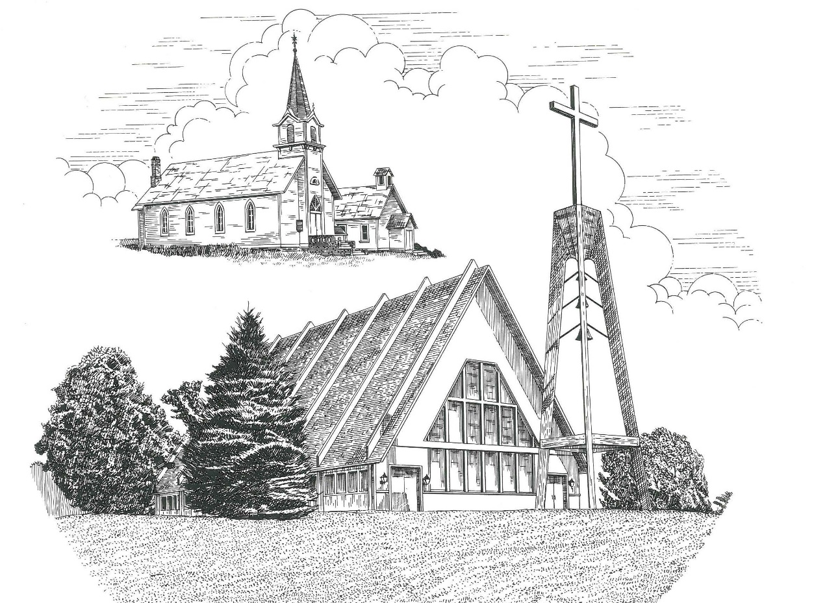

Fourth Sunday in Advent December 22nd, 2019

WELCOME
Thanks for joining us!
Pastor Jacob Sherry Missouri Synod

~~PLEASE NOTE~~
Calling on the name of the Lord
Does not include the use of cell phones in the worship sanctuary.
Please check yours before the service begins. Thank you for your courtesy.
~~TO OUR GUESTS AND VISITORS~~
Please sign our guest book located on the stand at the church entrance. During the service, we ask you to sign the attendance booklet located at the end of each pew. If you need assistance or have questions about our worship service, please talk to an elder or any one of our church family. We are glad you could join us and hope to have you worship with us again soon.

~~ATTENDING HOLY COMMUNION~~
By checking the “Communing Today” box on the registration form found in the attendance booklet, you are agreeing with the following statements:

- I am a baptized Christian who believes Jesus Christ is my Lord and Savior.
- I believe that I am a sinner in need of Christ freely offered forgiveness.
- I believe that in the Lord’s Supper the body and blood of Jesus Christ
are truly present in, with, and under the bread and wine.
- I believe that my participation in Holy Communion grants me forgiveness
of my sins, new spiritual life, and eternal salvation.
- With God’s help, I sincerely seek to repent of my sins, live in service
to my Lord, and await His return.

If you agree with the above statements, you are welcome to attend the Lord’s Supper with us. May God bless your worship time with us.
We do offer gluten-free wafers, please quietly ask an elder to help you.

Order of Divine Service Setting Four

Pre-Service Music……………..Call to Worship………………….Greeting

OPENING HYMN: “Once He Came in Blessing”…..………………...LSB #333
OPENING LITURGY:
Confession & Absolution……………………………………….LSB p. 203
Kyrie……………………………………………………………..LSB p. 204
Salutation….…………………………………………………….LSB p. 205

Collect Prayer
Stir up Your power, O Lord, and come and help us by Your might, that the sins which weigh us down may be quickly lifted by Your grace and mercy; for You live and reign with the Father and the Holy Spirit, one God, now and forever.

THE HOLY SCRIPTURES

OLD TESTAMENT: (Isaiah 7:10-17)
¹⁰ Again the Lord spoke to Ahaz: ¹¹ “Ask a sign of the Lord your God; let it be deep as Sheol or high as heaven.” ¹² But Ahaz said, “I will not ask, and I will not put the Lord to the test.” ¹³ And he said, “Hear then, O house of David! Is it too little for you to weary men, that you weary my God also? ¹⁴ Therefore the Lord himself will give you a sign. Behold, the virgin shall conceive and bear a son, and shall call his name Immanuel. ¹⁵ He shall eat curds and honey when he knows how to refuse the evil and choose the good. ¹⁶ For before the boy knows how to refuse the evil and choose the good, the land whose two kings you dread will be deserted. ¹⁷ The Lord will bring upon you and upon your people and upon your father's house such days as have not come since the day that Ephraim departed from Judah—the king of Assyria!”

R: This is the Word of the Lord. Cong: Thanks be to God.

GRADUAL
Reader: Rejoice greatly, O daughter of Zion.
Cong.: Shout aloud, O daughter of Jerusalem.
Reader: Behold, your king is coming to you;
Cong.: righteous and having salvation.
Reader: Blessed is he who comes in the name of the Lord.
Cong.: From the house of the Lord we bless you.

EPISTLE: (Romans 1:1-7)
Paul, a servant of Christ Jesus, called to be an apostle, set apart for the gospel of God, ² which he promised beforehand through his prophets in the holy Scriptures, ³ concerning his Son, who was descended from David according to the flesh ⁴ and was declared to be the Son of God in power according to the Spirit of holiness by his resurrection from the dead, Jesus Christ our Lord, ⁵ through whom we have received grace and apostleship to bring about the obedience of faith for the sake of his name among all the nations, ⁶ including you who are called to belong to Jesus Christ, ⁷ To all those in Rome who are loved by God and called to be saints:
Grace to you and peace from God our Father and the Lord Jesus Christ.

R: This is the Word of the Lord. Cong: Thanks be to God.

(PLEASE RISE for the reading of the Gospel)

R: The Holy Gospel according to St. Matthew, the 1st Chapter.
Cong: Glory to You, O Lord.

HOLY GOSPEL: (Matthew 1:18-25)
¹⁸ Now the birth of Jesus Christ took place in this way. When his mother Mary had been betrothed to Joseph, before they came together she was found to be with child from the Holy Spirit. ¹⁹ And her husband Joseph, being a just man and unwilling to put her to shame, resolved to divorce her quietly. ²⁰ But as he considered these things, behold, an angel of the Lord appeared to him in a dream, saying, “Joseph, son of David, do not fear to take Mary as your wife, for that which is conceived in her is from the Holy Spirit. ²¹ She will bear a son, and you shall call his name Jesus, for he will save his people from their sins.” ²² All this took place to fulfill what the Lord had spoken by the prophet:
²³ “Behold, the virgin shall conceive and bear a son,
and they shall call his name Immanuel”
(which means, God with us). ²⁴ When Joseph woke from sleep, he did as the angel of the Lord commanded him: he took his wife, ²⁵ but knew her not until she had given birth to a son. And he called his name Jesus.

R: This is the Gospel of the Lord.
Cong: Praise to You, O Christ.
Nicene Creed…...……………………………………………………..……….LSB p. 206
I believe in one God, the Father Almighty, maker of heaven and earth and of all things visible and invisible.
And in one Lord Jesus Christ, the only-begotten Son of God, begotten of His Father before all worlds, God of God, Light of Light, very God of very God, begotten, not made, being of one substance with the Father, by whom all things were made; who for us men and for our salvation came down from heaven and was incarnate by the Holy Spirit of the virgin Mary and was made man; and was crucified also for us under Pontius Pilate. He suffered and was buried. And the third day He rose again according to the Scriptures and ascended into heaven and sits at the right hand of the Father. And He will come again with glory to judge both the living and the dead, whose kingdom will have no end.
And I believe in the Holy Spirit, the Lord and giver of life, who proceeds from the Father and the Son, who with the Father and the Son together is worshiped and glorified, who spoke by the prophets. And I believe in one holy Christian and apostolic Church, I acknowledge one Baptism for the remission of sins, and I look for the resurrection of the dead and the life of the world to come. Amen.

SERMON HYMN: “Come, Thou Precious Ransom, Come”…………………LSB #350

SERMON

THE GENERAL PRAYERS

GATHERING OF OUR FIRST FRUITS

Congregational Sharing of the Peace of the Lord
INSTITUTION OF THE LORD’S SUPPER
Preface…………………………………….…………….………..LSB p. 208
Proper Preface
It is truly good, right, and salutary that we should at all times and in all places give thanks to You, O Lord, holy Father, almighty and everlasting God, for the countless blessings You so freely bestow on us and all creation. Above all, we give thanks for Your boundless love shown to us when You sent Your only-begotten Son, Jesus Christ, into our flesh and laid on Him our sin, giving Him into death that we might not die eternally. Because He is now risen from the dead and lives and reigns to all eternity, all who believe in Him will overcome sin and death and will rise again to new life. Therefore, with angels and archangels and with all the company of heaven we laud and magnify Your glorious name, ever more praising You and saying:

Sanctus, Lord’s Prayer, The Words of Our Lord………………….....LSB pp. 208-209
Agnus Dei………………………………………………………………..LSB p. 210
If you are not communing it is acceptable to remaining seated.

COMMUNION DISTRIBUTION HYMNS:
LSB #357 “O Come, O Come, Emmanuel”
LSB #346 “When All the World Was Cursed”
LSB #334 “O Lord, How Shall I Meet You”

CLOSING LITURGY:………………………………………………....LSB pp. 211-212

CLOSING HYMN: “Go, My Children, with My Blessing”....................LSB #922

The Mission of Trinity Onekama Is To SERVE

For even the Son of Man did not come to be served
but to serve and to give his life as a ransom for many.
Mark 10:45

S haring Jesus’s truth
E quipping for life
R eaching Out
V aluing each other
E vangelizing all ages
Mission Statement
The mission of Trinity Onekama is to SERVE
For even the Son of Man did not come to be served, but to serve,
and to give his life as a ransom for many. Mark 10:45
S haring Jesus’ ruth
E quipping for life
R eaching Out
V aluing each other
E vangelizing all age

CHURCH INFORMATION
Church Office: (231) 889-4429 Website: www.trinityonekama.org
E-mail: trinityonekama@sbcglobal.net
Address: P.O. Box 119, 5471 Fairview Street, Onekama, MI 49675
Adult Bible Study: Sunday @ 9:15 am (year round)
Worship: Sunday @ 10:30 am The Lord’s Supper: Celebrated 2nd & 4th Sundays
Pastoral Hours: Wednesday and Friday 8:30am – Noon
Pastor Phone: 231-655-2680 Pastor Email: trinityonekama@gmail.com

Copyright licensing covered under CCLI #2802932

