**231-889-4429 5471 Fairview Street, Box 119 Onekama, MI**

**TRINITY LUTHERAN CHURCH**

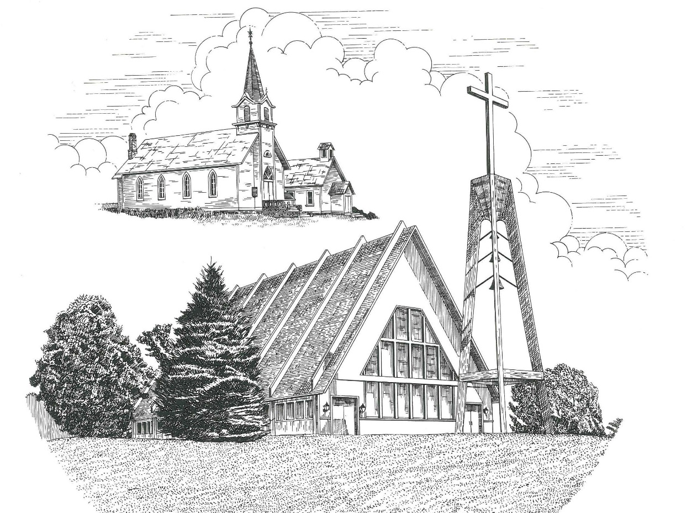

**New Year’s Eve December 31st, 2023**

**WELCOME**

**Thanks for joining us!**

**Pastor Jacob Sherry Missouri Synod**

**~~PLEASE NOTE~~Calling on the name of the Lord**

Does not include the use of cell phones in the worship sanctuary.

Please check yours before the service begins. Thank you for your courtesy.

**~~TO OUR GUESTS AND VISITORS~~**

Please sign our guest book located on the stand at the church entrance. During the service, we ask you to sign the attendance sheets located inside your bulletin and leave them on the pew as you leave. If you need assistance or have questions about our worship service, please talk to an elder or any one of our church family. We are glad you could join us and hope to have you worship with us again soon.

**~~ATTENDING HOLY COMMUNION~~**

By checking the “Communing Today” box on the registration form on the attendance sheet, you are agreeing with the following statements:

* **I am a baptized Christian who believes Jesus Christ is my Lord and Savior.**
* **I believe that I am a sinner in need of Christ’s freely offered forgiveness.**
* **I believe that in the Lord’s Supper the body and blood of Jesus Christ**

**are truly present in, with, and under the bread and wine.**

* **I believe that my participation in Holy Communion grants me forgiveness**

**of my sins, new spiritual life, and eternal salvation.**

* **With God’s help, I sincerely seek to repent of my sins, live in service**

**to my Lord, and await His return.**

**If you agree with the above statements, you are welcome to attend the Lord’s Supper with us. May God bless your worship time with us.**

We do offer gluten-free wafers, please quietly ask an elder to help you.

**Order of Divine Service Setting One**

**Pre-Service Music……………..Call to Worship………………….Greeting**

**OPENING HYMN:** *“Joy to the World”*………………………………..LSB #387

**CONFESSION & ABSOLUTION**……………………………………..LSB p. 151

**INTROIT**

P: Our help is in the name of the Lord,

**C: who made heaven and earth.**

P: O sing to the Lord a new song, for he has done marvelous things!

**C: His right hand and his holy arm have worked salvation for him.**

P: The Lord has made known his salvation;

**C: he has revealed his righteousness in the sight of the nations.**

P: He has remembered his steadfast love and faithfulness to the house of Israel.

**C: All the ends of the earth have seen the salvation of our God.**

**ALL: Glory be to the Father and to the Son and to the Holy Spirit; as it was in the**

**beginning, is now, and will be forever. Amen.**

P: Our help is in the name of the Lord,

**C: who made heaven and earth.**

**KYRIE**…………………………………………………………………...LSB pp. 152-153

**THIS IS THE FEAST**…………………………………………………...LSB p. 155

**SALUTATION**…………………………………………………………..LSB p. 156

**Collect Prayer**

Eternal God, we commit to Your mercy and forgiveness the year now ending and commend to Your blessing and love the times yet to come. In the new year, abide among us with Your Holy Spirit that we may always trust in the saving name of our Lord Jesus Christ, who lives and reigns with the You and the Holy Spirit, one God, now and forever.

**THE HOLY SCRIPTURES**

**OLD TESTAMENT:** (Isaiah 30:15-17)

**15**For thus said the Lord God, the Holy One of Israel,  
“In returning and rest you shall be saved;  
    in quietness and in trust shall be your strength.”  
But you were unwilling, **16**and you said,  
“No! We will flee upon horses”;  
    therefore you shall flee away;  
and, “We will ride upon swift steeds”;  
    therefore your pursuers shall be swift.  
**17**A thousand shall flee at the threat of one;  
    at the threat of five you shall flee,  
till you are left  
    like a flagstaff on the top of a mountain,  
    like a signal on a hill.

**R:** This is the Word of the Lord**.** **Cong: Thanks be to God.**

**GRADUAL**

Reader: Teach us to number our days

**C: that we may get a heart of wisdom.**

Reader: Satisfy us in the morning with Your steadfast love,

**C: that we may rejoice and be glad all our days.**

**EPISTLE:** (Romans 8:31b-39)

**31**If God is for us, who can be against us? **32**He who did not spare his own Son but gave him up for us all, how will he not also with him graciously give us all things? **33**Who shall bring any charge against God's elect? It is God who justifies. **34**Who is to condemn? Christ Jesus is the one who died—more than that, who was raised—who is at the right hand of God, who indeed is interceding for us. **35**Who shall separate us from the love of Christ? Shall tribulation, or distress, or persecution, or famine, or nakedness, or danger, or sword? **36**As it is written,

“For your sake we are being killed all the day long;  
   we are regarded as sheep to be slaughtered.”

**37**No, in all these things we are more than conquerors through him who loved us. **38**For I am sure that neither death nor life, nor angels nor rulers, nor things present nor things to come, nor powers, **39**nor height nor depth, nor anything else in all creation, will be able to separate us from the love of God in Christ Jesus our Lord.

**R:** This is the Word of the Lord. **Cong: Thanks be to God.**

**(PLEASE RISE for the reading of the Gospel)**



**R:** The Holy Gospel according to St. Luke, the 12th chapter.



**HOLY GOSPEL:** (Luke 12:35-40)

**35**“Stay dressed for action and keep your lamps burning, **36**and be like men who are waiting for their master to come home from the wedding feast, so that they may open the door to him at once when he comes and knocks. **37**Blessed are those servants whom the master finds awake when he comes. Truly, I say to you, he will dress himself for service and have them recline at table, and he will come and serve them. **38**If he comes in the second watch, or in the third, and finds them awake, blessed are those servants! **39**But know this, that if the master of the house had known at what hour the thief was coming, he would not have left his house to be broken into. **40**You also must be ready, for the Son of Man is coming at an hour you do not expect.”

**R:** This is the Gospel of the Lord.



**SERMON HYMN**: *“Across the Sky the Shades of Night”*………………LSB #899

**SERMON**

**NICENE CREED**

I believe in one God, the Father Almighty, maker of heaven and earth and of all things visible and invisible.

And in one Lord Jesus Christ, the only-begotten Son of God, begotten of His Father before all worlds, God of God, Light of Light, very God of very God, begotten, not made, being of one substance with the Father, by whom all things were made; who for us men and for our salvation came down from heaven and was incarnate by the Holy Spirit of the virgin Mary and was made man; and was crucified also for us under Pontius Pilate. He suffered and was buried. And the third day He rose again according to the Scriptures and ascended into heaven and sits at the right hand of the Father. And He will come again with glory to judge both the living and the dead, whose kingdom will have no end.

And I believe in the Holy Spirit, the Lord and giver of life, who proceeds from the Father and the Son, who with the Father and the Son together is worshiped and glorified, who spoke by the prophets. And I believe in one holy Christian and apostolic Church, I acknowledge one Baptism for the remission of sins, and I look for the resurrection of the dead and the life of the world to come. Amen.

**THE GENERAL PRAYERS OF THE CHURCH**

**COLLECTION OF THE OFFERING**

**OFFERTORY**…………………………………………………………...LSB pp. 159-160

**Sharing the Peace of the Lord**

**SERVICE OF THE SACRAMENT**

**PREFACE**……………………………………………………………………..LSB p. 160

**Proper Preface**

It is truly good, right, and salutary that we should at all times and in all places give thanks to You, holy Lord, almighty Father, everlasting God, through Jesus Christ, our Lord, for in the mystery of the Word made flesh You have given us a new revelation of Your glory that, seeing You in the person of Your Son, we may know and love those things which are not seen. Therefore, with angels and archangels and with all the company of heaven we laud and magnify Your glorious name, ever more praising You and saying:

**SANCTUS**……………………………………………………………………...LSB p. 161

**THE WORDS OF OUR LORD**……………………………………………….LSB p. 162

**AGNUS DEI**……………………………………………………………………LSB p. 163

*If you are not communing, it is acceptable to remain seated.*

**COMMUNION DISTRIBUTION HYMNS**

LSB #384 *“Of the Father’s Love Begotten”*

LSB #376 *“Once in Royal David’s City”*

LSB #388 *“Go Tell It on the Mountain”*

**POST COMMUNION CANTICLE:** *“Thank the Lord”*………………….....LSB p. 164

**POST-COMMUNION COLLECT PRAYER**………………………………LSB p. 166

**BENEDICTION**……………………………………………………………….LSB p. 166

**CLOSING HYMN:** *“Angels from the Realms of Glory”* ……..…………….. LSB #367

The Mission of Trinity Onekama Is To **SERVE**

For even the Son of Man did not come to be served

but to serve and to give his life as a ransom for many.            
                                                                       Mark 10:45



**S**haring Jesus’s **t**ruth

**E**quipping for life

**R**eaching Out

**V**aluing each other

**E**vangelizing all ages

Mission Statement

The mission of Trinity Onekama is to SERVE

For even the Son of Man did not come to be served, but to serve,

and to give his life as a ransom for many. Mark 10:45

S haring Jesus’ ruth

E quipping for life

R eaching Out

V aluing each other

E vangelizing all age

**CHURCH INFORMATION**

**Church Office:** (231) 889-4429 **Website:** www.trinityonekama.org

**E-mail:** [trinityonekama@sbcglobal.net](mailto:trinityonekama@sbcglobal.net)

**Address:** P.O. Box 119, 5471 Fairview Street, Onekama, MI 49675

**Sunday School & Adult Bible Study**: Sunday @ 9:30 am

**Worship:** Sunday @ 10:30 am **The Lord’s Supper:**  Celebrated 2nd & 4th Sundays

**Pastoral Hours:** Wednesday and Friday 9:00am – Noon

**Pastor Phone:** 231-655-2680 **Pastor Email:** trinityonekama@gmail.com

**Copyright licensing covered under CCLI #2802932**