231-889-4429 5471 Fairview Street, Box 119 Onekama, MI

TRINITY LUTHERAN CHURCH
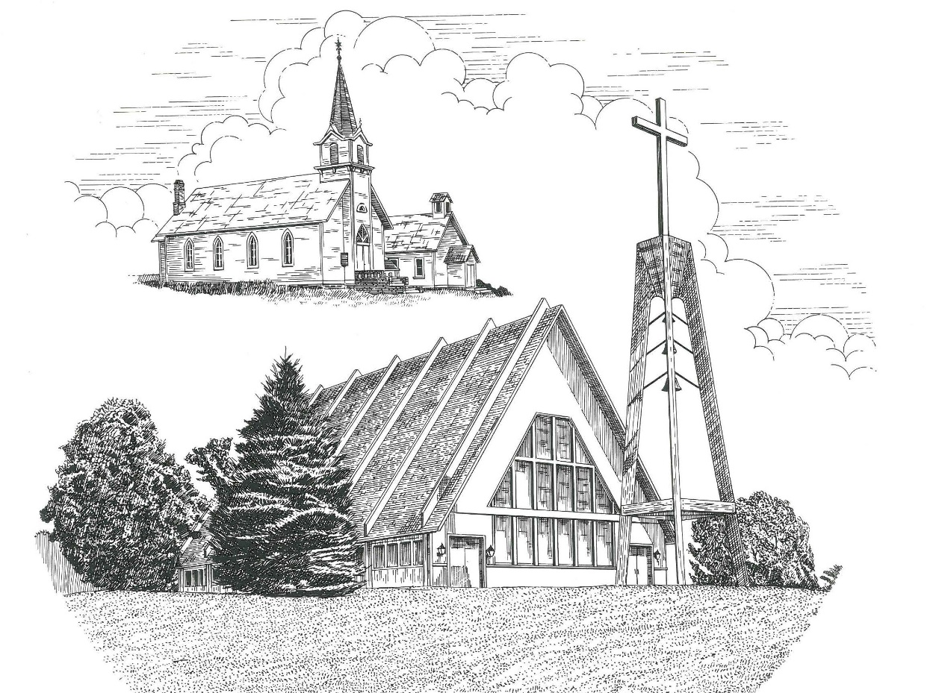

Sixth Sunday after the Epiphany February 12th, 2023

WELCOME
Thanks for joining us!
Pastor Jacob Sherry Missouri Synod

~~PLEASE NOTE~~
Calling on the name of the Lord
Does not include the use of cell phones in the worship sanctuary.
Please check yours before the service begins. Thank you for your courtesy.
~~TO OUR GUESTS AND VISITORS~~
Please sign our guest book located on the stand at the church entrance. During the service, we ask you to sign the attendance sheet in your bulletin and leave it on the pew as you leave. If you need assistance or have questions about our worship service, please talk to an elder or any one of our church family. We are glad you could join us and hope to have you worship with us again soon.

~~ATTENDING HOLY COMMUNION~~
By checking the “Communing Today” box on the registration form found on the attendance sheet in your bulletin, you are agreeing with the following statements:

- I am a baptized Christian who believes Jesus Christ is my Lord and Savior.
- I believe that I am a sinner in need of Christ’s freely offered forgiveness.
- I believe that in the Lord’s Supper the body and blood of Jesus Christ
are truly present in, with, and under the bread and wine.
- I believe that my participation in Holy Communion grants me forgiveness
of my sins, new spiritual life, and eternal salvation.
- With God’s help, I sincerely seek to repent of my sins, live in service
to my Lord, and await His return.

If you agree with the above statements, you are welcome to attend the Lord’s Supper with us. May God bless your worship time with us.
We do offer gluten-free wafers, please quietly ask an elder to help you.

Order of Divine Service Setting Four

Pre-Service Music……………..Call to Worship………………….Greeting

OPENING HYMN: “Hail, Thou Once Despised Jesus”…………….…LSB #531

OPENING LITURGY
Confession & Absolution……………………………………….LSB p. 203
Kyrie……………………………………………………………..LSB p. 204
Gloria in Excelsis………………………………………………..LSB p. 204
Salutation….…………………………………………………….LSB p. 205

Collect Prayer
O Lord, graciously hear the prayers of Your people that we who justly suffer the consequences of our sin may be mercifully delivered by Your goodness to the glory of Your name; through Jesus Christ, Your Son, our Lord, who lives and reigns with Your and the Holy Spirit, one God, now and forever.

THE HOLY SCRIPTURES

OLD TESTAMENT: (Deuteronomy 30:15-20)
¹⁵ “See, I have set before you today life and good, death and evil. ¹⁶ If you obey the commandments of the Lord your God that I command you today, by loving the Lord your God, by walking in his ways, and by keeping his commandments and his statutes and his rules, then you shall live and multiply, and the Lord your God will bless you in the land that you are entering to take possession of it. ¹⁷ But if your heart turns away, and you will not hear, but are drawn away to worship other gods and serve them, ¹⁸ I declare to you today, that you shall surely perish. You shall not live long in the land that you are going over the Jordan to enter and possess. ¹⁹ I call heaven and earth to witness against you today, that I have set before you life and death, blessing and curse. Therefore choose life, that you and your offspring may live, ²⁰ loving the Lord your God, obeying his voice and holding fast to him, for he is your life and length of days, that you may dwell in the land that the Lord swore to your fathers, to Abraham, to Isaac, and to Jacob, to give them.”

R: This is the Word of the Lord. Cong: Thanks be to God.

GRADUAL
Reader: Praise the Lord, all nations!
Cong.: Extol him, all peoples!
Reader: For great is his steadfast love toward us,
Cong.: and the faithfulness of the Lord endures forever.
Reader: Ascribe to the Lord the glory due his name;
Cong.: bring an offering, and come into his courts!

EPISTLE: (1 Corinthians 3:1-9)
But I, brothers, could not address you as spiritual people, but as people of the flesh, as infants in Christ. ² I fed you with milk, not solid food, for you were not ready for it. And even now you are not yet ready, ³ for you are still of the flesh. For while there is jealousy and strife among you, are you not of the flesh and behaving only in a human way? ⁴ For when one says, “I follow Paul,” and another, “I follow Apollos,” are you not being merely human?
⁵ What then is Apollos? What is Paul? Servants through whom you believed, as the Lord assigned to each. ⁶ I planted, Apollos watered, but God gave the growth. ⁷ So neither he who plants nor he who waters is anything, but only God who gives the growth. ⁸ He who plants and he who waters are one, and each will receive his wages according to his labor. ⁹ For we are God's fellow workers. You are God's field, God's building.

R: This is the Word of the Lord. Cong: Thanks be to God.

(PLEASE RISE for the reading of the Gospel)

R: The Holy Gospel according to St. Matthew, the 5th chapter.

Cong: Glory to You, O Lord

HOLY GOSPEL: (Matthew 5:21-37)
²¹ “You have heard that it was said to those of old, ‘You shall not murder; and whoever murders will be liable to judgment.’ ²² But I say to you that everyone who is angry with his brother will be liable to judgment; whoever insults his brother will be liable to the council; and whoever says, ‘You fool!’ will be liable to the hell of fire. ²³ So if you are offering your gift at the altar and there remember that your brother has something against you, ²⁴ leave your gift there before the altar and go. First be reconciled to your brother, and then come and offer your gift. ²⁵ Come to terms quickly with your accuser while you are going with him to court, lest your accuser hand you over to the judge, and the judge to the guard, and you be put in prison. ²⁶ Truly, I say to you, you will never get out until you have paid the last penny.
²⁷ “You have heard that it was said, ‘You shall not commit adultery.’ ²⁸ But I say to you that everyone who looks at a woman with lustful intent has already committed adultery with her in his heart. ²⁹ If your right eye causes you to sin, tear it out and throw it away. For it is better that you lose one of your members than that your whole body be thrown into hell. ³⁰ And if your right hand causes you to sin, cut it off and throw it away. For it is better that you lose one of your members than that your whole body go into hell.
³¹ “It was also said, ‘Whoever divorces his wife, let him give her a certificate of divorce.’ ³² But I say to you that everyone who divorces his wife, except on the ground of sexual immorality, makes her commit adultery, and whoever marries a divorced woman commits adultery.
³³ “Again you have heard that it was said to those of old, ‘You shall not swear falsely, but shall perform to the Lord what you have sworn.’ ³⁴ But I say to you, Do not take an oath at all, either by heaven, for it is the throne of God, ³⁵ or by the earth, for it is his footstool, or by Jerusalem, for it is the city of the great King. ³⁶ And do not take an oath by your head, for you cannot make one hair white or black. ³⁷ Let what you say be simply ‘Yes’ or ‘No’; anything more than this comes from evil.

R: This is the Gospel of the Lord. Cong: Praise to You, O Christ.

NICENE CREED
I believe in one God, the Father Almighty, maker of heaven and earth and of all things visible and invisible.
And in one Lord Jesus Christ, the only-begotten Son of God, begotten of His Father before all worlds, God of God, Light of Light, very God of very God, begotten, not made, being of one substance with the Father, by whom all things were made; who for us men and for our salvation came down from heaven and was incarnate by the Holy Spirit of the virgin Mary and was made man; and was crucified also for us under Pontius Pilate. He suffered and was buried. And the third day He rose again according to the Scriptures and ascended into heaven and sits at the right hand of the Father. And He will come again with glory to judge both the living and the dead, whose kingdom will have no end.
And I believe in the Holy Spirit, the Lord and giver of life, who proceeds from the Father and the Son, who with the Father and the Son together is worshiped and glorified, who spoke by the prophets. And I believe in one holy Christian and apostolic Church, I acknowledge one Baptism for the remission of sins, and I look for the resurrection of the dead and the life of the world to come. Amen.

SERMON HYMN: “Songs of Thankfulness and Praise”………………LSB #394

SERMON

THE GENERAL PRAYERS

OFFERTORY HYMN: “Let the Vineyards Be Fruitful”………………LSB #955

Sharing the Peace of the Lord

SERVICE OF THE SACRAMENT
Preface…………………………………….…………….………..LSB p. 208
Proper Preface
It is truly good, right, and salutary that we should at all times and in all places give thanks to You, O Lord, holy Father, almighty and everlasting God, for the countless blessings You so freely bestow on us and all creation. Above all, we give thanks for Your boundless love shown to us when You sent Your only-begotten Son, Jesus Christ, into our flesh and laid on Him our sin, giving Him into death that we might not die eternally. Because He is now risen from the dead and lives and reigns to all eternity, all who believe in Him will overcome sin and death and will rise again to new life. Therefore, with angels and archangels and with all the company of heaven we laud and magnify Your glorious name, ever more praising You and saying:

Sanctus, Lord’s Prayer, The Words of Our Lord………………….....LSB pp. 208-209
Agnus Dei………………………………………………………………..LSB p. 210
If you are not communing, it is acceptable to remain seated.

COMMUNION DISTRIBUTION HYMNS:
LSB #633 “At the Lamb’s High Feast We Sing”
LSB #725 “Children of the Heavenly Father”
LSB #729“I Am Trusting Thee, Lord Jesus”

CLOSING LITURGY:………………………………………………....LSB pp. 211-212

CLOSING HYMN: “Sent Forth by God’s Blessing”..............................LSB #643

The Mission of Trinity Onekama Is To SERVE

For even the Son of Man did not come to be served
but to serve and to give his life as a ransom for many.
Mark 10:45

S haring Jesus’s truth
E quipping for life
R eaching Out
V aluing each other
E vangelizing all ages
Mission Statement
The mission of Trinity Onekama is to SERVE
For even the Son of Man did not come to be served, but to serve,
and to give his life as a ransom for many. Mark 10:45
S haring Jesus’ ruth
E quipping for life
R eaching Out
V aluing each other
E vangelizing all age

CHURCH INFORMATION
Church Office: (231) 889-4429 Website: www.trinityonekama.org
E-mail: trinityonekama@sbcglobal.net
Address: P.O. Box 119, 5471 Fairview Street, Onekama, MI 49675
Sunday School & Adult Bible Study: Sunday @ 9:30am
Worship: Sunday @ 10:30 am The Lord’s Supper: Celebrated 2nd & 4th Sundays
Pastoral Hours: Wednesday and Friday 9:00am – Noon
Pastor Phone: 231-655-2680 Pastor Email: trinityonekama@gmail.com

Copyright licensing covered under CCLI #2802932

