**231-889-4429 5471 Fairview Street, Box 119 Onekama, MI**

**TRINITY LUTHERAN CHURCH**

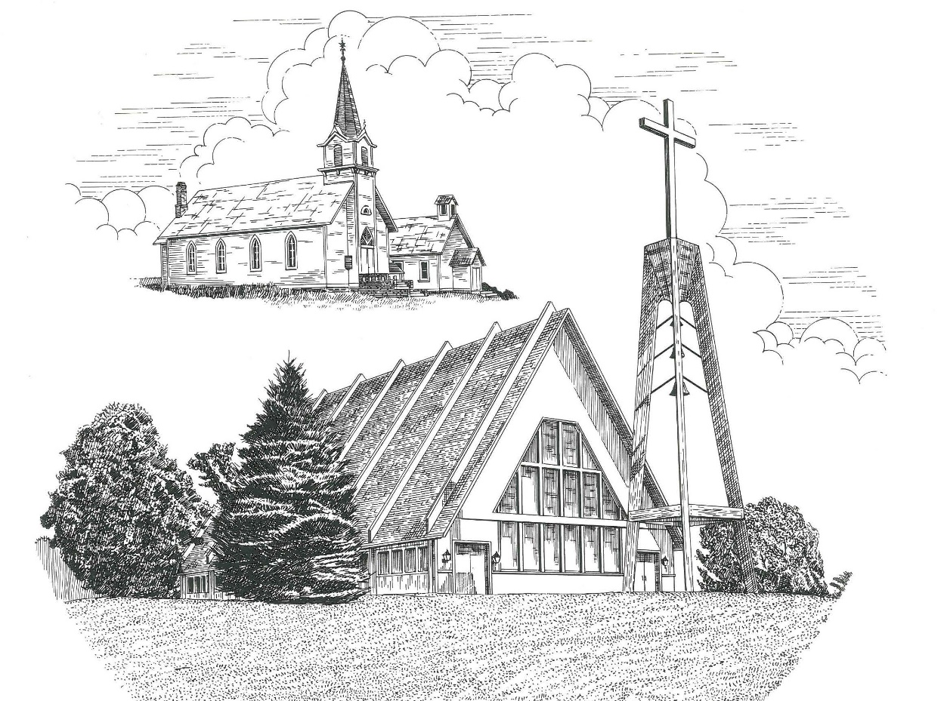

**Sixth Sunday after Epiphany February 13th, 2022**

**WELCOME**

**Thanks for joining us!**

**Pastor Jacob Sherry Missouri Synod**

**~~PLEASE NOTE~~Calling on the name of the Lord**

Does not include the use of cell phones in the worship sanctuary.

Please check yours before the service begins. Thank you for your courtesy.

**~~TO OUR GUESTS AND VISITORS~~**

Please sign our guest book located on the stand at the church entrance. During the service, we ask you to sign the attendance sheets located inside your bulletin and leave them on the pew as you leave. If you need assistance or have questions about our worship service, please talk to an elder or any one of our church family. We are glad you could join us and hope to have you worship with us again soon.

**~~ATTENDING HOLY COMMUNION~~**

By checking the “Communing Today” box on the registration form found on the attendance sheet, you are agreeing with the following statements:

* **I am a baptized Christian who believes Jesus Christ is my Lord and Savior.**
* **I believe that I am a sinner in need of Christ freely offered forgiveness.**
* **I believe that in the Lord’s Supper the body and blood of Jesus Christ**

**are truly present in, with, and under the bread and wine.**

* **I believe that my participation in Holy Communion grants me forgiveness**

**of my sins, new spiritual life, and eternal salvation.**

* **With God’s help, I sincerely seek to repent of my sins, live in service**

**to my Lord, and await His return.**

**If you agree with the above statements, you are welcome to attend the Lord’s Supper with us. May God bless your worship time with us.**

We do offer gluten-free wafers, please quietly ask an elder to help you.

**Order of Divine Service Setting One**

**Pre-Service Music……………..Call to Worship………………….Greeting**

**OPENING HYMN:** *“With the Lord Begin Your Task”*………………...LSB #869

**CONFESSION & ABSOLUTION**……………………………………..LSB p. 151

**KYRIE**…………………………………………………………………...LSB pp. 152-153

**THIS IS THE FEAST**…………………………………………………...LSB p. 155

**SALUTATION**…………………………………………………………..LSB p. 156

**Collect Prayer**

O Lord, graciously hear the prayers of Your people that we who justly suffer the consequences of our sin may be mercifully delivered by Your goodness to the glory of Your name; through the same Jesus Christ, Your Son, our Lord, who lives and reigns with You and the Holy Spirit, one God, now and forever.

**THE HOLY SCRIPTURES**

**OLD TESTAMENT:** (Jeremiah 17:5-8)

**5**Thus says the Lord:  
“Cursed is the man who trusts in man  
    and makes flesh his strength,  
    whose heart turns away from the Lord.  
**6**He is like a shrub in the desert,  
    and shall not see any good come.  
He shall dwell in the parched places of the wilderness,  
    in an uninhabited salt land.

**7**“Blessed is the man who trusts in the Lord,  
    whose trust is the Lord.  
**8**He is like a tree planted by water,  
    that sends out its roots by the stream,  
and does not fear when heat comes,  
    for its leaves remain green,  
and is not anxious in the year of drought,  
    for it does not cease to bear fruit.”

**R:** This is the Word of the Lord**.** **Cong: Thanks be to God.**

**GRADUAL**

Reader: Praise the Lord, all nations!

**Cong.: Extol him, all peoples!**

Reader: For great is his steadfast love toward us,

**Cong.: and the faithfulness of the Lord endures forever.**

Reader: Ascribe to the Lord the glory due his name;

**Cong.: bring an offering, and come into his courts!**

**EPISTLE:** (1 Corinthians 15:12-20)

**12**Now if Christ is proclaimed as raised from the dead, how can some of you say that there is no resurrection of the dead?  **13**But if there is no resurrection of the dead, then not even Christ has been raised.  **14**And if Christ has not been raised, then our preaching is in vain and your faith is in vain.  **15**We are even found to be misrepresenting God, because we testified about God that he raised Christ, whom he did not raise if it is true that the dead are not raised.  **16**For if the dead are not raised, not even Christ has been raised. **17**And if Christ has not been raised, your faith is futile and you are still in your sins. **18**Then those also who have fallen asleep in Christ have perished.  **19**If in Christ we have hope in this life only, we are of all people most to be pitied. **20**But in fact Christ has been raised from the dead, the firstfruits of those who have fallen asleep.

**R:** This is the Word of the Lord. **Cong: Thanks be to God.**

**(PLEASE RISE for the reading of the Gospel)**



**R:** The Holy Gospel according to St. Luke, the 6th chapter.



**HOLY GOSPEL:** (Luke 6:17-26)

**17**And Jesus came down with them and stood on a level place, with a great crowd of his disciples and a great multitude of people from all Judea and Jerusalem and the seacoast of Tyre and Sidon, **18**who came to hear him and to be healed of their diseases.  And those who were troubled with unclean spirits were cured.  **19**And all the crowd sought to touch him, for power came out from him and healed them all. **20**And he lifted up his eyes on his disciples, and said:

“Blessed are you who are poor, for yours is the kingdom of God.

**21**“Blessed are you who are hungry now, for you shall be satisfied.

“Blessed are you who weep now, for you shall laugh.

**22**“Blessed are you when people hate you and when they exclude you and revile you and spurn your name as evil, on account of the Son of Man!  **23**Rejoice in that day, and leap for joy, for behold, your reward is great in heaven; for so their fathers did to the prophets.

**24**“But woe to you who are rich, for you have received your consolation.

**25**“Woe to you who are full now, for you shall be hungry.

“Woe to you who laugh now, for you shall mourn and weep.

**26**“Woe to you, when all people speak well of you, for so their fathers did to the false prophets.

**R:** This is the Gospel of the Lord.



**SERMON HYMN**: *“Jesus Sat with His Disciples”*………………….............LSB #932

**SERMON**

**NICENE CREED**

I believe in one God, the Father Almighty, maker of heaven and earth and of all things visible and invisible.

And in one Lord Jesus Christ, the only-begotten Son of God, begotten of His Father before all worlds, God of God, Light of Light, very God of very God, begotten, not made, being of one substance with the Father, by whom all things were made; who for us men and for our salvation came down from heaven and was incarnate by the Holy Spirit of the virgin Mary and was made man; and was crucified also for us under Pontius Pilate. He suffered and was buried. And the third day He rose again according to the Scriptures and ascended into heaven and sits at the right hand of the Father. And He will come again with glory to judge both the living and the dead, whose kingdom will have no end.

And I believe in the Holy Spirit, the Lord and giver of life, who proceeds from the Father and the Son, who with the Father and the Son together is worshiped and glorified, who spoke by the prophets. And I believe in one holy Christian and apostolic Church, I acknowledge one Baptism for the remission of sins, and I look for the resurrection of the dead and the life of the world to come. Amen.

**THE GENERAL PRAYERS OF THE CHURCH**

**SERVICE OF THE SACRAMENT**

**PREFACE**…………………………………………………………………….LSB p. 160

**Proper Preface**

It is truly good, right, and salutary that we should at all times and in all places give thanks to You, holy Lord, almighty Father, everlasting God, through Jesus Christ, our Lord, for what had been hidden from before the foundation of the world You have made known to the nations in Your Son. In Him, being found in the substance of our mortal nature, You have manifested the fullness of Your glory. Therefore, with angels and archangels and with all the company of heaven we laud and magnify Your glorious name, ever more praising You and saying:

**SANCTUS**……………………………………………………………………...LSB p. 161

**THE WORDS OF OUR LORD**……………………………………………….LSB p. 162

**AGNUS DEI**……………………………………………………………………LSB p. 163

*If you are not communing, it is acceptable to remain seated.*

**COMMUNION DISTRIBUTION HYMNS**

LSB #607 *“From the Depths of Woe I Cry to Thee”*

LSB #627 *“Jesus Christ, Our Blessed Savior”*

**THANK THE LORD**………………………………………………………….LSB p. 164

**POST-COMMUNION COLLECT PRAYER**……………………………….LSB p. 166

**BENEDICTION**……………………………………………………………….LSB p. 166

**CLOSING HYMN:** *“How Sweet the Name of Jesus Sounds”*……..…………LSB #524

The Mission of Trinity Onekama Is To **SERVE**

For even the Son of Man did not come to be served

but to serve and to give his life as a ransom for many.            
                                                                       Mark 10:45



**S**haring Jesus’s **t**ruth

**E**quipping for life

**R**eaching Out

**V**aluing each other

**E**vangelizing all ages

Mission Statement

The mission of Trinity Onekama is to SERVE

For even the Son of Man did not come to be served, but to serve,

and to give his life as a ransom for many. Mark 10:45

S haring Jesus’ ruth

E quipping for life

R eaching Out

V aluing each other

E vangelizing all age

**CHURCH INFORMATION**

**Church Office:** (231) 889-4429 **Website:** www.trinityonekama.org

**E-mail:** [trinityonekama@sbcglobal.net](mailto:trinityonekama@sbcglobal.net)

**Address:** P.O. Box 119, 5471 Fairview Street, Onekama, MI 49675

**Adult Bible Study**: Sunday @ 11:30 am (year round)

**Worship:** Sunday @ 10:30 am **The Lord’s Supper:**  Celebrated 2nd & 4th Sundays

**Pastoral Hours:** Wednesday and Friday 9:00am – Noon

**Pastor Phone:** 231-655-2680 **Pastor Email:** trinityonekama@gmail.com

**Copyright licensing covered under CCLI #2802932**