231-889-4429 5471 Fairview Street, Box 119 Onekama, MI

TRINITY LUTHERAN CHURCH
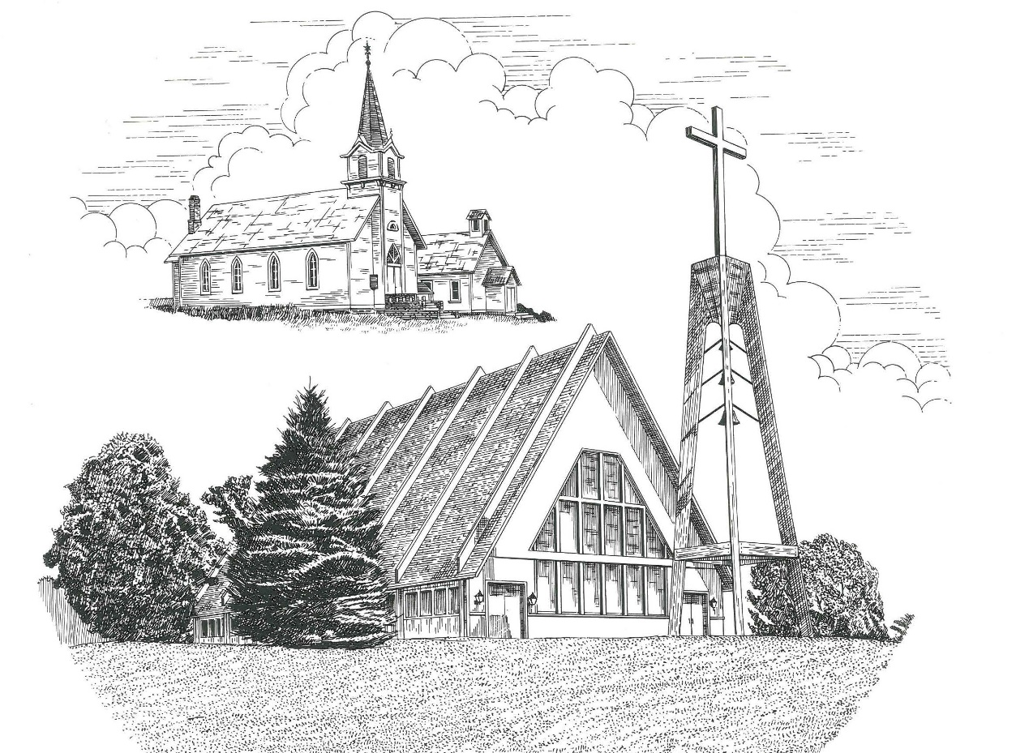

First Sunday in Lent February 26th, 2023

WELCOME
Thanks for joining us!
Pastor Jacob Sherry Missouri Synod

~~PLEASE NOTE~~
Calling on the name of the Lord
Does not include the use of cell phones in the worship sanctuary.
Please check yours before the service begins. Thank you for your courtesy.
~~TO OUR GUESTS AND VISITORS~~
Please sign our guest book located on the stand at the church entrance. During the service, we ask you to sign the attendance sheet in your bulletin and leave it on the pew as you leave. If you need assistance or have questions about our worship service, please talk to an elder or any one of our church family. We are glad you could join us and hope to have you worship with us again soon.

~~ATTENDING HOLY COMMUNION~~
By checking the “Communing Today” box on the registration form found on the attendance sheet in your bulletin, you are agreeing with the following statements:

- I am a baptized Christian who believes Jesus Christ is my Lord and Savior.
- I believe that I am a sinner in need of Christ’s freely offered forgiveness.
- I believe that in the Lord’s Supper the body and blood of Jesus Christ
are truly present in, with, and under the bread and wine.
- I believe that my participation in Holy Communion grants me forgiveness
of my sins, new spiritual life, and eternal salvation.
- With God’s help, I sincerely seek to repent of my sins, live in service
to my Lord, and await His return.

If you agree with the above statements, you are welcome to attend the Lord’s Supper with us. May God bless your worship time with us.
We do offer gluten-free wafers, please quietly ask an elder to help you.

Order of Divine Service Setting Four

Pre-Service Music……………..Call to Worship………………….Greeting

OPENING HYMN: “We Are Called to Stand Together”………………LSB #828

OPENING LITURGY
Confession & Absolution……………………………………….LSB p. 203
Kyrie……………………………………………………………..LSB p. 204
Salutation….…………………………………………………….LSB p. 205

Collect Prayer
O Lord God, You led Your ancient people through the wilderness and brought them to the promised land. Guide the people of Your Church that following our Savior we may walk through the wilderness of this world toward the glory of the world to come; through Jesus Christ, Your Son, our Lord, who lives and reigns with Your and the Holy Spirit, one God, now and forever.

THE HOLY SCRIPTURES

OLD TESTAMENT: (Genesis 3:1-21)
Now the serpent was more crafty than any other beast of the field that the Lord God had made. He said to the woman, “Did God actually say, ‘You shall not eat of any tree in the garden’?” ² And the woman said to the serpent, “We may eat of the fruit of the trees in the garden, ³ but God said, ‘You shall not eat of the fruit of the tree that is in the midst of the garden, neither shall you touch it, lest you die.’” ⁴ But the serpent said to the woman, “You will not surely die. ⁵ For God knows that when you eat of it your eyes will be opened, and you will be like God, knowing good and evil.” ⁶ So when the woman saw that the tree was good for food, and that it was a delight to the eyes, and that the tree was to be desired to make one wise, she took of its fruit and ate, and she also gave some to her husband who was with her, and he ate. ⁷ Then the eyes of both were opened, and they knew that they were naked. And they sewed fig leaves together and made themselves loincloths.
⁸ And they heard the sound of the Lord God walking in the garden in the cool of the day, and the man and his wife hid themselves from the presence of the Lord God among the trees of the garden. ⁹ But the Lord God called to the man and said to him, “Where are you?” ¹⁰ And he said, “I heard the sound of you in the garden, and I was afraid, because I was naked, and I hid myself.” ¹¹ He said, “Who told you that you were naked? Have you eaten of the tree of which I commanded you not to eat?” ¹² The man said, “The woman whom you gave to be with me, she gave me fruit of the tree, and I ate.” ¹³ Then the Lord God said to the woman, “What is this that you have done?” The woman said, “The serpent deceived me, and I ate.”
¹⁴ The Lord God said to the serpent,
“Because you have done this,
cursed are you above all livestock
and above all beasts of the field;
on your belly you shall go,
and dust you shall eat
all the days of your life.
¹⁵ I will put enmity between you and the woman,
and between your offspring and her offspring;
he shall bruise your head,
and you shall bruise his heel.”
¹⁶ To the woman he said,
“I will surely multiply your pain in childbearing;
in pain you shall bring forth children.
Your desire shall be contrary to your husband,
but he shall rule over you.”
¹⁷ And to Adam he said,
“Because you have listened to the voice of your wife
and have eaten of the tree
of which I commanded you,
‘You shall not eat of it,’
cursed is the ground because of you;
in pain you shall eat of it all the days of your life;
¹⁸ thorns and thistles it shall bring forth for you;
and you shall eat the plants of the field.
¹⁹ By the sweat of your face
you shall eat bread,
till you return to the ground,
for out of it you were taken;
for you are dust,
and to dust you shall return.”
²⁰ The man called his wife's name Eve, because she was the mother of all living. ²¹ And the Lord God made for Adam and for his wife garments of skins and clothed them.

R: This is the Word of the Lord. Cong: Thanks be to God.

GRADUAL
Reader: O come, let us fix our eyes on Jesus,
Cong.: the founder and perfecter of our faith,
Reader: who for the joy that was set before him endured the cross, despising the shame,
Cong.: and is seated at the right hand of the throne of God.

EPISTLE: (Romans 5:12-19)
¹² Therefore, just as sin came into the world through one man, and death through sin, and so death spread to all men because all sinned— ¹³ for sin indeed was in the world before the law was given, but sin is not counted where there is no law. ¹⁴ Yet death reigned from Adam to Moses, even over those whose sinning was not like the transgression of Adam, who was a type of the one who was to come.
¹⁵ But the free gift is not like the trespass. For if many died through one man's trespass, much more have the grace of God and the free gift by the grace of that one man Jesus Christ abounded for many. ¹⁶ And the free gift is not like the result of that one man's sin. For the judgment following one trespass brought condemnation, but the free gift following many trespasses brought justification. ¹⁷ For if, because of one man's trespass, death reigned through that one man, much more will those who receive the abundance of grace and the free gift of righteousness reign in life through the one man Jesus Christ. ¹⁸ Therefore, as one trespass led to condemnation for all men, so one act of righteousness leads to justification and life for all men. ¹⁹ For as by the one man's disobedience the many were made sinners, so by the one man's obedience the many will be made righteous.

R: This is the Word of the Lord. Cong: Thanks be to God.

(PLEASE RISE for the reading of the Gospel)

R: The Holy Gospel according to St. Matthew, the 4th chapter.
Cong: Glory to You, O Lord

HOLY GOSPEL: (Matthew 4:1-11)
Then Jesus was led up by the Spirit into the wilderness to be tempted by the devil. ² And after fasting forty days and forty nights, he was hungry. ³ And the tempter came and said to him, “If you are the Son of God, command these stones to become loaves of bread.” ⁴ But he answered, “It is written,
“‘Man shall not live by bread alone,
but by every word that comes from the mouth of God.’”
⁵ Then the devil took him to the holy city and set him on the pinnacle of the temple ⁶ and said to him, “If you are the Son of God, throw yourself down, for it is written,
“‘He will command his angels concerning you,’
and
“‘On their hands they will bear you up,
lest you strike your foot against a stone.’”
⁷ Jesus said to him, “Again it is written, ‘You shall not put the Lord your God to the test.’” ⁸ Again, the devil took him to a very high mountain and showed him all the kingdoms of the world and their glory. ⁹ And he said to him, “All these I will give you, if you will fall down and worship me.” ¹⁰ Then Jesus said to him, “Be gone, Satan! For it is written,
“‘You shall worship the Lord your God
and him only shall you serve.’”
¹¹ Then the devil left him, and behold, angels came and were ministering to him.

R: This is the Gospel of the Lord. Cong: Praise to You, O Christ.

NICENE CREED
I believe in one God, the Father Almighty, maker of heaven and earth and of all things visible and invisible.
And in one Lord Jesus Christ, the only-begotten Son of God, begotten of His Father before all worlds, God of God, Light of Light, very God of very God, begotten, not made, being of one substance with the Father, by whom all things were made; who for us men and for our salvation came down from heaven and was incarnate by the Holy Spirit of the virgin Mary and was made man; and was crucified also for us under Pontius Pilate. He suffered and was buried. And the third day He rose again according to the Scriptures and ascended into heaven and sits at the right hand of the Father. And He will come again with glory to judge both the living and the dead, whose kingdom will have no end.
And I believe in the Holy Spirit, the Lord and giver of life, who proceeds from the Father and the Son, who with the Father and the Son together is worshiped and glorified, who spoke by the prophets. And I believe in one holy Christian and apostolic Church, I acknowledge one Baptism for the remission of sins, and I look for the resurrection of the dead and the life of the world to come. Amen.

SERMON HYMN: “O Christ, You Walked the Road”…………………LSB #424

SERMON

THE GENERAL PRAYERS

OFFERTORY HYMN: “Let the Vineyards Be Fruitful”………………LSB #955

Sharing the Peace of the Lord

SERVICE OF THE SACRAMENT
Preface…………………………………….…………….………..LSB p. 208
Proper Preface
It is truly good, right, and salutary that we should at all times and in all places give thanks to You, O Lord, holy Father, almighty and everlasting God, for the countless blessings You so freely bestow on us and all creation. Above all, we give thanks for Your boundless love shown to us when You sent Your only-begotten Son, Jesus Christ, into our flesh and laid on Him our sin, giving Him into death that we might not die eternally. Because He is now risen from the dead and lives and reigns to all eternity, all who believe in Him will overcome sin and death and will rise again to new life. Therefore, with angels and archangels and with all the company of heaven we laud and magnify Your glorious name, ever more praising You and saying:

Sanctus, Lord’s Prayer, The Words of Our Lord………………….....LSB pp. 208-209
Agnus Dei………………………………………………………………..LSB p. 210
If you are not communing, it is acceptable to remain seated.

COMMUNION DISTRIBUTION HYMNS:
LSB #656 “A Mighty Fortress Is Our God”
LSB #953 “We All Believe in One True God”
LSB #588 “Jesus Loves Me”

CLOSING LITURGY:………………………………………………....LSB pp. 211-212

CLOSING HYMN: “Alas! And Did My Savior Bleed”..........................LSB #437

CHURCH INFORMATION
Church Office: (231) 889-4429 Website: www.trinityonekama.org
E-mail: trinityonekama@sbcglobal.net
Address: P.O. Box 119, 5471 Fairview Street, Onekama, MI 49675
Sunday School & Adult Bible Study: Sunday @ 9:30am
Worship: Sunday @ 10:30 am The Lord’s Supper: Celebrated 2nd & 4th Sundays
Pastoral Hours: Wednesday and Friday 9:00am – Noon
Pastor Phone: 231-655-2680 Pastor Email: trinityonekama@gmail.com

Copyright licensing covered under CCLI #2802932

