**231-889-4429 5471 Fairview Street, Box 119 Onekama, MI**

**TRINITY LUTHERAN CHURCH**

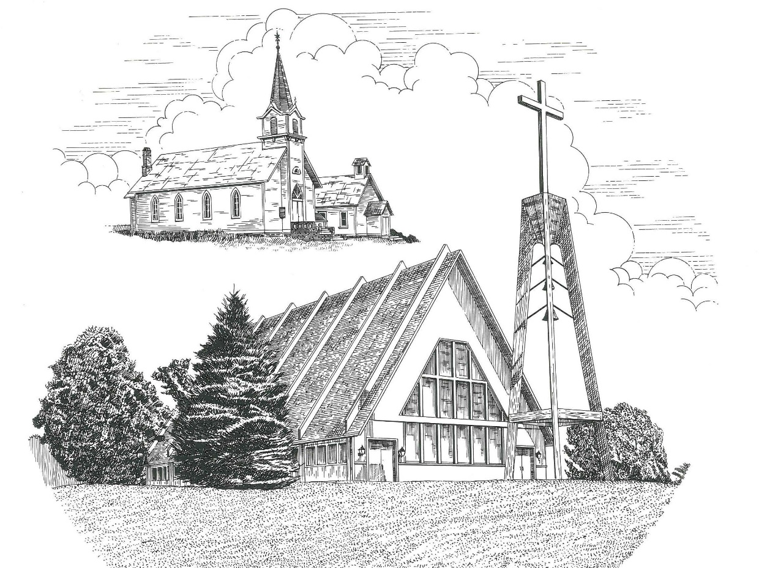

**The Transfiguration of Our Lord February 27th, 2022**

**WELCOME**

**Thanks for joining us!**

**Pastor Jacob Sherry Missouri Synod**

**~~PLEASE NOTE~~Calling on the name of the Lord**

Does not include the use of cell phones in the worship sanctuary.

Please check yours before the service begins. Thank you for your courtesy.

**~~TO OUR GUESTS AND VISITORS~~**

Please sign our guest book located on the stand at the church entrance. During the service, we ask you to sign the attendance sheets located inside your bulletin and leave them on the pew as you leave. If you need assistance or have questions about our worship service, please talk to an elder or any one of our church family. We are glad you could join us and hope to have you worship with us again soon.

**~~ATTENDING HOLY COMMUNION~~**

By checking the “Communing Today” box on the registration form found in the attendance booklet, you are agreeing with the following statements:

* **I am a baptized Christian who believes Jesus Christ is my Lord and Savior.**
* **I believe that I am a sinner in need of Christ freely offered forgiveness.**
* **I believe that in the Lord’s Supper the body and blood of Jesus Christ**

**are truly present in, with, and under the bread and wine.**

* **I believe that my participation in Holy Communion grants me forgiveness**

**of my sins, new spiritual life, and eternal salvation.**

* **With God’s help, I sincerely seek to repent of my sins, live in service**

**to my Lord, and await His return.**

**If you agree with the above statements, you are welcome to attend the Lord’s Supper with us. May God bless your worship time with us.**

We do offer gluten-free wafers, please quietly ask an elder to help you.

**Order of Divine Service Setting One**

**Pre-Service Music……………..Call to Worship………………….Greeting**

**OPENING HYMN:** *“O Wondrous Type! O Vision Fair”*……………..LSB #413

**CONFESSION & ABSOLUTION**……………………………………..LSB p. 151

**KYRIE**…………………………………………………………………...LSB pp. 152-153

**THIS IS THE FEAST**…………………………………………………...LSB p. 155

**SALUTATION**…………………………………………………………..LSB p. 156

**Collect Prayer**

O God, in the glorious transfiguration of Your beloved Son You confirmed the mysteries of the faith by the testimony of Moses and Elijah. In the voice that came from the bright cloud You wonderfully foreshadowed our adoption by grace. Mercifully make us co-heirs with the King in His glory and bring us to the fullness of our inheritance in heaven; through the same Jesus Christ, our Lord, who lives and reigns with You and the Holy Spirit, one God, now and forever.

**THE HOLY SCRIPTURES**

**OLD TESTAMENT:** (Deuteronomy 34:1-12)

Then Moses went up from the plains of Moab to Mount Nebo, to the top of Pisgah, which is opposite Jericho. And the Lord showed him all the land, Gilead as far as Dan, **2**all Naphtali, the land of Ephraim and Manasseh, all the land of Judah as far as the western sea, **3**the Negeb, and the Plain, that is, the Valley of Jericho the city of palm trees, as far as Zoar.  **4**And the Lord said to him, “This is the land of which I swore to Abraham, to Isaac, and to Jacob, ‘I will give it to your offspring.’  I have let you see it with your eyes, but you shall not go over there.”  **5**So Moses the servant of the Lord died there in the land of Moab, according to the word of the Lord, **6**and he buried him in the valley in the land of Moab opposite Beth-peor; but no one knows the place of his burial to this day. **7**Moses was 120 years old when he died.  His eye was undimmed, and his vigor unabated. **8**And the people of Israel wept for Moses in the plains of Moab thirty days. Then the days of weeping and mourning for Moses were ended.

**9**And Joshua the son of Nun was full of the spirit of wisdom, for Moses had laid his hands on him. So the people of Israel obeyed him and did as the Lord had commanded Moses.  **10**And there has not arisen a prophet since in Israel like Moses, whom the Lord knew face to face, **11**none like him for all the signs and the wonders that the Lord sent him to do in the land of Egypt, to Pharaoh and to all his servants and to all his land, **12**and for all the mighty power and all the great deeds of terror that Moses did in the sight of all Israel.

**R:** This is the Word of the Lord**.** **Cong: Thanks be to God.**

**GRADUAL**

Reader: Praise the Lord, all nations!

**Cong.: Extol him, all peoples!**

Reader: For great is his steadfast love toward us,

**Cong.: and the faithfulness of the Lord endures forever.**

Reader: Ascribe to the Lord the glory due his name;

**Cong.: bring an offering, and come into his courts!**

**EPISTLE:** (Hebrews 3:1-6)

Therefore, holy brothers, you who share in a heavenly calling, consider Jesus, the apostle and high priest of our confession, **2**who was faithful to him who appointed him, just as Moses also was faithful in all God's house.  **3**For Jesus has been counted worthy of more glory than Moses—as much more glory as the builder of a house has more honor than the house itself.  **4**(For every house is built by someone, but the builder of all things is God.) **5**Now Moses was faithful in all God's house as a servant, to testify to the things that were to be spoken later, **6**but Christ is faithful over God's house as a son. And we are his house, if indeed we hold fast our confidence and our boasting in our hope.

**R:** This is the Word of the Lord. **Cong: Thanks be to God.**

**(PLEASE RISE for the reading of the Gospel)**



**R:** The Holy Gospel according to St. Luke, the 9th chapter.



**HOLY GOSPEL:** (Luke 9:28-36)

**28**Now about eight days after these sayings Jesus took with him Peter and John and James and went up on the mountain to pray.  **29**And as he was praying, the appearance of his face was altered, and his clothing became dazzling white.  **30**And behold, two men were talking with him, Moses and Elijah, **31**who appeared in glory and spoke of his departure, which he was about to accomplish at Jerusalem.  **32**Now Peter and those who were with him were heavy with sleep, but when they became fully awake they saw his glory and the two men who stood with him.  **33**And as the men were parting from him, Peter said to Jesus, “Master, it is good that we are here. Let us make three tents, one for you and one for Moses and one for Elijah”—not knowing what he said.  **34**As he was saying these things, a cloud came and overshadowed them, and they were afraid as they entered the cloud.  **35**And a voice came out of the cloud, saying, “This is my Son, my Chosen One; listen to him!”  **36**And when the voice had spoken, Jesus was found alone.  And they kept silent and told no one in those days anything of what they had seen.

**R:** This is the Gospel of the Lord.



**SERMON HYMN**: *“’Tis Good, Lord, to Be Here”*…………………...............LSB #414

**SERMON**

**NICENE CREED**

I believe in one God, the Father Almighty, maker of heaven and earth and of all things visible and invisible.

And in one Lord Jesus Christ, the only-begotten Son of God, begotten of His Father before all worlds, God of God, Light of Light, very God of very God, begotten, not made, being of one substance with the Father, by whom all things were made; who for us men and for our salvation came down from heaven and was incarnate by the Holy Spirit of the virgin Mary and was made man; and was crucified also for us under Pontius Pilate. He suffered and was buried. And the third day He rose again according to the Scriptures and ascended into heaven and sits at the right hand of the Father. And He will come again with glory to judge both the living and the dead, whose kingdom will have no end.

And I believe in the Holy Spirit, the Lord and giver of life, who proceeds from the Father and the Son, who with the Father and the Son together is worshiped and glorified, who spoke by the prophets. And I believe in one holy Christian and apostolic Church, I acknowledge one Baptism for the remission of sins, and I look for the resurrection of the dead and the life of the world to come. Amen.

**THE GENERAL PRAYERS OF THE CHURCH**

**SERVICE OF THE SACRAMENT**

**PREFACE**……………………………………………………………………..LSB p. 160

**Proper Preface**

It is truly good, right, and salutary that we should at all times and in all places give thanks to You, holy Lord, almighty Father, everlasting God, through Jesus Christ, our Lord, who at His transfiguration revealed His glory to His disciples that they might be strengthened to proclaim His cross and resurrection and with all the faithful look forward to the glory of life everlasting. Therefore, with angels and archangels and with all the company of heaven we laud and magnify Your glorious name, ever more praising You and saying:

**SANCTUS**……………………………………………………………………...LSB p. 161

**THE WORDS OF OUR LORD**……………………………………………….LSB p. 162

**AGNUS DEI**……………………………………………………………………LSB p. 163

*If you are not communing, it is acceptable to remain seated.*

**COMMUNION DISTRIBUTION HYMNS**

LSB #633 *“At the Lamb’s High Feast We Sing”*

LSB #813 *“Rejoice, O Pilgrim Throng”*

**THANK THE LORD**………………………………………………………….LSB p. 164

**POST-COMMUNION COLLECT PRAYER**……………………………….LSB p. 166

**BENEDICTION**……………………………………………………………….LSB p. 166

**CLOSING HYMN:** *“Alleluia, Song of Gladness”*……..……………………..LSB #417

The Mission of Trinity Onekama Is To **SERVE**

For even the Son of Man did not come to be served

but to serve and to give his life as a ransom for many.            
                                                                       Mark 10:45



**S**haring Jesus’s **t**ruth

**E**quipping for life

**R**eaching Out

**V**aluing each other

**E**vangelizing all ages

Mission Statement

The mission of Trinity Onekama is to SERVE

For even the Son of Man did not come to be served, but to serve,

and to give his life as a ransom for many. Mark 10:45

S haring Jesus’ ruth

E quipping for life

R eaching Out

V aluing each other

E vangelizing all age

**CHURCH INFORMATION**

**Church Office:** (231) 889-4429 **Website:** www.trinityonekama.org

**E-mail:** [trinityonekama@sbcglobal.net](mailto:trinityonekama@sbcglobal.net)

**Address:** P.O. Box 119, 5471 Fairview Street, Onekama, MI 49675

**Adult Bible Study**: Sunday @ 11:30 am (year round)

**Worship:** Sunday @ 10:30 am **The Lord’s Supper:**  Celebrated 2nd & 4th Sundays

**Pastoral Hours:** Wednesday and Friday 9:00am – Noon

**Pastor Phone:** 231-655-2680 **Pastor Email:** trinityonekama@gmail.com

**Copyright licensing covered under CCLI #2802932**