231-889-4429 5471 Fairview Street, Box 119 Onekama, MI

TRINITY LUTHERAN CHURCH
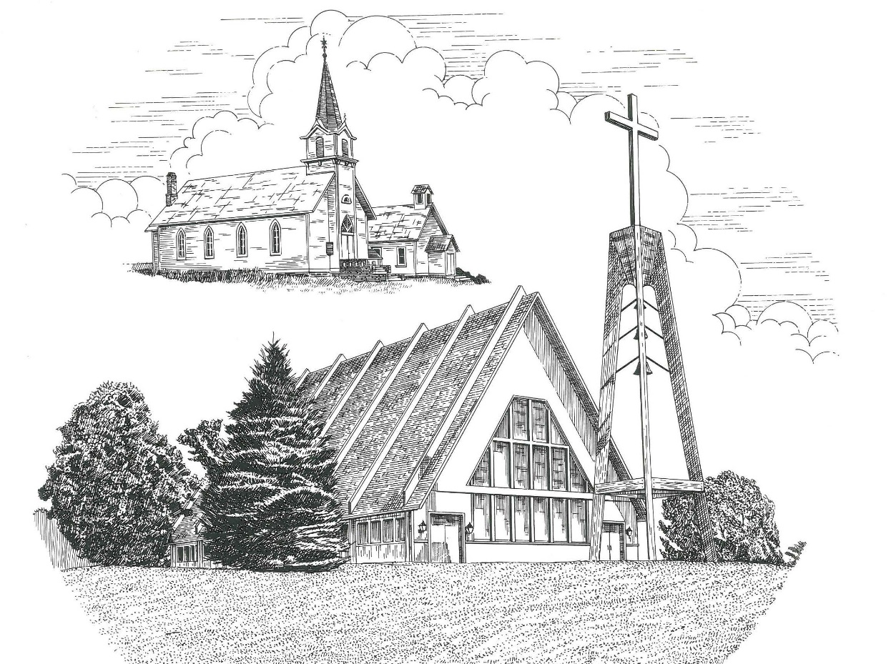

Second Sunday in Lent February 28th, 2021

WELCOME
Thanks for joining us!
Pastor Jacob Sherry Missouri Synod

~~PLEASE NOTE~~
Calling on the name of the Lord
Does not include the use of cell phones in the worship sanctuary.
Please check yours before the service begins. Thank you for your courtesy.
~~TO OUR GUESTS AND VISITORS~~
Please sign our guest book located on the stand at the church entrance. During the service, we ask you to sign the attendance booklet located at the end of each pew. If you need assistance or have questions about our worship service, please talk to an elder or any one of our church family. We are glad you could join us and hope to have you worship with us again soon.

~~ATTENDING HOLY COMMUNION~~
By checking the “Communing Today” box on the registration form found in the attendance booklet, you are agreeing with the following statements:

- I am a baptized Christian who believes Jesus Christ is my Lord and Savior.
- I believe that I am a sinner in need of Christ freely offered forgiveness.
- I believe that in the Lord’s Supper the body and blood of Jesus Christ
are truly present in, with, and under the bread and wine.
- I believe that my participation in Holy Communion grants me forgiveness
of my sins, new spiritual life, and eternal salvation.
- With God’s help, I sincerely seek to repent of my sins, live in service
to my Lord, and await His return.

If you agree with the above statements, you are welcome to attend the Lord’s Supper with us. May God bless your worship time with us.
We do offer gluten-free wafers, please quietly ask an elder to help you.

Covid-19 Guidance for Worship
* Masks are to be properly worn during worship.
* Please sit on the ends of the pews and not directly behind someone.
* Maintain social distancing with other members even at the communion rail.
* If you are feeling ill, please remain home and watch the service online.
Order of Divine Service Setting Four

Pre-Service Music……………..Call to Worship………………….Greeting

OPENING HYMN: “God Himself Is Present”……………...................LSB #907
OPENING LITURGY:
Confession & Absolution……………………………………….LSB p. 203
Kyrie……………………………………………………………..LSB p. 204
Salutation….…………………………………………………….LSB p. 205

Collect Prayer
O God, You see that of ourselves we have no strength. By Your mighty power defend us from all adversities that may happen to the body and from all evil thoughts that may assault and hurt the soul; through the same Jesus Christ, our Lord, who lives and reigns with You and the Holy Spirit, one God, now and forever.

THE HOLY SCRIPTURES

OLD TESTAMENT: (Genesis 17:1-7, 15-16)
When Abram was ninety-nine years old the Lord appeared to Abram and said to him, “I am God Almighty; walk before me, and be blameless, ² that I may make my covenant between me and you, and may multiply you greatly.” ³ Then Abram fell on his face. And God said to him, ⁴ “Behold, my covenant is with you, and you shall be the father of a multitude of nations. ⁵ No longer shall your name be called Abram, but your name shall be Abraham, for I have made you the father of a multitude of nations. ⁶ I will make you exceedingly fruitful, and I will make you into nations, and kings shall come from you. ⁷ And I will establish my covenant between me and you and your offspring after you throughout their generations for an everlasting covenant, to be God to you and to your offspring after you. ⁸ And I will give to you and to your offspring after you the land of your sojournings, all the land of Canaan, for an everlasting possession, and I will be their God.” ¹⁵ And God said to Abraham, “As for Sarai your wife, you shall not call her name Sarai, but Sarah shall be her name. ¹⁶ I will bless her, and moreover, I will give you a son by her. I will bless her, and she shall become nations; kings of peoples shall come from her.”

R: This is the Word of the Lord. Cong: Thanks be to God.
GRADUAL
Reader: O come, let us fix our eyes on Jesus,
Cong.: the founder and perfecter of our faith,
Reader: who for the joy that was set before him endured the cross, despising the shame,
Cong.: and is seated at the right hand of the throne of God.

EPISTLE: (Romans 5:1-11)
Therefore, since we have been justified by faith, we] have peace with God through our Lord Jesus Christ. ² Through him we have also obtained access by faith into this grace in which we stand, and we rejoice in hope of the glory of God. ³ Not only that, but we rejoice in our sufferings, knowing that suffering produces endurance, ⁴ and endurance produces character, and character produces hope, ⁵ and hope does not put us to shame, because God's love has been poured into our hearts through the Holy Spirit who has been given to us. ⁶ For while we were still weak, at the right time Christ died for the ungodly. ⁷ For one will scarcely die for a righteous person—though perhaps for a good person one would dare even to die— ⁸ but God shows his love for us in that while we were still sinners, Christ died for us. ⁹ Since, therefore, we have now been justified by his blood, much more shall we be saved by him from the wrath of God. ¹⁰ For if while we were enemies we were reconciled to God by the death of his Son, much more, now that we are reconciled, shall we be saved by his life. ¹¹ More than that, we also rejoice in God through our Lord Jesus Christ, through whom we have now received reconciliation.

R: This is the Word of the Lord. Cong: Thanks be to God.

(PLEASE RISE for the reading of the Gospel)

R: The Holy Gospel according to St. Mark, the 8th chapter.
Cong: Glory to You, O Lord

HOLY GOSPEL: (Mark 8:27-38)
²⁷ And Jesus went on with his disciples to the villages of Caesarea Philippi. And on the way he asked his disciples, “Who do people say that I am?” ²⁸ And they told him, “John the Baptist; and others say, Elijah; and others, one of the prophets.” ²⁹ And he asked them, “But who do you say that I am?” Peter answered him, “You are the Christ.” ³⁰ And he strictly charged them to tell no one about him.
³¹ And he began to teach them that the Son of Man must suffer many things and be rejected by the elders and the chief priests and the scribes and be killed, and after three days rise again. ³² And he said this plainly. And Peter took him aside and began to rebuke him. ³³ But turning and seeing his disciples, he rebuked Peter and said, “Get behind me, Satan! For you are not setting your mind on the things of God, but on the things of man.”
³⁴ And calling the crowd to him with his disciples, he said to them, “If anyone would come after me, let him deny himself and take up his cross and follow me. ³⁵ For whoever would save his life will lose it, but whoever loses his life for my sake and the gospel's will save it. ³⁶ For what does it profit a man to gain the whole world and forfeit his soul? ³⁷ For what can a man give in return for his soul? ³⁸ For whoever is ashamed of me and of my words in this adulterous and sinful generation, of him will the Son of Man also be ashamed when he comes in the glory of his Father with the holy angels.”

R: This is the Gospel of the Lord. Cong: Praise to You, O Christ.

Nicene Creed
I believe in one God, the Father Almighty, maker of heaven and earth and of all things visible and invisible.
And in one Lord Jesus Christ, the only-begotten Son of God, begotten of His Father before all worlds, God of God, Light of Light, very God of very God, begotten, not made, being of one substance with the Father, by whom all things were made; who for us men and for our salvation came down from heaven and was incarnate by the Holy Spirit of the virgin Mary and was made man; and was crucified also for us under Pontius Pilate. He suffered and was buried. And the third day He rose again according to the Scriptures and ascended into heaven and sits at the right hand of the Father. And He will come again with glory to judge both the living and the dead, whose kingdom will have no end.
And I believe in the Holy Spirit, the Lord and giver of life, who proceeds from the Father and the Son, who with the Father and the Son together is worshiped and glorified, who spoke by the prophets. And I believe in one holy Christian and apostolic Church, I acknowledge one Baptism for the remission of sins, and I look for the resurrection of the dead and the life of the world to come. Amen.

SERMON HYMN: “Jesus, Refuge of the Weary”………………..…………..LSB #423

SERMON
THE GENERAL PRAYERS

INSTITUTION OF THE LORD’S SUPPER
Preface…………………………………….…………….……….LSB p. 208

Proper Preface
It is truly good, right, and salutary that we should at all times and in all places give thanks to You, O Lord, holy Father, almighty and everlasting God, for the countless blessings You so freely bestow on us and all creation. Above all, we give thanks for Your boundless love shown to us when You sent Your only-begotten Son, Jesus Christ, into our flesh and laid on Him our sin, giving Him into death that we might not die eternally. Because He is now risen from the dead and lives and reigns to all eternity, all who believe in Him will overcome sin and death and will rise again to new life. Therefore, with angels and archangels and with all the company of heaven we laud and magnify Your glorious name, ever more praising You and saying:

Sanctus, Lord’s Prayer, The Words of Our Lord………………….....LSB pp. 208-209
Agnus Dei………………………………………………………………..LSB p. 210
If you are not communing it is acceptable to remaining seated.

COMMUNION DISTRIBUTION HYMNS:
LSB #708 “Lord, Thee I Love with All My Heart”
LSB #763 “When Peace, like a River”

CLOSING LITURGY:………………………………………………....LSB pp. 211-212

CLOSING HYMN: “Lift High the Cross”..............................................LSB #837

Special Prayers

Morris Armbruster Kipp Kline Barbara Potter
Carolyn Burrus (surgery) Rita Merkey Steve Schimke
Kaydence Devenport Lavonne Miller Julia Schoedel (Foot)
Dylan Gladding Pam Monroe (recovering) Rev. Jeff Walsh (Cancer)
Bob Hilliard (surgery) Jim Poellet Sandy Wing
Jill Hoseler (Cancer) Shirley Poellet Thelma Zalud

Prayers for Our Military
Andrew Burch, Jr., grandson of John & Loree Sprawka.
Mark Granzotto with U.S. Navy in Bahrain, grandson of Rita Merkey
Army Major Riley Morgan Kennedy, stationed in Washington, DC, George & Margaret Punches’ grand-niece
Steve & Carol Sprawka, son & daughter-in-law of John & Loree Sprawka
Derek Sprawka, grandson of John & Loree Sprawka
Alyssa Eisenlohr with the U.S. Navy in Japan, friend of Janette & Fred May
Ian Nelson, nephew of Jack and Pebbla Nelson
Tyge Nelson & family, nephew of Jack and Pebbla Nelson
Lt. Tim Brandt at Uniformed Services University, Bethesda, MD, son of Bruce & Debbie Brandt

If you wish to add someone’s name, please call or e-mail the church office.
When someone’s name is placed on prayer lists,
his or her name will remain until instructed to remove it. Thank you!

The Mission of Trinity Onekama Is To SERVE

For even the Son of Man did not come to be served
but to serve and to give his life as a ransom for many.
Mark 10:45

S haring Jesus’s truth
E quipping for life
R eaching Out
V aluing each other
E vangelizing all ages
Mission Statement
The mission of Trinity Onekama is to SERVE
For even the Son of Man did not come to be served, but to serve,
and to give his life as a ransom for many. Mark 10:45
S haring Jesus’ ruth
E quipping for life
R eaching Out
V aluing each other
E vangelizing all age

CHURCH INFORMATION
Church Office: (231) 889-4429 Website: www.trinityonekama.org
E-mail: trinityonekama@sbcglobal.net
Address: P.O. Box 119, 5471 Fairview Street, Onekama, MI 49675
Adult Bible Study: Sunday @ 9:15 am (year round)
Worship: Sunday @ 10:30 am The Lord’s Supper: Celebrated 2nd & 4th Sundays
Pastoral Hours: Wednesday and Friday 8:30am – Noon
Pastor Phone: 231-655-2680 Pastor Email: trinityonekama@gmail.com

Copyright licensing covered under CCLI #2802932

