231-889-4429 5471 Fairview Street, Box 119 Onekama, MI

TRINITY LUTHERAN CHURCH
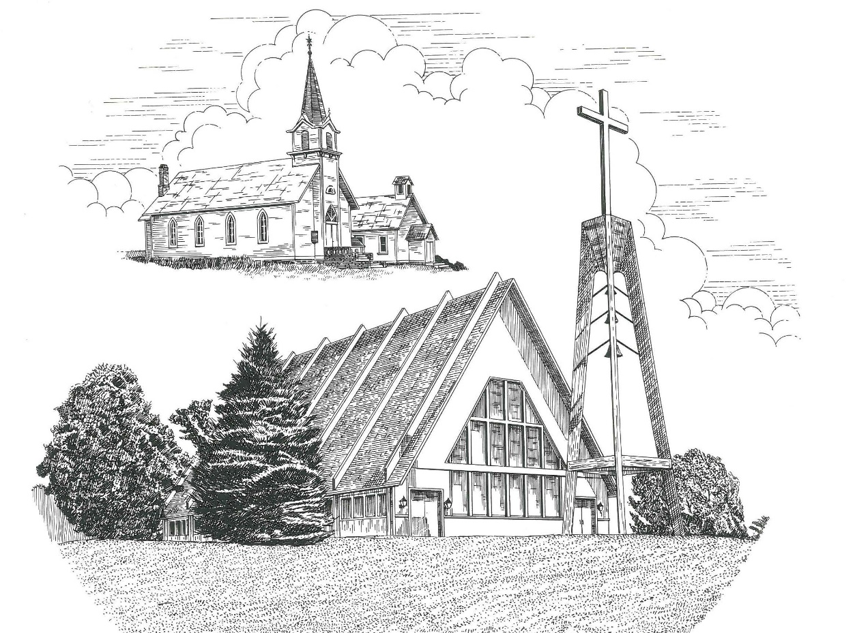

The Baptism of Our Lord January 10th, 2021

WELCOME
Thanks for joining us!
Pastor Jacob Sherry Missouri Synod

~~PLEASE NOTE~~
Calling on the name of the Lord
Does not include the use of cell phones in the worship sanctuary.
Please check yours before the service begins. Thank you for your courtesy.
~~TO OUR GUESTS AND VISITORS~~
Please sign our guest book located on the stand at the church entrance. During the service, we ask you to sign the attendance booklet located at the end of each pew. If you need assistance or have questions about our worship service, please talk to an elder or any one of our church family. We are glad you could join us and hope to have you worship with us again soon.

~~ATTENDING HOLY COMMUNION~~
By checking the “Communing Today” box on the registration form found in the attendance booklet, you are agreeing with the following statements:

- I am a baptized Christian who believes Jesus Christ is my Lord and Savior.
- I believe that I am a sinner in need of Christ freely offered forgiveness.
- I believe that in the Lord’s Supper the body and blood of Jesus Christ
are truly present in, with, and under the bread and wine.
- I believe that my participation in Holy Communion grants me forgiveness
of my sins, new spiritual life, and eternal salvation.
- With God’s help, I sincerely seek to repent of my sins, live in service
to my Lord, and await His return.

If you agree with the above statements, you are welcome to attend the Lord’s Supper with us. May God bless your worship time with us.
We do offer gluten-free wafers, please quietly ask an elder to help you.

Order of Divine Service Setting Four

Pre-Service Music……………..Call to Worship………………….Greeting

OPENING HYMN: “God’s Own Child, I Gladly Say It”……………...LSB #594
OPENING LITURGY:
Confession & Absolution……………………………………….LSB p. 203
Kyrie……………………………………………………………..LSB p. 204
Gloria in Excelsis………………………………………………..LSB p. 204
Salutation….…………………………………………………….LSB p. 205

Collect Prayer
Father in heaven, at the Baptism of Jesus in the Jordan River You proclaimed Him Your beloved Son and anointed Him with the Holy Spirit. Make all who are baptized in His name faithful in their calling as Your children and inheritors with Him of everlasting life; through the same Jesus Christ, our Lord, who lives and reigns with You and the Holy Spirit, one God, now and forever.

THE HOLY SCRIPTURES

OLD TESTAMENT: (Genesis 1:1-5)
In the beginning, God created the heavens and the earth. ² The earth was without form and void, and darkness was over the face of the deep. And the Spirit of God was hovering over the face of the waters. ³ And God said, “Let there be light,” and there was light. ⁴ And God saw that the light was good. And God separated the light from the darkness. ⁵ God called the light Day, and the darkness he called Night. And there was evening and there was morning, the first day.

R: This is the Word of the Lord. Cong: Thanks be to God.

GRADUAL
Reader: Praise the Lord, all nations!
Cong.: Extol him, all peoples!
Reader: For great us his steadfast love toward us,
Cong.: and the faithfulness of the Lord endures forever.
Reader: Ascribe to the Lord the glory due his name;
Cong.: bring an offering, and come into his courts!
EPISTLE: (Romans 6:1-11)
What shall we say then? Are we to continue in sin that grace may abound? ² By no means! How can we who died to sin still live in it? ³ Do you not know that all of us who have been baptized into Christ Jesus were baptized into his death? ⁴ We were buried therefore with him by baptism into death, in order that, just as Christ was raised from the dead by the glory of the Father, we too might walk in newness of life. ⁵ For if we have been united with him in a death like his, we shall certainly be united with him in a resurrection like his. ⁶ We know that our old self was crucified with him in order that the body of sin might be brought to nothing, so that we would no longer be enslaved to sin. ⁷ For one who has died has been set free from sin. ⁸ Now if we have died with Christ, we believe that we will also live with him. ⁹ We know that Christ, being raised from the dead, will never die again; death no longer has dominion over him. ¹⁰ For the death he died he died to sin, once for all, but the life he lives he lives to God. ¹¹ So you also must consider yourselves dead to sin and alive to God in Christ Jesus.

R: This is the Word of the Lord. Cong: Thanks be to God.

(PLEASE RISE for the reading of the Gospel)

R: The Holy Gospel according to St. Mark, the 1st chapter.
Cong: Glory to You, O Lord

HOLY GOSPEL: (Mark 1:4-11)
⁴ John appeared, baptizing in the wilderness and proclaiming a baptism of repentance for the forgiveness of sins. ⁵ And all the country of Judea and all Jerusalem were going out to him and were being baptized by him in the river Jordan, confessing their sins. ⁶ Now John was clothed with camel's hair and wore a leather belt around his waist and ate locusts and wild honey. ⁷ And he preached, saying, “After me comes he who is mightier than I, the strap of whose sandals I am not worthy to stoop down and untie. ⁸ I have baptized you with water, but he will baptize you with the Holy Spirit.”
⁹ In those days Jesus came from Nazareth of Galilee and was baptized by John in the Jordan. ¹⁰ And when he came up out of the water, immediately he saw the heavens being torn open and the Spirit descending on him like a dove. ¹¹ And a voice came from heaven, “You are my beloved Son; with you I am well pleased.”

R: This is the Gospel of the Lord. Cong: Praise to You, O Christ.

Nicene Creed
I believe in one God, the Father Almighty, maker of heaven and earth and of all things visible and invisible.
And in one Lord Jesus Christ, the only-begotten Son of God, begotten of His Father before all worlds, God of God, Light of Light, very God of very God, begotten, not made, being of one substance with the Father, by whom all things were made; who for us men and for our salvation came down from heaven and was incarnate by the Holy Spirit of the virgin Mary and was made man; and was crucified also for us under Pontius Pilate. He suffered and was buried. And the third day He rose again according to the Scriptures and ascended into heaven and sits at the right hand of the Father. And He will come again with glory to judge both the living and the dead, whose kingdom will have no end.
And I believe in the Holy Spirit, the Lord and giver of life, who proceeds from the Father and the Son, who with the Father and the Son together is worshiped and glorified, who spoke by the prophets. And I believe in one holy Christian and apostolic Church, I acknowledge one Baptism for the remission of sins, and I look for the resurrection of the dead and the life of the world to come. Amen.

SERMON HYMN: “To Jordan’s River Came Our Lord”………………..….LSB #405
SERMON
THE GENERAL PRAYERS

INSTITUTION OF THE LORD’S SUPPER
Preface…………………………………….…………….……………..LSB p. 208

Proper Preface
It is truly good, right, and salutary that we should at all times and in all places give thanks to You, O Lord, holy Father, almighty and everlasting God, for the countless blessings You so freely bestow on us and all creation. Above all, we give thanks for Your boundless love shown to us when You sent Your only-begotten Son, Jesus Christ, into our flesh and laid on Him our sin, giving Him into death that we might not die eternally. Because He is now risen from the dead and lives and reigns to all eternity, all who believe in Him will overcome sin and death and will rise again to new life. Therefore, with angels and archangels and with all the company of heaven we laud and magnify Your glorious name, ever more praising You and saying:

Sanctus, Lord’s Prayer, The Words of Our Lord………………….....LSB pp. 208-209
Agnus Dei………………………………………………………………..LSB p. 210
If you are not communing it is acceptable to remaining seated.

COMMUNION DISTRIBUTION HYMNS:
LSB #590 “Baptized into Your Name Most Holy”
LSB #596 “All Christians Who Have Been Baptized”

CLOSING LITURGY:………………………………………………....LSB pp. 211-212

CLOSING HYMN: “Songs of Thankfulness and Praise”......................LSB #394

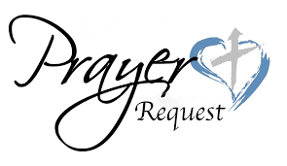

Special Prayers

Morris Armbruster Margaret Meachum Barbara Potter
Kaydence Devenport Rita Merkey Steve Schimke
Dylan Gladding Pam Monroe Julia Schoedel (Foot)
Jill Hoseler (Cancer) Jim Poellet Rev. Jeff Walsh (Cancer)
Shirley Poellet Sandy Wing
Thelma Zalud

For the family & friends of Calvin “Pete” Lutz who died on Friday, January 1st, 2021.

For the 97th birthday celebration of Marjorie Reckow on January 15th.

Prayers for Our Military
Andrew Burch, Jr., grandson of John & Loree Sprawka.
Mark Granzotto with U.S. Navy in Bahrain, grandson of Rita Merkey
Army Major Riley Morgan Kennedy, stationed in Washington, DC, George & Margaret Punches’ grand-niece
Steve & Carol Sprawka, son & daughter-in-law of John & Loree Sprawka
Derek Sprawka, grandson of John & Loree Sprawka
Alyssa Eisenlohr with the U.S. Navy in Japan, friend of Janette & Fred May
Ian Nelson, nephew of Jack and Pebbla Nelson
Tyge Nelson & family, nephew of Jack and Pebbla Nelson
Lt. Tim Brandt at Uniformed Services University, Bethesda, MD, son of Bruce & Debbie Brandt

If you wish to add someone’s name, please call or e-mail the church office.
When someone’s name is placed on prayer lists,
his or her name will remain until instructed to remove it. Thank you!

The Mission of Trinity Onekama Is To SERVE

For even the Son of Man did not come to be served
but to serve and to give his life as a ransom for many.
Mark 10:45

S haring Jesus’s truth
E quipping for life
R eaching Out
V aluing each other
E vangelizing all ages
Mission Statement
The mission of Trinity Onekama is to SERVE
For even the Son of Man did not come to be served, but to serve,
and to give his life as a ransom for many. Mark 10:45
S haring Jesus’ ruth
E quipping for life
R eaching Out
V aluing each other
E vangelizing all age

CHURCH INFORMATION
Church Office: (231) 889-4429 Website: www.trinityonekama.org
E-mail: trinityonekama@sbcglobal.net
Address: P.O. Box 119, 5471 Fairview Street, Onekama, MI 49675
Adult Bible Study: Sunday @ 9:15 am (year round)
Worship: Sunday @ 10:30 am The Lord’s Supper: Celebrated 2nd & 4th Sundays
Pastoral Hours: Wednesday and Friday 8:30am – Noon
Pastor Phone: 231-655-2680 Pastor Email: trinityonekama@gmail.com

Copyright licensing covered under CCLI #2802932

