231-889-4429 5471 Fairview Street, Box 119 Onekama, MI

TRINITY LUTHERAN CHURCH
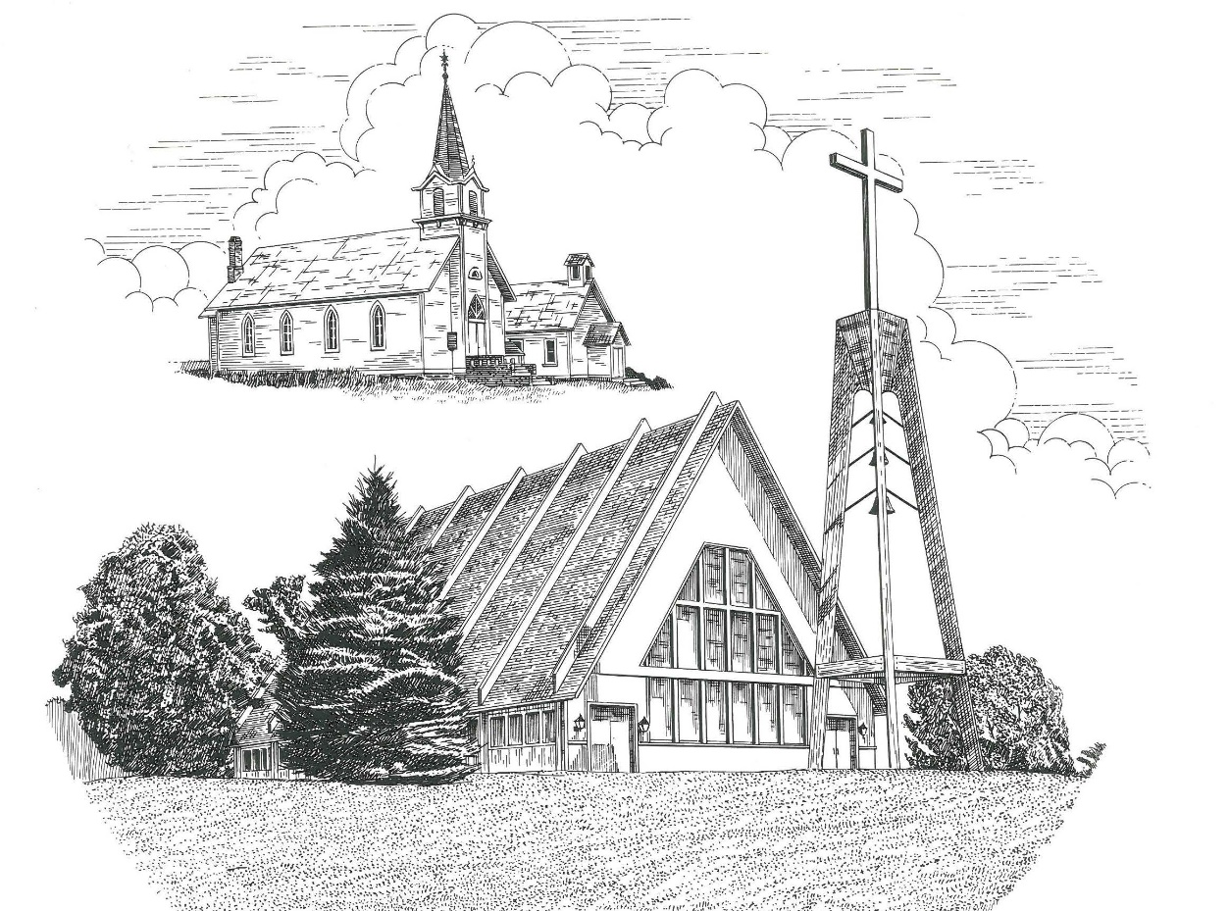

Third Sunday after Epiphany January 22nd, 2023

WELCOME
Thanks for joining us!
Pastor Jacob Sherry Missouri Synod

~~PLEASE NOTE~~
Calling on the name of the Lord
Does not include the use of cell phones in the worship sanctuary.
Please check yours before the service begins. Thank you for your courtesy.
~~TO OUR GUESTS AND VISITORS~~
Please sign our guest book located on the stand at the church entrance. During the service, we ask you to sign the attendance sheet located in your bulletin and place it on the pew when you leave. If you need assistance or have questions about our worship service, please talk to an elder or any one of our church family. We are glad you could join us and hope to have you worship with us again soon.

~~ATTENDING HOLY COMMUNION~~
By checking the “Communing Today” box on the registration form found on the attendance sheet, you are agreeing with the following statements:

- I am a baptized Christian who believes Jesus Christ is my Lord and Savior.
- I believe that I am a sinner in need of Christ’s freely offered forgiveness.
- I believe that in the Lord’s Supper the body and blood of Jesus Christ
are truly present in, with, and under the bread and wine.
- I believe that my participation in Holy Communion grants me forgiveness
of my sins, new spiritual life, and eternal salvation.
- With God’s help, I sincerely seek to repent of my sins, live in service
to my Lord, and await His return.

If you agree with the above statements, you are welcome to attend the Lord’s Supper with us. May God bless your worship time with us.
We do offer gluten-free wafers, please quietly ask an elder to help you.

Order of Divine Service Setting Three

Pre-Service Music……………..Call to Worship………………….Greeting

OPENING HYMN: “Fruitful Trees, the Spirit’s Sowing”.......................LSB #691
OPENING LITURGY:
Confession & Absolution………..………………………………LSB pp. 184-185
Kyrie…………………………………….………………………..LSB p. 186
Gloria in Excelsis………………………………………………...LSB pp. 187-189
Salutation….……………………………….…………………….LSB p. 189

Collect Prayer
Almighty and everlasting God, mercifully look upon our infirmities and stretch forth the hand of Your majesty to heal and defend us; through Jesus Christ, Your Son, our Lord, who lives and reigns with You and the Holy Spirit, one God, now and forever.

THE HOLY SCRIPTURES

OLD TESTAMENT: (Isaiah 9:1-4)
But there will be no gloom for her who was in anguish. In the former time he brought into contempt the land of Zebulun and the land of Naphtali, but in the latter time he has made glorious the way of the sea, the land beyond the Jordan, Galilee of the nations.

² The people who walked in darkness
have seen a great light;
those who dwelt in a land of deep darkness,
on them has light shone.
³ You have multiplied the nation;
you have increased its joy;
they rejoice before you
as with joy at the harvest,
as they are glad when they divide the spoil.
⁴ For the yoke of his burden,
and the staff for his shoulder,
the rod of his oppressor,
you have broken as on the day of Midian.

R: This is the Word of the Lord. Cong: Thanks be to God.
GRADUAL
Reader: Praise the Lord, all nations!
Cong.: Extol him, all peoples!
Reader: For great is his steadfast love toward us,
Cong.: and the faithfulness of the Lord endures forever.
Reader: Ascribe to the Lord the glory due his name;
Cong.: bring an offering, and come into his courts!

EPISTLE: (1 Corinthians 1:10-18)
¹⁰ I appeal to you, brothers, by the name of our Lord Jesus Christ, that all of you agree, and that there be no divisions among you, but that you be united in the same mind and the same judgment. ¹¹ For it has been reported to me by Chloe's people that there is quarreling among you, my brothers. ¹² What I mean is that each one of you says, “I follow Paul,” or “I follow Apollos,” or “I follow Cephas,” or “I follow Christ.” ¹³ Is Christ divided? Was Paul crucified for you? Or were you baptized in the name of Paul? ¹⁴ I thank God that I baptized none of you except Crispus and Gaius, ¹⁵ so that no one may say that you were baptized in my name. ¹⁶ (I did baptize also the household of Stephanas. Beyond that, I do not know whether I baptized anyone else.) ¹⁷ For Christ did not send me to baptize but to preach the gospel, and not with words of eloquent wisdom, lest the cross of Christ be emptied of its power. ¹⁸ For the word of the cross is folly to those who are perishing, but to us who are being saved it is the power of God.

R: This is the Word of the Lord. Cong: Thanks be to God.

(PLEASE RISE for the reading of the Gospel)

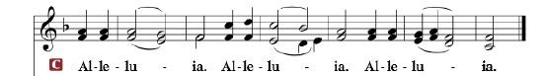

R: The Holy Gospel according to St. Matthew, the 4th chapter.

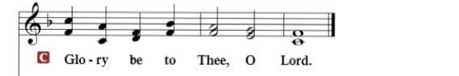

HOLY GOSPEL: (Matthew 4:12-25)
¹² Now when Jesus heard that John had been arrested, he withdrew into Galilee. ¹³ And leaving Nazareth he went and lived in Capernaum by the sea, in the territory of Zebulun and Naphtali, ¹⁴ so that what was spoken by the prophet Isaiah might be fulfilled:

¹⁵ “The land of Zebulun and the land of Naphtali,
the way of the sea, beyond the Jordan, Galilee of the Gentiles—
¹⁶ the people dwelling in darkness
have seen a great light,
and for those dwelling in the region and shadow of death,
on them a light has dawned.”

¹⁷ From that time Jesus began to preach, saying, “Repent, for the kingdom of heaven is at hand.”
¹⁸ While walking by the Sea of Galilee, he saw two brothers, Simon (who is called Peter) and Andrew his brother, casting a net into the sea, for they were fishermen. ¹⁹ And he said to them, “Follow me, and I will make you fishers of men.” ²⁰ Immediately they left their nets and followed him. ²¹ And going on from there he saw two other brothers, James the son of Zebedee and John his brother, in the boat with Zebedee their father, mending their nets, and he called them. ²² Immediately they left the boat and their father and followed him.
²³ And he went throughout all Galilee, teaching in their synagogues and proclaiming the gospel of the kingdom and healing every disease and every affliction among the people. ²⁴ So his fame spread throughout all Syria, and they brought him all the sick, those afflicted with various diseases and pains, those oppressed by demons, those having seizures, and paralytics, and he healed them. ²⁵ And great crowds followed him from Galilee and the Decapolis, and from Jerusalem and Judea, and from beyond the Jordan.

R: This is the Gospel of the Lord.

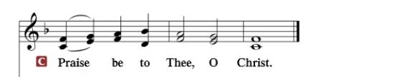

Nicene Creed
I believe in one God, the Father Almighty, maker of heaven and earth and of all things visible and invisible.
And in one Lord Jesus Christ, the only-begotten Son of God, begotten of His Father before all worlds, God of God, Light of Light, very God of very God, begotten, not made, being of one substance with the Father, by whom all things were made; who for us men and for our salvation came down from heaven and was incarnate by the Holy Spirit of the virgin Mary and was made man; and was crucified also for us under Pontius Pilate. He suffered and was buried. And the third day He rose again according to the Scriptures and ascended into heaven and sits at the right hand of the Father. And He will come again with glory to judge both the living and the dead, whose kingdom will have no end.
And I believe in the Holy Spirit, the Lord and giver of life, who proceeds from the Father and the Son, who with the Father and the Son together is worshiped and glorified, who spoke by the prophets. And I believe in one holy Christian and apostolic Church, I acknowledge one Baptism for the remission of sins, and I look for the resurrection of the dead and the life of the world to come. Amen.

SERMON HYMN: “O Christ, Our True and Only Light”……………..LSB #839

SERMON

OFFERTORY…………………………………………………………...LSB pp. 192-193

GENERAL PRAYERS OF THE CHURCH

Sharing the Peace of the Lord

SERVICE OF THE SACRAMENT
Preface…………………………………….…………….……….LSB p. 194
Proper Preface
It is truly good, right, and salutary that we should at all times and in all places give thanks to You, holy Lord, almighty Father, everlasting God, through Jesus Christ, our Lord, who, having created all things, took on human flesh and was born of the virgin Mary. For our sake He died on the cross and rose from the dead to put an end to death, thus fulfilling Your will and gaining for You a holy people. Therefore, with angels and archangels and with all the company of heaven we laud and magnify Your glorious name, ever more praising You and saying:

Sanctus, Lord’s Prayer, The Words of Our Lord………………….....LSB pp. 195-197
Agnus Dei………………………………………………………………..LSB p. 198
If you are not communing, it is acceptable to remain seated.

COMMUNION DISTRIBUTION HYMNS:
LSB #617 “O Lord, We Praise Thee”
LSB #629 “What Is This Bread”
LSB #692 “Praise to You and Adoration”

NUNC DIMITTIS………………………………………………………LSB pp. 199-200

BENEDICTION

CLOSING HYMN: “Lord, Dismiss Us with Your Blessing”..................LSB #924

The Mission of Trinity Onekama Is To SERVE

For even the Son of Man did not come to be served
but to serve and to give his life as a ransom for many.
Mark 10:45

S haring Jesus’s truth
E quipping for life
R eaching Out
V aluing each other
E vangelizing all ages
Mission Statement
The mission of Trinity Onekama is to SERVE
For even the Son of Man did not come to be served, but to serve,
and to give his life as a ransom for many. Mark 10:45
S haring Jesus’ ruth
E quipping for life
R eaching Out
V aluing each other
E vangelizing all age

CHURCH INFORMATION
Church Office: (231) 889-4429 Website: www.trinityonekama.org
E-mail: trinityonekama@sbcglobal.net
Address: P.O. Box 119, 5471 Fairview Street, Onekama, MI 49675
Adult Bible Study: Sunday @ 9:30am (year round)
Worship: Sunday @ 10:30 am The Lord’s Supper: Celebrated 2nd & 4th Sundays
Pastoral Hours: Wednesday and Friday 9:00am – Noon
Pastor Phone: 231-655-2680 Pastor Email: trinityonekama@gmail.com

Copyright licensing covered under CCLI #2802932

