**231-889-4429 5471 Fairview Street, Box 119 Onekama, MI**

**TRINITY LUTHERAN CHURCH**

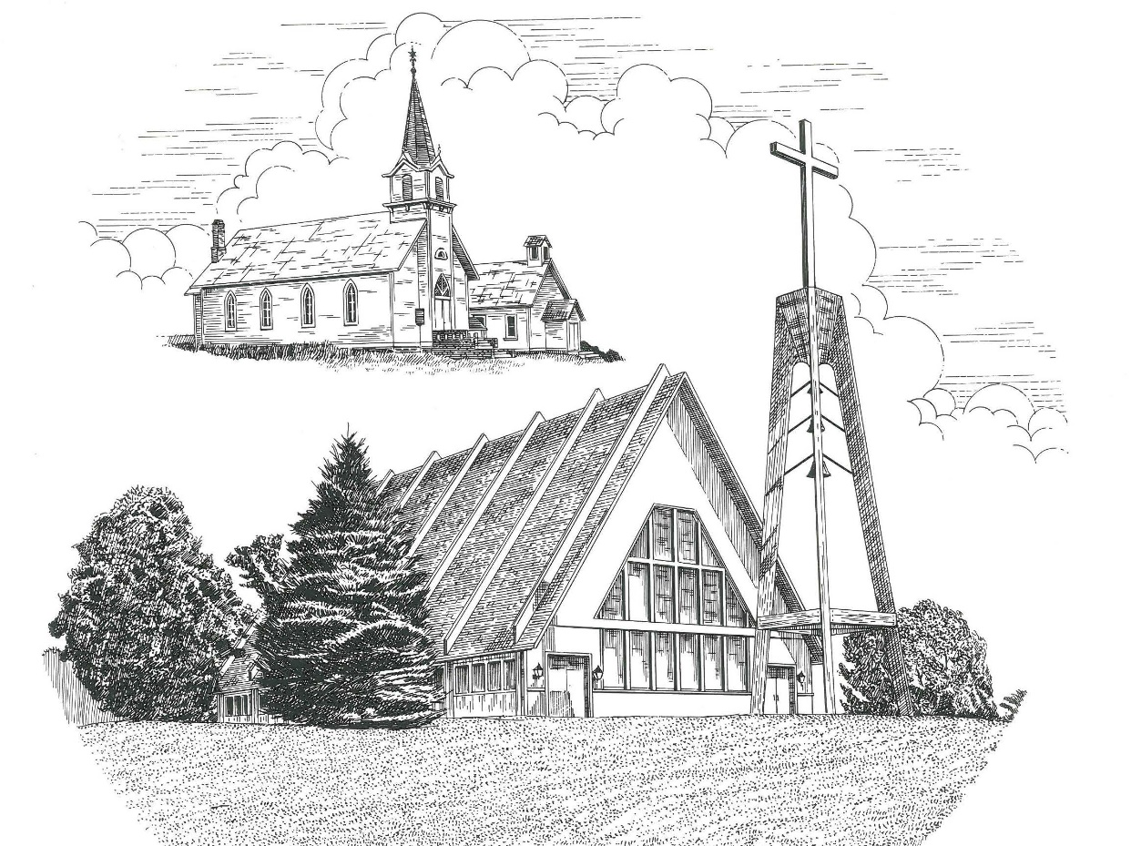

**Fifth Sunday after Pentecost July 10th, 2022**

**WELCOME**

**Thanks for joining us!**

**Pastor Jacob Sherry Missouri Synod**

**~~PLEASE NOTE~~Calling on the name of the Lord**

Does not include the use of cell phones in the worship sanctuary.

Please check yours before the service begins. Thank you for your courtesy.

**~~TO OUR GUESTS AND VISITORS~~**

Please sign our guest book located on the stand at the church entrance. During the service, we ask you to sign the attendance sheets located inside your bulletin and leave them on the pew as you leave. If you need assistance or have questions about our worship service, please talk to an elder or any one of our church family. We are glad you could join us and hope to have you worship with us again soon.

**~~ATTENDING HOLY COMMUNION~~**

By checking the “Communing Today” box on the registration form on the attendance sheet, you are agreeing with the following statements:

* **I am a baptized Christian who believes Jesus Christ is my Lord and Savior.**
* **I believe that I am a sinner in need of Christ freely offered forgiveness.**
* **I believe that in the Lord’s Supper the body and blood of Jesus Christ**

**are truly present in, with, and under the bread and wine.**

* **I believe that my participation in Holy Communion grants me forgiveness**

**of my sins, new spiritual life, and eternal salvation.**

* **With God’s help, I sincerely seek to repent of my sins, live in service**

**to my Lord, and await His return.**

**If you agree with the above statements, you are welcome to attend the Lord’s Supper with us. May God bless your worship time with us.**

We do offer gluten-free wafers, please quietly ask an elder to help you.

**Order of Divine Service Setting One**

**Pre-Service Music……………..Call to Worship………………….Greeting**

**OPENING HYMN:** *“Fruitful Trees, the Spirit’s Sowing”*……………..LSB #691

**CONFESSION & ABSOLUTION**……………………………………..LSB p. 151

**KYRIE**…………………………………………………………………...LSB pp. 152-153

**THIS IS THE FEAST**…………………………………………………...LSB p. 155

**SALUTATION**…………………………………………………………..LSB p. 156

**Collect Prayer**

Lord Jesus Christ, in Your deep compassion You rescue us from whatever may hurt us. Teach us to love You above all things and to love our neighbors as ourselves; for You live and reign with the Father and the Holy Spirit, one God, now and forever.

**THE HOLY SCRIPTURES**

**OLD TESTAMENT:** (Leviticus 19:9-18)

**9**“When you reap the harvest of your land, you shall not reap your field right up to its edge, neither shall you gather the gleanings after your harvest.  **10**And you shall not strip your vineyard bare, neither shall you gather the fallen grapes of your vineyard. You shall leave them for the poor and for the sojourner: I am the Lord your God.

**11**“You shall not steal; you shall not deal falsely; you shall not lie to one another.  **12**You shall not swear by my name falsely, and so profane the name of your God: I am the Lord.

**13**“You shall not oppress your neighbor or rob him.  The wages of a hired worker shall not remain with you all night until the morning.  **14**You shall not curse the deaf or put a stumbling block before the blind, but you shall fear your God: I am the Lord.

**15**“You shall do no injustice in court. You shall not be partial to the poor or defer to the great, but in righteousness shall you judge your neighbor.  **16**You shall not go around as a slanderer among your people, and you shall not stand up against the life of your neighbor: I am the Lord.

**17**“You shall not hate your brother in your heart, but you shall reason frankly with your neighbor, lest you incur sin because of him.  **18**You shall not take vengeance or bear a grudge against the sons of your own people, but you shall love your neighbor as yourself: I am the Lord.

**R:** This is the Word of the Lord**.** **Cong: Thanks be to God.**

**GRADUAL**

Reader: How beautiful are the feet of those who preach the good news,

**Cong.: who publish peace and bring good news of salvation.**

Reader: Their voice has gone out to all the earth,

**Cong.: and their words to the ends of the world.**

**EPISTLE:** (Colossians 1:1-14)

Paul, an apostle of Christ Jesus by the will of God, and Timothy our brother, **2**to the saints and faithful brothers in Christ at Colossae: Grace to you and peace from God our Father.

**3**We always thank God, the Father of our Lord Jesus Christ, when we pray for you, **4**since we heard of your faith in Christ Jesus and of the love that you have for all the saints, **5**because of the hope laid up for you in heaven. Of this you have heard before in the word of the truth, the gospel, **6**which has come to you, as indeed in the whole world it is bearing fruit and increasing—as it also does among you, since the day you heard it and understood the grace of God in truth, **7**just as you learned it from Epaphras our beloved fellow servant.  He is a faithful minister of Christ on your behalf **8**and has made known to us your love in the Spirit.

**9**And so, from the day we heard, we have not ceased to pray for you, asking that you may be filled with the knowledge of his will in all spiritual wisdom and understanding, **10**so as to walk in a manner worthy of the Lord, fully pleasing to him: bearing fruit in every good work and increasing in the knowledge of God; **11**being strengthened with all power, according to his glorious might, for all endurance and patience with joy; **12**giving thanks to the Father, who has qualified you to share in the inheritance of the saints in light.  **13**He has delivered us from the domain of darkness and transferred us to the kingdom of his beloved Son, **14**in whom we have redemption, the forgiveness of sins.

**R:** This is the Word of the Lord. **Cong: Thanks be to God.**

**(PLEASE RISE for the reading of the Gospel)**



**R:** The Holy Gospel according to St. Luke, the 10th chapter.



**HOLY GOSPEL:** (Luke 10:25-37)

**25**And behold, a lawyer stood up to put him to the test, saying, “Teacher, what shall I do to inherit eternal life?”  **26**He said to him, “What is written in the Law? How do you read it?”  **27**And he answered, “You shall love the Lord your God with all your heart and with all your soul and with all your strength and with all your mind, and your neighbor as yourself.”  **28**And he said to him, “You have answered correctly; do this, and you will live.”

**29**But he, desiring to justify himself, said to Jesus, “And who is my neighbor?”  **30**Jesus replied, “A man was going down from Jerusalem to Jericho, and he fell among robbers, who stripped him and beat him and departed, leaving him half dead.  **31**Now by chance a priest was going down that road, and when he saw him he passed by on the other side. **32**So likewise a Levite, when he came to the place and saw him, passed by on the other side.  **33**But a Samaritan, as he journeyed, came to where he was, and when he saw him, he had compassion.  **34**He went to him and bound up his wounds, pouring on oil and wine. Then he set him on his own animal and brought him to an inn and took care of him.  **35**And the next day he took out two denarii and gave them to the innkeeper, saying, ‘Take care of him, and whatever more you spend, I will repay you when I come back.’  **36**Which of these three, do you think, proved to be a neighbor to the man who fell among the robbers?”  **37**He said, “The one who showed him mercy.” And Jesus said to him, “You go, and do likewise.”

**R:** This is the Gospel of the Lord.



**SERMON HYMN**: *“Where Charity and Love Prevail”*…………………LSB #845

**SERMON**

**NICENE CREED**

I believe in one God, the Father Almighty, maker of heaven and earth and of all things visible and invisible.

And in one Lord Jesus Christ, the only-begotten Son of God, begotten of His Father before all worlds, God of God, Light of Light, very God of very God, begotten, not made, being of one substance with the Father, by whom all things were made; who for us men and for our salvation came down from heaven and was incarnate by the Holy Spirit of the virgin Mary and was made man; and was crucified also for us under Pontius Pilate. He suffered and was buried. And the third day He rose again according to the Scriptures and ascended into heaven and sits at the right hand of the Father. And He will come again with glory to judge both the living and the dead, whose kingdom will have no end.

And I believe in the Holy Spirit, the Lord and giver of life, who proceeds from the Father and the Son, who with the Father and the Son together is worshiped and glorified, who spoke by the prophets. And I believe in one holy Christian and apostolic Church, I acknowledge one Baptism for the remission of sins, and I look for the resurrection of the dead and the life of the world to come. Amen.

**THE GENERAL PRAYERS OF THE CHURCH**

**OFFERTORY**…………………………………………………………...LSB pp. 159-160

**SERVICE OF THE SACRAMENT**

**PREFACE**……………………………………………………………………..LSB p. 160

**Proper Preface**

It is truly good, right, and salutary that we should at all times and in all places give thanks to You, holy Lord, almighty Father, everlasting God, through Jesus Christ, our Lord, who, out of love for His fallen creation, humbled Himself by taking on the form of a servant, becoming obedient unto death, even death upon a cross. Risen from the dead, He has freed us from eternal death and given us life everlasting. Therefore, with angels and archangels and with all the company of heaven we laud and magnify Your glorious name, ever more praising You and saying:

**SANCTUS**……………………………………………………………………...LSB p. 161

**THE WORDS OF OUR LORD**……………………………………………….LSB p. 162

**AGNUS DEI**……………………………………………………………………LSB p. 163

*If you are not communing, it is acceptable to remain seated.*

**COMMUNION DISTRIBUTION HYMNS**

LSB #752 *“Be Still, My Soul”*

LSB #637 *“Draw Near and Take the Body of the Lord”*

LSB #872 *“Come, Thou Bright and Morning Star”*

**THANK THE LORD**………………………………………………………….LSB p. 164

**POST-COMMUNION COLLECT PRAYER**……………………………….LSB p. 166

**BENEDICTION**……………………………………………………………….LSB p. 166

**CLOSING HYMN:** *“The Church’s One Foundation”*……..…………………LSB #644

The Mission of Trinity Onekama Is To **SERVE**

For even the Son of Man did not come to be served

but to serve and to give his life as a ransom for many.            
                                                                       Mark 10:45



**S**haring Jesus’s **t**ruth

**E**quipping for life

**R**eaching Out

**V**aluing each other

**E**vangelizing all ages

Mission Statement

The mission of Trinity Onekama is to SERVE

For even the Son of Man did not come to be served, but to serve,

and to give his life as a ransom for many. Mark 10:45

S haring Jesus’ ruth

E quipping for life

R eaching Out

V aluing each other

E vangelizing all age

**CHURCH INFORMATION**

**Church Office:** (231) 889-4429 **Website:** www.trinityonekama.org

**E-mail:** [trinityonekama@sbcglobal.net](mailto:trinityonekama@sbcglobal.net)

**Address:** P.O. Box 119, 5471 Fairview Street, Onekama, MI 49675

**Adult Bible Study**: Sunday @ 11:30 am (year round)

**Worship:** Sunday @ 10:30 am **The Lord’s Supper:**  Celebrated 2nd & 4th Sundays

**Pastoral Hours:** Wednesday and Friday 9:00am – Noon

**Pastor Phone:** 231-655-2680 **Pastor Email:** trinityonekama@gmail.com

**Copyright licensing covered under CCLI #2802932**