231-889-4429 5471 Fairview Street, Box 119 Onekama, MI

TRINITY LUTHERAN CHURCH
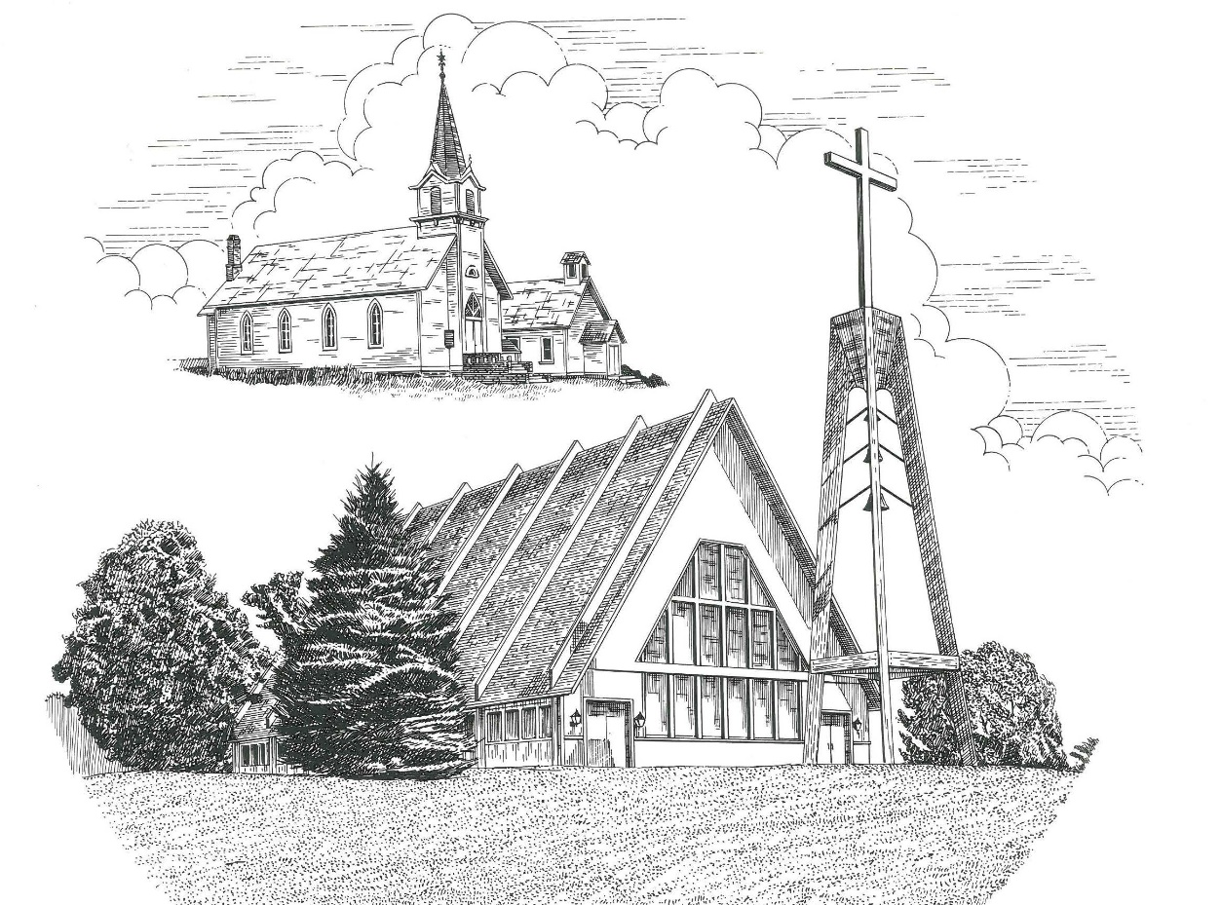

Ninth Sunday after Pentecost July 25th, 2021

WELCOME
Thanks for joining us!
Pastor Jacob Sherry Missouri Synod

~~PLEASE NOTE~~
Calling on the name of the Lord
Does not include the use of cell phones in the worship sanctuary.
Please check yours before the service begins. Thank you for your courtesy.
~~TO OUR GUESTS AND VISITORS~~
Please sign our guest book located on the stand at the church entrance. During the service, we ask you to sign the attendance booklet located at the end of each pew. If you need assistance or have questions about our worship service, please talk to an elder or any one of our church family. We are glad you could join us and hope to have you worship with us again soon.

~~ATTENDING HOLY COMMUNION~~
By checking the “Communing Today” box on the registration form found in the attendance booklet, you are agreeing with the following statements:

- I am a baptized Christian who believes Jesus Christ is my Lord and Savior.
- I believe that I am a sinner in need of Christ freely offered forgiveness.
- I believe that in the Lord’s Supper the body and blood of Jesus Christ
are truly present in, with, and under the bread and wine.
- I believe that my participation in Holy Communion grants me forgiveness
of my sins, new spiritual life, and eternal salvation.
- With God’s help, I sincerely seek to repent of my sins, live in service
to my Lord, and await His return.

If you agree with the above statements, you are welcome to attend the Lord’s Supper with us. May God bless your worship time with us.
We do offer gluten-free wafers, please quietly ask an elder to help you.

Order of Divine Service Setting Three

Pre-Service Music……………..Call to Worship………………….Greeting

OPENING HYMN: “O Holy Spirit, Enter In”........................................LSB #913

OPENING LITURGY:
Confession & Absolution………..………………………………LSB pp. 184-185
Kyrie…………………………………….………………………..LSB p. 186
Gloria in Excelsis……...…………………………………………LSB pp. 187-188
Salutation….……………………………….…………………….LSB p. 189

Collect Prayer
Almighty and most merciful God, the protector of all who trust in You, strengthen our faith and give us courage to believe that in Your love You will rescue us from all adversities; through Jesus Christ, Your Son, our Lord, who lives and reigns with You and the Holy Spirit, one God, now and forever.

THE HOLY SCRIPTURES

OLD TESTAMENT: (Genesis 9:8-17)
⁸ Then God said to Noah and to his sons with him, ⁹ “Behold, I establish my covenant with you and your offspring after you, ¹⁰ and with every living creature that is with you, the birds, the livestock, and every beast of the earth with you, as many as came out of the ark; it is for every beast of the earth. ¹¹ I establish my covenant with you, that never again shall all flesh be cut off by the waters of the flood, and never again shall there be a flood to destroy the earth.” ¹² And God said, “This is the sign of the covenant that I make between me and you and every living creature that is with you, for all future generations: ¹³ I have set my bow in the cloud, and it shall be a sign of the covenant between me and the earth. ¹⁴ When I bring clouds over the earth and the bow is seen in the clouds, ¹⁵ I will remember my covenant that is between me and you and every living creature of all flesh. And the waters shall never again become a flood to destroy all flesh. ¹⁶ When the bow is in the clouds, I will see it and remember the everlasting covenant between God and every living creature of all flesh that is on the earth.” ¹⁷ God said to Noah, “This is the sign of the covenant that I have established between me and all flesh that is on the earth.”

R: This is the Word of the Lord. Cong: Thanks be to God.

GRADUAL
Reader: Oh, the depth of the riches and wisdom and knowledge of God!
Cong.: How unsearchable are his judgments and how inscrutable his ways!
Reader: For from him and through him and to him are all things.
Cong.: To him be glory forever. Amen.

EPISTLE: (Ephesians 3:14-21)
¹⁴ For this reason I bow my knees before the Father, ¹⁵ from whom every family in heaven and on earth is named, ¹⁶ that according to the riches of his glory he may grant you to be strengthened with power through his Spirit in your inner being, ¹⁷ so that Christ may dwell in your hearts through faith—that you, being rooted and grounded in love, ¹⁸ may have strength to comprehend with all the saints what is the breadth and length and height and depth, ¹⁹ and to know the love of Christ that surpasses knowledge, that you may be filled with all the fullness of God. ²⁰ Now to him who is able to do far more abundantly than all that we ask or think, according to the power at work within us, ²¹ to him be glory in the church and in Christ Jesus throughout all generations, forever and ever. Amen.

R: This is the Word of the Lord. Cong: Thanks be to God.

(PLEASE RISE for the reading of the Gospel)

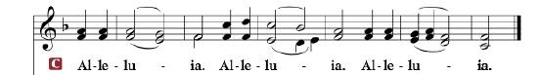

R: The Holy Gospel according to St. Mark, the 6th chapter.

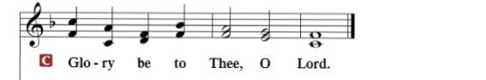

HOLY GOSPEL: (Mark 6:45-56)
⁴⁵ Immediately Jesus made his disciples get into the boat and go before him to the other side, to Bethsaida, while he dismissed the crowd. ⁴⁶ And after he had taken leave of them, he went up on the mountain to pray. ⁴⁷ And when evening came, the boat was out on the sea, and he was alone on the land. ⁴⁸ And he saw that they were making headway painfully, for the wind was against them. And about the fourth watch of the night he came to them, walking on the sea. He meant to pass by them, ⁴⁹ but when they saw him walking on the sea they thought it was a ghost, and cried out, ⁵⁰ for they all saw him and were terrified. But immediately he spoke to them and said, “Take heart; it is I. Do not be afraid.” ⁵¹ And he got into the boat with them, and the wind ceased. And they were utterly astounded, ⁵² for they did not understand about the loaves, but their hearts were hardened.
⁵³ When they had crossed over, they came to land at Gennesaret and moored to the shore. ⁵⁴ And when they got out of the boat, the people immediately recognized him ⁵⁵ and ran about the whole region and began to bring the sick people on their beds to wherever they heard he was. ⁵⁶ And wherever he came, in villages, cities, or countryside, they laid the sick in the marketplaces and implored him that they might touch even the fringe of his garment. And as many as touched it were made well.

R: This is the Gospel of the Lord.

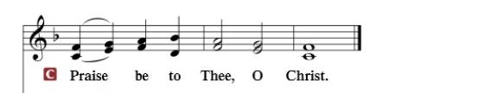

Nicene Creed
I believe in one God, the Father Almighty, maker of heaven and earth and of all things visible and invisible.
And in one Lord Jesus Christ, the only-begotten Son of God, begotten of His Father before all worlds, God of God, Light of Light, very God of very God, begotten, not made, being of one substance with the Father, by whom all things were made; who for us men and for our salvation came down from heaven and was incarnate by the Holy Spirit of the virgin Mary and was made man; and was crucified also for us under Pontius Pilate. He suffered and was buried. And the third day He rose again according to the Scriptures and ascended into heaven and sits at the right hand of the Father. And He will come again with glory to judge both the living and the dead, whose kingdom will have no end.
And I believe in the Holy Spirit, the Lord and giver of life, who proceeds from the Father and the Son, who with the Father and the Son together is worshiped and glorified, who spoke by the prophets. And I believe in one holy Christian and apostolic Church, I acknowledge one Baptism for the remission of sins, and I look for the resurrection of the dead and the life of the world to come. Amen.

SERMON HYMN: “Beautiful Savior”...................................................LSB #537

SERMON

OFFERTORY……………………………………………………..……LSB pp. 192-193

THE GENERAL PRAYERS OF THE CHURCH

INSTITUTION OF THE LORD’S SUPPER
Preface…………………………………….…………….……….LSB p. 194

Proper Preface
It is truly good, right, and salutary that we should at all times and in all places give thanks to You, holy Lord, almighty Father, everlasting God, through Jesus Christ, our Lord, who, out of love for His fallen creation, humbled Himself by taking on the form of a servant, becoming obedient unto death, even death upon a cross. Risen from the dead, He has freed us from eternal death and given us life everlasting. Therefore, with angels and archangels and with all the company of heaven we laud and magnify Your glorious name, ever more praising You and saying:
Sanctus, Lord’s Prayer, The Words of Our Lord………………….....LSB pp. 195-197
Agnus Dei………………………………………………………………..LSB p. 198
If you are not communing it is acceptable to remain seated.

COMMUNION DISTRIBUTION HYMNS:
LSB #633 “At the Lamb’s High Feast We Sing”
LSB #818 “In Thee Is Gladness”

NUNC DIMITTIS………………………………………………………LSB pp. 199-200

BENEDICTION

CLOSING HYMN: “Sent Forth by God’s Blessing”..............................LSB #643

The Mission of Trinity Onekama Is To SERVE

For even the Son of Man did not come to be served
but to serve and to give his life as a ransom for many.
Mark 10:45

S haring Jesus’s truth
E quipping for life
R eaching Out
V aluing each other
E vangelizing all ages
Mission Statement
The mission of Trinity Onekama is to SERVE
For even the Son of Man did not come to be served, but to serve,
and to give his life as a ransom for many. Mark 10:45
S haring Jesus’ ruth
E quipping for life
R eaching Out
V aluing each other
E vangelizing all age

CHURCH INFORMATION
Church Office: (231) 889-4429 Website: www.trinityonekama.org
E-mail: trinityonekama@sbcglobal.net
Address: P.O. Box 119, 5471 Fairview Street, Onekama, MI 49675
Adult Bible Study: Sunday @ 9:15 am (year round)
Worship: Sunday @ 10:30 am The Lord’s Supper: Celebrated 2nd & 4th Sundays
Pastoral Hours: Wednesday and Friday 8:30am – Noon
Pastor Phone: 231-655-2680 Pastor Email: trinityonekama@gmail.com

Copyright licensing covered under CCLI #2802932

