**231-889-4429 5471 Fairview Street, Box 119 Onekama, MI**

**TRINITY LUTHERAN CHURCH**

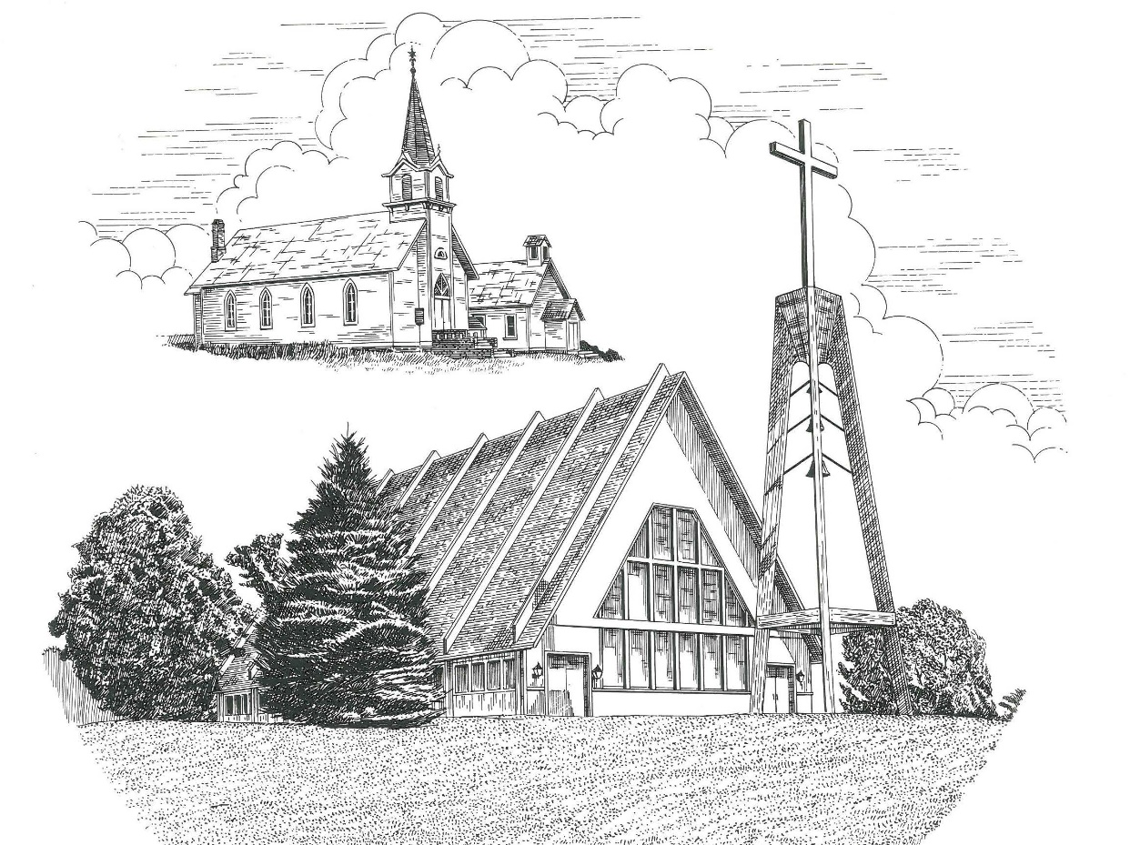

**Eighth Sunday after Pentecost July 31st, 2022**

**WELCOME**

**Thanks for joining us!**

**Pastor Jacob Sherry Missouri Synod**

**Worship Theme: *Seeing With The Eyes of God!***

***+++***

**Trumpet Prelude:** *Amazing Grace arr. Britton*

**Scripture of the Week:** *Colossians 3:1*

***… now set your sights on the rich treasures and joys of heaven where [Christ] sits beside God in the place of honor and power.***

**Invocation & Opening Prayer**

Shout to the Lord

My Jesus, my Savior, Lord there is none like You.   
All my days, I want to praise the wonders of Your mighty love.

My Comfort, my Shelter, Tower of refuge and strength,

Let every breath, all that I am, never cease to worship You.

*Chorus*: Shout to the Lord, all the earth, let us sing,   
Power and majesty, praise to the King.   
Mountains bow down and the seas will roar,  
At the sound of Your name.

I sing for joy at the work of Your hands.   
Forever I’ll love You, forever I’ll stand.

Nothing compares to the promise I have in You.   
  
*Darlene Zschech © 1993 Hillsongs/Integrity Hosanna! Music*

God of Wonders

1 – Lord of all creation, of the water, earth, and sky,

The heavens are your tabernacle; Glory to the Lord on high.

*Chorus*: God of wonders beyond our galaxy. You are holy, holy.   
The universe declares your majesty: You are holy, holy.

*Bridge*: Lord of heaven and earth. (repeat)

2 – Early in the morning, I will celebrate the light.   
And when I stumble into darkness, I will call your name by night. *Chorus*

*Bridge*: Lord of heaven and earth. (repeat)

Hallelujah to the Lord of heaven and earth! (3X)

*Chorus*: God of wonders beyond our galaxy. You are holy, holy.

Precious Lord, reveal Your heart to me: Father holy, holy.  
The universe declares your majesty: You are holy, holy.

Hallelujah to the Lord of heaven and earth! (3X)

*Marc Byrd & Steve Hindalong © 2000 Meaux Mercy/Storm Boy Music/New Spring Publishing*

*(Congregation will join in reading the* ***bold-faced underlined portions****)*

*Ecclesiastes 1 & 2 (selected verses)* [Solomon writes:] 2In my opinion, nothing is worthwhile; everything is futile. 12I, the Preacher, was king of Israel, living in Jerusalem. **And I applied myself to search for understanding about everything in the universe.** I discovered that the lot of man, which God has dealt to him, is not a happy one. It is all foolishness, chasing the wind. 18And I am disgusted about this—that I must leave the fruits of all my hard work to others. 20-23So I turned in despair from hard work as the answer to my search for satisfaction. For though I spend my life searching for wisdom, knowledge, and skill, I must leave all of it to someone who hasn’t done a day’s work in his life; he inherits all my efforts, free of charge. **This is not only foolish, but unfair.** So what does a man get for all his hard work? Days full of sorrow and grief, and restless, bitter nights. It is all utterly ridiculous. 24-26So I decided that there was nothing better for a man to do than to enjoy his food and drink and his job. **Then I realized that even this pleasure is from the hand of God.** For who can eat or enjoy apart from him? For God gives those who please him wisdom, knowledge, and joy.

**Confessing Sin & Receiving Mercy:**

**Jesus Paid It All**

1. I hear the Savior say, “Thy strength indeed is small;

Child of weakness, watch and pray, Find in Me thine all in all.”

***Refrain:* Jesus paid it all, All to Him I owe;**

**Sin had left a crimson stain, He washed it white as snow.**

2. Lord, now indeed I find Thy pow’r, and Thine alone,

Can change the leper’s spots and melt the heart of stone. ***Refrain:***

3. And now complete in Him, My robe, His righteousness,

Close sheltered ‘neath His side, I am divinely blest.

*Elvina Hall 1865. Public Domain*

*Colossians 3:1-11* Since you became alive again, so to speak, when Christ arose from the dead, **now set your sights on the rich treasurers and joys of heaven where he sits beside God in the place of honor and power.** 2Let heaven fill your thoughts; **don’t spend your time worrying about things down here.** 3You should have as little desire for this world as a dead person does. Your real life is in heaven with Christ and God. 4And when Christ who is our real life comes back again, you will shine with him and share in all his glories. 5Away then with sinful, earthly things; deaden the evil desires lurking within you; have nothing to do with sexual sin, impurity, lust, and shameful desires; don’t worship the good things of life, for that is idolatry. 6God’s terrible anger is upon those who do such things. 7You used to do them when your life was still part of this world; 8**but now is the time to cast off and throw away all these rotten garments of anger, hatred, cursing, and dirty language.** 9Don’t tell lies to each other; it was your old life with all its wickedness that did that sort of thing; now it is dead and gone. 10You are living a brand new kind of life that is continually learning more and more of what is right, and trying constantly to be more and more like Christ who created this new life within you. 11In this new life one’s nationality or race or education or social position is unimportant; **such things mean nothing.** Whether a person has Christ is what matters, **and he is equally available to all.**

*Luke 12:13-21*  Then someone called from the crowd, **“Sir, please tell my brother to divide my father’s estate with me.”** 14But Jesus replied, “Man, who made me a judge over you to decide such things as that? 15Beware! Don’t always be wishing for what you don’t have. **For real life and real living are not related to how rich we are.”** 16Then he gave an illustration: “A rich man had a fertile farm that produced fine crops. 17In fact, his barns were full to overflowing—he couldn’t get everything in. He thought about his problem, 18and finally exclaimed, ‘I know—I’ll tear down my barns and build bigger ones! Then I’ll have room enough. 19And I’ll sit back and say to myself, **“Friend, you have enough stored away for years to come. Now take it easy!** Wine, women, and song for you! 20But God said to him, “Fool! Tonight you die. Then who will get it all?’ 21**“Yes, every man is a fool who gets rich on earth but not in heaven.”**

**Ancient Words**

1. Holy words long preserved for our walk in this world

They resound with God’s own heart; O, let the ancient words impart.

Words of life, words of hope, give us strength, help us cope

In this world, where e’er we roam, ancient words will guide us home.

***Refrain:* Ancient words, ever true, changing me, changing you.**

**We have come with open hearts. Oh, let the ancient words impart.**

2. Holy words of our faith handed down to this age

Came to us through sacrifice: O heed the faithful words of Christ.

Holy words long preserved for our walk in this world

They resound with God’s own heart; O, let the ancient words impart. ***Refrain x2***

*Lynn De Shazo © 2002 Hosanna! Integrity Music*

**Kid’s Message: *Clean or Dirty Eyeglasses?***

**Message of Christ in Word and song:  *Clear Vision: Real Life, Real Living***

**The Offering**

Today, in addition to our regular offerings received during worship, we are gathering a love-offering to support David Paul Britton’s ministry at the exits following the service. Give cheerfully, as the Holy Spirit guides you. Mr. Britton’s primary means of support comes from God’s people, as he travels each week serving our Lord and His Church. If you prefer a tax-deductible donation, make your check payable to:

***Peace Lutheran Church – MMME.***Or, donate online through his website at **www.davidpaulbritton.com**

**Prayers of the Church**

**The Lord’s Prayer**

Our Father, who art in heaven, hallowed be Thy name, Thy Kingdom come, Thy will be done on earth as it is in heaven; give us this day our daily bread; and forgive us our trespasses as we forgive those who trespass against us; and lead us not into temptation, but deliver us from evil. For Thine is the kingdom and the power and the glory forever and ever. Amen.

**Benediction**

**Closing Hymn: I Saw the Light**

***Chorus:* I saw the light, I saw the light. No more darkness, no more night.**

**Now I’m so happy, no sorrow in sight. Praise the Lord, I saw the light.**

1. I wandered so aimless, a life filled with sin. I wouldn’t let my dear Savior in.

Then Jesus came like an angel in the night: Praise the Lord, I saw the light. ***Chorus***

2. Just like a blind man, I wandered along. Worries and fears I claimed for my own.

Then like a blind man, God gave me back my sight: Praise the Lord, I saw the light.

***Chorus***

3. I was a fool to wander and stray. Straight is the gate and narrow the way.

Now I have traded the wrong for the right: Praise the Lord, I saw the light. ***Chorus***

*Words and music Hank Williams, Sr. 1948; © Warner/Chappell, Inc.*

*All songs printed by permission.*

+++



*Guest Worship Leader*

**David Paul Britton**

*Music, Ministry & Mission Education (MMME)*

The Mission of Trinity Onekama Is To **SERVE**

For even the Son of Man did not come to be served

but to serve and to give his life as a ransom for many.            
                                                                       Mark 10:45



**S**haring Jesus’s **t**ruth

**E**quipping for life

**R**eaching Out

**V**aluing each other

**E**vangelizing all ages

Mission Statement

The mission of Trinity Onekama is to SERVE

For even the Son of Man did not come to be served, but to serve,

and to give his life as a ransom for many. Mark 10:45

S haring Jesus’ ruth

E quipping for life

R eaching Out

V aluing each other

E vangelizing all age

**CHURCH INFORMATION**

**Church Office:** (231) 889-4429 **Website:** www.trinityonekama.org

**E-mail:** [trinityonekama@sbcglobal.net](mailto:trinityonekama@sbcglobal.net)

**Address:** P.O. Box 119, 5471 Fairview Street, Onekama, MI 49675

**Adult Bible Study**: Sunday @ 11:30 am

**Worship:** Sunday @ 10:30 am **The Lord’s Supper:**  Celebrated 2nd & 4th Sundays

**Pastoral Hours:** Wednesday and Friday 9:00am – Noon

**Pastor Phone:** 231-655-2680 **Pastor Email:** trinityonekama@gmail.com

**Copyright licensing covered under CCLI #2802932**