231-889-4429 5471 Fairview Street, Box 119 Onekama, MI

TRINITY LUTHERAN CHURCH
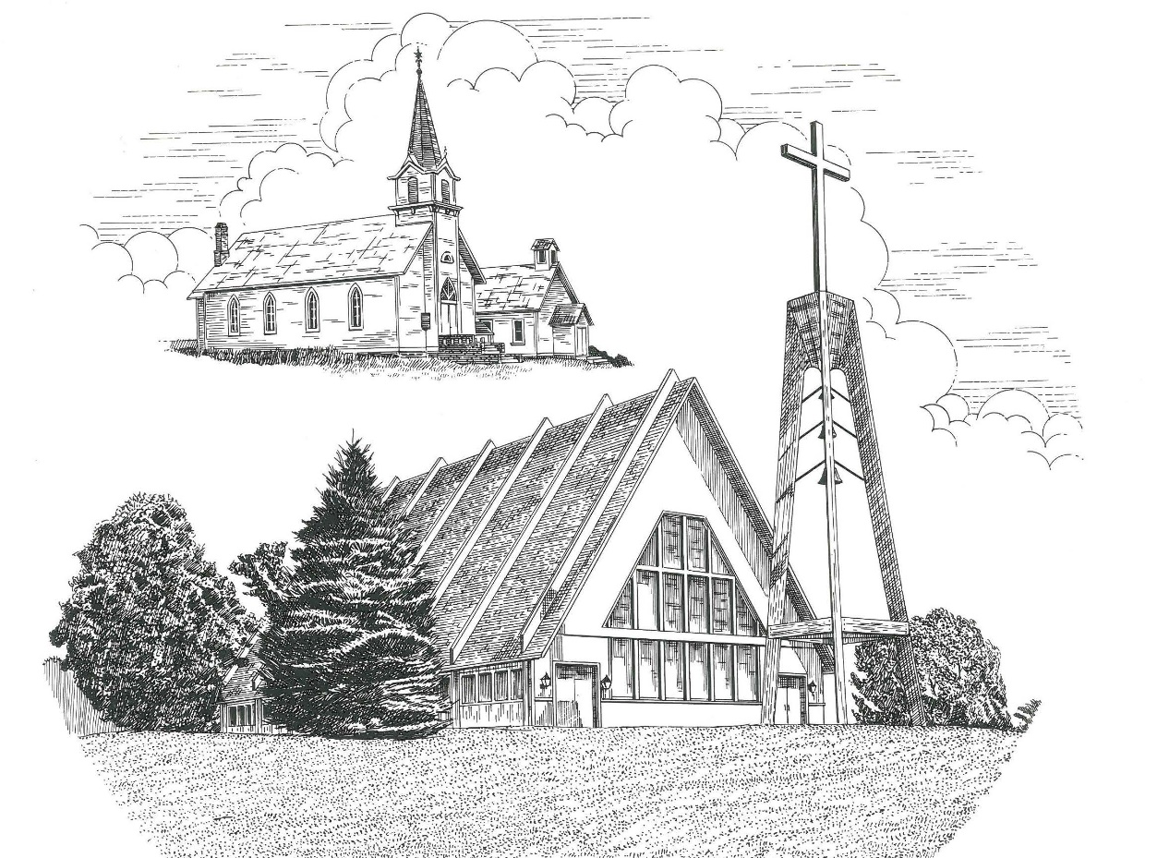

Fourth Sunday in Lent March 10th, 2024

WELCOME
Thanks for joining us!
Pastor Jacob Sherry Missouri Synod

~~PLEASE NOTE~~
Calling on the name of the Lord
Does not include the use of cell phones in the worship sanctuary.
Please check yours before the service begins. Thank you for your courtesy.
~~TO OUR GUESTS AND VISITORS~~
Please sign our guest book located on the stand at the church entrance. During the service, we ask you to sign the attendance sheet located in your bulletin and place it on the pew when you leave. If you need assistance or have questions about our worship service, please talk to an elder or any one of our church family. We are glad you could join us and hope to have you worship with us again soon.

~~ATTENDING HOLY COMMUNION~~
By checking the “Communing Today” box on the registration form found on the attendance sheet, you are agreeing with the following statements:

- I am a baptized Christian who believes Jesus Christ is my Lord and Savior.
- I believe that I am a sinner in need of Christ’s freely offered forgiveness.
- I believe that in the Lord’s Supper the body and blood of Jesus Christ
are truly present in, with, and under the bread and wine.
- I believe that my participation in Holy Communion grants me forgiveness
of my sins, new spiritual life, and eternal salvation.
- With God’s help, I sincerely seek to repent of my sins, live in service
to my Lord, and await His return.

If you agree with the above statements, you are welcome to attend the Lord’s Supper with us. May God bless your worship time with us.
We do offer gluten-free wafers, please quietly ask an elder to help you.

Order of Divine Service Setting Three

Pre-Service Music……………..Call to Worship………………….Greeting

OPENING HYMN: “God Himself Is Present”...................................................LSB #907

CONFESSION & ABSOLUTION
P: In the name of the Father and of the Son and of the Holy Spirit.
C: Amen.

P: Beloved in the Lord! Let us draw near with a true heart and confess our sins unto God our Father, beseeching Him in the name of our Lord Jesus Christ to grant us forgiveness.

P: Our help is in the name of the Lord,
C: who made heaven and earth.
P: I said, I will confess my transgressions unto the Lord,
C: and You forgave the iniquity of my sin.

P: O almighty God, merciful Father,
C: I, a poor, miserable sinner, confess unto You all my sins and iniquities with which I have ever offended You and justly deserve Your temporal and eternal punishment. But I am heartily sorry for them and sincerely repent of them, and I pray You of Your boundless mercy and for the sake of the holy, innocent, bitter sufferings and death of Your beloved Son, Jesus Christ, to be gracious and merciful to me, a poor, sinful being.

P: Upon this your confession, I, by virtue of my office, as a called and ordained servant of the Word, announce the grace of God unto all of you, and in the stead and by the command of my Lord Jesus Christ I forgive you all your sins in the name of the Father and of the Son and of the Holy Spirit.
C: Amen.

INTROIT
P: The Lord is my light and my salvation; whom shall I fear?
C: The Lord is the stronghold of my life; of whom shall I be afraid?
P: Though an army encamp against me, my heart shall not fear;
C: though war arise against me, yet I will be confident.
P: One thing have I asked of the Lord, that will I seek after:
C: that I may dwell in the house of the Lord all the days of my life,
P: to gaze upon the beauty of the Lord
C: and to inquire in his temple.
P: For he will hide me in his shelter in the day of trouble;
C: he will conceal me under the cover of his tent; he will lift me high upon a rock.
ALL: Glory be to the Father and to the Son and to the Holy Spirit; as it was in the
beginning, is now, and will be forever. Amen.

KYRIE…………………………………….…………………………..LSB p. 186
SALUTATION….……………………………….……………………LSB p. 189

Collect Prayer
Almighty God, our heavenly Father, Your mercies are new every morning; and though we deserve only punishment, You receive us as Your children and provide for all our needs of body and soul. Grant that we may heartily acknowledge Your merciful goodness, give thanks for all Your benefits, and serve You in willing obedience; through Jesus Christ, Your Son, our Lord, who lives and reigns with You and the Holy Spirit, one God, now and forever.

THE HOLY SCRIPTURES

OLD TESTAMENT: (Numbers 21:4-9)
⁴ From Mount Hor they set out by the way to the Red Sea, to go around the land of Edom. And the people became impatient on the way. ⁵ And the people spoke against God and against Moses, “Why have you brought us up out of Egypt to die in the wilderness? For there is no food and no water, and we loathe this worthless food.” ⁶ Then the Lord sent fiery serpents among the people, and they bit the people, so that many people of Israel died. ⁷ And the people came to Moses and said, “We have sinned, for we have spoken against the Lord and against you. Pray to the Lord, that he take away the serpents from us.” So Moses prayed for the people. ⁸ And the Lord said to Moses, “Make a fiery serpent and set it on a pole, and everyone who is bitten, when he sees it, shall live.” ⁹ So Moses made a bronze serpent and set it on a pole. And if a serpent bit anyone, he would look at the bronze serpent and live.
R: This is the Word of the Lord. Cong: Thanks be to God.

GRADUAL
Reader: O come, let us fix our eyes on Jesus,
Cong.: the founder and perfecter of our faith,
Reader: who for the joy that was set before him endured the cross, despising the shame,
Cong.: and is seated at the right hand of the throne of God.

EPISTLE: (Ephesians 2:1-10)
And you were dead in the trespasses and sins ² in which you once walked, following the course of this world, following the prince of the power of the air, the spirit that is now at work in the sons of disobedience— ³ among whom we all once lived in the passions of our flesh, carrying out the desires of the body and the mind, and were by nature children of wrath, like the rest of mankind. ⁴ But God, being rich in mercy, because of the great love with which he loved us, ⁵ even when we were dead in our trespasses, made us alive together with Christ—by grace you have been saved— ⁶ and raised us up with him and seated us with him in the heavenly places in Christ Jesus, ⁷ so that in the coming ages he might show the immeasurable riches of his grace in kindness toward us in Christ Jesus. ⁸ For by grace you have been saved through faith. And this is not your own doing; it is the gift of God, ⁹ not a result of works, so that no one may boast. ¹⁰ For we are his workmanship, created in Christ Jesus for good works, which God prepared beforehand, that we should walk in them.

R: This is the Word of the Lord. Cong: Thanks be to God.

(PLEASE RISE for the reading of the Gospel)

R: The Holy Gospel according to St. John, the 3rd chapter.

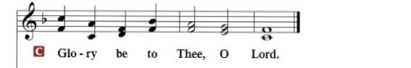

HOLY GOSPEL: (John 3:14-21)
¹⁴ And as Moses lifted up the serpent in the wilderness, so must the Son of Man be lifted up, ¹⁵ that whoever believes in him may have eternal life. ¹⁶ “For God so loved the world, that he gave his only Son, that whoever believes in him should not perish but have eternal life. ¹⁷ For God did not send his Son into the world to condemn the world, but in order that the world might be saved through him. ¹⁸ Whoever believes in him is not condemned, but whoever does not believe is condemned already, because he has not believed in the name of the only Son of God. ¹⁹ And this is the judgment: the light has come into the world, and people loved the darkness rather than the light because their works were evil. ²⁰ For everyone who does wicked things hates the light and does not come to the light, lest his works should be exposed. ²¹ But whoever does what is true comes to the light, so that it may be clearly seen that his works have been carried out in God.”

R: This is the Gospel of the Lord.

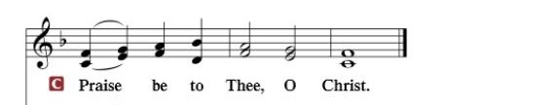

Nicene Creed
I believe in one God, the Father Almighty, maker of heaven and earth and of all things visible and invisible.
And in one Lord Jesus Christ, the only-begotten Son of God, begotten of His Father before all worlds, God of God, Light of Light, very God of very God, begotten, not made, being of one substance with the Father, by whom all things were made; who for us men and for our salvation came down from heaven and was incarnate by the Holy Spirit of the virgin Mary and was made man; and was crucified also for us under Pontius Pilate. He suffered and was buried. And the third day He rose again according to the Scriptures and ascended into heaven and sits at the right hand of the Father. And He will come again with glory to judge both the living and the dead, whose kingdom will have no end.
And I believe in the Holy Spirit, the Lord and giver of life, who proceeds from the Father and the Son, who with the Father and the Son together is worshiped and glorified, who spoke by the prophets. And I believe in one holy Christian and apostolic Church, I acknowledge one Baptism for the remission of sins, and I look for the resurrection of the dead and the life of the world to come. Amen.

SERMON HYMN: “God Loved the World So That He Gave”.………..LSB #571

SERMON

COLLECTION OF THE OFFERING
OFFERTORY…………………………………………………………...LSB pp. 192-193

GENERAL PRAYERS OF THE CHURCH

Sharing the Peace of the Lord

SERVICE OF THE SACRAMENT
Preface…………………………………….…………….……….LSB p. 194
Proper Preface
It is truly good, right, and salutary that we should at all times and in all places give thanks to You, holy Lord, almighty Father, everlasting God, through Jesus Christ, our Lord, who overcame the assaults of the devil and gave His life as a ransom for many that with cleansed hearts we might be prepared joyfully to celebrate the paschal feast in sincerity and truth. Therefore, with angels and archangels and with all the company of heaven we laud and magnify Your glorious name, ever more praising You and saying:

Sanctus, Lord’s Prayer, The Words of Our Lord………………….....LSB pp. 195-197
Agnus Dei………………………………………………………………..LSB p. 198
If you are not communing, it is acceptable to remain seated.

COMMUNION DISTRIBUTION HYMNS:
LSB #420 “Christ, the Life of All the Living”
LSB #628 “Your Table I Approach”
LSB #422 “On My Heart Imprint Your Image”

NUNC DIMITTIS………………………………………………………LSB pp. 199-200

BENEDICTION

CLOSING HYMN: “In the Cross of Christ I Glory”..............................LSB #427

The Mission of Trinity Onekama Is To SERVE

For even the Son of Man did not come to be served
but to serve and to give his life as a ransom for many.
Mark 10:45

S haring Jesus’s truth
E quipping for life
R eaching Out
V aluing each other
E vangelizing all ages
Mission Statement
The mission of Trinity Onekama is to SERVE
For even the Son of Man did not come to be served, but to serve,
and to give his life as a ransom for many. Mark 10:45
S haring Jesus’ ruth
E quipping for life
R eaching Out
V aluing each other
E vangelizing all age

CHURCH INFORMATION
Church Office: (231) 889-4429 Website: www.trinityonekama.org
E-mail: trinityonekama@sbcglobal.net
Address: P.O. Box 119, 5471 Fairview Street, Onekama, MI 49675
Sunday School & Adult Bible Study: Sunday @ 9:30am
Worship: Sunday @ 10:30 am The Lord’s Supper: Celebrated 2nd & 4th Sundays
Pastoral Hours: Wednesday and Friday 9:00am – Noon
Pastor Phone: 231-655-2680 Pastor Email: trinityonekama@gmail.com

Copyright licensing covered under CCLI #2802932

