**231-889-4429 5471 Fairview Street, Box 119 Onekama, MI**

**TRINITY LUTHERAN CHURCH**

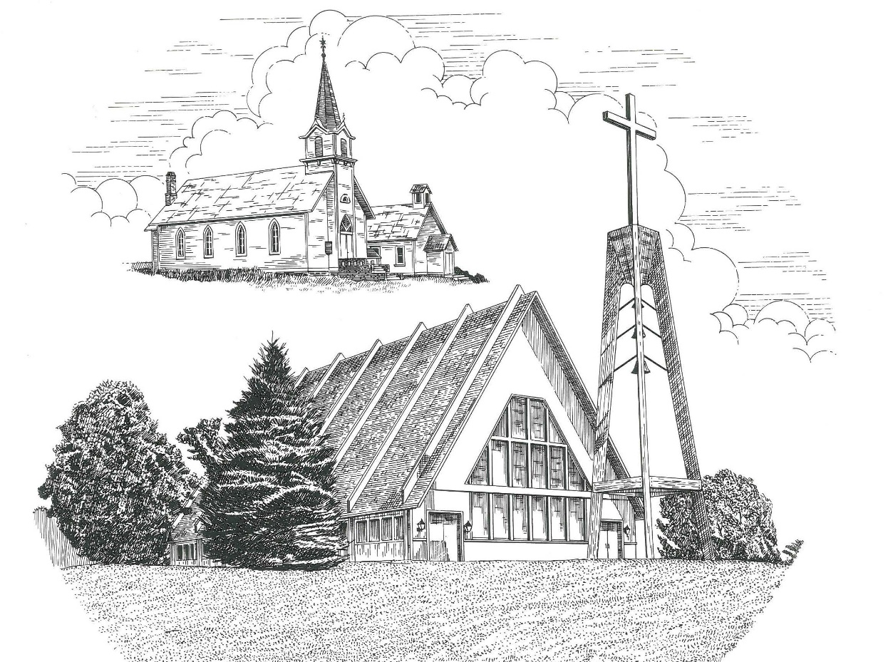

**Fifth Sunday in Lent March 26th, 2023**

**WELCOME**

**Thanks for joining us!**

**Pastor Jacob Sherry Missouri Synod**

**~~PLEASE NOTE~~Calling on the name of the Lord**

Does not include the use of cell phones in the worship sanctuary.

Please check yours before the service begins. Thank you for your courtesy.

**~~TO OUR GUESTS AND VISITORS~~**

Please sign our guest book located on the stand at the church entrance. During the service, we ask you to sign the attendance sheets located inside your bulletin and leave them on the pew as you leave. If you need assistance or have questions about our worship service, please talk to an elder or any one of our church family. We are glad you could join us and hope to have you worship with us again soon.

**~~ATTENDING HOLY COMMUNION~~**

By checking the “Communing Today” box on the registration form on the attendance sheet, you are agreeing with the following statements:

* **I am a baptized Christian who believes Jesus Christ is my Lord and Savior.**
* **I believe that I am a sinner in need of Christ’s freely offered forgiveness.**
* **I believe that in the Lord’s Supper the body and blood of Jesus Christ**

**are truly present in, with, and under the bread and wine.**

* **I believe that my participation in Holy Communion grants me forgiveness**

**of my sins, new spiritual life, and eternal salvation.**

* **With God’s help, I sincerely seek to repent of my sins, live in service**

**to my Lord, and await His return.**

**If you agree with the above statements, you are welcome to attend the Lord’s Supper with us. May God bless your worship time with us.**

We do offer gluten-free wafers, please quietly ask an elder to help you.

**Order of Divine Service Setting One**

**Pre-Service Music……………..Call to Worship………………….Greeting**

**OPENING HYMN:** *“Christ, Whose Glory Fills the Skies”*……………LSB #873

**CONFESSION & ABSOLUTION**……………………………………..LSB p. 151

**KYRIE**…………………………………………………………………...LSB pp. 152-153

**SALUTATION**…………………………………………………………..LSB p. 156

**Collect Prayer**

Almighty God, by Your great goodness mercifully look upon Your people that we may be governed and preserved evermore in body and soul; through Jesus Christ, Your Son, our Lord, who lives and reigns with the You and the Holy Spirit, one God, now and forever.

**THE HOLY SCRIPTURES**

**OLD TESTAMENT:** (Ezekiel 37:1-14)

The hand of the Lord was upon me, and he brought me out in the Spirit of the Lord and set me down in the middle of the valley; it was full of bones. **2**And he led me around among them, and behold, there were very many on the surface of the valley, and behold, they were very dry. **3**And he said to me, “Son of man, can these bones live?” And I answered, “O Lord God, you know.” **4**Then he said to me, “Prophesy over these bones, and say to them, O dry bones, hear the word of the Lord. **5**Thus says the Lord God to these bones: Behold, I will cause breath to enter you, and you shall live. **6**And I will lay sinews upon you, and will cause flesh to come upon you, and cover you with skin, and put breath in you, and you shall live, and you shall know that I am the Lord.”

**7**So I prophesied as I was commanded. And as I prophesied, there was a sound, and behold, a rattling, and the bones came together, bone to its bone. **8**And I looked, and behold, there were sinews on them, and flesh had come upon them, and skin had covered them. But there was no breath in them. **9**Then he said to me, “Prophesy to the breath; prophesy, son of man, and say to the breath, Thus says the Lord God: Come from the four winds, O breath, and breathe on these slain, that they may live.” **10**So I prophesied as he commanded me, and the breath came into them, and they lived and stood on their feet, an exceedingly great army.

**11**Then he said to me, “Son of man, these bones are the whole house of Israel. Behold, they say, ‘Our bones are dried up, and our hope is lost; we are indeed cut off.’ **12**Therefore prophesy, and say to them, Thus says the Lord God: Behold, I will open your graves and raise you from your graves, O my people. And I will bring you into the land of Israel. **13**And you shall know that I am the Lord, when I open your graves, and raise you from your graves, O my people. **14**And I will put my Spirit within you, and you shall live, and I will place you in your own land. Then you shall know that I am the Lord; I have spoken, and I will do it, declares the Lord.”

**R:** This is the Word of the Lord**.** **Cong: Thanks be to God.**

**GRADUAL**

Reader: O come, let us fix our eyes on Jesus,

**Cong.: the founder and perfecter of our faith,**

Reader: who for the joy that was set before him endured the cross, despising the shame,

**Cong.: and is seated at the right hand of the throne of God.**

**EPISTLE:** (Romans 8:1-11)

There is therefore now no condemnation for those who are in Christ Jesus. **2**For the law of the Spirit of life has set you free in Christ Jesus from the law of sin and death. **3** For God has done what the law, weakened by the flesh, could not do. By sending his own Son in the likeness of sinful flesh and for sin, he condemned sin in the flesh, **4**in order that the righteous requirement of the law might be fulfilled in us, who walk not according to the flesh but according to the Spirit. **5**For those who live according to the flesh set their minds on the things of the flesh, but those who live according to the Spirit set their minds on the things of the Spirit. **6**For to set the mind on the flesh is death, but to set the mind on the Spirit is life and peace. **7**For the mind that is set on the flesh is hostile to God, for it does not submit to God's law; indeed, it cannot. **8**Those who are in the flesh cannot please God.

**9**You, however, are not in the flesh but in the Spirit, if in fact the Spirit of God dwells in you. Anyone who does not have the Spirit of Christ does not belong to him. **10**But if Christ is in you, although the body is dead because of sin, the Spirit is life because of righteousness. **11**If the Spirit of him who raised Jesus from the dead dwells in you, he who raised Christ Jesus from the dead will also give life to your mortal bodies through his Spirit who dwells in you.

**R:** This is the Word of the Lord. **Cong: Thanks be to God.**

**(PLEASE RISE for the reading of the Gospel)**

**R:** The Holy Gospel according to St. John, the 11th chapter.



**HOLY GOSPEL:** (John 11:1-45)

Now a certain man was ill, Lazarus of Bethany, the village of Mary and her sister Martha. **2**It was Mary who anointed the Lord with ointment and wiped his feet with her hair, whose brother Lazarus was ill. **3**So the sisters sent to him, saying, “Lord, he whom you love is ill.” **4**But when Jesus heard it he said, “This illness does not lead to death. It is for the glory of God, so that the Son of God may be glorified through it.”

**5**Now Jesus loved Martha and her sister and Lazarus. **6**So, when he heard that Lazarus was ill, he stayed two days longer in the place where he was. **7**Then after this he said to the disciples, “Let us go to Judea again.” **8**The disciples said to him, “Rabbi, the Jews were just now seeking to stone you, and are you going there again?” **9**Jesus answered, “Are there not twelve hours in the day? If anyone walks in the day, he does not stumble, because he sees the light of this world. **10**But if anyone walks in the night, he stumbles, because the light is not in him.” **11**After saying these things, he said to them, “Our friend Lazarus has fallen asleep, but I go to awaken him.” **12**The disciples said to him, “Lord, if he has fallen asleep, he will recover.” **13**Now Jesus had spoken of his death, but they thought that he meant taking rest in sleep. **14**Then Jesus told them plainly, “Lazarus has died, **15**and for your sake I am glad that I was not there, so that you may believe. But let us go to him.” **16**So Thomas, called the Twin, said to his fellow disciples, “Let us also go, that we may die with him.”

**17**Now when Jesus came, he found that Lazarus had already been in the tomb four days. **18**Bethany was near Jerusalem, about two miles off, **19**and many of the Jews had come to Martha and Mary to console them concerning their brother. **20**So when Martha heard that Jesus was coming, she went and met him, but Mary remained seated in the house. **21**Martha said to Jesus, “Lord, if you had been here, my brother would not have died. **22**But even now I know that whatever you ask from God, God will give you.” **23**Jesus said to her, “Your brother will rise again.” **24**Martha said to him, “I know that he will rise again in the resurrection on the last day.” **25**Jesus said to her, “I am the resurrection and the life. Whoever believes in me, though he die, yet shall he live, **26**and everyone who lives and believes in me shall never die. Do you believe this?” **27**She said to him, “Yes, Lord; I believe that you are the Christ, the Son of God, who is coming into the world.”

**28**When she had said this, she went and called her sister Mary, saying in private, “The Teacher is here and is calling for you.” **29**And when she heard it, she rose quickly and went to him. **30**Now Jesus had not yet come into the village, but was still in the place where Martha had met him. **31**When the Jews who were with her in the house, consoling her, saw Mary rise quickly and go out, they followed her, supposing that she was going to the tomb to weep there. **32**Now when Mary came to where Jesus was and saw him, she fell at his feet, saying to him, “Lord, if you had been here, my brother would not have died.” **33**When Jesus saw her weeping, and the Jews who had come with her also weeping, he was deeply moved in his spirit and greatly troubled. **34**And he said, “Where have you laid him?” They said to him, “Lord, come and see.” **35**Jesus wept. **36**So the Jews said, “See how he loved him!” **37**But some of them said, “Could not he who opened the eyes of the blind man also have kept this man from dying?”

**38**Then Jesus, deeply moved again, came to the tomb. It was a cave, and a stone lay against it. **39**Jesus said, “Take away the stone.” Martha, the sister of the dead man, said to him, “Lord, by this time there will be an odor, for he has been dead four days.” **40**Jesus said to her, “Did I not tell you that if you believed you would see the glory of God?” **41**So they took away the stone. And Jesus lifted up his eyes and said, “Father, I thank you that you have heard me. **42**I knew that you always hear me, but I said this on account of the people standing around, that they may believe that you sent me.” **43**When he had said these things, he cried out with a loud voice, “Lazarus, come out.” **44**The man who had died came out, his hands and feet bound with linen strips, and his face wrapped with a cloth. Jesus said to them, “Unbind him, and let him go.” **45**Many of the Jews therefore, who had come with Mary and had seen what he did, believed in him,

**R:** This is the Gospel of the Lord.



**SERMON HYMN**: *“My Song Is Love Unknown”*…………………..................LSB #430

**SERMON**

**NICENE CREED**

I believe in one God, the Father Almighty, maker of heaven and earth and of all things visible and invisible.

And in one Lord Jesus Christ, the only-begotten Son of God, begotten of His Father before all worlds, God of God, Light of Light, very God of very God, begotten, not made, being of one substance with the Father, by whom all things were made; who for us men and for our salvation came down from heaven and was incarnate by the Holy Spirit of the virgin Mary and was made man; and was crucified also for us under Pontius Pilate. He suffered and was buried. And the third day He rose again according to the Scriptures and ascended into heaven and sits at the right hand of the Father. And He will come again with glory to judge both the living and the dead, whose kingdom will have no end.

And I believe in the Holy Spirit, the Lord and giver of life, who proceeds from the Father and the Son, who with the Father and the Son together is worshiped and glorified, who spoke by the prophets. And I believe in one holy Christian and apostolic Church, I acknowledge one Baptism for the remission of sins, and I look for the resurrection of the dead and the life of the world to come. Amen.

**THE GENERAL PRAYERS OF THE CHURCH**

**OFFERTORY**…………………………………………………………...LSB pp. 159-160

**Sharing the Peace of the Lord**

**SERVICE OF THE SACRAMENT**

**PREFACE**……………………………………………………………………..LSB p. 160

**Proper Preface**

It is truly good, right, and salutary that we should at all times and in all places give thanks to You, holy Lord, almighty Father, everlasting God, through Jesus Christ, our Lord, who overcame the assaults of the devil and gave His life as a ransom for many that with cleansed hearts we might be prepared joyfully to celebrate the paschal feast in sincerity and truth. Therefore, with angels and archangels and with all the company of heaven we laud and magnify Your glorious name, ever more praising You and saying:

**SANCTUS**……………………………………………………………………...LSB p. 161

**THE WORDS OF OUR LORD**……………………………………………….LSB p. 162

**AGNUS DEI**……………………………………………………………………LSB p. 163

*If you are not communing, it is acceptable to remain seated.*

**COMMUNION DISTRIBUTION HYMNS**

LSB #794 *“The Lord, My God, Be Praised”*

LSB #573 *“Lord, ‘Tis Not That I Did Choose Thee”*

LSB #627 *“Jesus Christ, Our Blessed Savior”*

**NUNC DIMITTIS – *“Song of Simeon”***……………………………………...LSB p. 165

**POST-COMMUNION COLLECT PRAYER**………………………………LSB p. 166

**BENEDICTION**……………………………………………………………….LSB p. 166

**CLOSING HYMN:** *“In the Cross of Christ I Glory”*……..………………….LSB #427

**CHURCH INFORMATION**

**Church Office:** (231) 889-4429 **Website:** www.trinityonekama.org

**E-mail:** [trinityonekama@sbcglobal.net](mailto:trinityonekama@sbcglobal.net)

**Address:** P.O. Box 119, 5471 Fairview Street, Onekama, MI 49675

**Sunday School & Adult Bible Study**: Sunday @ 9:30am

**Worship:** Sunday @ 10:30 am **The Lord’s Supper:**  Celebrated 2nd & 4th Sundays

**Pastoral Hours:** Wednesday and Friday 9:00am – Noon

**Pastor Phone:** 231-655-2680 **Pastor Email:** trinityonekama@gmail.com

**Copyright licensing covered under CCLI #2802932**