231-889-4429 5471 Fairview Street Onekama, MI

TRINITY LUTHERAN CHURCH
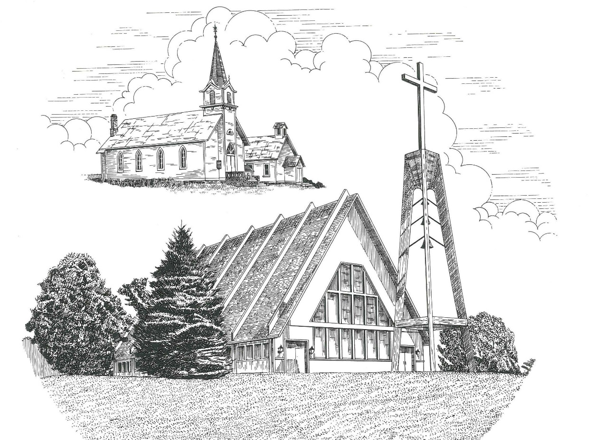

The Resurrection of Our Lord March 31st, 2024

WELCOME
Thanks for joining us!
Pastor Jacob Sherry Missouri Synod

~~PLEASE NOTE~~
Calling on the name of the Lord
Does not include the use of cell phones in the worship sanctuary.
Please check yours before the service begins. Thank you for your courtesy.
~~TO OUR GUESTS AND VISITORS~~
Please sign our guest book located on the stand at the church entrance. During the service, we ask you to sign the attendance sheet in your bulletin and leave it on the pew as you leave. If you need assistance or have questions about our worship service, please talk to an elder or any one of our church family. We are glad you could join us and hope to have you worship with us again soon.

~~ATTENDING HOLY COMMUNION~~
By checking the “Communing Today” box on the registration form found on the attendance sheet in your bulletin, you are agreeing with the following statements:

- I am a baptized Christian who believes Jesus Christ is my Lord and Savior.
- I believe that I am a sinner in need of Christ’s freely offered forgiveness.
- I believe that in the Lord’s Supper the body and blood of Jesus Christ
are truly present in, with, and under the bread and wine.
- I believe that my participation in Holy Communion grants me forgiveness
of my sins, new spiritual life, and eternal salvation.
- With God’s help, I sincerely seek to repent of my sins, live in service
to my Lord, and await His return.

If you agree with the above statements, you are welcome to attend the Lord’s Supper with us. May God bless your worship time with us.
We do offer gluten-free wafers, please quietly ask an elder to help you.

Order of Divine Service Setting Four

Pre-Service Music……………..Call to Worship………………….Greeting

OPENING HYMN: “Jesus Christ Is Risen Today”……………………LSB #457

CONFESSION & ABSOLUTION……….…………………………….LSB p. 203

INTROIT
P: I will sing to the Lord, for he has triumphed gloriously;
C: the horse and his rider he has thrown into the sea.
P: The Lord is my strength and my song,
C: and he has become my salvation;
P: Your right hand, O Lord, glorious in power,
C: your right hand, O Lord, shatters the enemy.
P: You have led in your steadfast love the people whom you have redeemed;
C: you have guided them by your strength to your holy abode.
P: You will bring them in and plant them on your own mountain,
C: the place, O Lord, which you have made for your abode,
P: the sanctuary, O Lord, which your hands have established.
C: The Lord will reign forever and ever.
ALL: Glory be to the Father and to the Son and to the Holy Spirit; as it was in the
beginning, is now and will be forever. Amen.

KYRIE…………………………………………………………………….LSB p. 204
GLORIA IN EXCELSIS…………………………………………………LSB p. 204
SALUTATION.…………………………………………………………...LSB p. 205

Collect Prayer
Almighty God the Father, through Your only-begotten Son, Jesus Christ, You have overcome death and opened the gate of everlasting life to us. Grant that we, who celebrate with joy the day of our Lord’s resurrection, may be raised from the death of sin by Your life-giving Spirit; through Jesus Christ, our Lord, who lives and reigns with You and the Holy Spirit, one God, now and forever.

THE HOLY SCRIPTURES

OLD TESTAMENT: (Isaiah 25:6-9)
⁶ On this mountain the Lord of hosts will make for all peoples
a feast of rich food, a feast of well-aged wine,
of rich food full of marrow, of aged wine well refined.
⁷ And he will swallow up on this mountain
the covering that is cast over all peoples,
the veil that is spread over all nations.
⁸ He will swallow up death forever;
and the Lord God will wipe away tears from all faces,
and the reproach of his people he will take away from all the earth,
for the Lord has spoken.
⁹ It will be said on that day,
“Behold, this is our God; we have waited for him, that he might save us.
This is the Lord; we have waited for him;
let us be glad and rejoice in his salvation.”

R: This is the Word of the Lord. Cong: Thanks be to God.

GRADUAL
Reader: Christ has risen from the dead.
Cong.: God the Father has crowned him with glory and honor,
Reader: He has given him dominion over the works of his hands;
Cong.: he has put all things under his feet.

EPISTLE: (1 Corinthians 15:1-11)
Now I would remind you, brothers, of the gospel I preached to you, which you received, in which you stand, ² and by which you are being saved, if you hold fast to the word I preached to you—unless you believed in vain.
³ For I delivered to you as of first importance what I also received: that Christ died for our sins in accordance with the Scriptures, ⁴ that he was buried, that he was raised on the third day in accordance with the Scriptures, ⁵ and that he appeared to Cephas, then to the twelve. ⁶ Then he appeared to more than five hundred brothers at one time, most of whom are still alive, though some have fallen asleep. ⁷ Then he appeared to James, then to all the apostles. ⁸ Last of all, as to one untimely born, he appeared also to me. ⁹ For I am the least of the apostles, unworthy to be called an apostle, because I persecuted the church of God. ¹⁰ But by the grace of God I am what I am, and his grace toward me was not in vain. On the contrary, I worked harder than any of them, though it was not I, but the grace of God that is with me. ¹¹ Whether then it was I or they, so we preach and so you believed.

R: This is the Word of the Lord. Cong: Thanks be to God.

(PLEASE RISE for the reading of the Gospel)

R: The Holy Gospel according to St. Mark, the 16th chapter.
Cong: Glory to You, O Lord

HOLY GOSPEL: (Mark 16:1-8)
16 When the Sabbath was past, Mary Magdalene, Mary the mother of James, and Salome bought spices, so that they might go and anoint him. ² And very early on the first day of the week, when the sun had risen, they went to the tomb. ³ And they were saying to one another, “Who will roll away the stone for us from the entrance of the tomb?” ⁴ And looking up, they saw that the stone had been rolled back—it was very large. ⁵ And entering the tomb, they saw a young man sitting on the right side, dressed in a white robe, and they were alarmed. ⁶ And he said to them, “Do not be alarmed. You seek Jesus of Nazareth, who was crucified. He has risen; he is not here. See the place where they laid him. ⁷ But go, tell his disciples and Peter that he is going before you to Galilee. There you will see him, just as he told you.” ⁸ And they went out and fled from the tomb, for trembling and astonishment had seized them, and they said nothing to anyone, for they were afraid.

R: This is the Gospel of the Lord. Cong: Praise to You, O Christ.

NICENE CREED
I believe in one God, the Father Almighty, maker of heaven and earth and of all things visible and invisible.
And in one Lord Jesus Christ, the only-begotten Son of God, begotten of His Father before all worlds, God of God, Light of Light, very God of very God, begotten, not made, being of one substance with the Father, by whom all things were made; who for us men and for our salvation came down from heaven and was incarnate by the Holy Spirit of the virgin Mary and was made man; and was crucified also for us under Pontius Pilate. He suffered and was buried. And the third day He rose again according to the Scriptures and ascended into heaven and sits at the right hand of the Father. And He will come again with glory to judge both the living and the dead, whose kingdom will have no end.
And I believe in the Holy Spirit, the Lord and giver of life, who proceeds from the Father and the Son, who with the Father and the Son together is worshiped and glorified, who spoke by the prophets. And I believe in one holy Christian and apostolic Church, I acknowledge one Baptism for the remission of sins, and I look for the resurrection of the dead and the life of the world to come. Amen.

SERMON HYMN: “I Know That My Redeemer Lives”……….………………LSB #461

SERMON

THE GENERAL PRAYERS

COLLECTION OF THE OFFERING
OFFERTORY HYMN: “Doxology”…………………………………………..LSB #805

Sharing the Peace of the Lord

SERVICE OF THE SACRAMENT
Preface…………………………………….…………….………..LSB p. 208
Proper Preface
It is truly good, right, and salutary that we should at all times and in all places give thanks to You, O Lord, holy Father, almighty and everlasting God, for the countless blessings You so freely bestow on us and all creation. Above all, we give thanks for Your boundless love shown to us when You sent Your only-begotten Son, Jesus Christ, into our flesh and laid on Him our sin, giving Him into death that we might not die eternally. Because He is now risen from the dead and lives and reigns to all eternity, all who believe in Him will overcome sin and death and will rise again to new life. Therefore, with angels and archangels and with all the company of heaven we laud and magnify Your glorious name, ever more praising You and saying:

Sanctus, Lord’s Prayer, The Words of Our Lord………………….....LSB pp. 208-209
Agnus Dei………………………………………………………………..LSB p. 210
If you are not communing, it is acceptable to remain seated.

COMMUNION DISTRIBUTION HYMNS:
LSB #463 “Christ the Lord Is Risen Today; Alleluia”
LSB #467 “Awake, My Heart, with Gladness”
LSB #633 “At the Lamb’s High Feast We Sing”

CLOSING LITURGY:………………………………………………....LSB pp. 211-212

CLOSING HYMN: “Now All the Vault of Heaven Resounds”...............LSB #465

The Mission of Trinity Onekama Is To SERVE

For even the Son of Man did not come to be served
but to serve and to give his life as a ransom for many.
Mark 10:45

S haring Jesus’s truth
E quipping for life
R eaching Out
V aluing each other
E vangelizing all ages
Mission Statement
The mission of Trinity Onekama is to SERVE
For even the Son of Man did not come to be served, but to serve,
and to give his life as a ransom for many. Mark 10:45
S haring Jesus’ ruth
E quipping for life
R eaching Out
V aluing each other
E vangelizing all age

CHURCH INFORMATION
Church Office: (231) 889-4429 Website: www.trinityonekama.org
E-mail: trinityonekama@sbcglobal.net
Address: 5471 Fairview Street, Onekama, MI 49675
Mailing Address: P.O. Box 119, Onekama, MI 49675
Sunday School & Adult Bible Study: Sunday @ 9:30am
Worship: Sunday @ 10:30 am The Lord’s Supper: Celebrated 2nd & 4th Sundays
Pastoral Hours: Wednesday and Friday 9:00am – Noon
Pastor Phone: 231-655-2680 Pastor Email: trinityonekama@gmail.com

Copyright licensing covered under CCLI #2802932

