**231-889-4429 5471 Fairview Street, Box 119 Onekama, MI**

**TRINITY LUTHERAN CHURCH**

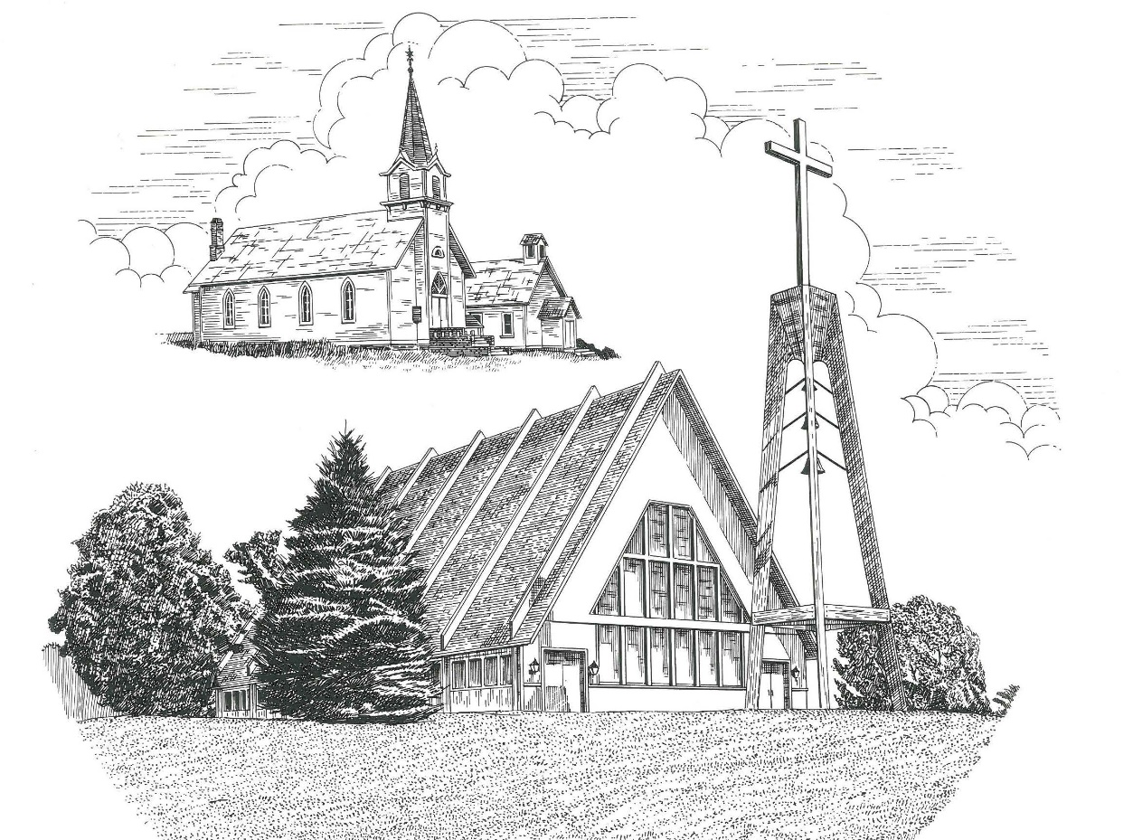

**Sixth Sunday of Easter May 22nd, 2022**

**WELCOME**

**Thanks for joining us!**

**Pastor Jacob Sherry Missouri Synod**

**~~PLEASE NOTE~~Calling on the name of the Lord**

Does not include the use of cell phones in the worship sanctuary.

Please check yours before the service begins. Thank you for your courtesy.

**~~TO OUR GUESTS AND VISITORS~~**

Please sign our guest book located on the stand at the church entrance. During the service, we ask you to sign the attendance sheets located inside your bulletin and leave them on the pew as you leave. If you need assistance or have questions about our worship service, please talk to an elder or any one of our church family. We are glad you could join us and hope to have you worship with us again soon.

**~~ATTENDING HOLY COMMUNION~~**

By checking the “Communing Today” box on the registration form on the attendance sheet, you are agreeing with the following statements:

* **I am a baptized Christian who believes Jesus Christ is my Lord and Savior.**
* **I believe that I am a sinner in need of Christ freely offered forgiveness.**
* **I believe that in the Lord’s Supper the body and blood of Jesus Christ**

**are truly present in, with, and under the bread and wine.**

* **I believe that my participation in Holy Communion grants me forgiveness**

**of my sins, new spiritual life, and eternal salvation.**

* **With God’s help, I sincerely seek to repent of my sins, live in service**

**to my Lord, and await His return.**

**If you agree with the above statements, you are welcome to attend the Lord’s Supper with us. May God bless your worship time with us.**

We do offer gluten-free wafers, please quietly ask an elder to help you.

**Order of Divine Service Setting One**

**Pre-Service Music……………..Call to Worship………………….Greeting**

**OPENING HYMN:** *“Jesus Christ Is Risen Today”*……………………LSB #457

**CONFESSION & ABSOLUTION**……………………………………..LSB p. 151

**KYRIE**…………………………………………………………………...LSB pp. 152-153

**THIS IS THE FEAST**…………………………………………………...LSB p. 155

**SALUTATION**…………………………………………………………..LSB p. 156

**Collect Prayer**

O God, the giver of all that is good, by Your holy inspiration grant that we may think those things that are right and by Your merciful guiding accomplish them; through Jesus Christ, Your Son, our Lord, who lives and reigns with You and the Holy Spirit, one God, now and forever.

**THE HOLY SCRIPTURES**

**FIRST READING:** (Acts 16:9-15)

**9**And a vision appeared to Paul in the night: a man of Macedonia was standing there, urging him and saying, “Come over to Macedonia and help us.”  **10**And when Paul had seen the vision, immediately we sought to go on into Macedonia, concluding that God had called us to preach the gospel to them. **11**So, setting sail from Troas, we made a direct voyage to Samothrace, and the following day to Neapolis, **12**and from there to Philippi, which is a leading city of the district of Macedonia and a Roman colony. We remained in this city some days.  **13**And on the Sabbath day we went outside the gate to the riverside, where we supposed there was a place of prayer, and we sat down and spoke to the women who had come together.  **14**One who heard us was a woman named Lydia, from the city of Thyatira, a seller of purple goods, who was a worshiper of God. The Lord opened her heart to pay attention to what was said by Paul.  **15**And after she was baptized, and her household as well, she urged us, saying, “If you have judged me to be faithful to the Lord, come to my house and stay.” And she prevailed upon us.

**R:** This is the Word of the Lord**.** **Cong: Thanks be to God.**

**GRADUAL**

Reader: Christ has risen from the dead.

**Cong.: God the Father has crowned him with glory and honor,**

Reader: He has given him dominion over the works of his hands;

**Cong.: he has put all things under his feet.**

**SECOND READING:** (Revelation 21:9-14, 21-27)

**9**Then came one of the seven angels who had the seven bowls full of the seven last plagues and spoke to me, saying, “Come, I will show you the Bride, the wife of the Lamb.”  **10**And he carried me away in the Spirit to a great, high mountain, and showed me the holy city Jerusalem coming down out of heaven from God, **11**having the glory of God, its radiance like a most rare jewel, like a jasper, clear as crystal.  **12**It had a great, high wall, with twelve gates, and at the gates twelve angels, and on the gates the names of the twelve tribes of the sons of Israel were inscribed— **13**on the east three gates, on the north three gates, on the south three gates, and on the west three gates.  **14**And the wall of the city had twelve foundations, and on them were the twelve names of the twelve apostles of the Lamb. **21**And the twelve gates were twelve pearls, each of the gates made of a single pearl, and the street of the city was pure gold, like transparent glass. **22**And I saw no temple in the city, for its temple is the Lord God the Almighty and the Lamb. **23**And the city has no need of sun or moon to shine on it, for the glory of God gives it light, and its lamp is the Lamb.  **24**By its light will the nations walk, and the kings of the earth will bring their glory into it, **25**and its gates will never be shut by day—and there will be no night there.  **26**They will bring into it the glory and the honor of the nations. **27**But nothing unclean will ever enter it, nor anyone who does what is detestable or false, but only those who are written in the Lamb's book of life.

**R:** This is the Word of the Lord. **Cong: Thanks be to God.**

**(PLEASE RISE for the reading of the Gospel)**



**R:** The Holy Gospel according to St. John, the 16th chapter.



**HOLY GOSPEL:** (John 16:23-33)

**23**In that day you will ask nothing of me. Truly, truly, I say to you, whatever you ask of the Father in my name, he will give it to you.  **24**Until now you have asked nothing in my name.  Ask, and you will receive, that your joy may be full.

**25**“I have said these things to you in figures of speech.  The hour is coming when I will no longer speak to you in figures of speech but will tell you plainly about the Father. **26**In that day you will ask in my name, and I do not say to you that I will ask the Father on your behalf; **27**for the Father himself loves you, because you have loved me and have believed that I came from God.  **28**I came from the Father and have come into the world, and now I am leaving the world and going to the Father.”

**29**His disciples said, “Ah, now you are speaking plainly and not using figurative speech! **30**Now we know that you know all things and do not need anyone to question you; this is why we believe that you came from God.”  **31**Jesus answered them, “Do you now believe? **32**Behold, the hour is coming, indeed it has come, when you will be scattered, each to his own home, and will leave me alone.  Yet I am not alone, for the Father is with me.  **33**I have said these things to you, that in me you may have peace.  In the world you will have tribulation. But take heart; I have overcome the world.”

**R:** This is the Gospel of the Lord.



**SERMON HYMN**: *“This Joyful Eastertide”*…………………..........................LSB #482

**SERMON**

**NICENE CREED**

I believe in one God, the Father Almighty, maker of heaven and earth and of all things visible and invisible.

And in one Lord Jesus Christ, the only-begotten Son of God, begotten of His Father before all worlds, God of God, Light of Light, very God of very God, begotten, not made, being of one substance with the Father, by whom all things were made; who for us men and for our salvation came down from heaven and was incarnate by the Holy Spirit of the virgin Mary and was made man; and was crucified also for us under Pontius Pilate. He suffered and was buried. And the third day He rose again according to the Scriptures and ascended into heaven and sits at the right hand of the Father. And He will come again with glory to judge both the living and the dead, whose kingdom will have no end.

And I believe in the Holy Spirit, the Lord and giver of life, who proceeds from the Father and the Son, who with the Father and the Son together is worshiped and glorified, who spoke by the prophets. And I believe in one holy Christian and apostolic Church, I acknowledge one Baptism for the remission of sins, and I look for the resurrection of the dead and the life of the world to come. Amen.

**THE GENERAL PRAYERS OF THE CHURCH**

**SERVICE OF THE SACRAMENT**

**PREFACE**……………………………………………………………………..LSB p. 160

**Proper Preface**

It is truly good, right, and salutary that we should at all times and in all places give thanks to You, holy Lord, almighty Father, everlasting God, through Jesus Christ, our Lord, who, out of love for His fallen creation, humbled Himself by taking on the form of a servant, becoming obedient unto death, even death upon a cross. Risen from the dead, He has freed us from eternal death and given us life everlasting. Therefore, with angels and archangels and with all the company of heaven we laud and magnify Your glorious name, ever more praising You and saying:

**SANCTUS**……………………………………………………………………...LSB p. 161

**THE WORDS OF OUR LORD**……………………………………………….LSB p. 162

**AGNUS DEI**……………………………………………………………………LSB p. 163

*If you are not communing, it is acceptable to remain seated.*

**COMMUNION DISTRIBUTION HYMNS**

LSB #556 *“Dear Christians, One and All, Rejoice”*

LSB #469 *“Christ the Lord is Risen Today”*

LSB #488 *“He Is Arisen! Glorious Word”*

**THANK THE LORD**………………………………………………………….LSB p. 164

**POST-COMMUNION COLLECT PRAYER**……………………………….LSB p. 166

**BENEDICTION**……………………………………………………………….LSB p. 166

**CLOSING HYMN:** *“Jesus Lives! The Victory’s Won”*……..………………..LSB #490

The Mission of Trinity Onekama Is To **SERVE**

For even the Son of Man did not come to be served

but to serve and to give his life as a ransom for many.            
                                                                       Mark 10:45



**S**haring Jesus’s **t**ruth

**E**quipping for life

**R**eaching Out

**V**aluing each other

**E**vangelizing all ages

Mission Statement

The mission of Trinity Onekama is to SERVE

For even the Son of Man did not come to be served, but to serve,

and to give his life as a ransom for many. Mark 10:45

S haring Jesus’ ruth

E quipping for life

R eaching Out

V aluing each other

E vangelizing all age

**CHURCH INFORMATION**

**Church Office:** (231) 889-4429 **Website:** www.trinityonekama.org

**E-mail:** [trinityonekama@sbcglobal.net](mailto:trinityonekama@sbcglobal.net)

**Address:** P.O. Box 119, 5471 Fairview Street, Onekama, MI 49675

**Adult Bible Study**: Sunday @ 11:30 am (year round)

**Worship:** Sunday @ 10:30 am **The Lord’s Supper:**  Celebrated 2nd & 4th Sundays

**Pastoral Hours:** Wednesday and Friday 9:00am – Noon

**Pastor Phone:** 231-655-2680 **Pastor Email:** trinityonekama@gmail.com

**Copyright licensing covered under CCLI #2802932**