**231-889-4429 5471 Fairview Street, Box 119 Onekama, MI**

**TRINITY LUTHERAN CHURCH**

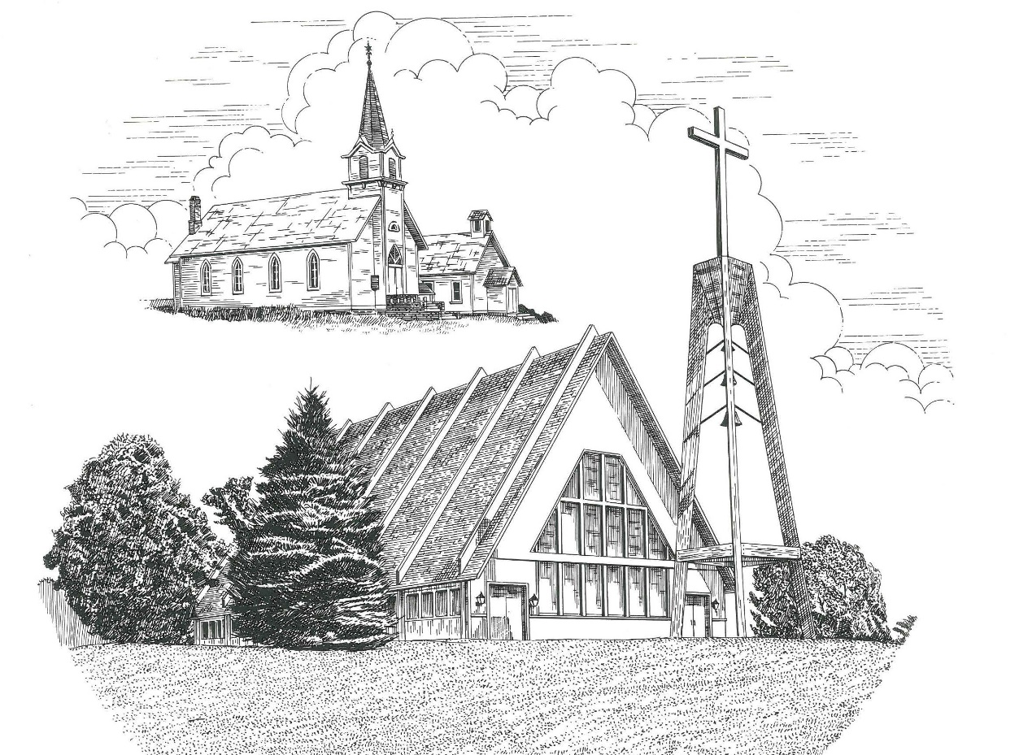

**The Day of Pentecost May 28th, 2023**

**WELCOME**

**Thanks for joining us!**

**Pastor Jacob Sherry Missouri Synod**

**~~PLEASE NOTE~~Calling on the name of the Lord**

Does not include the use of cell phones in the worship sanctuary.

Please check yours before the service begins. Thank you for your courtesy.

**~~TO OUR GUESTS AND VISITORS~~**

Please sign our guest book located on the stand at the church entrance. During the service, we ask you to sign the attendance sheets located inside your bulletin and leave them on the pew as you leave. If you need assistance or have questions about our worship service, please talk to an elder or any one of our church family. We are glad you could join us and hope to have you worship with us again soon.

**~~ATTENDING HOLY COMMUNION~~**

By checking the “Communing Today” box on the registration form on the attendance sheet, you are agreeing with the following statements:

* **I am a baptized Christian who believes Jesus Christ is my Lord and Savior.**
* **I believe that I am a sinner in need of Christ’s freely offered forgiveness.**
* **I believe that in the Lord’s Supper the body and blood of Jesus Christ**

**are truly present in, with, and under the bread and wine.**

* **I believe that my participation in Holy Communion grants me forgiveness**

**of my sins, new spiritual life, and eternal salvation.**

* **With God’s help, I sincerely seek to repent of my sins, live in service**

**to my Lord, and await His return.**

**If you agree with the above statements, you are welcome to attend the Lord’s Supper with us. May God bless your worship time with us.**

We do offer gluten-free wafers, please quietly ask an elder to help you.

**Order of Divine Service Setting One**

**Pre-Service Music……………..Call to Worship………………….Greeting**

**OPENING HYMN:** *“Creator Spirit, by Whose Aid”*…………………..LSB #500

**CONFESSION & ABSOLUTION**……………………………………..LSB p. 151

**KYRIE**…………………………………………………………………...LSB pp. 152-153

**THIS IS THE FEAST**…………………………………………………...LSB p. 155

**SALUTATION**…………………………………………………………..LSB p. 156

**Collect Prayer**

O God, on this day You once taught the hearts of Your faithful people by sending them the light of Your Holy Spirit. Grant us in our day by the same Spirit to have a right understanding in all things and evermore to rejoice in His holy consolation; through Jesus Christ, Your Son, our Lord, who lives and reigns with the You and the Holy Spirit, one God, now and forever.

**THE HOLY SCRIPTURES**

**OLD TESTAMENT:** (Numbers 11:24-30)

**24**So Moses went out and told the people the words of the Lord. And he gathered seventy men of the elders of the people and placed them around the tent. **25**Then the Lord came down in the cloud and spoke to him, and took some of the Spirit that was on him and put it on the seventy elders. And as soon as the Spirit rested on them, they prophesied. But they did not continue doing it.

**26**Now two men remained in the camp, one named Eldad, and the other named Medad, and the Spirit rested on them. They were among those registered, but they had not gone out to the tent, and so they prophesied in the camp. **27**And a young man ran and told Moses, “Eldad and Medad are prophesying in the camp.” **28**And Joshua the son of Nun, the assistant of Moses from his youth, said, “My lord Moses, stop them.” **29**But Moses said to him, “Are you jealous for my sake? Would that all the Lord's people were prophets, that the Lord would put his Spirit on them!” **30**And Moses and the elders of Israel returned to the camp.

**R:** This is the Word of the Lord**.** **Cong: Thanks be to God.**

**GRADUAL**

Reader: I will pour out my Spirit on all flesh,

**Cong.: and your sons and your daughters shall prophesy.**

Reader: With the heart one believes and is justified,

**Cong.: and with the mouth one confesses and is saved.**

**SECOND READING:** (Acts 2:1-21)

When the day of Pentecost arrived, they were all together in one place. **2**And suddenly there came from heaven a sound like a mighty rushing wind, and it filled the entire house where they were sitting. **3**And divided tongues as of fire appeared to them and rested on each one of them. **4**And they were all filled with the Holy Spirit and began to speak in other tongues as the Spirit gave them utterance.

**5**Now there were dwelling in Jerusalem Jews, devout men from every nation under heaven. **6**And at this sound the multitude came together, and they were bewildered, because each one was hearing them speak in his own language. **7**And they were amazed and astonished, saying, “Are not all these who are speaking Galileans? **8**And how is it that we hear, each of us in his own native language? **9**Parthians and Medes and Elamites and residents of Mesopotamia, Judea and Cappadocia, Pontus and Asia, **10**Phrygia and Pamphylia, Egypt and the parts of Libya belonging to Cyrene, and visitors from Rome, **11**both Jews and proselytes, Cretans and Arabians—we hear them telling in our own tongues the mighty works of God.” **12**And all were amazed and perplexed, saying to one another, “What does this mean?” **13**But others mocking said, “They are filled with new wine.”

**14**But Peter, standing with the eleven, lifted up his voice and addressed them: “Men of Judea and all who dwell in Jerusalem, let this be known to you, and give ear to my words. **15**For these people are not drunk, as you suppose, since it is only the third hour of the day. **16**But this is what was uttered through the prophet Joel:

**17**“‘And in the last days it shall be, God declares,  
that I will pour out my Spirit on all flesh,  
and your sons and your daughters shall prophesy,  
    and your young men shall see visions,  
    and your old men shall dream dreams;  
**18**even on my male servants and female servants  
    in those days I will pour out my Spirit, and they shall prophesy.  
**19**And I will show wonders in the heavens above  
    and signs on the earth below,  
    blood, and fire, and vapor of smoke;  
**20**the sun shall be turned to darkness  
    and the moon to blood,  
    before the day of the Lord comes, the great and magnificent day.  
**21**And it shall come to pass that everyone who calls upon the name of the Lord shall be saved.’

**R:** This is the Word of the Lord. **Cong: Thanks be to God.**

**(PLEASE RISE for the reading of the Gospel)**



**R:** The Holy Gospel according to St. John, the 7th chapter.



**HOLY GOSPEL:** (John 7:37-39)

**37**On the last day of the feast, the great day, Jesus stood up and cried out, “If anyone thirsts, let him come to me and drink. **38**Whoever believes in me, as the Scripture has said, ‘Out of his heart will flow rivers of living water.’” **39**Now this he said about the Spirit, whom those who believed in him were to receive, for as yet the Spirit had not been given, because Jesus was not yet glorified.

**R:** This is the Gospel of the Lord.



**SERMON HYMN**: *“Come, Holy Ghost, God and Lord”*……………....LSB #497

**SERMON**

**NICENE CREED**

I believe in one God, the Father Almighty, maker of heaven and earth and of all things visible and invisible.

And in one Lord Jesus Christ, the only-begotten Son of God, begotten of His Father before all worlds, God of God, Light of Light, very God of very God, begotten, not made, being of one substance with the Father, by whom all things were made; who for us men and for our salvation came down from heaven and was incarnate by the Holy Spirit of the virgin Mary and was made man; and was crucified also for us under Pontius Pilate. He suffered and was buried. And the third day He rose again according to the Scriptures and ascended into heaven and sits at the right hand of the Father. And He will come again with glory to judge both the living and the dead, whose kingdom will have no end.

And I believe in the Holy Spirit, the Lord and giver of life, who proceeds from the Father and the Son, who with the Father and the Son together is worshiped and glorified, who spoke by the prophets. And I believe in one holy Christian and apostolic Church, I acknowledge one Baptism for the remission of sins, and I look for the resurrection of the dead and the life of the world to come. Amen.

**THE GENERAL PRAYERS OF THE CHURCH**

**COLLECTION OF THE OFFERING**

**OFFERTORY:** *“We Give Thee But Thy Own”*……………………………….LSB #781

**Sharing the Peace of the Lord**

**SERVICE OF THE SACRAMENT**

**PREFACE**……………………………………………………………………..LSB p. 160

**Proper Preface**

It is truly good, right, and salutary that we should at all times and in all places give thanks to You, holy Lord, almighty Father, everlasting God, through Jesus Christ, our Lord, who ascended above the heavens and, sitting at Your right hand, poured out on this day the promised Holy Spirit on His chosen disciples. For all this the whole earth rejoices with exceeding joy. Therefore, with angels and archangels and with all the company of heaven we laud and magnify Your glorious name, ever more praising You and saying:

**SANCTUS**……………………………………………………………………...LSB p. 161

**THE WORDS OF OUR LORD**……………………………………………….LSB p. 162

**AGNUS DEI**……………………………………………………………………LSB p. 163

*If you are not communing, it is acceptable to remain seated.*

**COMMUNION DISTRIBUTION HYMNS**

LSB #496 *“Holy Spirit, Light Divine”*

LSB #637 *“Draw Near and Take the Body of the Lord”*

LSB #740 *“I Am Jesus’ Little Lamb”*

**POST COMMUNION CANTICLE:** *“Thank the Lord”*………………….....LSB p. 164

**POST-COMMUNION COLLECT PRAYER**………………………………LSB p. 166

**BENEDICTION**……………………………………………………………….LSB p. 166

**CLOSING HYMN:** *“On What Has Now Been Sown”*……..…………………LSB #921

The Mission of Trinity Onekama Is To **SERVE**

For even the Son of Man did not come to be served

but to serve and to give his life as a ransom for many.            
                                                                       Mark 10:45



**S**haring Jesus’s **t**ruth

**E**quipping for life

**R**eaching Out

**V**aluing each other

**E**vangelizing all ages

Mission Statement

The mission of Trinity Onekama is to SERVE

For even the Son of Man did not come to be served, but to serve,

and to give his life as a ransom for many. Mark 10:45

S haring Jesus’ ruth

E quipping for life

R eaching Out

V aluing each other

E vangelizing all age

**CHURCH INFORMATION**

**Church Office:** (231) 889-4429 **Website:** www.trinityonekama.org

**E-mail:** [trinityonekama@sbcglobal.net](mailto:trinityonekama@sbcglobal.net)

**Address:** P.O. Box 119, 5471 Fairview Street, Onekama, MI 49675

**Sunday School & Adult Bible Study**: Sunday @ 9:30 am

**Worship:** Sunday @ 10:30 am **The Lord’s Supper:**  Celebrated 2nd & 4th Sundays

**Pastoral Hours:** Wednesday and Friday 9:00am – Noon

**Pastor Phone:** 231-655-2680 **Pastor Email:** trinityonekama@gmail.com

**Copyright licensing covered under CCLI #2802932**