231-889-4429 5471 Fairview Street, Box 119 Onekama, MI

TRINITY LUTHERAN CHURCH
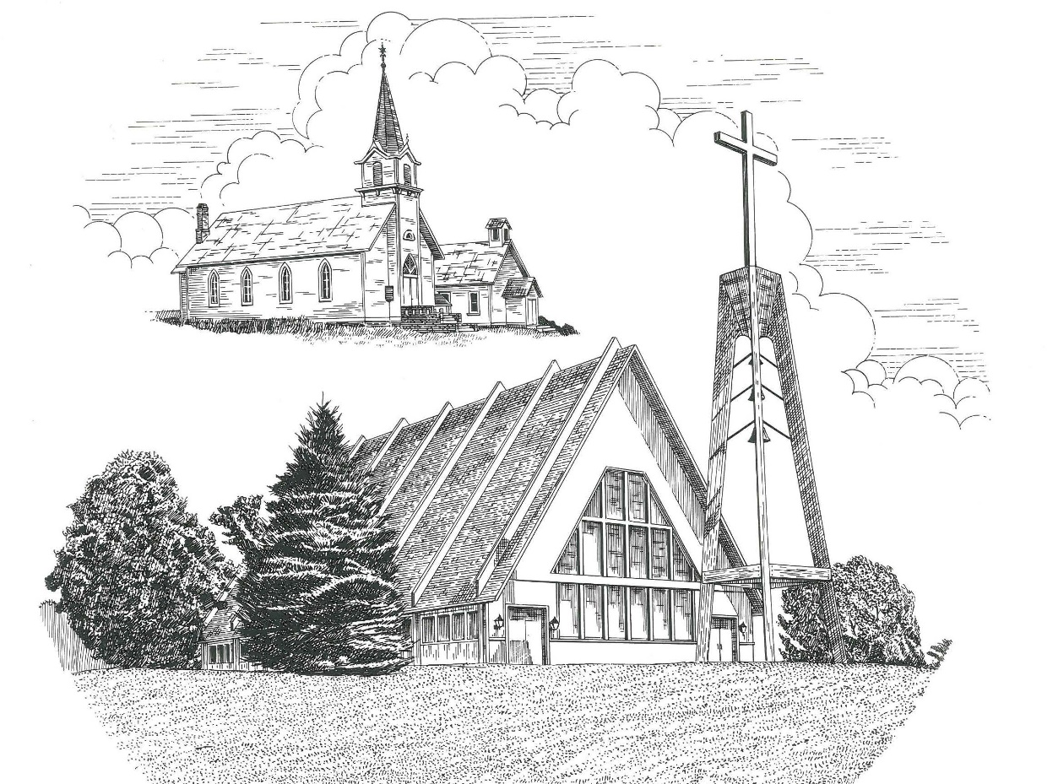

Twenty-Fifth Sunday after Pentecost November 14th, 2021

WELCOME
Thanks for joining us!
Pastor Jacob Sherry Missouri Synod

~~PLEASE NOTE~~
Calling on the name of the Lord
Does not include the use of cell phones in the worship sanctuary.
Please check yours before the service begins. Thank you for your courtesy.
~~TO OUR GUESTS AND VISITORS~~
Please sign our guest book located on the stand at the church entrance. During the service, we ask you to sign the attendance booklet located at the end of each pew. If you need assistance or have questions about our worship service, please talk to an elder or any one of our church family. We are glad you could join us and hope to have you worship with us again soon.

~~ATTENDING HOLY COMMUNION~~
By checking the “Communing Today” box on the registration form found in the attendance booklet, you are agreeing with the following statements:

- I am a baptized Christian who believes Jesus Christ is my Lord and Savior.
- I believe that I am a sinner in need of Christ freely offered forgiveness.
- I believe that in the Lord’s Supper the body and blood of Jesus Christ
are truly present in, with, and under the bread and wine.
- I believe that my participation in Holy Communion grants me forgiveness
of my sins, new spiritual life, and eternal salvation.
- With God’s help, I sincerely seek to repent of my sins, live in service
to my Lord, and await His return.

If you agree with the above statements, you are welcome to attend the Lord’s Supper with us. May God bless your worship time with us.
We do offer gluten-free wafers, please quietly ask an elder to help you.

Order of Divine Service Setting Four

Pre-Service Music……………..Call to Worship………………….Greeting

OPENING HYMN: “O God, My Faithful God”……………………….LSB #696

OPENING LITURGY:
Confession & Absolution……………………………………….LSB p. 203
Kyrie……………………………………………………………..LSB p. 204
Gloria in Excelsis………………………………………………..LSB p. 204
Salutation….…………………………………………………….LSB p. 205

Collect Prayer
O Lord, by Your bountiful goodness release us from the bonds of our sins, which by reason of our weakness we have brought upon ourselves, that we may stand firm until the day of our Lord Jesus Christ, who lives and reigns with You and the Holy Spirit, one God, now and forever.

THE HOLY SCRIPTURES

OLD TESTAMENT: (Daniel 12:1-3)
“At that time shall arise Michael, the great prince who has charge of your people. And there shall be a time of trouble, such as never has been since there was a nation till that time. But at that time your people shall be delivered, everyone whose name shall be found written in the book. ² And many of those who sleep in the dust of the earth shall awake, some to everlasting life, and some to shame and everlasting contempt. ³ And those who are wise shall shine like the brightness of the sky above; and those who turn many to righteousness, like the stars forever and ever.

R: This is the Word of the Lord. Cong: Thanks be to God.

GRADUAL
Reader: These are the ones coming out of the great tribulation.
Cong.: They have washed their robes and made them
white in the blood of the Lamb.
Reader: Blessed are those whose strength is in you,
Cong.: in whose heart are the highways to Zion.

EPISTLE: (Hebrews 10:11-25)
¹¹ And every priest stands daily at his service, offering repeatedly the same sacrifices, which can never take away sins. ¹² But when Christ had offered for all time a single sacrifice for sins, he sat down at the right hand of God, ¹³ waiting from that time until his enemies should be made a footstool for his feet. ¹⁴ For by a single offering he has perfected for all time those who are being sanctified. ¹⁵ And the Holy Spirit also bears witness to us; for after saying,
¹⁶ “This is the covenant that I will make with them
after those days, declares the Lord:
I will put my laws on their hearts,
and write them on their minds,”
¹⁷ then he adds,
“I will remember their sins and their lawless deeds no more.”

¹⁸ Where there is forgiveness of these, there is no longer any offering for sin. ¹⁹ Therefore, brothers, since we have confidence to enter the holy places by the blood of Jesus, ²⁰ by the new and living way that he opened for us through the curtain, that is, through his flesh, ²¹ and since we have a great priest over the house of God, ²² let us draw near with a true heart in full assurance of faith, with our hearts sprinkled clean from an evil conscience and our bodies washed with pure water. ²³ Let us hold fast the confession of our hope without wavering, for he who promised is faithful. ²⁴ And let us consider how to stir up one another to love and good works, ²⁵ not neglecting to meet together, as is the habit of some, but encouraging one another, and all the more as you see the Day drawing near.

R: This is the Word of the Lord. Cong: Thanks be to God.

(PLEASE RISE for the reading of the Gospel)

R: The Holy Gospel according to St. Mark, the 13th chapter.
Cong: Glory to You, O Lord

HOLY GOSPEL: (Mark 13:1-13)
And as Jesus came out of the temple, one of his disciples said to him, “Look, Teacher, what wonderful stones and what wonderful buildings!” ² And Jesus said to him, “Do you see these great buildings? There will not be left here one stone upon another that will not be thrown down.”
³ And as he sat on the Mount of Olives opposite the temple, Peter and James and John and Andrew asked him privately, ⁴ “Tell us, when will these things be, and what will be the sign when all these things are about to be accomplished?” ⁵ And Jesus began to say to them, “See that no one leads you astray. ⁶ Many will come in my name, saying, ‘I am he!’ and they will lead many astray. ⁷ And when you hear of wars and rumors of wars, do not be alarmed. This must take place, but the end is not yet. ⁸ For nation will rise against nation, and kingdom against kingdom. There will be earthquakes in various places; there will be famines. These are but the beginning of the birth pains.
⁹ “But be on your guard. For they will deliver you over to councils, and you will be beaten in synagogues, and you will stand before governors and kings for my sake, to bear witness before them. ¹⁰ And the gospel must first be proclaimed to all nations. ¹¹ And when they bring you to trial and deliver you over, do not be anxious beforehand what you are to say, but say whatever is given you in that hour, for it is not you who speak, but the Holy Spirit. ¹² And brother will deliver brother over to death, and the father his child, and children will rise against parents and have them put to death. ¹³ And you will be hated by all for my name's sake. But the one who endures to the end will be saved.
R: This is the Gospel of the Lord. Cong: Praise to You, O Christ.

Nicene Creed
I believe in one God, the Father Almighty, maker of heaven and earth and of all things visible and invisible.
And in one Lord Jesus Christ, the only-begotten Son of God, begotten of His Father before all worlds, God of God, Light of Light, very God of very God, begotten, not made, being of one substance with the Father, by whom all things were made; who for us men and for our salvation came down from heaven and was incarnate by the Holy Spirit of the virgin Mary and was made man; and was crucified also for us under Pontius Pilate. He suffered and was buried. And the third day He rose again according to the Scriptures and ascended into heaven and sits at the right hand of the Father. And He will come again with glory to judge both the living and the dead, whose kingdom will have no end.
And I believe in the Holy Spirit, the Lord and giver of life, who proceeds from the Father and the Son, who with the Father and the Son together is worshiped and glorified, who spoke by the prophets. And I believe in one holy Christian and apostolic Church, I acknowledge one Baptism for the remission of sins, and I look for the resurrection of the dead and the life of the world to come. Amen.

SERMON HYMN: “The Day Is Surely Drawing Near”………………..LSB #508

SERMON

THE GENERAL PRAYERS

INSTITUTION OF THE LORD’S SUPPER
Preface…………………………………….…………….………..LSB p. 208
Proper Preface
It is truly good, right, and salutary that we should at all times and in all places give thanks to You, O Lord, holy Father, almighty and everlasting God, for the countless blessings You so freely bestow on us and all creation. Above all, we give thanks for Your boundless love shown to us when You sent Your only-begotten Son, Jesus Christ, into our flesh and laid on Him our sin, giving Him into death that we might not die eternally. Because He is now risen from the dead and lives and reigns to all eternity, all who believe in Him will overcome sin and death and will rise again to new life. Therefore, with angels and archangels and with all the company of heaven we laud and magnify Your glorious name, ever more praising You and saying:

Sanctus, Lord’s Prayer, The Words of Our Lord………………….....LSB pp. 208-209
Agnus Dei………………………………………………………………..LSB p. 210
If you are not communing it is acceptable to remain seated.

COMMUNION DISTRIBUTION HYMNS:
LSB #628 “Your Table I Approach”
LSB #648 “Glorious Things of You Are Spoken”

CLOSING LITURGY:………………………………………………....LSB pp. 211-212

CLOSING HYMN: “Rejoice, Rejoice, Believers”..................................LSB #515

The Mission of Trinity Onekama Is To SERVE

For even the Son of Man did not come to be served
but to serve and to give his life as a ransom for many.
Mark 10:45

S haring Jesus’s truth
E quipping for life
R eaching Out
V aluing each other
E vangelizing all ages
Mission Statement
The mission of Trinity Onekama is to SERVE
For even the Son of Man did not come to be served, but to serve,
and to give his life as a ransom for many. Mark 10:45
S haring Jesus’ ruth
E quipping for life
R eaching Out
V aluing each other
E vangelizing all age

CHURCH INFORMATION
Church Office: (231) 889-4429 Website: www.trinityonekama.org
E-mail: trinityonekama@sbcglobal.net
Address: P.O. Box 119, 5471 Fairview Street, Onekama, MI 49675
Adult Bible Study: Sunday @ 9:15 am (year round)
Worship: Sunday @ 10:30 am The Lord’s Supper: Celebrated 2nd & 4th Sundays
Pastoral Hours: Wednesday and Friday 8:30am – Noon
Pastor Phone: 231-655-2680 Pastor Email: trinityonekama@gmail.com

Copyright licensing covered under CCLI #2802932

