231-889-4429 5471 Fairview Street, Box 119 Onekama, MI

TRINITY LUTHERAN CHURCH
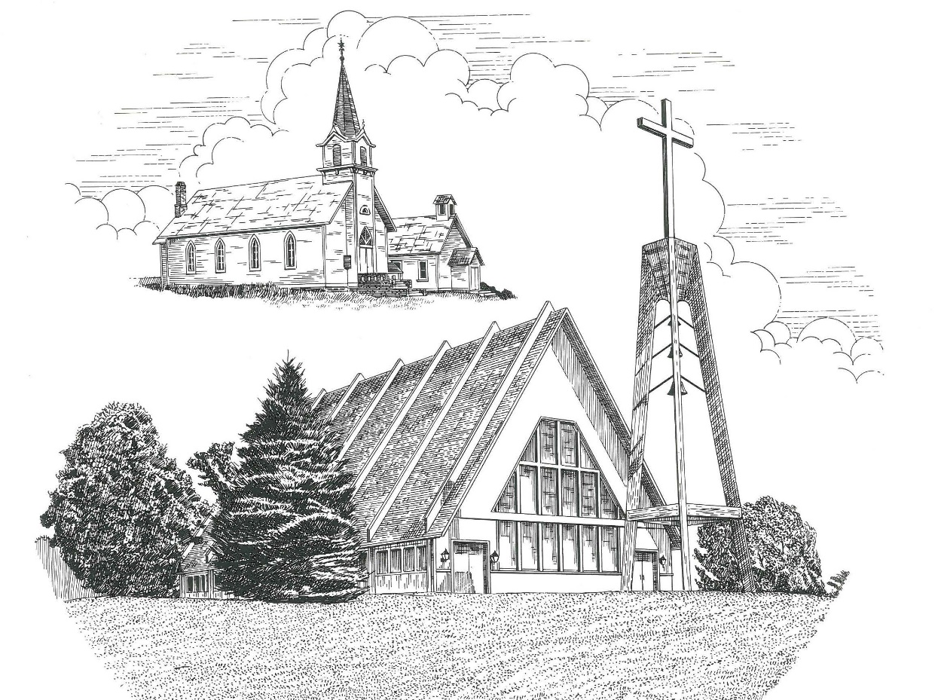

Stewardship Sunday/All Saints’ Day November 1st, 2020

WELCOME
Thanks for joining us!
Pastor Jacob Sherry Missouri Synod
~~PLEASE NOTE~~
Calling on the name of the Lord
Does not include the use of cell phones in the worship sanctuary.
Please check yours before the service begins. Thank you for your courtesy.
~~TO OUR GUESTS AND VISITORS~~
Please sign our guest book located on the stand at the church entrance. If you need assistance or have questions about our worship service, please talk to an elder or any one of our church family. We are glad you could join us and hope to have you worship with us again soon.

Order of Divine Service

Pre-Service Music……………..Call to Worship………………….Greeting

OPENING HYMN: “Be Still, My Soul”…………………………………….....LSB #752

INVOCATION
(P) In the name of the Father and of the Son and of the Holy Spirit.
(C) Amen.

PSALM 96:7-9
(P) ⁷ Ascribe to the Lord, O families of the peoples,
(C) ascribe to the Lord glory and strength!
(P) ⁸ Ascribe to the Lord the glory due his name;
(C) bring an offering, and come into his courts!
(P) ⁹ Worship the Lord in the splendor of holiness;
(C) tremble before him, all the earth!

CONFESSION
(P) If we say we have no sin, we deceive ourselves, and the truth is not in us.
(C) But if we confess our sins, God, who is faithful and just, will forgive our sins and cleanse us from all unrighteousness.

HYMN OF CONFESSION: “Forgive Us, Lord, for Shallow Thankfulness”…LSB #788

ABSOLUTION
(P) In the mercy of almighty God, Jesus Christ was given to die for us, and for His sake God forgives us all our sins. To those who believe in Jesus Christ He gives the power to become the children of God and bestows on them the Holy Spirit.
(C) May the Lord, who has begun this good work in us, bring it to completion in the day of our Lord Jesus Christ. Amen.

KYRIE

HYMN OF PRAISE: “We Praise You, O God”……………………………….LSB #785

(P) The Lord be with you.
(C) And also with you.
(P) Let us pray.
Collect Prayer
Merciful and gracious Lord, You cause Your Word to be proclaimed in every generation. Stir up our hearts and minds by Your Holy Spirit that we may receive this proclamation with humility and finally be exalted at the coming of Your Son, our Savior, Jesus Christ, who lives and reigns with You and the Holy Spirit, one God, now and forever.
(C) Amen.
THE HOLY SCRIPTURES

FIRST READING: (Revelation 7:9-17)
⁹ After this I looked, and behold, a great multitude that no one could number, from every nation, from all tribes and peoples and languages, standing before the throne and before the Lamb, clothed in white robes, with palm branches in their hands, ¹⁰ and crying out with a loud voice, “Salvation belongs to our God who sits on the throne, and to the Lamb!” ¹¹ And all the angels were standing around the throne and around the elders and the four living creatures, and they fell on their faces before the throne and worshiped God, ¹² saying, “Amen! Blessing and glory and wisdom and thanksgiving and honor and power and might be to our God forever and ever! Amen.”
¹³ Then one of the elders addressed me, saying, “Who are these, clothed in white robes, and from where have they come?” ¹⁴ I said to him, “Sir, you know.” And he said to me, “These are the ones coming out of the great tribulation. They have washed their robes and made them white in the blood of the Lamb.
¹⁵ “Therefore they are before the throne of God,
and serve him day and night in his temple;
and he who sits on the throne will shelter them with his presence.
¹⁶ They shall hunger no more, neither thirst anymore;
the sun shall not strike them,
nor any scorching heat.
¹⁷ For the Lamb in the midst of the throne will be their shepherd,
and he will guide them to springs of living water,
and God will wipe away every tear from their eyes.”

R: This is the Word of the Lord. Cong: Thanks be to God.

GRADUAL
Reader: These are the ones coming out of the great tribulation.
Cong.: They have washed their robes and made them white
in the blood of the Lamb.
Reader: Blessed are those whose strength is in you,
Cong.: in whose heart are the highways to Zion.

EPISTLE: (1 John 3:1-3)
See what kind of love the Father has given to us, that we should be called children of God; and so we are. The reason why the world does not know us is that it did not know him. ² Beloved, we are God's children now, and what we will be has not yet appeared; but we know that when he appears we shall be like him, because we shall see him as he is. ³ And everyone who thus hopes in him purifies himself as he is pure.

R: This is the Word of the Lord. Cong: Thanks be to God.

(PLEASE RISE for the reading of the Gospel)

R: The Holy Gospel according to St. Matthew, the 5th chapter.

HOLY GOSPEL: (Matthew 5:1-12)
Seeing the crowds, Jesus went up on the mountain, and when he sat down, his disciples came to him. ² And he opened his mouth and taught them, saying:
³ “Blessed are the poor in spirit, for theirs is the kingdom of heaven.
⁴ “Blessed are those who mourn, for they shall be comforted.
⁵ “Blessed are the meek, for they shall inherit the earth.
⁶ “Blessed are those who hunger and thirst for righteousness, for they shall be satisfied.
⁷ “Blessed are the merciful, for they shall receive mercy.
⁸ “Blessed are the pure in heart, for they shall see God.
⁹ “Blessed are the peacemakers, for they shall be called sons of God.
¹⁰ “Blessed are those who are persecuted for righteousness' sake, for theirs is the kingdom of heaven.
¹¹ “Blessed are you when others revile you and persecute you and utter all kinds of evil against you falsely on my account. ¹² Rejoice and be glad, for your reward is great in heaven, for so they persecuted the prophets who were before you.

R: This is the Gospel of the Lord.

THE CREED – The First Article
(ALL) I believe in God, the Father Almighty, maker of heaven and earth.

(P) What does this mean?
(ALL) I believe that God has made me and all creatures; that He has given me my body and soul, eyes, ears, and all my members, my reason and all my senses, and still takes care of them.

(Women) He also gives me clothing and shoes,
(Men) Food and drink,
(Women) House and home,
(Men) Wife and children, land, animals, and all that I have.

(ALL) He richly and daily provides me with all that I need to support this body and life. He defends me against all danger and guards and protects me from all evil. All this He does only out of fatherly, divine goodness and mercy, without any merit or worthiness in me. For all this it is my duty to thank and praise, serve and obey Him. This is most certainly true.

SERMON HYMN: “Take My Life and Let It Be”……...………………………LSB #783

SERMON

OFFERTORY HYMN: “We Give Thee But Thine Own”……………………..LSB #781
Verses 1 & 2
PRAYERS OF THE CHURCH

THE LORD’S PRAYER
INTROIT
(P) Offer right sacrifices, and put your trust in the Lord.
(C) With a freewill offering I will sacrifice to you; I will give thanks to your name, O Lord, for it is good.
(P) I must perform my vows to you, O God; I will render thank offerings to you.
(C) So will I ever sing praises to your name, as I perform my vows day after day.
(ALL) What shall I render to the Lord for all his benefits to me? I will offer the sacrifice of thanksgiving and call on the name of the Lord.

BENEDICTION
(P) The Lord bless you and keep you.
The Lord make His face shine on you and be gracious to you.
The Lord look upon you with favor and give you peace.
(C) Amen.

CLOSING HYMN: “For All the Saints”……………..………………………..LSB #677

The Mission of Trinity Onekama Is To SERVE

For even the Son of Man did not come to be served
but to serve and to give his life as a ransom for many.
Mark 10:45

S haring Jesus’s truth
E quipping for life
R eaching Out
V aluing each other
E vangelizing all ages
Mission Statement
The mission of Trinity Onekama is to SERVE
For even the Son of Man did not come to be served, but to serve,
and to give his life as a ransom for many. Mark 10:45
S haring Jesus’ ruth
E quipping for life
R eaching Out
V aluing each other
E vangelizing all age

CHURCH INFORMATION
Church Office: (231) 889-4429 Website: www.trinityonekama.org
E-mail: trinityonekama@sbcglobal.net
Address: P.O. Box 119, 5471 Fairview Street, Onekama, MI 49675
Adult Bible Study: Sunday @ 9:15 am (year round)
Worship: Sunday @ 10:30 am The Lord’s Supper: Celebrated 2nd & 4th Sundays
Pastoral Hours: Wednesday and Friday 8:30am – Noon
Pastor Phone: 231-655-2680 Pastor Email: trinityonekama@gmail.com

Copyright licensing covered under CCLI #2802932

