231-889-4429 5471 Fairview Street, Box 119 Onekama, MI

TRINITY LUTHERAN CHURCH
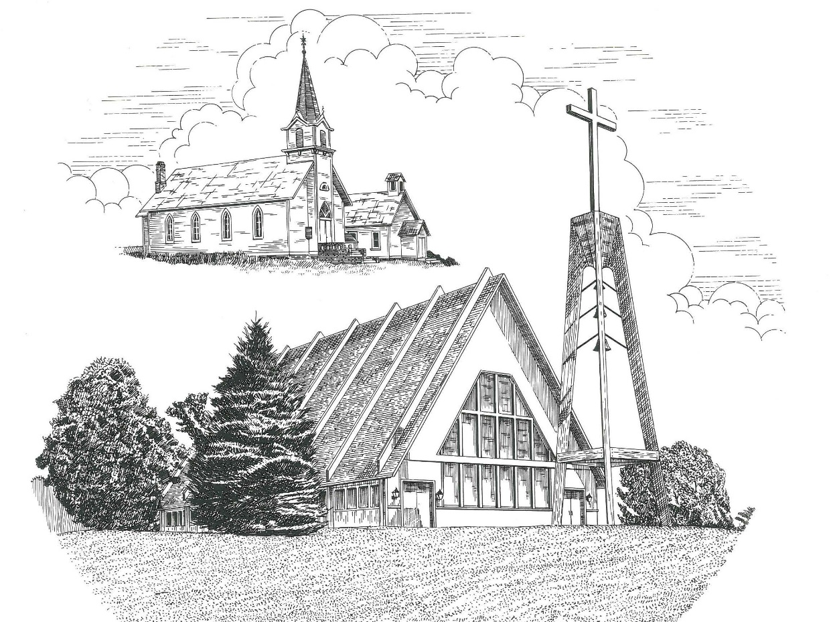

Last Sunday of the Church Year November 22nd, 2020

WELCOME
Thanks for joining us!
Pastor Jacob Sherry Missouri Synod

~~PLEASE NOTE~~
Calling on the name of the Lord
Does not include the use of cell phones in the worship sanctuary.
Please check yours before the service begins. Thank you for your courtesy.
~~TO OUR GUESTS AND VISITORS~~
Please sign our guest book located on the stand at the church entrance. During the service, we ask you to sign the attendance booklet located at the end of each pew. If you need assistance or have questions about our worship service, please talk to an elder or any one of our church family. We are glad you could join us and hope to have you worship with us again soon.

~~ATTENDING HOLY COMMUNION~~
By checking the “Communing Today” box on the registration form found in the attendance booklet, you are agreeing with the following statements:

- I am a baptized Christian who believes Jesus Christ is my Lord and Savior.
- I believe that I am a sinner in need of Christ freely offered forgiveness.
- I believe that in the Lord’s Supper the body and blood of Jesus Christ
are truly present in, with, and under the bread and wine.
- I believe that my participation in Holy Communion grants me forgiveness
of my sins, new spiritual life, and eternal salvation.
- With God’s help, I sincerely seek to repent of my sins, live in service
to my Lord, and await His return.

If you agree with the above statements, you are welcome to attend the Lord’s Supper with us. May God bless your worship time with us.
We do offer gluten-free wafers, please quietly ask an elder to help you.

Order of Divine Service Setting Three

Pre-Service Music……………..Call to Worship………………….Greeting

OPENING HYMN: “Hark the Glad Sound”..…………….....................LSB #349
OPENING LITURGY:
Confession & Absolution……………….……………………….LSB pp. 184-185
Kyrie…………………………………….………………………..LSB p. 186
Gloria in Excelsis………………………….……………………..LSB pp. 187-189
Salutation….……………………………….…………………….LSB p. 189

Collect Prayer
Eternal God, merciful Father, You have appointed Your Son as judge of the living and the dead. Enable us to wait for the day of His return with our eyes fixed on the kingdom prepared for Your own from the foundation of the world; through Jesus Christ, our Lord, who lives and reigns with You and the Holy Spirit, one God, now and forever.

THE HOLY SCRIPTURES

OLD TESTAMENT: (Ezekiel 34:11-16, 20-24)
¹¹ “For thus says the Lord God: Behold, I, I myself will search for my sheep and will seek them out. ¹² As a shepherd seeks out his flock when he is among his sheep that have been scattered, so will I seek out my sheep, and I will rescue them from all places where they have been scattered on a day of clouds and thick darkness. ¹³ And I will bring them out from the peoples and gather them from the countries, and will bring them into their own land. And I will feed them on the mountains of Israel, by the ravines, and in all the inhabited places of the country. ¹⁴ I will feed them with good pasture, and on the mountain heights of Israel shall be their grazing land. There they shall lie down in good grazing land, and on rich pasture they shall feed on the mountains of Israel. ¹⁵ I myself will be the shepherd of my sheep, and I myself will make them lie down, declares the Lord God. ¹⁶ I will seek the lost, and I will bring back the strayed, and I will bind up the injured, and I will strengthen the weak, and the fat and the strong I will destroy. I will feed them in justice.
²⁰ “Therefore, thus says the Lord God to them: Behold, I, I myself will judge between the fat sheep and the lean sheep. ²¹ Because you push with side and shoulder, and thrust at all the weak with your horns, till you have scattered them abroad, ²² I will rescue my flock; they shall no longer be a prey. And I will judge between sheep and sheep. ²³ And I will set up over them one shepherd, my servant David, and he shall feed them: he shall feed them and be their shepherd. ²⁴ And I, the Lord, will be their God, and my servant David shall be prince among them. I am the Lord; I have spoken.

R: This is the Word of the Lord. Cong: Thanks be to God.

GRADUAL
Reader: These are the ones coming out of the great tribulation.
Cong.: They have washed their robes and made them white
in the blood of the Lamb.
Reader: Blessed are those whose strength is in you,
Cong.: in whose heart are the highways to Zion.

EPISTLE: (1 Corinthians 15:20-28)
²⁰ But in fact Christ has been raised from the dead, the firstfruits of those who have fallen asleep. ²¹ For as by a man came death, by a man has come also the resurrection of the dead. ²² For as in Adam all die, so also in Christ shall all be made alive. ²³ But each in his own order: Christ the firstfruits, then at his coming those who belong to Christ. ²⁴ Then comes the end, when he delivers the kingdom to God the Father after destroying every rule and every authority and power. ²⁵ For he must reign until he has put all his enemies under his feet. ²⁶ The last enemy to be destroyed is death. ²⁷ For “God has put all things in subjection under his feet.” But when it says, “all things are put in subjection,” it is plain that he is excepted who put all things in subjection under him. ²⁸ When all things are subjected to him, then the Son himself will also be subjected to him who put all things in subjection under him, that God may be all in all.

R: This is the Word of the Lord. Cong: Thanks be to God.

(PLEASE RISE for the reading of the Gospel)

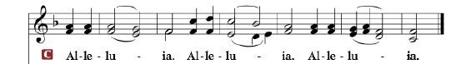

R: The Holy Gospel according to St. Matthew, the 25th chapter.

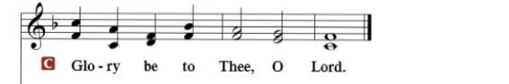

HOLY GOSPEL: (Matthew 25:31-46)
³¹ “When the Son of Man comes in his glory, and all the angels with him, then he will sit on his glorious throne. ³² Before him will be gathered all the nations, and he will separate people one from another as a shepherd separates the sheep from the goats. ³³ And he will place the sheep on his right, but the goats on the left. ³⁴ Then the King will say to those on his right, ‘Come, you who are blessed by my Father, inherit the kingdom prepared for you from the foundation of the world. ³⁵ For I was hungry and you gave me food, I was thirsty and you gave me drink, I was a stranger and you welcomed me, ³⁶ I was naked and you clothed me, I was sick and you visited me, I was in prison and you came to me.’ ³⁷ Then the righteous will answer him, saying, ‘Lord, when did we see you hungry and feed you, or thirsty and give you drink? ³⁸ And when did we see you a stranger and welcome you, or naked and clothe you? ³⁹ And when did we see you sick or in prison and visit you?’ ⁴⁰ And the King will answer them, ‘Truly, I say to you, as you did it to one of the least of these my brothers, you did it to me.’
⁴¹ “Then he will say to those on his left, ‘Depart from me, you cursed, into the eternal fire prepared for the devil and his angels. ⁴² For I was hungry and you gave me no food, I was thirsty and you gave me no drink, ⁴³ I was a stranger and you did not welcome me, naked and you did not clothe me, sick and in prison and you did not visit me.’ ⁴⁴ Then they also will answer, saying, ‘Lord, when did we see you hungry or thirsty or a stranger or naked or sick or in prison, and did not minister to you?’ ⁴⁵ Then he will answer them, saying, ‘Truly, I say to you, as you did not do it to one of the least of these, you did not do it to me.’ ⁴⁶ And these will go away into eternal punishment, but the righteous into eternal life.”

R: This is the Gospel of the Lord.

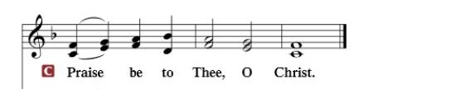

Nicene Creed…...……………………………………………………..…LSB p. 191
I believe in one God, the Father Almighty, maker of heaven and earth and of all things visible and invisible.
And in one Lord Jesus Christ, the only-begotten Son of God, begotten of His Father before all worlds, God of God, Light of Light, very God of very God, begotten, not made, being of one substance with the Father, by whom all things were made; who for us men and for our salvation came down from heaven and was incarnate by the Holy Spirit of the virgin Mary and was made man; and was crucified also for us under Pontius Pilate. He suffered and was buried. And the third day He rose again according to the Scriptures and ascended into heaven and sits at the right hand of the Father. And He will come again with glory to judge both the living and the dead, whose kingdom will have no end.
And I believe in the Holy Spirit, the Lord and giver of life, who proceeds from the Father and the Son, who with the Father and the Son together is worshiped and glorified, who spoke by the prophets. And I believe in one holy Christian and apostolic Church, I acknowledge one Baptism for the remission of sins, and I look for the resurrection of the dead and the life of the world to come. Amen.

SERMON HYMN: “God Loves Me Dearly”…………………………...LSB #392

SERMON

GATHERING OF OUR FIRST FRUITS & OFFERTORY…………LSB pp. 192-193

THE GENERAL PRAYERS OF THE CHURCH

INSTITUTION OF THE LORD’S SUPPER
Preface…………………………………….…………….……….LSB p. 194

Proper Preface
It is truly good, right, and salutary that we should at all times and in all places give thanks to You, holy Lord, almighty Father, everlasting God, through Jesus Christ, our Lord, who, out of love for His fallen creation, humbled Himself by taking on the form of a servant, becoming obedient unto death, even death upon a cross. Risen from the dead, He has freed us from eternal death and given us life everlasting. Therefore, with angels and archangels and with all the company of heaven we laud and magnify Your glorious name, ever more praising You and saying:

Sanctus, Lord’s Prayer, The Words of Our Lord………………….....LSB pp. 195-197
Agnus Dei………………………………………………………………..LSB p. 198
If you are not communing it is acceptable to remain seated.

COMMUNION DISTRIBUTION HYMNS:
LSB #397 “As with Gladness Men of Old”
LSB #434 “Lamb of God, Pure and Holy”

NUNC DIMITTIS………………………………………………………LSB pp. 199-200

BENEDICTION

CLOSING HYMN: “Now All the Vault of Heaven Resounds”...............LSB #465

The Mission of Trinity Onekama Is To SERVE

For even the Son of Man did not come to be served
but to serve and to give his life as a ransom for many.
Mark 10:45

S haring Jesus’s truth
E quipping for life
R eaching Out
V aluing each other
E vangelizing all ages
Mission Statement
The mission of Trinity Onekama is to SERVE
For even the Son of Man did not come to be served, but to serve,
and to give his life as a ransom for many. Mark 10:45
S haring Jesus’ ruth
E quipping for life
R eaching Out
V aluing each other
E vangelizing all age

CHURCH INFORMATION
Church Office: (231) 889-4429 Website: www.trinityonekama.org
E-mail: trinityonekama@sbcglobal.net
Address: P.O. Box 119, 5471 Fairview Street, Onekama, MI 49675
Adult Bible Study: Sunday @ 9:15 am (year round)
Worship: Sunday @ 10:30 am The Lord’s Supper: Celebrated 2nd & 4th Sundays
Pastoral Hours: Wednesday and Friday 8:30am – Noon
Pastor Phone: 231-655-2680 Pastor Email: trinityonekama@gmail.com

Copyright licensing covered under CCLI #2802932

