231-889-4429 5471 Fairview Street, Box 119 Onekama, MI

TRINITY LUTHERAN CHURCH
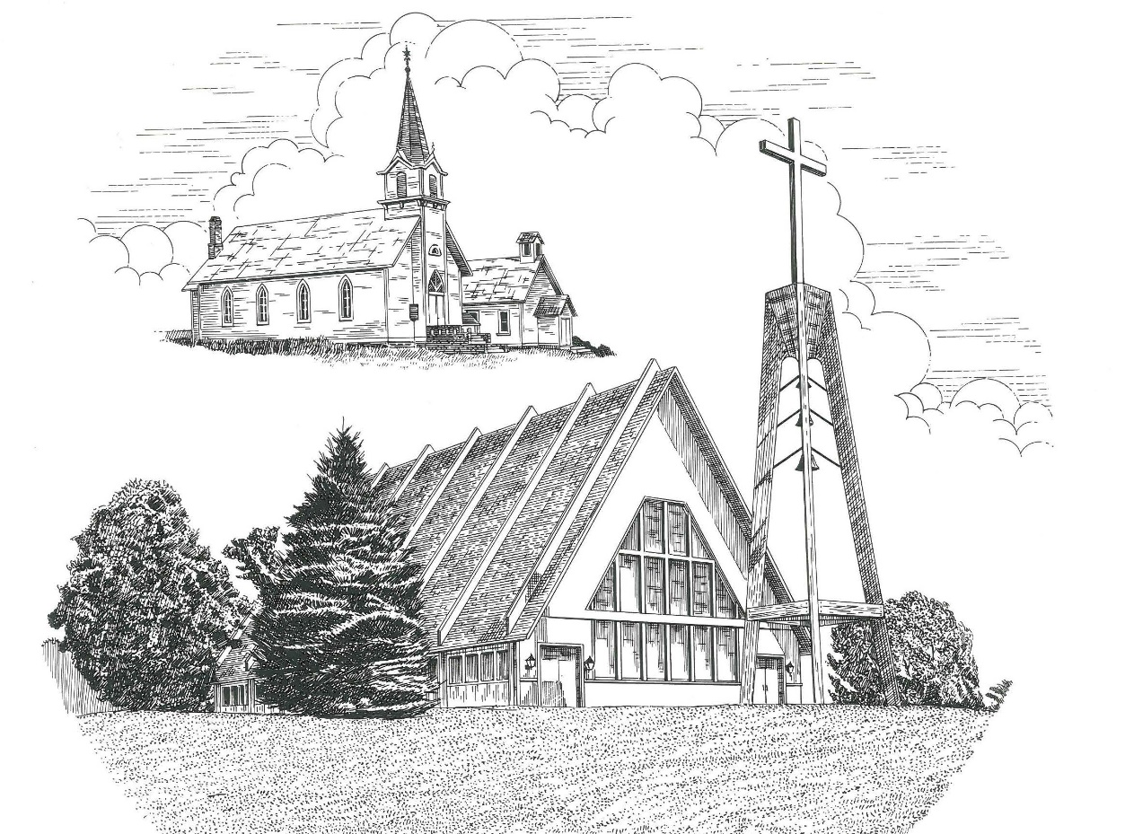

The Last Sunday of the Church Year November 24th, 2019

WELCOME
Thanks for joining us!
Pastor Jacob Sherry Missouri Synod

~~PLEASE NOTE~~
Calling on the name of the Lord
Does not include the use of cell phones in the worship sanctuary.
Please check yours before the service begins. Thank you for your courtesy.
~~TO OUR GUESTS AND VISITORS~~
Please sign our guest book located on the stand at the church entrance. During the service, we ask you to sign the attendance booklet located at the end of each pew. If you need assistance or have questions about our worship service, please talk to an elder or any one of our church family. We are glad you could join us and hope to have you worship with us again soon.

~~ATTENDING HOLY COMMUNION~~
By checking the “Communing Today” box on the registration form found in the attendance booklet, you are agreeing with the following statements:

- I am a baptized Christian who believes Jesus Christ is my Lord and Savior.
- I believe that I am a sinner in need of Christ freely offered forgiveness.
- I believe that in the Lord’s Supper the body and blood of Jesus Christ
are truly present in, with, and under the bread and wine.
- I believe that my participation in Holy Communion grants me forgiveness
of my sins, new spiritual life, and eternal salvation.
- With God’s help, I sincerely seek to repent of my sins, live in service
to my Lord, and await His return.

If you agree with the above statements, you are welcome to attend the Lord’s Supper with us. May God bless your worship time with us.
We do offer gluten-free wafers, please quietly ask an elder to help you.

Order of Divine Service Setting Four

Pre-Service Music……………..Call to Worship………………….Greeting

OPENING HYMN: “The Bridegroom Soon Will Call Us”…..……………….LSB #514
OPENING LITURGY:
Confession & Absolution……………………………………….LSB p. 203
Kyrie……………………………………………………………..LSB p. 204
Gloria in Excelsis………………………………………………..LSB p. 204
Salutation….…………………………………………………….LSB p. 205

Collect Prayer
Lord Jesus Christ, You reign among us by the preaching of Your cross. Forgive Your people their offenses that we, being governed by Your bountiful goodness, may enter at last into Your eternal paradise; for You live and reign with the Father and the Holy Spirit, one God, now and forever.

THE HOLY SCRIPTURES

OLD TESTAMENT: (Malachi 3:13-18)
¹³ “Your words have been hard against me, says the Lord. But you say, ‘How have we spoken against you?’ ¹⁴ You have said, ‘It is vain to serve God. What is the profit of our keeping his charge or of walking as in mourning before the Lord of hosts? ¹⁵ And now we call the arrogant blessed. Evildoers not only prosper but they put God to the test and they escape.’”
¹⁶ Then those who feared the Lord spoke with one another. The Lord paid attention and heard them, and a book of remembrance was written before him of those who feared the Lord and esteemed his name. ¹⁷ “They shall be mine, says the Lord of hosts, in the day when I make up my treasured possession, and I will spare them as a man spares his son who serves him. ¹⁸ Then once more you shall see the distinction between the righteous and the wicked, between one who serves God and one who does not serve him.

R: This is the Word of the Lord. Cong: Thanks be to God.

GRADUAL
Reader: These are the ones coming out of the great tribulation.
Cong.: They have washed their robes and made them white in the blood
of the Lamb.
Reader: Blessed are those whose strength is in you,
Cong.: in whose hearts are the highways to Zion.

EPISTLE: (Colossians 1:13-20)
¹³ He has delivered us from the domain of darkness and transferred us to the kingdom of his beloved Son, ¹⁴ in whom we have redemption, the forgiveness of sins. ¹⁵ He is the image of the invisible God, the firstborn of all creation. ¹⁶ For by him all things were created, in heaven and on earth, visible and invisible, whether thrones or dominions or rulers or authorities—all things were created through him and for him. ¹⁷ And he is before all things, and in him all things hold together. ¹⁸ And he is the head of the body, the church. He is the beginning, the firstborn from the dead, that in everything he might be preeminent. ¹⁹ For in him all the fullness of God was pleased to dwell, ²⁰ and through him to reconcile to himself all things, whether on earth or in heaven, making peace by the blood of his cross.

R: This is the Word of the Lord. Cong: Thanks be to God.

(PLEASE RISE for the reading of the Gospel)

R: The Holy Gospel according to St. Luke, the 23rd Chapter.
Cong: Glory to You, O Lord.

HOLY GOSPEL: (Luke 23:27-43)
²⁷ And there followed him a great multitude of the people and of women who were mourning and lamenting for him. ²⁸ But turning to them Jesus said, “Daughters of Jerusalem, do not weep for me, but weep for yourselves and for your children. ²⁹ For behold, the days are coming when they will say, ‘Blessed are the barren and the wombs that never bore and the breasts that never nursed!’ ³⁰ Then they will begin to say to the mountains, ‘Fall on us,’ and to the hills, ‘Cover us.’ ³¹ For if they do these things when the wood is green, what will happen when it is dry?”
³² Two others, who were criminals, were led away to be put to death with him. ³³ And when they came to the place that is called The Skull, there they crucified him, and the criminals, one on his right and one on his left. ³⁴ And Jesus said, “Father, forgive them, for they know not what they do.” And they cast lots to divide his garments. ³⁵ And the people stood by, watching, but the rulers scoffed at him, saying, “He saved others; let him save himself, if he is the Christ of God, his Chosen One!” ³⁶ The soldiers also mocked him, coming up and offering him sour wine ³⁷ and saying, “If you are the King of the Jews, save yourself!” ³⁸ There was also an inscription over him, “This is the King of the Jews.”
³⁹ One of the criminals who were hanged railed at him, saying, “Are you not the Christ? Save yourself and us!” ⁴⁰ But the other rebuked him, saying, “Do you not fear God, since you are under the same sentence of condemnation? ⁴¹ And we indeed justly, for we are receiving the due reward of our deeds; but this man has done nothing wrong.” ⁴² And he said, “Jesus, remember me when you come into your kingdom.” ⁴³ And he said to him, “Truly, I say to you, today you will be with me in paradise.”

R: This is the Gospel of the Lord.
Cong: Praise to You, O Christ.

Nicene Creed…...……………………………………………………..…LSB p. 206
I believe in one God, the Father Almighty, maker of heaven and earth and of all things visible and invisible.
And in one Lord Jesus Christ, the only-begotten Son of God, begotten of His Father before all worlds, God of God, Light of Light, very God of very God, begotten, not made, being of one substance with the Father, by whom all things were made; who for us men and for our salvation came down from heaven and was incarnate by the Holy Spirit of the virgin Mary and was made man; and was crucified also for us under Pontius Pilate. He suffered and was buried. And the third day He rose again according to the Scriptures and ascended into heaven and sits at the right hand of the Father. And He will come again with glory to judge both the living and the dead, whose kingdom will have no end.
And I believe in the Holy Spirit, the Lord and giver of life, who proceeds from the Father and the Son, who with the Father and the Son together is worshiped and glorified, who spoke by the prophets. And I believe in one holy Christian and apostolic Church, I acknowledge one Baptism for the remission of sins, and I look for the resurrection of the dead and the life of the world to come. Amen.

SERMON HYMN: “Wake, Awake, for Night Is Flying”……………….LSB #516

SERMON

THE GENERAL PRAYERS

GATHERING OF OUR FIRST FRUITS

Congregational Sharing of the Peace of the Lord
INSTITUTION OF THE LORD’S SUPPER
Preface…………………………………….…………….………..LSB p. 208
Proper Preface
It is truly good, right, and salutary that we should at all times and in all places give thanks to You, O Lord, holy Father, almighty and everlasting God, for the countless blessings You so freely bestow on us and all creation. Above all, we give thanks for Your boundless love shown to us when You sent Your only-begotten Son, Jesus Christ, into our flesh and laid on Him our sin, giving Him into death that we might not die eternally. Because He is now risen from the dead and lives and reigns to all eternity, all who believe in Him will overcome sin and death and will rise again to new life. Therefore, with angels and archangels and with all the company of heaven we laud and magnify Your glorious name, ever more praising You and saying:

Sanctus, Lord’s Prayer, The Words of Our Lord………………….....LSB pp. 208-209
Agnus Dei………………………………………………………………..LSB p. 210
If you are not communing it is acceptable to remaining seated.

COMMUNION DISTRIBUTION HYMNS:
LSB #549 “All Hail the Power of Jesus’ Name”
LSB #515 “Rejoice, Rejoice, Believers”

CLOSING LITURGY:………………………………………………....LSB pp. 211-212

CLOSING HYMN: “Rock of Ages, Cleft for Me”...................................LSB #761

The Mission of Trinity Onekama Is To SERVE

For even the Son of Man did not come to be served
but to serve and to give his life as a ransom for many.
Mark 10:45

S haring Jesus’s truth
E quipping for life
R eaching Out
V aluing each other
E vangelizing all ages
Mission Statement
The mission of Trinity Onekama is to SERVE
For even the Son of Man did not come to be served, but to serve,
and to give his life as a ransom for many. Mark 10:45
S haring Jesus’ ruth
E quipping for life
R eaching Out
V aluing each other
E vangelizing all age

CHURCH INFORMATION
Church Office: (231) 889-4429 Website: www.trinityonekama.org
E-mail: trinityonekama@sbcglobal.net
Address: P.O. Box 119, 5471 Fairview Street, Onekama, MI 49675
Adult Bible Study: Sunday @ 9:15 am (year round)
Worship: Sunday @ 10:30 am The Lord’s Supper: Celebrated 2nd & 4th Sundays
Pastoral Hours: Wednesday and Friday 8:30am – Noon
Pastor Phone: 231-655-2680 Pastor Email: trinityonekama@gmail.com

Copyright licensing covered under CCLI #2802932

