231-889-4429 5471 Fairview Street, Box 119 Onekama, MI

TRINITY LUTHERAN CHURCH
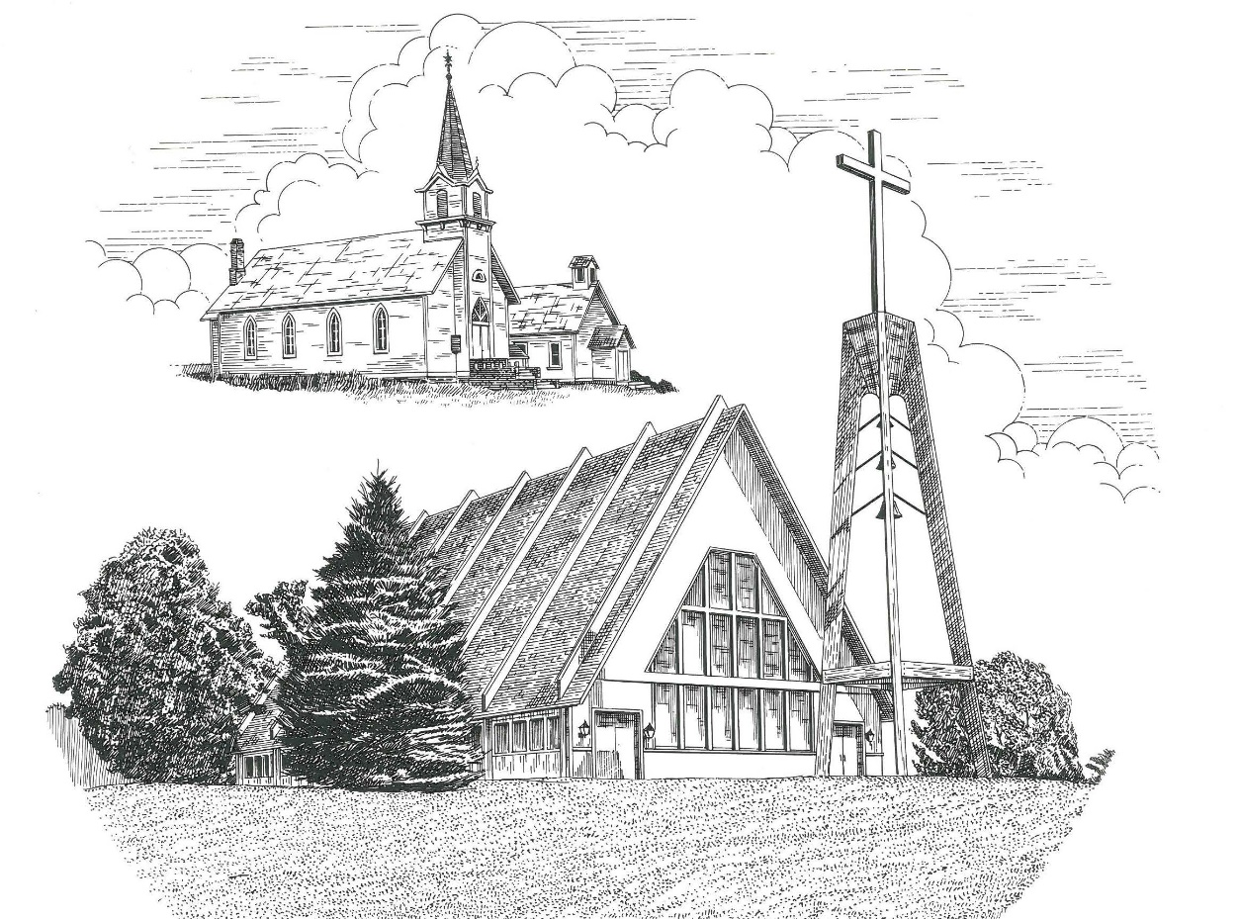

Twenty-First Sunday after Pentecost October 22nd, 2023

WELCOME
Thanks for joining us!
Pastor Jacob Sherry Missouri Synod

~~PLEASE NOTE~~
Calling on the name of the Lord
Does not include the use of cell phones in the worship sanctuary.
Please check yours before the service begins. Thank you for your courtesy.
~~TO OUR GUESTS AND VISITORS~~
Please sign our guest book located on the stand at the church entrance. During the service, we ask you to sign the attendance sheet located in your bulletin and place it on the pew when you leave. If you need assistance or have questions about our worship service, please talk to an elder or any one of our church family. We are glad you could join us and hope to have you worship with us again soon.

~~ATTENDING HOLY COMMUNION~~
By checking the “Communing Today” box on the registration form found on the attendance sheet, you are agreeing with the following statements:

- I am a baptized Christian who believes Jesus Christ is my Lord and Savior.
- I believe that I am a sinner in need of Christ’s freely offered forgiveness.
- I believe that in the Lord’s Supper the body and blood of Jesus Christ
are truly present in, with, and under the bread and wine.
- I believe that my participation in Holy Communion grants me forgiveness
of my sins, new spiritual life, and eternal salvation.
- With God’s help, I sincerely seek to repent of my sins, live in service
to my Lord, and await His return.

If you agree with the above statements, you are welcome to attend the Lord’s Supper with us. May God bless your worship time with us.
We do offer gluten-free wafers, please quietly ask an elder to help you.

Order of Divine Service Setting Three

Pre-Service Music……………..Call to Worship………………….Greeting

OPENING HYMN: “Church of God, Elect and Glorious”................................LSB #646

CONFESSION & ABSOLUTION
P: In the name of the Father and of the Son and of the Holy Spirit.
C: Amen.

P: Beloved in the Lord! Let us draw near with a true heart and confess our sins unto God our Father, beseeching Him in the name of our Lord Jesus Christ to grant us forgiveness.

P: Our help is in the name of the Lord,
C: who made heaven and earth.
P: I said, I will confess my transgressions unto the Lord,
C: and You forgave the iniquity of my sin.

P: O almighty God, merciful Father,
C: I, a poor, miserable sinner, confess unto You all my sins and iniquities with which I have ever offended You and justly deserve Your temporal and eternal punishment. But I am heartily sorry for them and sincerely repent of them, and I pray You of Your boundless mercy and for the sake of the holy, innocent, bitter sufferings and death of Your beloved Son, Jesus Christ, to be gracious and merciful to me, a poor, sinful being.

P: Upon this your confession, I, by virtue of my office, as a called and ordained servant of the Word, announce the grace of God unto all of you, and in the stead and by the command of my Lord Jesus Christ I forgive you all your sins in the name of the Father and of the Son and of the Holy Spirit.
C: Amen.

INTROIT
P: The Lord is your keeper;
C: The Lord is your shade on our right hand.
P: I lift up my eyes to the hills.
C: From where does my help come?
P: My help comes from the Lord,
C: who made heaven and earth.
P: He will not let your foot be moved;
C: he who keeps you will not slumber.
P: Behold, he who keeps Israel
C: will neither slumber nor sleep.
P: The Lord will keep you from all evil;
C: he will keep your life.
P: The Lord will keep your going out and your coming in
C: from this time forth and forevermore.

P: The Lord be with you.

P: Let us pray.
Collect Prayer
O God, the protector of all who trust in You, have mercy on us that with You as our ruler and guide we may so pass through things temporal that we lose not the things eternal; through Jesus Christ, Your Son, our Lord, who lives and reigns with You and the Holy Spirit, one God, now and forever.

THE HOLY SCRIPTURES

OLD TESTAMENT: (Isaiah 45:1-7)
Thus says the Lord to his anointed, to Cyrus,
whose right hand I have grasped,
to subdue nations before him
and to loose the belts of kings,
to open doors before him
that gates may not be closed:
² “I will go before you
and level the exalted places,
I will break in pieces the doors of bronze
and cut through the bars of iron,
³ I will give you the treasures of darkness
and the hoards in secret places,
that you may know that it is I, the Lord,
the God of Israel, who call you by your name.
⁴ For the sake of my servant Jacob,
and Israel my chosen,
I call you by your name,
I name you, though you do not know me.
⁵ I am the Lord, and there is no other,
besides me there is no God;
I equip you, though you do not know me,
⁶ that people may know, from the rising of the sun
and from the west, that there is none besides me;
I am the Lord, and there is no other.
⁷ I form light and create darkness;
I make well-being and create calamity;
I am the Lord, who does all these things.

R: This is the Word of the Lord. Cong: Thanks be to God.

GRADUAL
Reader: He will command his angels concerning you
Cong.: to guard you in all your ways.
Reader: Bless the Lord, O my soul,
Cong.: and all that is within me, bless his holy name!

EPISTLE: (1 Thessalonians 1:1-10)
Paul, Silvanus, and Timothy, To the church of the Thessalonians in God the Father and the Lord Jesus Christ: Grace to you and peace.
² We give thanks to God always for all of you, constantly mentioning you in our prayers, ³ remembering before our God and Father your work of faith and labor of love and steadfastness of hope in our Lord Jesus Christ. ⁴ For we know, brothers loved by God, that he has chosen you, ⁵ because our gospel came to you not only in word, but also in power and in the Holy Spirit and with full conviction. You know what kind of men we proved to be among you for your sake. ⁶ And you became imitators of us and of the Lord, for you received the word in much affliction, with the joy of the Holy Spirit, ⁷ so that you became an example to all the believers in Macedonia and in Achaia. ⁸ For not only has the word of the Lord sounded forth from you in Macedonia and Achaia, but your faith in God has gone forth everywhere, so that we need not say anything. ⁹ For they themselves report concerning us the kind of reception we had among you, and how you turned to God from idols to serve the living and true God, ¹⁰ and to wait for his Son from heaven, whom he raised from the dead, Jesus who delivers us from the wrath to come.

R: This is the Word of the Lord. Cong: Thanks be to God.

(PLEASE RISE for the reading of the Gospel)

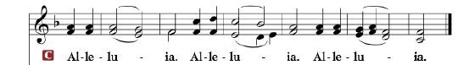

R: The Holy Gospel according to St. Matthew, the 22nd chapter.

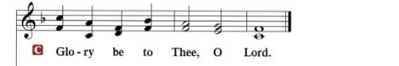

HOLY GOSPEL: (Matthew 22:15-22)
¹⁵ Then the Pharisees went and plotted how to entangle him in his words. ¹⁶ And they sent their disciples to him, along with the Herodians, saying, “Teacher, we know that you are true and teach the way of God truthfully, and you do not care about anyone's opinion, for you are not swayed by appearances. ¹⁷ Tell us, then, what you think. Is it lawful to pay taxes to Caesar, or not?” ¹⁸ But Jesus, aware of their malice, said, “Why put me to the test, you hypocrites? ¹⁹ Show me the coin for the tax.” And they brought him a denarius. ²⁰ And Jesus said to them, “Whose likeness and inscription is this?” ²¹ They said, “Caesar's.” Then he said to them, “Therefore render to Caesar the things that are Caesar's, and to God the things that are God's.” ²² When they heard it, they marveled. And they left him and went away.

R: This is the Gospel of the Lord.

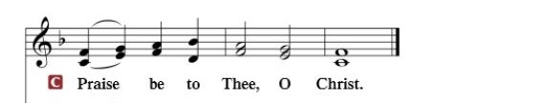

Nicene Creed
I believe in one God, the Father Almighty, maker of heaven and earth and of all things visible and invisible.
And in one Lord Jesus Christ, the only-begotten Son of God, begotten of His Father before all worlds, God of God, Light of Light, very God of very God, begotten, not made, being of one substance with the Father, by whom all things were made; who for us men and for our salvation came down from heaven and was incarnate by the Holy Spirit of the virgin Mary and was made man; and was crucified also for us under Pontius Pilate. He suffered and was buried. And the third day He rose again according to the Scriptures and ascended into heaven and sits at the right hand of the Father. And He will come again with glory to judge both the living and the dead, whose kingdom will have no end.
And I believe in the Holy Spirit, the Lord and giver of life, who proceeds from the Father and the Son, who with the Father and the Son together is worshiped and glorified, who spoke by the prophets. And I believe in one holy Christian and apostolic Church, I acknowledge one Baptism for the remission of sins, and I look for the resurrection of the dead and the life of the world to come. Amen.

SERMON HYMN: “Holy God, We Praise Your Name”…………….…LSB #940

SERMON

COLLECTION OF THE OFFERING

GENERAL PRAYERS OF THE CHURCH

Sharing the Peace of the Lord

SERVICE OF THE SACRAMENT
P: The Lord be with you.

P: Lift up your hearts

P: Let us give thanks unto the Lord, our God.

Proper Preface
It is truly good, right, and salutary that we should at all times and in all places give thanks to You, holy Lord, almighty Father, everlasting God, through Jesus Christ, our Lord, who, having created all things, took on human flesh and was born of the virgin Mary. For our sake He died on the cross and rose from the dead to put an end to death, thus fulfilling Your will and gaining for You a holy people. Therefore, with angels and archangels and with all the company of heaven we laud and magnify Your glorious name, ever more praising You and saying:

THE LORD’S PRAYER

THE WORDS OF OUR LORD

P: The peace of the Lord be with you always.

If you are not communing, it is acceptable to remain seated.

COMMUNION DISTRIBUTION HYMNS:
LSB #801 “How Great Thou Art”
LSB #743 “Jesus, Priceless Treasure”
LSB #582 “God’s Word Is Our Great Heritage”

P: O give thanks unto the Lord, for He is good.

P: We give thanks to You, almighty God, that You have refreshed us through this salutary gift, and we implore You that of Your mercy You would strengthen us through the same in faith toward You and in fervent love toward one another; through Jesus Christ, Your Son, our Lord, who lives and reigns with You and the Holy Spirit, one God, now and forever.

P: The Lord be with you.

P: Bless we the Lord.

P: The Lord bless you and keep you. The Lord make His face shine upon you and be gracious unto you. The Lord lift up His countenance upon you and give you peace.

CLOSING HYMN: “The Lord, My God, Be Praised”...........................LSB #794

The Mission of Trinity Onekama Is To SERVE

For even the Son of Man did not come to be served
but to serve and to give his life as a ransom for many.
Mark 10:45

S haring Jesus’s truth
E quipping for life
R eaching Out
V aluing each other
E vangelizing all ages
Mission Statement
The mission of Trinity Onekama is to SERVE
For even the Son of Man did not come to be served, but to serve,
and to give his life as a ransom for many. Mark 10:45
S haring Jesus’ ruth
E quipping for life
R eaching Out
V aluing each other
E vangelizing all age

CHURCH INFORMATION
Church Office: (231) 889-4429 Website: www.trinityonekama.org
E-mail: trinityonekama@sbcglobal.net
Address: P.O. Box 119, 5471 Fairview Street, Onekama, MI 49675
Sunday School & Adult Bible Study: Sunday @ 9:30 am
Worship: Sunday @ 10:30 am The Lord’s Supper: Celebrated 2nd & 4th Sundays
Pastoral Hours: Wednesday and Friday 9:00am – Noon
Pastor Phone: 231-655-2680 Pastor Email: trinityonekama@gmail.com

Copyright licensing covered under CCLI #2802932

