231-889-4429 5471 Fairview Street, Box 119 Onekama, MI

TRINITY LUTHERAN CHURCH
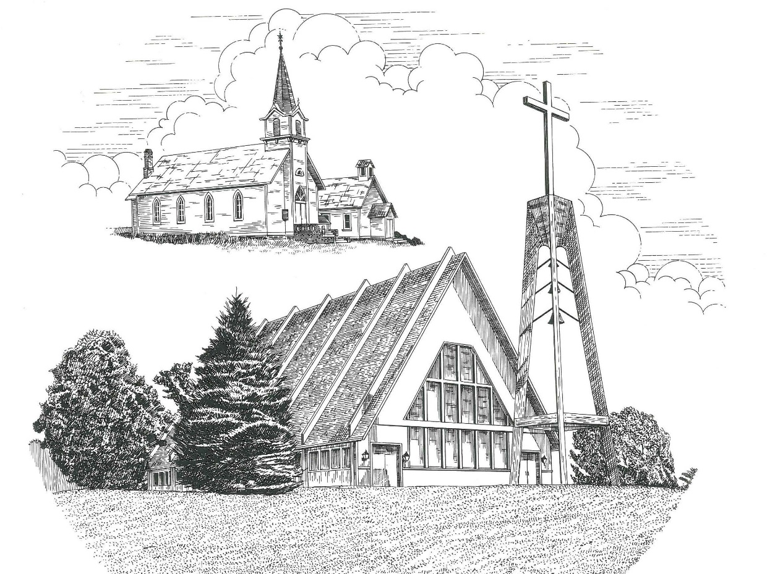

Twentieth Sunday after Pentecost October 23rd, 2022

WELCOME
Thanks for joining us!
Pastor Jacob Sherry Missouri Synod

~~PLEASE NOTE~~
Calling on the name of the Lord
Does not include the use of cell phones in the worship sanctuary.
Please check yours before the service begins. Thank you for your courtesy.
~~TO OUR GUESTS AND VISITORS~~
Please sign our guest book located on the stand at the church entrance. During the service, we ask you to sign the attendance sheet located in your bulletin and place it on the pew when you leave. If you need assistance or have questions about our worship service, please talk to an elder or any one of our church family. We are glad you could join us and hope to have you worship with us again soon.

~~ATTENDING HOLY COMMUNION~~
By checking the “Communing Today” box on the registration form found on the attendance sheet, you are agreeing with the following statements:

- I am a baptized Christian who believes Jesus Christ is my Lord and Savior.
- I believe that I am a sinner in need of Christ’s freely offered forgiveness.
- I believe that in the Lord’s Supper the body and blood of Jesus Christ
are truly present in, with, and under the bread and wine.
- I believe that my participation in Holy Communion grants me forgiveness
of my sins, new spiritual life, and eternal salvation.
- With God’s help, I sincerely seek to repent of my sins, live in service
to my Lord, and await His return.

If you agree with the above statements, you are welcome to attend the Lord’s Supper with us. May God bless your worship time with us.
We do offer gluten-free wafers, please quietly ask an elder to help you.

Order of Divine Service Setting Three

Pre-Service Music……………..Call to Worship………………….Greeting

OPENING HYMN: “O Blessed, Holy Trinity”.......................................LSB #876
OPENING LITURGY:
Confession & Absolution………..………………………………LSB pp. 184-185
Kyrie…………………………………….………………………..LSB p. 186
Gloria in Excelsis………………………………………………...LSB pp. 187-189
Salutation….……………………………….…………………….LSB p. 189

Collect Prayer
Almighty and everlasting God, You are always more ready to hear than we to pray and always ready to give more than we either desire or deserve. Pour down on us the abundance of Your mercy; forgive us those things of which our conscience is afraid; and give us those good things for which we are not worthy to ask except by the merits and mediation of Jesus Christ, Your Son, our Lord, who lives and reigns with You and the Holy Spirit, one God, now and forever.

THE HOLY SCRIPTURES

OLD TESTAMENT: (Genesis 4:1-15)
Now Adam knew Eve his wife, and she conceived and bore Cain, saying, “I have gotten a man with the help of the Lord.” ² And again, she bore his brother Abel. Now Abel was a keeper of sheep, and Cain a worker of the ground. ³ In the course of time Cain brought to the Lord an offering of the fruit of the ground, ⁴ and Abel also brought of the firstborn of his flock and of their fat portions. And the Lord had regard for Abel and his offering, ⁵ but for Cain and his offering he had no regard. So Cain was very angry, and his face fell. ⁶ The Lord said to Cain, “Why are you angry, and why has your face fallen? ⁷ If you do well, will you not be accepted? And if you do not do well, sin is crouching at the door. Its desire is contrary to you, but you must rule over it.”
⁸ Cain spoke to Abel his brother. And when they were in the field, Cain rose up against his brother Abel and killed him. ⁹ Then the Lord said to Cain, “Where is Abel your brother?” He said, “I do not know; am I my brother's keeper?” ¹⁰ And the Lord said, “What have you done? The voice of your brother's blood is crying to me from the ground. ¹¹ And now you are cursed from the ground, which has opened its mouth to receive your brother's blood from your hand. ¹² When you work the ground, it shall no longer yield to you its strength. You shall be a fugitive and a wanderer on the earth.” ¹³ Cain said to the Lord, “My punishment is greater than I can bear. ¹⁴ Behold, you have driven me today away from the ground, and from your face I shall be hidden. I shall be a fugitive and a wanderer on the earth, and whoever finds me will kill me.” ¹⁵ Then the Lord said to him, “Not so! If anyone kills Cain, vengeance shall be taken on him sevenfold.” And the Lord put a mark on Cain, lest any who found him should attack him.

R: This is the Word of the Lord. Cong: Thanks be to God.

GRADUAL
Reader: He will command his angels concerning you
Cong.: to guard you in all your ways.
Reader: Bless the Lord, O my soul,
Cong.: and all that is within me, bless his holy name!

EPISTLE: (Revelation 21:1-8)
Then I saw a new heaven and a new earth, for the first heaven and the first earth had passed away, and the sea was no more. ² And I saw the holy city, new Jerusalem, coming down out of heaven from God, prepared as a bride adorned for her husband. ³ And I heard a loud voice from the throne saying, “Behold, the dwelling place of God is with man. He will dwell with them, and they will be his people, and God himself will be with them as their God. ⁴ He will wipe away every tear from their eyes, and death shall be no more, neither shall there be mourning, nor crying, nor pain anymore, for the former things have passed away.”
⁵ And he who was seated on the throne said, “Behold, I am making all things new.” Also he said, “Write this down, for these words are trustworthy and true.” ⁶ And he said to me, “It is done! I am the Alpha and the Omega, the beginning and the end. To the thirsty I will give from the spring of the water of life without payment. ⁷ The one who conquers will have this heritage, and I will be his God and he will be my son. ⁸ But as for the cowardly, the faithless, the detestable, as for murderers, the sexually immoral, sorcerers, idolaters, and all liars, their portion will be in the lake that burns with fire and sulfur, which is the second death.”

R: This is the Word of the Lord. Cong: Thanks be to God.

(PLEASE RISE for the reading of the Gospel)

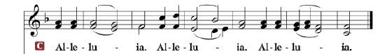

R: The Holy Gospel according to St. Luke, the 18th chapter.

HOLY GOSPEL: (Luke 18:9-17)
⁹ Jesus also told this parable to some who trusted in themselves that they were righteous, and treated others with contempt: ¹⁰ “Two men went up into the temple to pray, one a Pharisee and the other a tax collector. ¹¹ The Pharisee, standing by himself, prayed thus: ‘God, I thank you that I am not like other men, extortioners, unjust, adulterers, or even like this tax collector. ¹² I fast twice a week; I give tithes of all that I get.’ ¹³ But the tax collector, standing far off, would not even lift up his eyes to heaven, but beat his breast, saying, ‘God, be merciful to me, a sinner!’ ¹⁴ I tell you, this man went down to his house justified, rather than the other. For everyone who exalts himself will be humbled, but the one who humbles himself will be exalted.”
¹⁵ Now they were bringing even infants to him that he might touch them. And when the disciples saw it, they rebuked them. ¹⁶ But Jesus called them to him, saying, “Let the children come to me, and do not hinder them, for to such belongs the kingdom of God. ¹⁷ Truly, I say to you, whoever does not receive the kingdom of God like a child shall not enter it.”

R: This is the Gospel of the Lord.

Nicene Creed
I believe in one God, the Father Almighty, maker of heaven and earth and of all things visible and invisible.
And in one Lord Jesus Christ, the only-begotten Son of God, begotten of His Father before all worlds, God of God, Light of Light, very God of very God, begotten, not made, being of one substance with the Father, by whom all things were made; who for us men and for our salvation came down from heaven and was incarnate by the Holy Spirit of the virgin Mary and was made man; and was crucified also for us under Pontius Pilate. He suffered and was buried. And the third day He rose again according to the Scriptures and ascended into heaven and sits at the right hand of the Father. And He will come again with glory to judge both the living and the dead, whose kingdom will have no end.
And I believe in the Holy Spirit, the Lord and giver of life, who proceeds from the Father and the Son, who with the Father and the Son together is worshiped and glorified, who spoke by the prophets. And I believe in one holy Christian and apostolic Church, I acknowledge one Baptism for the remission of sins, and I look for the resurrection of the dead and the life of the world to come. Amen.

SERMON HYMN: “Lo! He Comes with Clouds Descending”………..LSB #336

SERMON

OFFERTORY…………………………………………………………...LSB pp. 192-193

GENERAL PRAYERS OF THE CHURCH

Sharing the Peace of the Lord

SERVICE OF THE SACRAMENT
Preface…………………………………….…………….……….LSB p. 194
Proper Preface
It is truly good, right, and salutary that we should at all times and in all places give thanks to You, holy Lord, almighty Father, everlasting God, through Jesus Christ, our Lord, who, out of love for His fallen creation, humbled Himself by taking on the form of a servant, becoming obedient unto death, even death upon a cross. Risen from the dead, He has freed us from eternal death and given us life everlasting. Therefore, with angels and archangels and with all the company of heaven we laud and magnify Your glorious name, ever more praising You and saying:

Sanctus, Lord’s Prayer, The Words of Our Lord………………….....LSB pp. 195-197
Agnus Dei………………………………………………………………..LSB p. 198
If you are not communing, it is acceptable to remain seated.

COMMUNION DISTRIBUTION HYMNS:
LSB #615 “When in the Hour of Deepest Need”
LSB #642 “O Living Bread from Heaven”
LSB #632 “O Jesus, Blessed Lord, to Thee”

NUNC DIMITTIS………………………………………………………LSB pp. 199-200

BENEDICTION

CLOSING HYMN: “A Hymn of Glory Let Us Sing”.............................LSB #493

The Mission of Trinity Onekama Is To SERVE

For even the Son of Man did not come to be served
but to serve and to give his life as a ransom for many.
Mark 10:45

S haring Jesus’s truth
E quipping for life
R eaching Out
V aluing each other
E vangelizing all ages
Mission Statement
The mission of Trinity Onekama is to SERVE
For even the Son of Man did not come to be served, but to serve,
and to give his life as a ransom for many. Mark 10:45
S haring Jesus’ ruth
E quipping for life
R eaching Out
V aluing each other
E vangelizing all age

CHURCH INFORMATION
Church Office: (231) 889-4429 Website: www.trinityonekama.org
E-mail: trinityonekama@sbcglobal.net
Address: P.O. Box 119, 5471 Fairview Street, Onekama, MI 49675
Adult Bible Study: Sunday @ 11:30 am (year round)
Worship: Sunday @ 10:30 am The Lord’s Supper: Celebrated 2nd & 4th Sundays
Pastoral Hours: Wednesday and Friday 9:00am – Noon
Pastor Phone: 231-655-2680 Pastor Email: trinityonekama@gmail.com

Copyright licensing covered under CCLI #2802932

