231-889-4429 5471 Fairview Street, Box 119 Onekama, MI

TRINITY LUTHERAN CHURCH
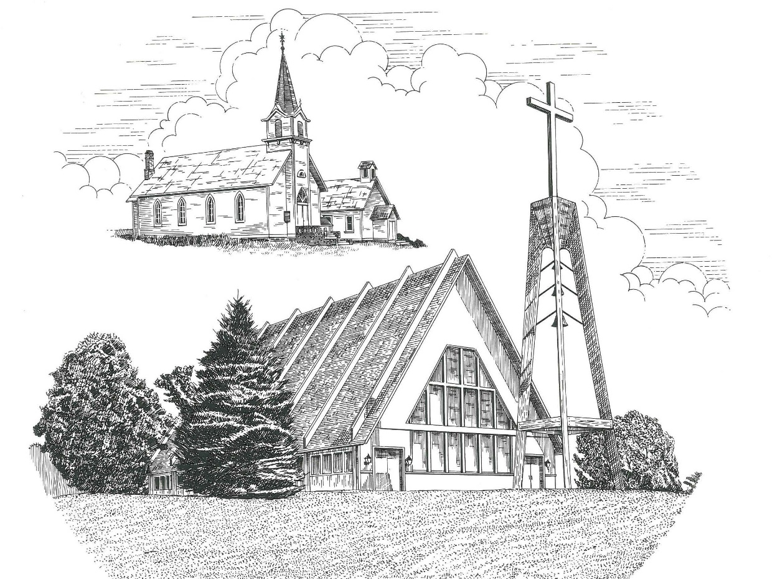

Nineteenth Sunday after Pentecost October 8th, 2023

WELCOME
Thanks for joining us!
Pastor Jacob Sherry Missouri Synod

~~PLEASE NOTE~~
Calling on the name of the Lord
Does not include the use of cell phones in the worship sanctuary.
Please check yours before the service begins. Thank you for your courtesy.
~~TO OUR GUESTS AND VISITORS~~
Please sign our guest book located on the stand at the church entrance. During the service, we ask you to sign the attendance sheet located in your bulletin and place it on the pew when you leave. If you need assistance or have questions about our worship service, please talk to an elder or any one of our church family. We are glad you could join us and hope to have you worship with us again soon.

~~ATTENDING HOLY COMMUNION~~
By checking the “Communing Today” box on the registration form found on the attendance sheet, you are agreeing with the following statements:

- I am a baptized Christian who believes Jesus Christ is my Lord and Savior.
- I believe that I am a sinner in need of Christ’s freely offered forgiveness.
- I believe that in the Lord’s Supper the body and blood of Jesus Christ
are truly present in, with, and under the bread and wine.
- I believe that my participation in Holy Communion grants me forgiveness
of my sins, new spiritual life, and eternal salvation.
- With God’s help, I sincerely seek to repent of my sins, live in service
to my Lord, and await His return.

If you agree with the above statements, you are welcome to attend the Lord’s Supper with us. May God bless your worship time with us.
We do offer gluten-free wafers, please quietly ask an elder to help you.

Order of Divine Service Setting Three

Pre-Service Music……………..Call to Worship………………….Greeting

OPENING HYMN: “Blessed Jesus, at Your Word”................................LSB #904

OPENING LITURGY:
Confession & Absolution………..………………………………LSB pp. 184-185

INTROIT
P: O give thanks to the Lord, for he is good;
C: for his steadfast love endures forever!
P: The stone that the builders rejected
C: has become the cornerstone.
P: This is the Lord’s doing;
C: it is marvelous in our eyes.
P: This is the day that the Lord has made;
C: let us rejoice and be glad in it.
ALL: Glory be to the Father and to the Son and to the Holy Spirit; as it was in the
beginning, is now, and will be forever. Amen.
P: O give thanks to the Lord, for he is good;
C: for his steadfast love endures forever!

Kyrie…………………………………….………………………..LSB p. 186
Gloria in Excelsis………………………………………………...LSB pp. 187-189
Salutation….……………………………….…………………….LSB p. 189

Collect Prayer
Gracious God, You gave Your Son into the hands of sinful men who killed Him. Forgive us when we reject Your unfailing love, and grant us the fullness of Your salvation; through Jesus Christ, Your Son, our Lord, who lives and reigns with You and the Holy Spirit, one God, now and forever.

THE HOLY SCRIPTURES

OLD TESTAMENT: (Isaiah 5:1-7)
Let me sing for my beloved
my love song concerning his vineyard:
My beloved had a vineyard
on a very fertile hill.
² He dug it and cleared it of stones,
and planted it with choice vines;
he built a watchtower in the midst of it,
and hewed out a wine vat in it;
and he looked for it to yield grapes,
but it yielded wild grapes.
³ And now, O inhabitants of Jerusalem
and men of Judah,
judge between me and my vineyard.
⁴ What more was there to do for my vineyard,
that I have not done in it?
When I looked for it to yield grapes,
why did it yield wild grapes?
⁵ And now I will tell you
what I will do to my vineyard.
I will remove its hedge,
and it shall be devoured;
I will break down its wall,
and it shall be trampled down.
⁶ I will make it a waste;
it shall not be pruned or hoed,
and briers and thorns shall grow up;
I will also command the clouds
that they rain no rain upon it.
⁷ For the vineyard of the Lord of hosts
is the house of Israel,
and the men of Judah
are his pleasant planting;
and he looked for justice,
but behold, bloodshed;
for righteousness,
but behold, an outcry!

R: This is the Word of the Lord. Cong: Thanks be to God.

GRADUAL
Reader: He will command his angels concerning you
Cong.: to guard you in all your ways.
Reader: Bless the Lord, O my soul,
Cong.: and all that is within me, bless his holy name!

EPISTLE: (Philippians 3:4b-14)
⁴ If anyone else thinks he has reason for confidence in the flesh, I have more: ⁵circumcised on the eighth day, of the people of Israel, of the tribe of Benjamin, a Hebrew of Hebrews; as to the law, a Pharisee; ⁶ as to zeal, a persecutor of the church; as to righteousness under the law, blameless. ⁷ But whatever gain I had, I counted as loss for the sake of Christ. ⁸ Indeed, I count everything as loss because of the surpassing worth of knowing Christ Jesus my Lord. For his sake I have suffered the loss of all things and count them as rubbish, in order that I may gain Christ ⁹ and be found in him, not having a righteousness of my own that comes from the law, but that which comes through faith in Christ, the righteousness from God that depends on faith— ¹⁰ that I may know him and the power of his resurrection, and may share his sufferings, becoming like him in his death, ¹¹ that by any means possible I may attain the resurrection from the dead.
¹² Not that I have already obtained this or am already perfect, but I press on to make it my own, because Christ Jesus has made me his own. ¹³ Brothers, I do not consider that I have made it my own. But one thing I do: forgetting what lies behind and straining forward to what lies ahead, ¹⁴ I press on toward the goal for the prize of the upward call of God in Christ Jesus.

R: This is the Word of the Lord. Cong: Thanks be to God.

(PLEASE RISE for the reading of the Gospel)

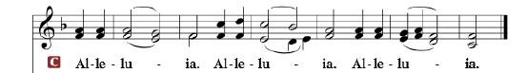

R: The Holy Gospel according to St. Matthew, the 21st chapter.

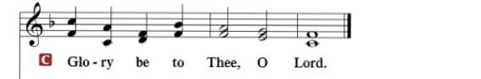

HOLY GOSPEL: (Matthew 21:33-46)
³³ “Hear another parable. There was a master of a house who planted a vineyard and put a fence around it and dug a winepress in it and built a tower and leased it to tenants, and went into another country. ³⁴ When the season for fruit drew near, he sent his servants to the tenants to get his fruit. ³⁵ And the tenants took his servants and beat one, killed another, and stoned another. ³⁶ Again he sent other servants, more than the first. And they did the same to them. ³⁷ Finally he sent his son to them, saying, ‘They will respect my son.’ ³⁸ But when the tenants saw the son, they said to themselves, ‘This is the heir. Come, let us kill him and have his inheritance.’ ³⁹ And they took him and threw him out of the vineyard and killed him. ⁴⁰ When therefore the owner of the vineyard comes, what will he do to those tenants?” ⁴¹ They said to him, “He will put those wretches to a miserable death and let out the vineyard to other tenants who will give him the fruits in their seasons.”
⁴² Jesus said to them, “Have you never read in the Scriptures:
“‘The stone that the builders rejected
has become the cornerstone;
this was the Lord's doing,
and it is marvelous in our eyes’?
⁴³ Therefore I tell you, the kingdom of God will be taken away from you and given to a people producing its fruits. ⁴⁴ And the one who falls on this stone will be broken to pieces; and when it falls on anyone, it will crush him.”
⁴⁵ When the chief priests and the Pharisees heard his parables, they perceived that he was speaking about them. ⁴⁶ And although they were seeking to arrest him, they feared the crowds, because they held him to be a prophet.

R: This is the Gospel of the Lord.

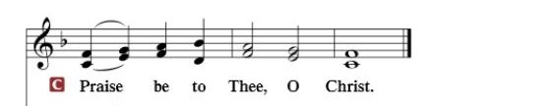

Nicene Creed
I believe in one God, the Father Almighty, maker of heaven and earth and of all things visible and invisible.
And in one Lord Jesus Christ, the only-begotten Son of God, begotten of His Father before all worlds, God of God, Light of Light, very God of very God, begotten, not made, being of one substance with the Father, by whom all things were made; who for us men and for our salvation came down from heaven and was incarnate by the Holy Spirit of the virgin Mary and was made man; and was crucified also for us under Pontius Pilate. He suffered and was buried. And the third day He rose again according to the Scriptures and ascended into heaven and sits at the right hand of the Father. And He will come again with glory to judge both the living and the dead, whose kingdom will have no end.
And I believe in the Holy Spirit, the Lord and giver of life, who proceeds from the Father and the Son, who with the Father and the Son together is worshiped and glorified, who spoke by the prophets. And I believe in one holy Christian and apostolic Church, I acknowledge one Baptism for the remission of sins, and I look for the resurrection of the dead and the life of the world to come. Amen.

SERMON HYMN: “O Love, How Deep”………………………………LSB #544

SERMON

COLLCTION OF THE OFFERING
OFFERTORY…………………………………………………………...LSB pp. 192-193

GENERAL PRAYERS OF THE CHURCH

Sharing the Peace of the Lord

SERVICE OF THE SACRAMENT
Preface…………………………………….…………….……….LSB p. 194
Proper Preface
It is truly good, right, and salutary that we should at all times and in all places give thanks to You, holy Lord, almighty Father, everlasting God, through Jesus Christ, our Lord, who, having created all things, took on human flesh and was born of the virgin Mary. For our sake He died on the cross and rose from the dead to put an end to death, thus fulfilling Your will and gaining for You a holy people. Therefore, with angels and archangels and with all the company of heaven we laud and magnify Your glorious name, ever more praising You and saying:

Sanctus, Lord’s Prayer, The Words of Our Lord………………….....LSB pp. 195-197
Agnus Dei………………………………………………………………..LSB p. 198
If you are not communing, it is acceptable to remain seated.

COMMUNION DISTRIBUTION HYMNS:
LSB #694 “Thee Will I Love, My Strength, My Tower”
LSB #573 “Lord, ‘Tis Not That I Did Choose Thee”
LSB #689 “Let Me Be Thine Forever”

NUNC DIMITTIS………………………………………………………LSB pp. 199-200

BENEDICTION

CLOSING HYMN: “Praise the Almighty”.............................................LSB #797

CHURCH INFORMATION
Church Office: (231) 889-4429 Website: www.trinityonekama.org
E-mail: trinityonekama@sbcglobal.net
Address: P.O. Box 119, 5471 Fairview Street, Onekama, MI 49675
Sunday School & Adult Bible Study: Sunday @ 9:30am
Worship: Sunday @ 10:30 am The Lord’s Supper: Celebrated 2nd & 4th Sundays
Pastoral Hours: Wednesday and Friday 9:00am – Noon
Pastor Phone: 231-655-2680 Pastor Email: trinityonekama@gmail.com

Copyright licensing covered under CCLI #2802932

