231-889-4429 5471 Fairview Street, Box 119 Onekama, MI

TRINITY LUTHERAN CHURCH
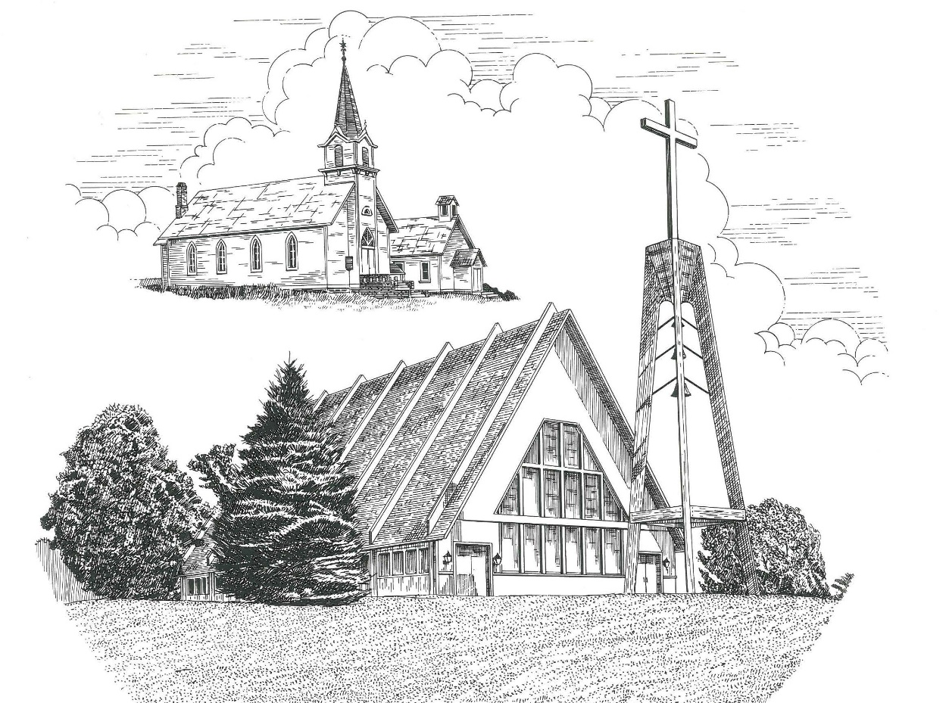

Fifteenth Sunday after Pentecost September 10th, 2023

WELCOME
Thanks for joining us!
Pastor Jacob Sherry Missouri Synod

~~PLEASE NOTE~~
Calling on the name of the Lord
Does not include the use of cell phones in the worship sanctuary.
Please check yours before the service begins. Thank you for your courtesy.
~~TO OUR GUESTS AND VISITORS~~
Please sign our guest book located on the stand at the church entrance. During the service, we ask you to sign the attendance sheet in your bulletin and leave it on the pew as you leave. If you need assistance or have questions about our worship service, please talk to an elder or any one of our church family. We are glad you could join us and hope to have you worship with us again soon.

~~ATTENDING HOLY COMMUNION~~
By checking the “Communing Today” box on the registration form found on the attendance sheet in your bulletin, you are agreeing with the following statements:

- I am a baptized Christian who believes Jesus Christ is my Lord and Savior.
- I believe that I am a sinner in need of Christ’s freely offered forgiveness.
- I believe that in the Lord’s Supper the body and blood of Jesus Christ
are truly present in, with, and under the bread and wine.
- I believe that my participation in Holy Communion grants me forgiveness
of my sins, new spiritual life, and eternal salvation.
- With God’s help, I sincerely seek to repent of my sins, live in service
to my Lord, and await His return.

If you agree with the above statements, you are welcome to attend the Lord’s Supper with us. May God bless your worship time with us.
We do offer gluten-free wafers, please quietly ask an elder to help you.

Order of Divine Service Setting Four

Pre-Service Music……………..Call to Worship………………….Greeting

OPENING HYMN: “Come, Thou Almighty King”…………………….LSB #905

OPENING LITURGY
Confession & Absolution……………………………………….LSB p. 203
Kyrie……………………………………………………………..LSB p. 204
Gloria in Excelsis………………………………………………..LSB p. 204
Salutation….…………………………………………………….LSB p. 205

Collect Prayer
O God, from whom all good proceeds, grant to us, Your humble servants, Your holy inspiration, that we may set our minds on the things that are right and, by Your merciful guiding, accomplish them; through Jesus Christ, Your Son, our Lord, who lives and reigns with You and the Holy Spirit, one God, now and forever.

THE HOLY SCRIPTURES

OLD TESTAMENT: (Ezekiel 33:7-9)
⁷ “So you, son of man, I have made a watchman for the house of Israel. Whenever you hear a word from my mouth, you shall give them warning from me. ⁸ If I say to the wicked, O wicked one, you shall surely die, and you do not speak to warn the wicked to turn from his way, that wicked person shall die in his iniquity, but his blood I will require at your hand. ⁹ But if you warn the wicked to turn from his way, and he does not turn from his way, that person shall die in his iniquity, but you will have delivered your soul.

R: This is the Word of the Lord. Cong: Thanks be to God.

GRADUAL
Reader: Fear the Lord, you his saints,
Cong.: for those who fear him lack nothing!
Reader: Many are the afflictions of the righteous,
Cong.: but the Lord delivers him out of them all.
EPISTLE: (Romans 13:1-10)
Let every person be subject to the governing authorities. For there is no authority except from God, and those that exist have been instituted by God. ² Therefore whoever resists the authorities resists what God has appointed, and those who resist will incur judgment. ³ For rulers are not a terror to good conduct, but to bad. Would you have no fear of the one who is in authority? Then do what is good, and you will receive his approval, ⁴ for he is God's servant for your good. But if you do wrong, be afraid, for he does not bear the sword in vain. For he is the servant of God, an avenger who carries out God's wrath on the wrongdoer. ⁵ Therefore one must be in subjection, not only to avoid God's wrath but also for the sake of conscience. ⁶ For because of this you also pay taxes, for the authorities are ministers of God, attending to this very thing. ⁷ Pay to all what is owed to them: taxes to whom taxes are owed, revenue to whom revenue is owed, respect to whom respect is owed, honor to whom honor is owed.
⁸ Owe no one anything, except to love each other, for the one who loves another has fulfilled the law. ⁹ For the commandments, “You shall not commit adultery, You shall not murder, You shall not steal, You shall not covet,” and any other commandment, are summed up in this word: “You shall love your neighbor as yourself.” ¹⁰ Love does no wrong to a neighbor; therefore love is the fulfilling of the law.

R: This is the Word of the Lord. Cong: Thanks be to God.

(PLEASE RISE for the reading of the Gospel)

R: The Holy Gospel according to St. Matthew, the 18th chapter.
Cong: Glory to You, O Lord

HOLY GOSPEL: (Matthew 18:1-20)
At that time the disciples came to Jesus, saying, “Who is the greatest in the kingdom of heaven?” ² And calling to him a child, he put him in the midst of them ³ and said, “Truly, I say to you, unless you turn and become like children, you will never enter the kingdom of heaven. ⁴ Whoever humbles himself like this child is the greatest in the kingdom of heaven. ⁵ “Whoever receives one such child in my name receives me, ⁶ but whoever causes one of these little ones who believe in me to sin, it would be better for him to have a great millstone fastened around his neck and to be drowned in the depth of the sea.
⁷ “Woe to the world for temptations to sin! For it is necessary that temptations come, but woe to the one by whom the temptation comes! ⁸ And if your hand or your foot causes you to sin, cut it off and throw it away. It is better for you to enter life crippled or lame than with two hands or two feet to be thrown into the eternal fire. ⁹ And if your eye causes you to sin, tear it out and throw it away. It is better for you to enter life with one eye than with two eyes to be thrown into the hell of fire.
¹⁰ “See that you do not despise one of these little ones. For I tell you that in heaven their angels always see the face of my Father who is in heaven. ¹² What do you think? If a man has a hundred sheep, and one of them has gone astray, does he not leave the ninety-nine on the mountains and go in search of the one that went astray? ¹³ And if he finds it, truly, I say to you, he rejoices over it more than over the ninety-nine that never went astray. ¹⁴ So it is not the will of my Father who is in heaven that one of these little ones should perish.
¹⁵ “If your brother sins against you, go and tell him his fault, between you and him alone. If he listens to you, you have gained your brother. ¹⁶ But if he does not listen, take one or two others along with you, that every charge may be established by the evidence of two or three witnesses. ¹⁷ If he refuses to listen to them, tell it to the church. And if he refuses to listen even to the church, let him be to you as a Gentile and a tax collector. ¹⁸ Truly, I say to you, whatever you bind on earth shall be bound in heaven, and whatever you loose on earth shall be loosed in heaven. ¹⁹ Again I say to you, if two of you agree on earth about anything they ask, it will be done for them by my Father in heaven. ²⁰ For where two or three are gathered in my name, there am I among them.”

R: This is the Gospel of the Lord. Cong: Praise to You, O Christ.

NICENE CREED
I believe in one God, the Father Almighty, maker of heaven and earth and of all things visible and invisible.
And in one Lord Jesus Christ, the only-begotten Son of God, begotten of His Father before all worlds, God of God, Light of Light, very God of very God, begotten, not made, being of one substance with the Father, by whom all things were made; who for us men and for our salvation came down from heaven and was incarnate by the Holy Spirit of the virgin Mary and was made man; and was crucified also for us under Pontius Pilate. He suffered and was buried. And the third day He rose again according to the Scriptures and ascended into heaven and sits at the right hand of the Father. And He will come again with glory to judge both the living and the dead, whose kingdom will have no end.
And I believe in the Holy Spirit, the Lord and giver of life, who proceeds from the Father and the Son, who with the Father and the Son together is worshiped and glorified, who spoke by the prophets. And I believe in one holy Christian and apostolic Church, I acknowledge one Baptism for the remission of sins, and I look for the resurrection of the dead and the life of the world to come. Amen.

SERMON HYMN: “My Soul, Now Praise Your Maker”……………….LSB #820

SERMON

THE GENERAL PRAYERS

COLLECTION OF THE OFFERING

OFFERTORY HYMN: “Let the Vineyards Be Fruitful”………………LSB #955

Sharing the Peace of the Lord

SERVICE OF THE SACRAMENT
Preface…………………………………….…………….………..LSB p. 208
Proper Preface
It is truly good, right, and salutary that we should at all times and in all places give thanks to You, O Lord, holy Father, almighty and everlasting God, for the countless blessings You so freely bestow on us and all creation. Above all, we give thanks for Your boundless love shown to us when You sent Your only-begotten Son, Jesus Christ, into our flesh and laid on Him our sin, giving Him into death that we might not die eternally. Because He is now risen from the dead and lives and reigns to all eternity, all who believe in Him will overcome sin and death and will rise again to new life. Therefore, with angels and archangels and with all the company of heaven we laud and magnify Your glorious name, ever more praising You and saying:

Sanctus, Lord’s Prayer, The Words of Our Lord………………….....LSB pp. 208-209
Agnus Dei………………………………………………………………..LSB p. 210
If you are not communing, it is acceptable to remain seated.

COMMUNION DISTRIBUTION HYMNS:
LSB #610 “Lord Jesus, Think on Me”
LSB #620 “Jesus Comes Today with Healing”
LSB #637 “Draw Near and Take the Body of the Lord”

CLOSING LITURGY:………………………………………………....LSB pp. 211-212

CLOSING HYMN: “Lord, Dismiss Us with Your Blessing”..................LSB #924

The Mission of Trinity Onekama Is To SERVE

For even the Son of Man did not come to be served
but to serve and to give his life as a ransom for many.
Mark 10:45

S haring Jesus’s truth
E quipping for life
R eaching Out
V aluing each other
E vangelizing all ages
Mission Statement
The mission of Trinity Onekama is to SERVE
For even the Son of Man did not come to be served, but to serve,
and to give his life as a ransom for many. Mark 10:45
S haring Jesus’ ruth
E quipping for life
R eaching Out
V aluing each other
E vangelizing all age

CHURCH INFORMATION
Church Office: (231) 889-4429 Website: www.trinityonekama.org
E-mail: trinityonekama@sbcglobal.net
Address: P.O. Box 119, 5471 Fairview Street, Onekama, MI 49675
Sunday School & Adult Bible Study: Sunday @ 9:30am
Worship: Sunday @ 10:30 am The Lord’s Supper: Celebrated 2nd & 4th Sundays
Pastoral Hours: Wednesday and Friday 9:00am – Noon
Pastor Phone: 231-655-2680 Pastor Email: trinityonekama@gmail.com

Copyright licensing covered under CCLI #2802932

