**231-889-4429 5471 Fairview Street, Box 119 Onekama, MI**

**TRINITY LUTHERAN CHURCH**

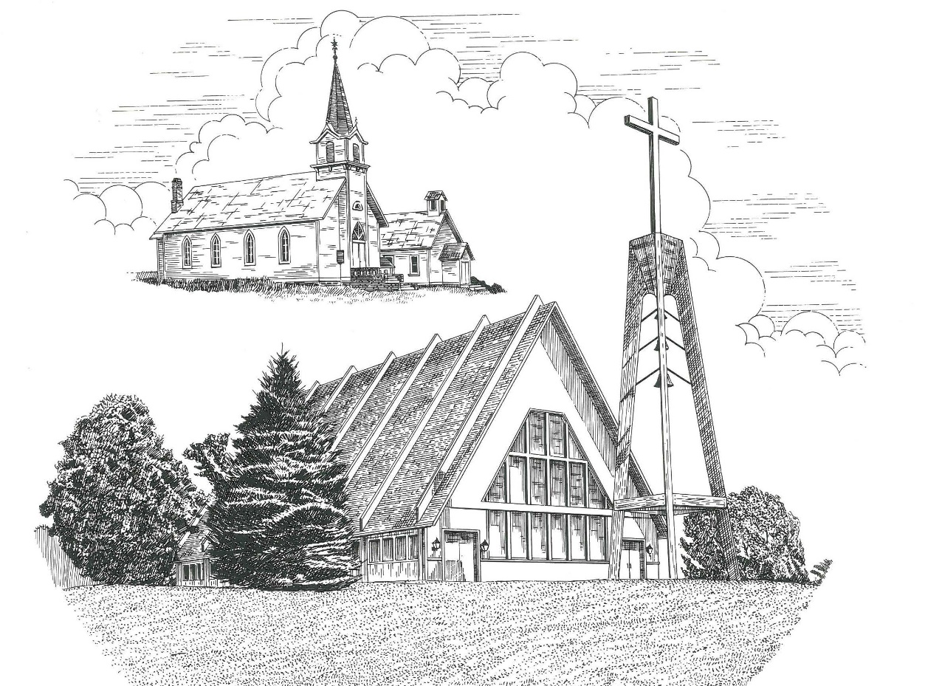

**Fifteenth Sunday after Pentecost September 13th, 2020**

**WELCOME**

**Thanks for joining us!**

**Pastor Jacob Sherry Missouri Synod**

**~~PLEASE NOTE~~Calling on the name of the Lord**

Does not include the use of cell phones in the worship sanctuary.

Please check yours before the service begins. Thank you for your courtesy.

**~~TO OUR GUESTS AND VISITORS~~**

Please sign our guest book located on the stand at the church entrance. During the service, we ask you to sign the attendance booklet located at the end of each pew. If you need assistance or have questions about our worship service, please talk to an elder or any one of our church family. We are glad you could join us and hope to have you worship with us again soon.

**~~ATTENDING HOLY COMMUNION~~**

By checking the “Communing Today” box on the registration form found in the attendance booklet, you are agreeing with the following statements:

* **I am a baptized Christian who believes Jesus Christ is my Lord and Savior.**
* **I believe that I am a sinner in need of Christ freely offered forgiveness.**
* **I believe that in the Lord’s Supper the body and blood of Jesus Christ**

**are truly present in, with, and under the bread and wine.**

* **I believe that my participation in Holy Communion grants me forgiveness**

**of my sins, new spiritual life, and eternal salvation.**

* **With God’s help, I sincerely seek to repent of my sins, live in service**

**to my Lord, and await His return.**

**If you agree with the above statements, you are welcome to attend the Lord’s Supper with us. May God bless your worship time with us.**

We do offer gluten-free wafers, please quietly ask an elder to help you.

**Order of Divine Service Setting One**

**Pre-Service Music……………..Call to Worship………………….Greeting**

**OPENING HYMN:** *“Today Your Mercy Calls Us”*…………………….......…..LSB #915

**CONFESSION & ABSOLUTION**…………………………………………....LSB p. 151

**KYRIE**…………………………………………………………………...LSB pp. 152-153

**THIS IS THE FEAST**……………………………………………………..…...LSB p. 155

**SALUTATION**…………………………………………………………….…..LSB p. 156

**Collect Prayer**

O God, our refuge and strength, the author of all godliness, hear the devout prayers of Your Church, especially in times of persecution, and grant that what we ask in faith we may obtain; through Jesus Christ, our Lord, who lives and reigns with You and the Holy Spirit, one God, now and forever.

**C: Amen.**

**THE HOLY SCRIPTURES**

**OLD TESTAMENT:** (Genesis 50:15-21)

**15**When Joseph's brothers saw that their father was dead, they said, “It may be that Joseph will hate us and pay us back for all the evil that we did to him.”  **16**So they sent a message to Joseph, saying, “Your father gave this command before he died: **17**‘Say to Joseph, “Please forgive the transgression of your brothers and their sin, because they did evil to you.”’ And now, please forgive the transgression of the servants of the God of your father.” Joseph wept when they spoke to him.  **18**His brothers also came and fell down before him and said, “Behold, we are your servants.”  **19**But Joseph said to them, “Do not fear, for am I in the place of God?  **20**As for you, you meant evil against me, but God meant it for good, to bring it about that many people should be kept alive, as they are today.  **21**So do not fear; I will provide for you and your little ones.” Thus he comforted them and spoke kindly to them.

**R:** This is the Word of the Lord**.** **Cong: Thanks be to God.**

**GRADUAL**

Reader: Fear the Lord, you his saints,

**Cong.: for those who fear him lack nothing!**

Reader: Many are the afflictions of the righteous,

**Cong.: but the Lord delivers him out of them all.**

**EPISTLE:** (Romans 14:1-12)

As for the one who is weak in faith, welcome him, but not to quarrel over opinions.  **2**One person believes he may eat anything, while the weak person eats only vegetables.  **3**Let not the one who eats despise the one who abstains, and let not the one who abstains pass judgment on the one who eats, for God has welcomed him.  **4**Who are you to pass judgment on the servant of another? It is before his own master that he stands or falls. And he will be upheld, for the Lord is able to make him stand. **5**One person esteems one day as better than another, while another esteems all days alike.  Each one should be fully convinced in his own mind.  **6**The one who observes the day, observes it in honor of the Lord. The one who eats, eats in honor of the Lord, since he gives thanks to God, while the one who abstains, abstains in honor of the Lord and gives thanks to God.  **7**For none of us lives to himself, and none of us dies to himself.  **8**For if we live, we live to the Lord, and if we die, we die to the Lord. So then, whether we live or whether we die, we are the Lord's.  **9**For to this end Christ died and lived again, that he might be Lord both of the dead and of the living.

**10**Why do you pass judgment on your brother? Or you, why do you despise your brother? For we will all stand before the judgment seat of God; **11**for it is written,

“As I live, says the Lord, every knee shall bow to me,  
  and every tongue shall confess to God.”

**12**So then each of us will give an account of himself to God.

**R:** This is the Word of the Lord. **Cong: Thanks be to God.**

**(PLEASE RISE for the reading of the Gospel)**



**R:** The Holy Gospel according to St. Matthew, the 18th chapter.



**HOLY GOSPEL:** (Matthew 18:21-35)

**21**Then Peter came up and said to him, “Lord, how often will my brother sin against me, and I forgive him?  As many as seven times?”  **22**Jesus said to him, “I do not say to you seven times, but seventy-seven times.

**23**“Therefore the kingdom of heaven may be compared to a king who wished to settle accounts with his servants.  **24**When he began to settle, one was brought to him who owed him ten thousand talents.  **25**And since he could not pay, his master ordered him to be sold, with his wife and children and all that he had, and payment to be made.  **26**So the servant fell on his knees, imploring him, ‘Have patience with me, and I will pay you everything.’  **27**And out of pity for him, the master of that servant released him and forgave him the debt.  **28**But when that same servant went out, he found one of his fellow servants who owed him a hundred denarii, and seizing him, he began to choke him, saying, ‘Pay what you owe.’  **29**So his fellow servant fell down and pleaded with him, ‘Have patience with me, and I will pay you.’  **30**He refused and went and put him in prison until he should pay the debt.  **31**When his fellow servants saw what had taken place, they were greatly distressed, and they went and reported to their master all that had taken place.  **32**Then his master summoned him and said to him, ‘You wicked servant! I forgave you all that debt because you pleaded with me.  **33**And should not you have had mercy on your fellow servant, as I had mercy on you?’  **34**And in anger his master delivered him to the jailers, until he should pay all his debt.  **35**So also my heavenly Father will do to every one of you, if you do not forgive your brother from your heart.”

**R:** This is the Gospel of the Lord.



**SERMON HYMN**: *“Jesus, Thy Boundless Love to Me”*………………………LSB #683

**SERMON**

**NICENE CREED**

I believe in one God, the Father Almighty, maker of heaven and earth and of all things visible and invisible.

And in one Lord Jesus Christ, the only-begotten Son of God, begotten of His Father before all worlds, God of God, Light of Light, very God of very God, begotten, not made, being of one substance with the Father, by whom all things were made; who for us men and for our salvation came down from heaven and was incarnate by the Holy Spirit of the virgin Mary and was made man; and was crucified also for us under Pontius Pilate. He suffered and was buried. And the third day He rose again according to the Scriptures and ascended into heaven and sits at the right hand of the Father. And He will come again with glory to judge both the living and the dead, whose kingdom will have no end.

And I believe in the Holy Spirit, the Lord and giver of life, who proceeds from the Father and the Son, who with the Father and the Son together is worshiped and glorified, who spoke by the prophets. And I believe in one holy Christian and apostolic Church, I acknowledge one Baptism for the remission of sins, and I look for the resurrection of the dead and the life of the world to come. Amen.

**THE GENERAL PRAYERS OF THE CHURCH**

**SERVICE OF THE SACRAMENT**

**PREFACE**……………………………………………………………………..LSB p. 160

**Proper Preface**

It is truly good, right, and salutary that we should at all times and in all places give thanks to You, holy Lord, almighty Father, everlasting God, through Jesus Christ, who, out of love for His fallen creation, humbled Himself by taking on the form of a servant, becoming obedient unto death, even death upon a cross. Risen from the dead, He has freed us from eternal death and given us life everlasting. Therefore, with angels and archangels and with all the company of heaven we laud and magnify Your glorious name, ever more praising You and saying:

**SANCTUS**……………………………………………………………………...LSB p. 161

**LORD’S PRAYER**

**THE WORDS OF OUR LORD**…………………………………………….....LSB p. 162

**AGNUS DEI**…………………………………………………………………....LSB p. 163

*If you are not communing it is acceptable to remain seated.*

**COMMUNION DISTRIBUTION HYMNS**

LSB #570 *“Just as I Am, without One Plea”*

LSB #559 *“Oh, How Great Is Your Compassion”*

**THANK THE LORD**………………………………………………………….LSB p. 164

**POST-COMMUNION COLLECT PRAYER**……………………………….LSB p. 166

**BENEDICTION**……………………………………………………………….LSB p. 166

**CLOSING HYMN:** *“Savior, Again to Thy Dear Name We Raise”*……..……..LSB #917

The Mission of Trinity Onekama Is To **SERVE**

For even the Son of Man did not come to be served

but to serve and to give his life as a ransom for many.            
                                                                       Mark 10:45



**S**haring Jesus’s **t**ruth

**E**quipping for life

**R**eaching Out

**V**aluing each other

**E**vangelizing all ages

Mission Statement

The mission of Trinity Onekama is to SERVE

For even the Son of Man did not come to be served, but to serve,

and to give his life as a ransom for many. Mark 10:45

S haring Jesus’ ruth

E quipping for life

R eaching Out

V aluing each other

E vangelizing all age

**CHURCH INFORMATION**

**Church Office:** (231) 889-4429 **Website:** www.trinityonekama.org

**E-mail:** [trinityonekama@sbcglobal.net](mailto:trinityonekama@sbcglobal.net)

**Address:** P.O. Box 119, 5471 Fairview Street, Onekama, MI 49675

**Adult Bible Study**: Sunday @ 9:15 am (year round)

**Worship:** Sunday @ 10:30 am **The Lord’s Supper:**  Celebrated 2nd & 4th Sundays

**Pastoral Hours:** Wednesday and Friday 8:30am – Noon

**Pastor Phone:** 231-655-2680 **Pastor Email:** trinityonekama@gmail.com

**Copyright licensing covered under CCLI #2802932**