231-889-4429 5471 Fairview Street, Box 119 Onekama, MI

TRINITY LUTHERAN CHURCH
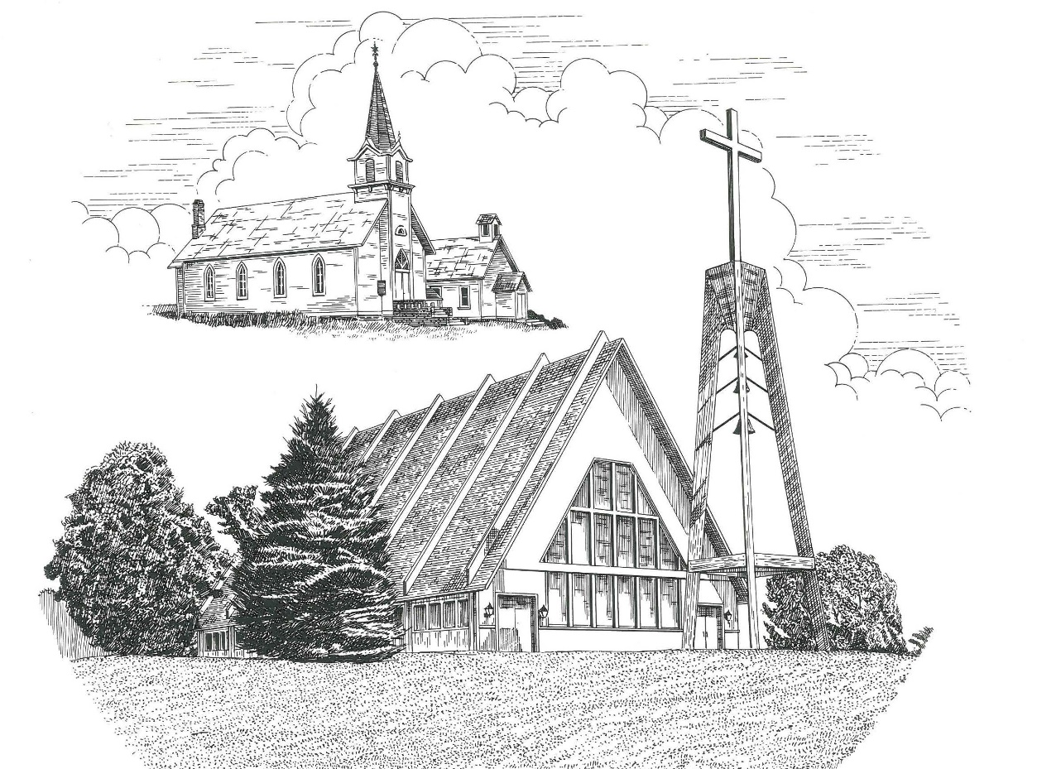

Seventeenth Sunday after Pentecost September 24th, 2023

WELCOME
Thanks for joining us!
Pastor Jacob Sherry Missouri Synod

~~PLEASE NOTE~~
Calling on the name of the Lord
Does not include the use of cell phones in the worship sanctuary.
Please check yours before the service begins. Thank you for your courtesy.
~~TO OUR GUESTS AND VISITORS~~
Please sign our guest book located on the stand at the church entrance. During the service, we ask you to sign the attendance sheet in your bulletin and leave it on the pew as you leave. If you need assistance or have questions about our worship service, please talk to an elder or any one of our church family. We are glad you could join us and hope to have you worship with us again soon.

~~ATTENDING HOLY COMMUNION~~
By checking the “Communing Today” box on the registration form found on the attendance sheet in your bulletin, you are agreeing with the following statements:

- I am a baptized Christian who believes Jesus Christ is my Lord and Savior.
- I believe that I am a sinner in need of Christ’s freely offered forgiveness.
- I believe that in the Lord’s Supper the body and blood of Jesus Christ
are truly present in, with, and under the bread and wine.
- I believe that my participation in Holy Communion grants me forgiveness
of my sins, new spiritual life, and eternal salvation.
- With God’s help, I sincerely seek to repent of my sins, live in service
to my Lord, and await His return.

If you agree with the above statements, you are welcome to attend the Lord’s Supper with us. May God bless your worship time with us.
We do offer gluten-free wafers, please quietly ask an elder to help you.

Order of Divine Service Setting Four

Pre-Service Music……………..Call to Worship………………….Greeting

OPENING HYMN: “Gracious God, You Send Great Blessings”……..LSB #782

OPENING LITURGY
Confession & Absolution……………………………………….LSB p. 203

INTROIT
P: I will offer to you the sacrifice of thanksgiving
C: and call on the name of the Lord.
P: What shall I render to the Lord
C: for all his benefits to me?
P: I will lift up the cup of salvation
C: and call on the name of the Lord.
P: Precious in the sight of the Lord
C: is the death of his saints.
P: O Lord, I am your servant;
C: I am your servant, the son of your maidservant. You have loosed my bonds.
ALL: Glory be to the Father and to the Son and to the Holy Spirit; as it was in the
beginning, is now and will be forever. Amen.
P: I will offer to you the sacrifice of thanksgiving
C: and call on the name of the Lord.

Kyrie……………………………………………………………..LSB p. 204
Gloria in Excelsis………………………………………………..LSB p. 204
Salutation….…………………………………………………….LSB p. 205

Collect Prayer
Lord God, heavenly Father, since we cannot stand before You relying on anything we have done, help us trust in Your abiding grace and live according to Your Word; through Jesus Christ, Your Son, our Lord, who lives and reigns with You and the Holy Spirit, one God, now and forever.

THE HOLY SCRIPTURES

OLD TESTAMENT: (Isaiah 55:6-9)
⁶ “Seek the Lord while he may be found;
call upon him while he is near;
⁷ let the wicked forsake his way,
and the unrighteous man his thoughts;
let him return to the Lord, that he may have compassion on him,
and to our God, for he will abundantly pardon.
⁸ For my thoughts are not your thoughts,
neither are your ways my ways, declares the Lord.
⁹ For as the heavens are higher than the earth,
so are my ways higher than your ways
and my thoughts than your thoughts.

R: This is the Word of the Lord. Cong: Thanks be to God.

GRADUAL
Reader: Fear the Lord, you his saints,
Cong.: for those who fear him lack nothing!
Reader: Many are the afflictions of the righteous,
Cong.: but the Lord delivers him out of them all.

EPISTLE: (Philippians 1:12-14, 19-30)
¹² I want you to know, brothers, that what has happened to me has really served to advance the gospel, ¹³ so that it has become known throughout the whole imperial guard and to all the rest that my imprisonment is for Christ. ¹⁴ And most of the brothers, having become confident in the Lord by my imprisonment, are much more bold to speak the word without fear.
Yes, and I will rejoice, ¹⁹ for I know that through your prayers and the help of the Spirit of Jesus Christ this will turn out for my deliverance, ²⁰ as it is my eager expectation and hope that I will not be at all ashamed, but that with full courage now as always Christ will be honored in my body, whether by life or by death. ²¹ For to me to live is Christ, and to die is gain. ²² If I am to live in the flesh, that means fruitful labor for me. Yet which I shall choose I cannot tell. ²³ I am hard pressed between the two. My desire is to depart and be with Christ, for that is far better. ²⁴ But to remain in the flesh is more necessary on your account. ²⁵ Convinced of this, I know that I will remain and continue with you all, for your progress and joy in the faith, ²⁶ so that in me you may have ample cause to glory in Christ Jesus, because of my coming to you again.
²⁷ Only let your manner of life be worthy of the gospel of Christ, so that whether I come and see you or am absent, I may hear of you that you are standing firm in one spirit, with one mind striving side by side for the faith of the gospel, ²⁸ and not frightened in anything by your opponents. This is a clear sign to them of their destruction, but of your salvation, and that from God. ²⁹ For it has been granted to you that for the sake of Christ you should not only believe in him but also suffer for his sake, ³⁰ engaged in the same conflict that you saw I had and now hear that I still have.

R: This is the Word of the Lord. Cong: Thanks be to God.

(PLEASE RISE for the reading of the Gospel)

R: The Holy Gospel according to St. Matthew, the 20th chapter.
Cong: Glory to You, O Lord

HOLY GOSPEL: (Matthew 20:1-16)
“For the kingdom of heaven is like a master of a house who went out early in the morning to hire laborers for his vineyard. ² After agreeing with the laborers for a denarius a day, he sent them into his vineyard. ³ And going out about the third hour he saw others standing idle in the marketplace, ⁴ and to them he said, ‘You go into the vineyard too, and whatever is right I will give you.’ ⁵ So they went. Going out again about the sixth hour and the ninth hour, he did the same. ⁶ And about the eleventh hour he went out and found others standing. And he said to them, ‘Why do you stand here idle all day?’ ⁷ They said to him, ‘Because no one has hired us.’ He said to them, ‘You go into the vineyard too.’ ⁸ And when evening came, the owner of the vineyard said to his foreman, ‘Call the laborers and pay them their wages, beginning with the last, up to the first.’ ⁹ And when those hired about the eleventh hour came, each of them received a denarius. ¹⁰ Now when those hired first came, they thought they would receive more, but each of them also received a denarius. ¹¹ And on receiving it they grumbled at the master of the house, ¹² saying, ‘These last worked only one hour, and you have made them equal to us who have borne the burden of the day and the scorching heat.’ ¹³ But he replied to one of them, ‘Friend, I am doing you no wrong. Did you not agree with me for a denarius? ¹⁴ Take what belongs to you and go. I choose to give to this last worker as I give to you. ¹⁵ Am I not allowed to do what I choose with what belongs to me? Or do you begrudge my generosity?’ ¹⁶ So the last will be first, and the first last.”

R: This is the Gospel of the Lord. Cong: Praise to You, O Christ.

NICENE CREED
I believe in one God, the Father Almighty, maker of heaven and earth and of all things visible and invisible.
And in one Lord Jesus Christ, the only-begotten Son of God, begotten of His Father before all worlds, God of God, Light of Light, very God of very God, begotten, not made, being of one substance with the Father, by whom all things were made; who for us men and for our salvation came down from heaven and was incarnate by the Holy Spirit of the virgin Mary and was made man; and was crucified also for us under Pontius Pilate. He suffered and was buried. And the third day He rose again according to the Scriptures and ascended into heaven and sits at the right hand of the Father. And He will come again with glory to judge both the living and the dead, whose kingdom will have no end.
And I believe in the Holy Spirit, the Lord and giver of life, who proceeds from the Father and the Son, who with the Father and the Son together is worshiped and glorified, who spoke by the prophets. And I believe in one holy Christian and apostolic Church, I acknowledge one Baptism for the remission of sins, and I look for the resurrection of the dead and the life of the world to come. Amen.

SERMON HYMN: “Take My Life and Let It Be”………………………LSB #783

SERMON

THE GENERAL PRAYERS

COLLECTION OF THE OFFERING

OFFERTORY HYMN: “Let the Vineyards Be Fruitful”………………LSB #955

Sharing the Peace of the Lord

SERVICE OF THE SACRAMENT
Preface…………………………………….…………….………..LSB p. 208
Proper Preface
It is truly good, right, and salutary that we should at all times and in all places give thanks to You, O Lord, holy Father, almighty and everlasting God, for the countless blessings You so freely bestow on us and all creation. Above all, we give thanks for Your boundless love shown to us when You sent Your only-begotten Son, Jesus Christ, into our flesh and laid on Him our sin, giving Him into death that we might not die eternally. Because He is now risen from the dead and lives and reigns to all eternity, all who believe in Him will overcome sin and death and will rise again to new life. Therefore, with angels and archangels and with all the company of heaven we laud and magnify Your glorious name, ever more praising You and saying:

Sanctus, Lord’s Prayer, The Words of Our Lord………………….....LSB pp. 208-209
Agnus Dei………………………………………………………………..LSB p. 210
If you are not communing, it is acceptable to remain seated.

COMMUNION DISTRIBUTION HYMNS:
LSB #781 “We Give Thee But Thine Own”
LSB #788 “Forgive Us, Lord, for Shallow Thankfulness”
LSB #787 “The Temple Rang with Golden Coins”

CLOSING LITURGY:………………………………………………....LSB pp. 211-212

CLOSING HYMN: “Praise and Thanksgiving”.....................................LSB #789

The Mission of Trinity Onekama Is To SERVE

For even the Son of Man did not come to be served
but to serve and to give his life as a ransom for many.
Mark 10:45

S haring Jesus’s truth
E quipping for life
R eaching Out
V aluing each other
E vangelizing all ages
Mission Statement
The mission of Trinity Onekama is to SERVE
For even the Son of Man did not come to be served, but to serve,
and to give his life as a ransom for many. Mark 10:45
S haring Jesus’ ruth
E quipping for life
R eaching Out
V aluing each other
E vangelizing all age

CHURCH INFORMATION
Church Office: (231) 889-4429 Website: www.trinityonekama.org
E-mail: trinityonekama@sbcglobal.net
Address: P.O. Box 119, 5471 Fairview Street, Onekama, MI 49675
Sunday School & Adult Bible Study: Sunday @ 9:30am
Worship: Sunday @ 10:30 am The Lord’s Supper: Celebrated 2nd & 4th Sundays
Pastoral Hours: Wednesday and Friday 9:00am – Noon
Pastor Phone: 231-655-2680 Pastor Email: trinityonekama@gmail.com

Copyright licensing covered under CCLI #2802932

