**231-889-4429 5471 Fairview Street, Box 119 Onekama, MI**

**TRINITY LUTHERAN CHURCH**

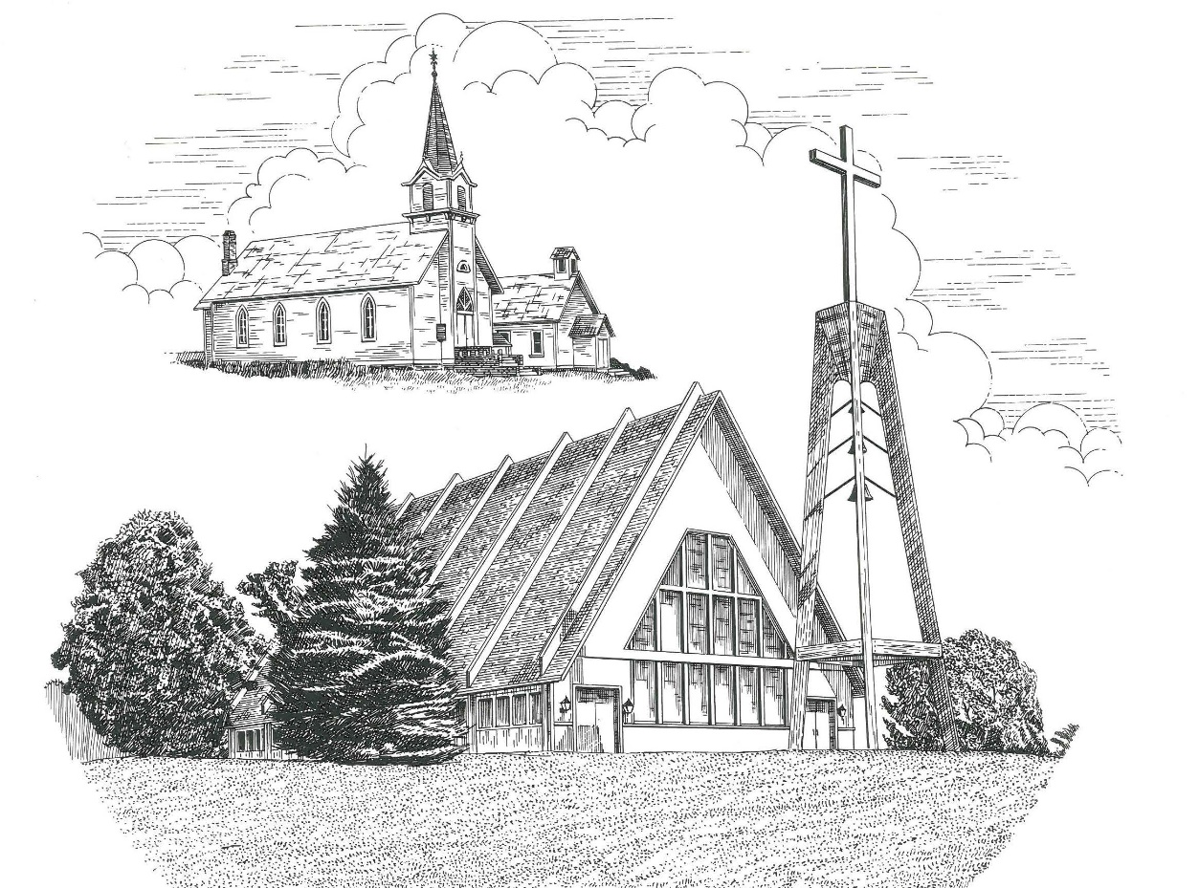

**Sixteenth Sunday after Pentecost September 25th, 2022**

**WELCOME**

**Thanks for joining us!**

**Pastor Jacob Sherry Missouri Synod**

**~~PLEASE NOTE~~Calling on the name of the Lord**

Does not include the use of cell phones in the worship sanctuary.

Please check yours before the service begins. Thank you for your courtesy.

**~~TO OUR GUESTS AND VISITORS~~**

Please sign our guest book located on the stand at the church entrance. During the service, we ask you to sign the attendance sheets located inside your bulletin and leave them on the pew as you leave. If you need assistance or have questions about our worship service, please talk to an elder or any one of our church family. We are glad you could join us and hope to have you worship with us again soon.

**~~ATTENDING HOLY COMMUNION~~**

By checking the “Communing Today” box on the registration form on the attendance sheet, you are agreeing with the following statements:

* **I am a baptized Christian who believes Jesus Christ is my Lord and Savior.**
* **I believe that I am a sinner in need of Christ freely offered forgiveness.**
* **I believe that in the Lord’s Supper the body and blood of Jesus Christ**

**are truly present in, with, and under the bread and wine.**

* **I believe that my participation in Holy Communion grants me forgiveness**

**of my sins, new spiritual life, and eternal salvation.**

* **With God’s help, I sincerely seek to repent of my sins, live in service**

**to my Lord, and await His return.**

**If you agree with the above statements, you are welcome to attend the Lord’s Supper with us. May God bless your worship time with us.**

We do offer gluten-free wafers, please quietly ask an elder to help you.

**Order of Divine Service Setting One**

**Pre-Service Music……………..Call to Worship………………….Greeting**

**OPENING HYMN:** *“Lord Jesus, Think on Me”*………………….........LSB #610

**CONFESSION & ABSOLUTION**……………………………………..LSB p. 151

**KYRIE**…………………………………………………………………...LSB pp. 152-153

**THIS IS THE FEAST**…………………………………………………...LSB p. 155

**SALUTATION**…………………………………………………………..LSB p. 156

**Collect Prayer**

O God, You are the strength of all who trust in You, and without Your aid we can do no good thing. Grant us the help of Your grace that we may please You in both will and deed; through Jesus Christ, Your Son, our Lord, who lives and reigns with the You and the Holy Spirit, one God, now and forever.

**THE HOLY SCRIPTURES**

**OLD TESTAMENT:** (Amos 6:1-7)

“Woe to those who are at ease in Zion,  
    and to those who feel secure on the mountain of Samaria,  
the notable men of the first of the nations,  
    to whom the house of Israel comes!  
**2**Pass over to Calneh, and see,  
    and from there go to Hamath the great;  
    then go down to Gath of the Philistines.  
Are you better than these kingdoms?  
    Or is their territory greater than your territory,  
**3**O you who put far away the day of disaster  
    and bring near the seat of violence?

**4**“Woe to those who lie on beds of ivory  
    and stretch themselves out on their couches,  
and eat lambs from the flock  
    and calves from the midst of the stall,  
**5**who sing idle songs to the sound of the harp  
    and like David invent for themselves instruments of music,  
**6**who drink wine in bowls  
    and anoint themselves with the finest oils,  
    but are not grieved over the ruin of Joseph!  
**7**Therefore they shall now be the first of those who go into exile,  
    and the revelry of those who stretch themselves out shall pass away.”

**R:** This is the Word of the Lord**.** **Cong: Thanks be to God.**

**GRADUAL**

Reader: He will command his angels concerning you

**Cong.: to guard you in all your ways.**

Reader: Bless the Lord, O my soul,

**Cong.: and all that is within me, bless his holy name!**

**EPISTLE:** (1 Timothy 3:1-13)

The saying is trustworthy: If anyone aspires to the office of overseer, he desires a noble task.  **2**Therefore an overseer must be above reproach, the husband of one wife, sober-minded, self-controlled, respectable, hospitable, able to teach, **3**not a drunkard, not violent but gentle, not quarrelsome, not a lover of money.  **4**He must manage his own household well, with all dignity keeping his children submissive, **5**for if someone does not know how to manage his own household, how will he care for God's church?  **6**He must not be a recent convert, or he may become puffed up with conceit and fall into the condemnation of the devil.  **7**Moreover, he must be well thought of by outsiders, so that he may not fall into disgrace, into a snare of the devil.

**8**Deacons likewise must be dignified, not double-tongued, not addicted to much wine, not greedy for dishonest gain.  **9**They must hold the mystery of the faith with a clear conscience. **10**And let them also be tested first; then let them serve as deacons if they prove themselves blameless.  **11**Their wives likewise must be dignified, not slanderers, but sober-minded, faithful in all things.  **12**Let deacons each be the husband of one wife, managing their children and their own households well.  **13**For those who serve well as deacons gain a good standing for themselves and also great confidence in the faith that is in Christ Jesus.

**R:** This is the Word of the Lord. **Cong: Thanks be to God.**

**(PLEASE RISE for the reading of the Gospel)**



**R:** The Holy Gospel according to St. Matthew, the 3rd chapter.



**HOLY GOSPEL:** (Matthew 3:13-17)

**13**Then Jesus came from Galilee to the Jordan to John, to be baptized by him.  **14**John would have prevented him, saying, “I need to be baptized by you, and do you come to me?”  **15**But Jesus answered him, “Let it be so now, for thus it is fitting for us to fulfill all righteousness.”  Then he consented.  **16**And when Jesus was baptized, immediately he went up from the water, and behold, the heavens were opened to him, and he saw the Spirit of God descending like a dove and coming to rest on him; **17**and behold, a voice from heaven said, “This is my beloved Son, with whom I am well pleased.”

**R:** This is the Gospel of the Lord.



**SERMON HYMN**: *“Lord, Thee I Love with All My Heart”*…………………...LSB #708

**SERMON**

**NICENE CREED**

I believe in one God, the Father Almighty, maker of heaven and earth and of all things visible and invisible.

And in one Lord Jesus Christ, the only-begotten Son of God, begotten of His Father before all worlds, God of God, Light of Light, very God of very God, begotten, not made, being of one substance with the Father, by whom all things were made; who for us men and for our salvation came down from heaven and was incarnate by the Holy Spirit of the virgin Mary and was made man; and was crucified also for us under Pontius Pilate. He suffered and was buried. And the third day He rose again according to the Scriptures and ascended into heaven and sits at the right hand of the Father. And He will come again with glory to judge both the living and the dead, whose kingdom will have no end.

And I believe in the Holy Spirit, the Lord and giver of life, who proceeds from the Father and the Son, who with the Father and the Son together is worshiped and glorified, who spoke by the prophets. And I believe in one holy Christian and apostolic Church, I acknowledge one Baptism for the remission of sins, and I look for the resurrection of the dead and the life of the world to come. Amen.

**THE GENERAL PRAYERS OF THE CHURCH**

**OFFERTORY**…………………………………………………………...LSB pp. 159-160

**Sharing the Peace of the Lord**

**SERVICE OF THE SACRAMENT**

**PREFACE**……………………………………………………………………..LSB p. 160

**Proper Preface**

It is truly good, right, and salutary that we should at all times and in all places give thanks to You, holy Lord, almighty Father, everlasting God, through Jesus Christ, our Lord, who, out of love for His fallen creation, humbled Himself by taking on the form of a servant, becoming obedient unto death, even death upon a cross. Risen from the dead, He has freed us from eternal death and given us life everlasting. Therefore, with angels and archangels and with all the company of heaven we laud and magnify Your glorious name, ever more praising You and saying:

**SANCTUS**……………………………………………………………………...LSB p. 161

**THE WORDS OF OUR LORD**……………………………………………….LSB p. 162

**AGNUS DEI**……………………………………………………………………LSB p. 163

*If you are not communing, it is acceptable to remain seated.*

**COMMUNION DISTRIBUTION HYMNS**

LSB #629 *“What Is This Bread”*

LSB #633 *“At the Lamb’s High Feast We Sing”*

LSB #827 *“Hark, the Voice of Jesus Calling”*

**THANK THE LORD**………………………………………………………….LSB p. 164

**POST-COMMUNION COLLECT PRAYER**……………………………….LSB p. 166

**BENEDICTION**……………………………………………………………….LSB p. 166

**CLOSING HYMN:** *“O, That the Lord Would Guide My Ways”*……..………LSB #707

The Mission of Trinity Onekama Is To **SERVE**

For even the Son of Man did not come to be served

but to serve and to give his life as a ransom for many.            
                                                                       Mark 10:45



**S**haring Jesus’s **t**ruth

**E**quipping for life

**R**eaching Out

**V**aluing each other

**E**vangelizing all ages

Mission Statement

The mission of Trinity Onekama is to SERVE

For even the Son of Man did not come to be served, but to serve,

and to give his life as a ransom for many. Mark 10:45

S haring Jesus’ ruth

E quipping for life

R eaching Out

V aluing each other

E vangelizing all age

**CHURCH INFORMATION**

**Church Office:** (231) 889-4429 **Website:** www.trinityonekama.org

**E-mail:** [trinityonekama@sbcglobal.net](mailto:trinityonekama@sbcglobal.net)

**Address:** P.O. Box 119, 5471 Fairview Street, Onekama, MI 49675

**Adult Bible Study**: Sunday @ 11:30 am (year round)

**Worship:** Sunday @ 10:30 am **The Lord’s Supper:**  Celebrated 2nd & 4th Sundays

**Pastoral Hours:** Wednesday and Friday 9:00am – Noon

**Pastor Phone:** 231-655-2680 **Pastor Email:** trinityonekama@gmail.com

**Copyright licensing covered under CCLI #2802932**