231-889-4429 5471 Fairview Street, Box 119 Onekama, MI

TRINITY LUTHERAN CHURCH
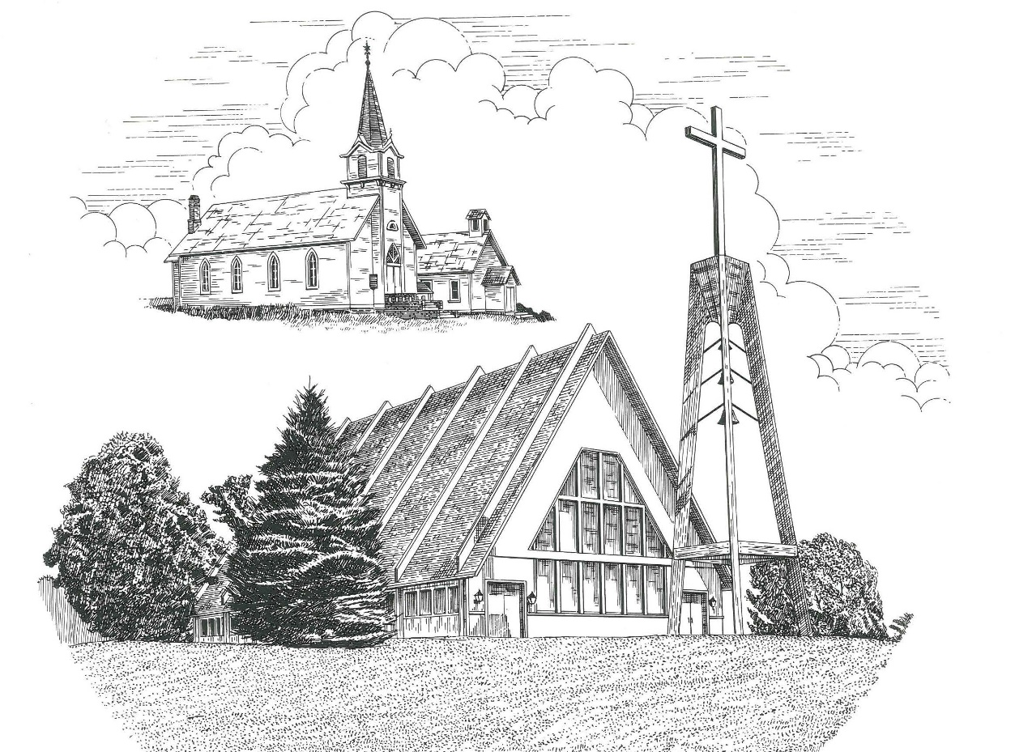

Seventeenth Sunday after Pentecost September 27th, 2020

WELCOME
Thanks for joining us!
Pastor Jacob Sherry Missouri Synod

~~PLEASE NOTE~~
Calling on the name of the Lord
Does not include the use of cell phones in the worship sanctuary.
Please check yours before the service begins. Thank you for your courtesy.
~~TO OUR GUESTS AND VISITORS~~
Please sign our guest book located on the stand at the church entrance. During the service, we ask you to sign the attendance booklet located at the end of each pew. If you need assistance or have questions about our worship service, please talk to an elder or any one of our church family. We are glad you could join us and hope to have you worship with us again soon.

~~ATTENDING HOLY COMMUNION~~
By checking the “Communing Today” box on the registration form found in the attendance booklet, you are agreeing with the following statements:

- I am a baptized Christian who believes Jesus Christ is my Lord and Savior.
- I believe that I am a sinner in need of Christ freely offered forgiveness.
- I believe that in the Lord’s Supper the body and blood of Jesus Christ
are truly present in, with, and under the bread and wine.
- I believe that my participation in Holy Communion grants me forgiveness
of my sins, new spiritual life, and eternal salvation.
- With God’s help, I sincerely seek to repent of my sins, live in service
to my Lord, and await His return.

If you agree with the above statements, you are welcome to attend the Lord’s Supper with us. May God bless your worship time with us.
We do offer gluten-free wafers, please quietly ask an elder to help you.

Order of Divine Service Setting Three

Pre-Service Music……………..Call to Worship………………….Greeting

OPENING HYMN: “Praise to the Lord, the Almighty”..……………...LSB #790
OPENING LITURGY:
Confession & Absolution……………….……………………….LSB pp. 184-185
Kyrie…………………………………….………………………..LSB p. 186
Gloria in Excelsis………………………….……………………..LSB pp. 187-189
Salutation….……………………………….…………………….LSB p. 189

Collect Prayer
Almighty God, You exalted Your Son to the place of all honor and authority. Enlighten our minds by Your Holy Spirit that, confessing Jesus as Lord, we may be led into all truth; through the same Jesus Christ, our Lord, who lives and reigns with You and the Holy Spirit, one God, now and forever.

THE HOLY SCRIPTURES

OLD TESTAMENT: (Ezekiel 18:1-4, 25-32)
The word of the Lord came to me: ² “What do you mean by repeating this proverb concerning the land of Israel, ‘The fathers have eaten sour grapes, and the children's teeth are set on edge’? ³ As I live, declares the Lord God, this proverb shall no more be used by you in Israel. ⁴ Behold, all souls are mine; the soul of the father as well as the soul of the son is mine: the soul who sins shall die.
²⁵ “Yet you say, ‘The way of the Lord is not just.’ Hear now, O house of Israel: Is my way not just? Is it not your ways that are not just? ²⁶ When a righteous person turns away from his righteousness and does injustice, he shall die for it; for the injustice that he has done he shall die. ²⁷ Again, when a wicked person turns away from the wickedness he has committed and does what is just and right, he shall save his life. ²⁸ Because he considered and turned away from all the transgressions that he had committed, he shall surely live; he shall not die. ²⁹ Yet the house of Israel says, ‘The way of the Lord is not just.’ O house of Israel, are my ways not just? Is it not your ways that are not just? ³⁰ “Therefore I will judge you, O house of Israel, everyone according to his ways, declares the Lord God. Repent and turn from all your transgressions, lest iniquity be your ruin. ³¹ Cast away from you all the transgressions that you have committed, and make yourselves a new heart and a new spirit! Why will you die, O house of Israel? ³² For I have no pleasure in the death of anyone, declares the Lord God; so turn, and live.”

R: This is the Word of the Lord. Cong: Thanks be to God.

GRADUAL
Reader: He will command his angels concerning you
Cong.: to guard you in all your ways.
Reader: Bless the Lord, O my soul,
Cong.: and all that is within me, bless his holy name!

EPISTLE: (Philippians 2:1-4, 14-18)
So if there is any encouragement in Christ, any comfort from love, any participation in the Spirit, any affection and sympathy, ² complete my joy by being of the same mind, having the same love, being in full accord and of one mind. ³ Do nothing from selfish ambition or conceit, but in humility count others more significant than yourselves. ⁴ Let each of you look not only to his own interests, but also to the interests of others.
¹⁴ Do all things without grumbling or disputing, ¹⁵ that you may be blameless and innocent, children of God without blemish in the midst of a crooked and twisted generation, among whom you shine as lights in the world, ¹⁶ holding fast to the word of life, so that in the day of Christ I may be proud that I did not run in vain or labor in vain. ¹⁷ Even if I am to be poured out as a drink offering upon the sacrificial offering of your faith, I am glad and rejoice with you all. ¹⁸ Likewise you also should be glad and rejoice with me.

R: This is the Word of the Lord. Cong: Thanks be to God.

(PLEASE RISE for the reading of the Gospel)

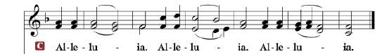

R: The Holy Gospel according to St. Matthew, the 21st chapter.

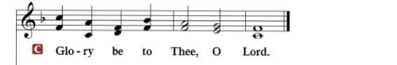

HOLY GOSPEL: (Matthew 21:23-32)
²³ And when Jesus entered the temple, the chief priests and the elders of the people came up to him as he was teaching, and said, “By what authority are you doing these things, and who gave you this authority?” ²⁴ Jesus answered them, “I also will ask you one question, and if you tell me the answer, then I also will tell you by what authority I do these things. ²⁵ The baptism of John, from where did it come? From heaven or from man?” And they discussed it among themselves, saying, “If we say, ‘From heaven,’ he will say to us, ‘Why then did you not believe him?’ ²⁶ But if we say, ‘From man,’ we are afraid of the crowd, for they all hold that John was a prophet.” ²⁷ So they answered Jesus, “We do not know.” And he said to them, “Neither will I tell you by what authority I do these things.
²⁸ “What do you think? A man had two sons. And he went to the first and said, ‘Son, go and work in the vineyard today.’ ²⁹ And he answered, ‘I will not,’ but afterward he changed his mind and went. ³⁰ And he went to the other son and said the same. And he answered, ‘I go, sir,’ but did not go. ³¹ Which of the two did the will of his father?” They said, “The first.” Jesus said to them, “Truly, I say to you, the tax collectors and the prostitutes go into the kingdom of God before you. ³² For John came to you in the way of righteousness, and you did not believe him, but the tax collectors and the prostitutes believed him. And even when you saw it, you did not afterward change your minds and believe him.

R: This is the Gospel of the Lord.

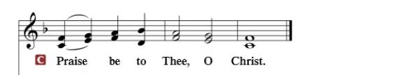

Nicene Creed…...……………………………………………………..…LSB p. 191
I believe in one God, the Father Almighty, maker of heaven and earth and of all things visible and invisible.
And in one Lord Jesus Christ, the only-begotten Son of God, begotten of His Father before all worlds, God of God, Light of Light, very God of very God, begotten, not made, being of one substance with the Father, by whom all things were made; who for us men and for our salvation came down from heaven and was incarnate by the Holy Spirit of the virgin Mary and was made man; and was crucified also for us under Pontius Pilate. He suffered and was buried. And the third day He rose again according to the Scriptures and ascended into heaven and sits at the right hand of the Father. And He will come again with glory to judge both the living and the dead, whose kingdom will have no end.
And I believe in the Holy Spirit, the Lord and giver of life, who proceeds from the Father and the Son, who with the Father and the Son together is worshiped and glorified, who spoke by the prophets. And I believe in one holy Christian and apostolic Church, I acknowledge one Baptism for the remission of sins, and I look for the resurrection of the dead and the life of the world to come. Amen.

SERMON HYMN: “Jerusalem the Golden”……………………………LSB #672

SERMON

GATHERING OF OUR FIRST FRUITS & OFFERTORY…………LSB pp. 192-193

THE GENERAL PRAYERS OF THE CHURCH

INSTITUTION OF THE LORD’S SUPPER
Preface…………………………………….…………….……….LSB p. 194

Proper Preface
It is truly good, right, and salutary that we should at all times and in all places give thanks to You, holy Lord, almighty Father, everlasting God, through Jesus Christ, our Lord, who, out of love for His fallen creation, humbled Himself by taking on the form of a servant, becoming obedient unto death, even death upon a cross. Risen from the dead, He has freed us from eternal death and given us life everlasting. Therefore, with angels and archangels and with all the company of heaven we laud and magnify Your glorious name, ever more praising You and saying:

Sanctus, Lord’s Prayer, The Words of Our Lord………………….....LSB pp. 195-197
Agnus Dei………………………………………………………………..LSB p. 198
If you are not communing it is acceptable to remain seated.

COMMUNION DISTRIBUTION HYMNS:
LSB #627 “Jesus Christ, Our Blessed Savior”
LSB #637 “Draw Near and Take the Body of the Lord”

NUNC DIMITTIS………………………………………………………LSB pp. 199-200

BENEDICTION

CLOSING HYMN: “My Hope Is Built on Nothing Less”.......................LSB #575

The Mission of Trinity Onekama Is To SERVE

For even the Son of Man did not come to be served
but to serve and to give his life as a ransom for many.
Mark 10:45

S haring Jesus’s truth
E quipping for life
R eaching Out
V aluing each other
E vangelizing all ages
Mission Statement
The mission of Trinity Onekama is to SERVE
For even the Son of Man did not come to be served, but to serve,
and to give his life as a ransom for many. Mark 10:45
S haring Jesus’ ruth
E quipping for life
R eaching Out
V aluing each other
E vangelizing all age

CHURCH INFORMATION
Church Office: (231) 889-4429 Website: www.trinityonekama.org
E-mail: trinityonekama@sbcglobal.net
Address: P.O. Box 119, 5471 Fairview Street, Onekama, MI 49675
Adult Bible Study: Sunday @ 9:15 am (year round)
Worship: Sunday @ 10:30 am The Lord’s Supper: Celebrated 2nd & 4th Sundays
Pastoral Hours: Wednesday and Friday 8:30am – Noon
Pastor Phone: 231-655-2680 Pastor Email: trinityonekama@gmail.com

Copyright licensing covered under CCLI #2802932

